UNITED STATES
SECURITIES AND EXCHANGE COMMISSION
Washington, D.C. 20549
FORM 10-Q
(MARK ONE)
x QUARTERLY REPORT PURSUANT TO SECTION 13 OR 15(d) OF THE SECURITIES EXCHANGE ACT OF 1934
For the quarterly period ended June 30, 2025
or
o TRANSITION REPORT PURSUANT TO SECTION 13 OR 15(d) OF THE SECURITIES EXCHANGE ACT OF 1934
For the transition period from _________ to _________
Commission file number: 001-40296
NUVVE HOLDING CORP.
(Exact Name of Registrant as Specified in Its Charter)
Delaware |  |  |  |  |  |  |  |  |  |  |  | 86-1617000
(State or other jurisdiction of  incorporation or organization) |  |  |  |  |  |  |  |  |  |  |  | (I.R.S. Employer  Identification No.)
2488 Historic Decatur Road, Suite 230 |  |  |  |  |  | San Diego, |  |  | California |  |  | 92106
(Address of principal executive offices) |  |  |  |  |  |  |  |  |  |  |  | (Zip Code)
 |  |  |  |  |  | (619) |  |  | 456-5161
(Registrant’s telephone number), including area code
N/A
(Former name, former address and former fiscal year, if changed since last report)
Securities registered pursuant to Section 12(b) of the Act:
Title of each class |  |  |  |  |  | Trading Symbols |  |  |  |  |  | Name of each exchange on which registered
Common Stock, par value $0.0001 per share |  |  |  |  |  | NVVE |  |  |  |  |  | The Nasdaq Stock Market
Warrants to Purchase Common Stock |  |  |  |  |  | NVVEW |  |  |  |  |  | The Nasdaq Stock Market
Indicate by check mark whether the registrant (1) has filed all reports required to be filed by Section 13 or 15(d) of the Securities Exchange Act of 1934 during the preceding 12 months (or for such shorter period that the registrant was required to file such reports), and (2) has been subject to such filing requirements for the past 90 days.
xYes o No
Indicate by check mark whether the registrant has submitted electronically every Interactive Data File required to be submitted pursuant to Rule 405 of Regulation S-T (§232.405 of this chapter) during the preceding 12 months (or for such shorter period that the registrant was required to submit such files).
x Yes o No
Indicate by check mark whether the registrant is a large accelerated filer, an accelerated filer, a non-accelerated filer, a smaller reporting company or an emerging growth company. See definitions of “large accelerated filer”, “accelerated filer”, “smaller reporting company”, and “emerging growth company” in Rule 12b-2 of the Exchange Act.
Large accelerated filer |  |  | o |  |  |  |  |  | Accelerated filer |  |  | o
Non-accelerated filer |  |  | x |  |  |  |  |  | Smaller reporting company |  |  | x
 |  |  |  |  |  |  |  |  | Emerging growth company |  |  | x
If an emerging growth company, indicate by check mark if the registrant has elected not to use the extended transition period for complying with any new or revised financial accounting standards provided pursuant to Section 13(a) of the Exchange Act. o
Indicate by check mark whether the registrant is a shell company (as defined in Rule 12b-2 of the Exchange Act).
o Yes x No
As of August 7, 2025, 18,868,425 shares of the issuer’s common stock, par value $0.0001 per share, were issued and outstanding.

NUVVE HOLDING CORP.
FORM 10-Q FOR THE QUARTER ENDED June 30, 2025
TABLE OF CONTENTS
PART I—FINANCIAL INFORMATION |  |  |  |  |  |  |  |  | 1
 |  |  | Item 1. |  |  | Interim Condensed Consolidated Financial Statements and Notes (Unaudited). |  |  | 1
 |  |  | Item 2. |  |  | Management’s Discussion and Analysis of Financial Condition and Results of Operations. |  |  | 40
 |  |  | Item 3. |  |  | Quantitative and Qualitative Disclosures About Market Risk. |  |  | 51
 |  |  | Item 4. |  |  | Controls and Procedures. |  |  | 51
PART II—OTHER INFORMATION |  |  |  |  |  |  |  |  | 52
 |  |  | Item 1. |  |  | Legal Proceedings. |  |  | 52
 |  |  | Item 1A. |  |  | Risk Factors. |  |  | 52
 |  |  | Item 2. |  |  | Unregistered Sales of Equity Securities and Use of Proceeds. |  |  | 60
 |  |  | Item 3. |  |  | Defaults Upon Senior Securities. |  |  | 60
 |  |  | Item 4. |  |  | Mine Safety Disclosures. |  |  | 60
 |  |  | Item 5. |  |  | Other Information. |  |  | 60
 |  |  | Item 6. |  |  | Exhibits. |  |  | 60

i

Cautionary Note Regarding Forward-Looking Statements

This Quarterly Report on Form 10-Q and other documents incorporated herein by reference contain forward-looking statements that are based on current expectations, estimates, forecasts and projections about us, our future performance, our financial condition, our products, our business strategy, our beliefs and our management’s assumptions. In addition, we, or others on our behalf, may make forward-looking statements in press releases or written statements, or in our communications and discussions with investors and analysts in the normal course of business through meetings, webcasts, phone calls and conference calls. These forward-looking statements can be identified by the use of words like “anticipates,” “estimates,” “projects,” “expects,” “plans,” “believes,” “intends,” “will,” “could,” “may,” “assumes” and other words of similar meaning. These statements are based on management’s beliefs, assumptions, estimates and observations of future events based on information available to our management at the time the statements are made and include any statements that do not relate to any historical or current fact. These statements are not guarantees of future performance and they involve certain risks, uncertainties and assumptions that are difficult to predict. Actual outcomes and results may differ materially from what is expressed, implied or forecast by our forward-looking statements due in part to the risks, uncertainties and assumptions described in Item 1A, “Risk Factors” in our Annual Report on Form 10-K for the year ended December 31, 2024, as well as those discussed elsewhere in this Quarterly Report on Form 10-Q and other factors described from time to time in our filings with the Securities and Exchange Commission (the “SEC”).

Factors that could cause actual results to differ materially from those in forward-looking statements include, risks related to the rollout of Nuvve's business and the timing of expected business milestones; Nuvve's dependence on widespread acceptance and adoption of electric vehicles and increased installation of charging stations; Nuvve's ability to maintain effective internal controls over financial reporting, including the remediation of identified material weaknesses in internal control over financial reporting relating to segregation of duties with respect to, and access controls to, its financial record keeping system, and Nuvve's accounting staffing levels; Nuvve's current dependence on sales of charging stations for most of its revenues; overall demand for electric vehicle charging and the potential for reduced demand if governmental rebates, tax credits and other financial incentives are reduced, modified or eliminated or governmental mandates to increase the use of electric vehicles or decrease the use of vehicles powered by fossil fuels, either directly or indirectly through mandated limits on carbon emissions, are reduced, modified or eliminated; potential adverse effects on Nuvve's backlog, revenue and gross margins if customers increasingly claim clean energy credits and, as a result, they are no longer available to be claimed by Nuvve; the effects of competition on Nuvve's future business; risks related to Nuvve's dependence on its intellectual property and the risk that Nuvve's technology could have undetected defects or errors; the risk that we conduct a portion of our operations through a joint venture exposes us to risks and uncertainties, many of which are outside of our control; changes in applicable laws or regulations; risks related to disruption of management time from ongoing business operations due to our joint ventures; risks relating to privacy and data protection laws, privacy or data breaches, or the loss of data; the possibility that Nuvve may be adversely affected by other economic, business, and/or competitive factors; risks related to changes in regulations applicable to our operations; risks related to our bitcoin treasury strategy; as well as other risks described in this Quarterly Report on Form 10-Q and other factors described from time to time in our filings with the SEC.

Given these risks and uncertainties, you should not rely on forward-looking statements as a prediction of actual results. Any or all of the forward-looking statements contained in this Quarterly Report on Form 10-Q and any other public statement made by us, including by our management, may turn out to be incorrect. We are including this cautionary note to make applicable and take advantage of the safe harbor provisions of the Private Securities Litigation Reform Act of 1995 for forward-looking statements. We expressly disclaim any obligation to update or revise any forward-looking statements, whether as a result of new information, future events, changes in assumptions or otherwise, except as required under federal securities laws and the rules and regulations of the SEC.

ii

PART I—FINANCIAL INFORMATION

Item 1. Interim Financial Statements

NUVVE HOLDING CORP. AND SUBSIDIARIES
CONDENSED CONSOLIDATED BALANCE SHEETS
(Unaudited)
 |  |  | June 30, 2025 |  |  |  |  |  | December 31, 2024
Assets
Current assets
Cash |  |  | $ | 1,767,406 |  |  |  |  | $ | 371,497
Restricted cash |  |  | 320,000 |  |  |  |  |  | 320,000
Accounts receivable, net |  |  | 349,352 |  |  |  |  |  | 2,148,198
Inventories |  |  | 4,267,084 |  |  |  |  |  | 4,591,902
Prepaid expenses |  |  | 752,133 |  |  |  |  |  | 494,986
Deferred costs - current |  |  | 944,653 |  |  |  |  |  | 417,290
Other current assets |  |  | 382,473 |  |  |  |  |  | 931,244
Total current assets |  |  | 8,783,101 |  |  |  |  |  | 9,275,117
Property and equipment, net |  |  | 710,119 |  |  |  |  |  | 613,958
Intangible assets, net |  |  | 1,142,047 |  |  |  |  |  | 1,062,766
Goodwill |  |  | 703,957 |  |  |  |  |  | —
Investment in equity securities |  |  | 670,951 |  |  |  |  |  | 670,951
Investment in leases |  |  | 99,749 |  |  |  |  |  | 101,415
Right-of-use operating lease assets |  |  | 4,222,680 |  |  |  |  |  | 4,493,360
Deferred costs - noncurrent |  |  | 594,558 |  |  |  |  |  | 564,558
Security deposit, long-term |  |  | 66,215 |  |  |  |  |  | 15,687
Total assets |  |  | $ | 16,993,377 |  |  |  |  | $ | 16,797,812
Liabilities and Equity
Current liabilities
Accounts payable |  |  | $ | 1,401,714 |  |  |  |  | $ | 1,882,357
Due to customers |  |  | 800,000 |  |  |  |  |  | —
Accrued expenses |  |  | 5,323,935 |  |  |  |  |  | 3,393,205
Deferred revenue - current |  |  | 971,759 |  |  |  |  |  | 506,496
Debt - term loan |  |  | 1,210,572 |  |  |  |  |  | 1,609,928
Due to related party - promissory notes - current |  |  | 516,231 |  |  |  |  |  | 562,241
Convertible notes - current |  |  | 2,032,074 |  |  |  |  |  | 2,475,162
Operating lease liabilities - current |  |  | 872,562 |  |  |  |  |  | 914,800
Other liabilities |  |  | 156,197 |  |  |  |  |  | 6,969
Total current liabilities |  |  | 13,285,044 |  |  |  |  |  | 11,351,158
Operating lease liabilities - noncurrent |  |  | 3,962,465 |  |  |  |  |  | 4,254,173
Due to related party - promissory notes - noncurrent |  |  | 1,106,500 |  |  |  |  |  | 840,500
Convertible notes - noncurrent |  |  | 354,587 |  |  |  |  |  | —
Deferred revenue - noncurrent |  |  | 546,241 |  |  |  |  |  | 771,747
Warrants/investment rights liability |  |  | 364,447 |  |  |  |  |  | 699,087
Other long-term liabilities |  |  | 202,332 |  |  |  |  |  | 170,794
Total liabilities |  |  | 19,821,616 |  |  |  |  |  | 18,087,459
Commitments and Contingencies
Mezzanine equity
Redeemable non-controlling interests, preferred shares, zero par value, 1,000,000 shares authorized, 0 shares issued and outstanding at June 30, 2025 and — shares issued and outstanding at December 31, 2024; aggregate liquidation preference of $0 and $3,750,201 at June 30, 2025 and December 31, 2024, respectively |  |  | — |  |  |  |  |  | —
Stockholders’ equity
Preferred Class A units, zero par value, 4,900,000 shares authorized; 4,900,000 units issued and outstanding at June 30, 2025, and zero units issued and outstanding at December 31, 2024, respectively |  |  | 774,976 |  |  |  |  |  | —
Class B units, zero par value, 2,500,000 units authorized; 100,000 units issued and outstanding at June 30, 2025, and zero units issued and outstanding at December 31, 2024, respectively |  |  | 100,000 |  |  |  |  |  | —
Preferred stock, $0.0001 par value, 1,000,000 shares authorized; zero shares issued and outstanding at June 30, 2025 and December 31, 2024, respectively |  |  | — |  |  |  |  |  | —
Common stock, $0.0001 par value, 200,000,000 shares authorized; 10,921,341 and 904,949 shares issued and outstanding at June 30, 2025 and December 31, 2024, respectively |  |  | 7,404 |  |  |  |  |  | 6,408
Treasury stock, at cost, 1,680 shares outstanding at June 30, 2025; 1,680 shares outstanding at December 31, 2024 |  |  | — |  |  |  |  |  | —
Additional paid-in capital |  |  | 182,310,448 |  |  |  |  |  | 164,285,336
Accumulated other comprehensive income |  |  | 53,881 |  |  |  |  |  | 46,494
Accumulated deficit |  |  | (185,850,879) |  |  |  |  |  | (165,599,076)
Nuvve Holding Corp. stockholders’ deficit |  |  | (2,604,170) |  |  |  |  |  | (1,260,838)
Non-controlling interests |  |  | (224,069) |  |  |  |  |  | (28,809)
Total stockholders’ deficit |  |  | (2,828,239) |  |  |  |  |  | (1,289,647)
Total deficit |  |  | (2,828,239) |  |  |  |  |  | (1,289,647)
Total Liabilities and Equity |  |  | $ | 16,993,377 |  |  |  |  | $ | 16,797,812

The accompanying notes are an integral part of these condensed consolidated financial statements.

1

NUVVE HOLDING CORP. AND SUBSIDIARIES
CONDENSED CONSOLIDATED STATEMENTS OF OPERATIONS
(Unaudited)
 |  |  | Three Months Ended June 30, |  |  |  |  |  |  |  |  |  |  |  | Six Months Ended June 30,
 |  |  | 2025 |  |  |  |  |  | 2024 |  |  |  |  |  | 2025 |  |  |  |  |  | 2024
Revenue
Products |  |  | $ | 141,905 |  |  |  |  | $ | 369,192 |  |  |  |  | $ | 707,456 |  |  |  |  | $ | 845,661
Services |  |  | 191,084 |  |  |  |  |  | 301,567 |  |  |  |  |  | 458,388 |  |  |  |  |  | 521,438
Grants |  |  | — |  |  |  |  |  | 131,421 |  |  |  |  |  | 79,610 |  |  |  |  |  | 214,837
Total revenue |  |  | 332,989 |  |  |  |  |  | 802,180 |  |  |  |  |  | 1,245,454 |  |  |  |  |  | 1,581,936
Operating expenses
Cost of products |  |  | 48,124 |  |  |  |  |  | 256,902 |  |  |  |  |  | 541,339 |  |  |  |  |  | 593,574
Cost of services |  |  | 82,941 |  |  |  |  |  | 345,813 |  |  |  |  |  | 150,970 |  |  |  |  |  | 518,585
Selling, general, and administrative |  |  | 13,905,986 |  |  |  |  |  | 4,489,772 |  |  |  |  |  | 18,960,049 |  |  |  |  |  | 10,417,882
Research and development |  |  | 1,093,163 |  |  |  |  |  | 1,473,567 |  |  |  |  |  | 1,976,935 |  |  |  |  |  | 3,063,144
Total operating expenses |  |  | 15,130,214 |  |  |  |  |  | 6,566,054 |  |  |  |  |  | 21,629,293 |  |  |  |  |  | 14,593,185
Operating loss |  |  | (14,797,225) |  |  |  |  |  | (5,763,874) |  |  |  |  |  | (20,383,839) |  |  |  |  |  | (13,011,249)
Other income (expense)
Interest (expense) income, net |  |  | (707,017) |  |  |  |  |  | 10,736 |  |  |  |  |  | (1,242,834) |  |  |  |  |  | 19,748
Change in fair value of convertible notes |  |  | 1,142,710 |  |  |  |  |  | — |  |  |  |  |  | 51,704 |  |  |  |  |  | —
Change in fair value of warrants/investment rights liability |  |  | 565,800 |  |  |  |  |  | 1,584,772 |  |  |  |  |  | 441,182 |  |  |  |  |  | 2,312,434
Change in fair value of derivative liability |  |  | — |  |  |  |  |  | 7,907 |  |  |  |  |  | — |  |  |  |  |  | (3,626)
Other, net |  |  | 227,270 |  |  |  |  |  | 211,444 |  |  |  |  |  | 686,724 |  |  |  |  |  | 4,941
Total other income (expense), net |  |  | 1,228,763 |  |  |  |  |  | 1,814,859 |  |  |  |  |  | (63,224) |  |  |  |  |  | 2,333,497
Loss before taxes |  |  | (13,568,462) |  |  |  |  |  | (3,949,015) |  |  |  |  |  | (20,447,063) |  |  |  |  |  | (10,677,752)
Income tax expense |  |  | — |  |  |  |  |  | — |  |  |  |  |  | — |  |  |  |  |  | —
Net loss |  |  | $ | (13,568,462) |  |  |  |  | $ | (3,949,015) |  |  |  |  | $ | (20,447,063) |  |  |  |  | $ | (10,677,752)
Less: Net loss attributable to non-controlling interests |  |  | (189,662) |  |  |  |  |  | (10,268) |  |  |  |  |  | (195,260) |  |  |  |  |  | (24,566)
Net loss attributable to Nuvve Holding Corp. |  |  | $ | (13,378,800) |  |  |  |  | $ | (3,938,747) |  |  |  |  | $ | (20,251,803) |  |  |  |  | $ | (10,653,186)
Less: Preferred dividends on redeemable non-controlling interests |  |  | — |  |  |  |  |  | 76,504 |  |  |  |  |  | — |  |  |  |  |  | 151,508
Less: Accretion on redeemable non-controlling interests preferred shares |  |  | — |  |  |  |  |  | 161,466 |  |  |  |  |  | — |  |  |  |  |  | 322,932
Net loss attributable to Nuvve Holding Corp. common stockholders |  |  | $ | (13,378,800) |  |  |  |  | $ | (4,176,717) |  |  |  |  | $ | (20,251,803) |  |  |  |  | $ | (11,127,626)
Net loss per share attributable to Nuvve Holding Corp. common stockholders, basic and diluted |  |  | $ | (2.12) |  |  |  |  | $ | (6.70) |  |  |  |  | $ | (4.97) |  |  |  |  | $ | (21.51)
Weighted-average shares used in computing net loss per share attributable to Nuvve Holding Corp. common stockholders, basic and diluted |  |  | 6,313,968 |  |  |  |  |  | 623,028 |  |  |  |  |  | 4,073,294 |  |  |  |  |  | 517,236

The accompanying notes are an integral part of these condensed consolidated financial statements.

2

NUVVE HOLDING CORP. AND SUBSIDIARIES
CONDENSED CONSOLIDATED STATEMENTS OF COMPREHENSIVE LOSS
(Unaudited)
 |  |  | Three Months Ended June 30, |  |  |  |  |  |  |  |  |  |  |  | Six Months Ended June 30,
 |  |  | 2025 |  |  |  |  |  | 2024 |  |  |  |  |  | 2025 |  |  |  |  |  | 2024
Net loss |  |  | $ | (13,568,462) |  |  |  |  | $ | (3,949,015) |  |  |  |  | $ | (20,447,063) |  |  |  |  | $ | (10,677,752)
Other comprehensive (loss) income, net of taxes
Foreign currency translation adjustments, net of taxes |  |  | 7,151 |  |  |  |  |  | (8,093) |  |  |  |  |  | 7,387 |  |  |  |  |  | (21,744)
Total comprehensive loss |  |  | $ | (13,561,311) |  |  |  |  | $ | (3,957,108) |  |  |  |  | $ | (20,439,676) |  |  |  |  | $ | (10,699,496)
Less: Comprehensive loss attributable to non-controlling interests |  |  | (189,662) |  |  |  |  |  | (10,268) |  |  |  |  |  | (195,260) |  |  |  |  |  | (24,566)
Comprehensive loss attributable to Nuvve Holding Corp. |  |  | $ | (13,371,649) |  |  |  |  | $ | (3,946,840) |  |  |  |  | $ | (20,244,416) |  |  |  |  | $ | (10,674,930)
Less: Preferred dividends on redeemable non-controlling interests |  |  | — |  |  |  |  |  | (76,504) |  |  |  |  |  | — |  |  |  |  |  | (151,508)
Less: Accretion on redeemable non-controlling interests preferred shares |  |  | — |  |  |  |  |  | (161,466) |  |  |  |  |  | — |  |  |  |  |  | (322,932)
Comprehensive loss attributable to Nuvve Holding Corp. common stockholders |  |  | $ | (13,371,649) |  |  |  |  | $ | (3,708,870) |  |  |  |  | $ | (20,244,416) |  |  |  |  | $ | (10,200,490)

The accompanying notes are an integral part of these condensed consolidated financial statements.

3

NUVVE HOLDING CORP. AND SUBSIDIARIES
CONDENSED CONSOLIDATED STATEMENTS OF STOCKHOLDERS’ EQUITY (DEFICIT)
(Unaudited)
 |  |  |  |  |  |  |  |  | Preferred Class A Units |  |  |  |  |  | Class B Units |  |  |  |  |  |  |  |  |  |  |  | Common Stock |  |  |  |  |  |  |  |  |  |  |  | Treasury Stock |  |  |  |  |  |  |  |  |  |  |  | Additional  Paid-in  Capital |  |  |  |  |  | Accumulated Other  Comprehensive  Income (Loss) |  |  |  |  |  | Accumulated  Deficit |  |  |  |  |  | Non-controlling Interests |  |  |  |  |  | Total
 |  |  |  |  |  |  |  |  |  |  |  |  |  |  | Shares |  |  |  |  |  | Amount |  |  |  |  |  | Shares |  |  |  |  |  | Amount |  |  |  |  |  | Shares |  |  |  |  |  | Amount |  |  |  |  |  |  |  |  | Shares |  |  |  |  |  |  |  |  |  |  |  | Amount
Balances December 31, 2024 |  |  |  |  |  |  |  |  |  |  |  |  |  |  | — |  |  |  |  |  | $ | — |  |  |  |  | — |  |  |  |  |  | — |  |  |  |  |  | 903,269 |  |  |  |  |  | $ | 6,408 |  |  |  |  | 1,680 |  |  |  |  |  | $ | — |  |  |  |  | $ | 164,285,336 |  |  |  |  | $ | 46,494 |  |  |  |  | $ | (165,599,076) |  |  |  |  | $ | (28,809) |  |  |  |  | $ | (1,289,647)
Stock-based compensation |  |  |  |  |  |  |  |  |  |  |  |  |  |  | — |  |  |  |  |  | — |  |  |  |  |  | — |  |  |  |  |  | — |  |  |  |  |  | — |  |  |  |  |  | — |  |  |  |  |  | — |  |  |  |  |  | — |  |  |  |  |  | 554,659 |  |  |  |  |  | — |  |  |  |  |  | — |  |  |  |  |  | — |  |  |  |  |  | 554,659
Proceeds from direct offering, net of offering costs |  |  |  |  |  |  |  |  |  |  |  |  |  |  | — |  |  |  |  |  | — |  |  |  |  |  | — |  |  |  |  |  | — |  |  |  |  |  | 213,428 |  |  |  |  |  | 21 |  |  |  |  |  | — |  |  |  |  |  | — |  |  |  |  |  | 564,847 |  |  |  |  |  | — |  |  |  |  |  | — |  |  |  |  |  | — |  |  |  |  |  | 564,868
Exercise of warrants/warrants issuance |  |  |  |  |  |  |  |  |  |  |  |  |  |  | — |  |  |  |  |  | — |  |  |  |  |  | — |  |  |  |  |  | — |  |  |  |  |  | 431,652 |  |  |  |  |  | 43 |  |  |  |  |  | — |  |  |  |  |  | — |  |  |  |  |  | 854,053 |  |  |  |  |  | — |  |  |  |  |  | — |  |  |  |  |  | — |  |  |  |  |  | 854,096
Conversion of convertible notes, net of offering costs |  |  |  |  |  |  |  |  |  |  |  |  |  |  | — |  |  |  |  |  | — |  |  |  |  |  | — |  |  |  |  |  | — |  |  |  |  |  | 1,568,019 |  |  |  |  |  | 157 |  |  |  |  |  | — |  |  |  |  |  | — |  |  |  |  |  | 2,952,426 |  |  |  |  |  | — |  |  |  |  |  | — |  |  |  |  |  | — |  |  |  |  |  | 2,952,583
Currency translation adjustment |  |  |  |  |  |  |  |  |  |  |  |  |  |  | — |  |  |  |  |  | — |  |  |  |  |  | — |  |  |  |  |  | — |  |  |  |  |  | — |  |  |  |  |  | — |  |  |  |  |  | — |  |  |  |  |  | — |  |  |  |  |  | — |  |  |  |  |  | 236 |  |  |  |  |  | — |  |  |  |  |  | — |  |  |  |  |  | 236
Net loss |  |  |  |  |  |  |  |  |  |  |  |  |  |  | — |  |  |  |  |  | — |  |  |  |  |  | — |  |  |  |  |  |  |  |  |  |  |  | — |  |  |  |  |  | — |  |  |  |  |  | — |  |  |  |  |  | — |  |  |  |  |  | — |  |  |  |  |  | — |  |  |  |  |  | (6,873,003) |  |  |  |  |  | (5,598) |  |  |  |  |  | (6,878,601)
Balances March 31, 2025 |  |  |  |  |  |  |  |  |  |  |  |  |  |  | — |  |  |  |  |  | — |  |  |  |  |  | — |  |  |  |  |  | — |  |  |  |  |  | 3,116,368 |  |  |  |  |  | 6,629 |  |  |  |  |  | 1,680 |  |  |  |  |  | — |  |  |  |  |  | 169,211,321 |  |  |  |  |  | 46,730 |  |  |  |  |  | (172,472,079) |  |  |  |  |  | (34,407) |  |  |  |  |  | (3,241,806)
Stock-based compensation |  |  |  |  |  |  |  |  |  |  |  |  |  |  | — |  |  |  |  |  | — |  |  |  |  |  | — |  |  |  |  |  | — |  |  |  |  |  | — |  |  |  |  |  | — |  |  |  |  |  | — |  |  |  |  |  | — |  |  |  |  |  | 14,022 |  |  |  |  |  | — |  |  |  |  |  | — |  |  |  |  |  | — |  |  |  |  |  | 14,022
Exercise of warrants |  |  |  |  |  |  |  |  |  |  |  |  |  |  | — |  |  |  |  |  | — |  |  |  |  |  | — |  |  |  |  |  | — |  |  |  |  |  | 1,651,643 |  |  |  |  |  | 165 |  |  |  |  |  | — |  |  |  |  |  | — |  |  |  |  |  | 1,221,084 |  |  |  |  |  | — |  |  |  |  |  | — |  |  |  |  |  | — |  |  |  |  |  | 1,221,249
Warrants issuance |  |  |  |  |  |  |  |  |  |  |  |  |  |  | — |  |  |  |  |  | — |  |  |  |  |  | — |  |  |  |  |  | — |  |  |  |  |  | — |  |  |  |  |  | — |  |  |  |  |  | — |  |  |  |  |  | — |  |  |  |  |  | 8,194,000 |  |  |  |  |  | — |  |  |  |  |  | — |  |  |  |  |  | — |  |  |  |  |  | 8,194,000
Conversion of convertible notes, net of offering costs |  |  |  |  |  |  |  |  |  |  |  |  |  |  | — |  |  |  |  |  | — |  |  |  |  |  | — |  |  |  |  |  | — |  |  |  |  |  | 6,153,330 |  |  |  |  |  | 609 |  |  |  |  |  | — |  |  |  |  |  | — |  |  |  |  |  | 3,670,020 |  |  |  |  |  | — |  |  |  |  |  | — |  |  |  |  |  | — |  |  |  |  |  | 3,670,630
Preferred Class A units issuance |  |  |  |  |  |  |  |  |  |  |  |  |  |  | 4,900,000 |  |  |  |  |  | 774,976 |  |  |  |  |  | — |  |  |  |  |  | — |  |  |  |  |  | — |  |  |  |  |  | — |  |  |  |  |  | — |  |  |  |  |  | — |  |  |  |  |  | — |  |  |  |  |  | — |  |  |  |  |  | — |  |  |  |  |  | — |  |  |  |  |  | 774,976
Class B units issuance |  |  |  |  |  |  |  |  |  |  |  |  |  |  | — |  |  |  |  |  | — |  |  |  |  |  | 100,000 |  |  |  |  |  | 100,000 |  |  |  |  |  | — |  |  |  |  |  | — |  |  |  |  |  | — |  |  |  |  |  | — |  |  |  |  |  | — |  |  |  |  |  | — |  |  |  |  |  | — |  |  |  |  |  | — |  |  |  |  |  | 100,000
Currency translation adjustment |  |  |  |  |  |  |  |  |  |  |  |  |  |  | — |  |  |  |  |  | — |  |  |  |  |  | — |  |  |  |  |  | — |  |  |  |  |  | — |  |  |  |  |  | — |  |  |  |  |  | — |  |  |  |  |  | — |  |  |  |  |  | — |  |  |  |  |  | 7,151 |  |  |  |  |  | — |  |  |  |  |  | — |  |  |  |  |  | 7,151
Net loss |  |  |  |  |  |  |  |  |  |  |  |  |  |  | — |  |  |  |  |  | — |  |  |  |  |  | — |  |  |  |  |  | — |  |  |  |  |  | — |  |  |  |  |  | — |  |  |  |  |  | — |  |  |  |  |  | — |  |  |  |  |  | — |  |  |  |  |  | — |  |  |  |  |  | (13,378,800) |  |  |  |  |  | (189,662) |  |  |  |  |  | (13,568,462)
Balances June 30, 2025 |  |  |  |  |  |  |  |  |  |  |  |  |  |  | 4,900,000 |  |  |  |  |  | $ | 774,976 |  |  |  |  | 100,000 |  |  |  |  |  | $ | 100,000 |  |  |  |  | 10,921,341 |  |  |  |  |  | $ | 7,404 |  |  |  |  | 1,680 |  |  |  |  |  | $ | — |  |  |  |  | $ | 182,310,448 |  |  |  |  | $ | 53,881 |  |  |  |  | $ | (185,850,879) |  |  |  |  | $ | (224,069) |  |  |  |  | $ | (2,828,239)

The accompanying notes are an integral part of these condensed consolidated financial statements.

4

NUVVE HOLDING CORP. AND SUBSIDIARIES
CONDENSED CONSOLIDATED STATEMENTS OF STOCKHOLDERS’ EQUITY (DEFICIT) (continued)
(Unaudited)

 |  |  |  |  |  |  |  |  | Common Stock |  |  |  |  |  | Additional  Paid-in  Capital |  |  |  |  |  | Accumulated Other  Comprehensive  Income (Loss) |  |  |  |  |  | Accumulated  Deficit |  |  |  |  |  | Non-controlling Interests |  |  |  |  |  | Total
 |  |  |  |  |  |  |  |  |  |  |  |  |  |  |  |  |  | Shares |  |  |  |  |  |  |  |  |  |  |  | Amount
Balances December 31, 2023 |  |  |  |  |  |  |  |  |  |  |  |  |  |  | 124,659 |  |  |  |  |  | $ | 5,927 |  |  |  |  | $ | 155,615,962 |  |  |  |  | $ | 93,676 |  |  |  |  | $ | (148,240,859) |  |  |  |  | $ | (4,894,101) |  |  |  |  | $ | 2,580,605
Exercise of stock options and vesting of restricted stock |  |  |  |  |  |  |  |  |  |  |  |  |  |  | 17,414 |  |  |  |  |  | 18 |  |  |  |  |  | (18) |  |  |  |  |  | — |  |  |  |  |  | — |  |  |  |  |  | — |  |  |  |  |  | —
Stock-based compensation |  |  |  |  |  |  |  |  |  |  |  |  |  |  | — |  |  |  |  |  | — |  |  |  |  |  | 846,514 |  |  |  |  |  | — |  |  |  |  |  | — |  |  |  |  |  | — |  |  |  |  |  | 846,514
Proceeds from common stock offering, net of offering costs |  |  |  |  |  |  |  |  |  |  |  |  |  |  | 303,500 |  |  |  |  |  | 304 |  |  |  |  |  | 5,029,118 |  |  |  |  |  | — |  |  |  |  |  | — |  |  |  |  |  | — |  |  |  |  |  | 5,029,422
Issuance of Pre-funded Warrants |  |  |  |  |  |  |  |  |  |  |  |  |  |  | 161,492 |  |  |  |  |  | 108 |  |  |  |  |  | — |  |  |  |  |  | — |  |  |  |  |  | — |  |  |  |  |  | — |  |  |  |  |  | 108
Currency translation adjustment |  |  |  |  |  |  |  |  |  |  |  |  |  |  | — |  |  |  |  |  | — |  |  |  |  |  | — |  |  |  |  |  | (13,651) |  |  |  |  |  | — |  |  |  |  |  | — |  |  |  |  |  | (13,651)
Preferred dividends - non-controlling interest |  |  |  |  |  |  |  |  |  |  |  |  |  |  | — |  |  |  |  |  | — |  |  |  |  |  | — |  |  |  |  |  | — |  |  |  |  |  | — |  |  |  |  |  | (75,004) |  |  |  |  |  | (75,004)
Accretion on redeemable non-controlling interests preferred shares |  |  |  |  |  |  |  |  |  |  |  |  |  |  | — |  |  |  |  |  | — |  |  |  |  |  | — |  |  |  |  |  | — |  |  |  |  |  | — |  |  |  |  |  | (161,466) |  |  |  |  |  | (161,466)
Net loss |  |  |  |  |  |  |  |  |  |  |  |  |  |  | — |  |  |  |  |  | — |  |  |  |  |  | — |  |  |  |  |  | — |  |  |  |  |  | (6,714,438) |  |  |  |  |  | (14,299) |  |  |  |  |  | (6,728,737)
Balances March 31, 2024 |  |  |  |  |  |  |  |  |  |  |  |  |  |  | 607,064 |  |  |  |  |  | 6,357 |  |  |  |  |  | 161,491,576 |  |  |  |  |  | 80,025 |  |  |  |  |  | (154,955,297) |  |  |  |  |  | (5,144,870) |  |  |  |  |  | 1,477,791
Exercise of stock options and vesting of restricted stock |  |  |  |  |  |  |  |  |  |  |  |  |  |  | 661 |  |  |  |  |  | 1 |  |  |  |  |  | (1) |  |  |  |  |  | — |  |  |  |  |  | — |  |  |  |  |  | — |  |  |  |  |  | —
Stock-based compensation |  |  |  |  |  |  |  |  |  |  |  |  |  |  | — |  |  |  |  |  | — |  |  |  |  |  | 481,800 |  |  |  |  |  | — |  |  |  |  |  | — |  |  |  |  |  | — |  |  |  |  |  | 481,800
Issuance of Pre-funded warrants |  |  |  |  |  |  |  |  |  |  |  |  |  |  | 14,998 |  |  |  |  |  | 15 |  |  |  |  |  | (15) |  |  |  |  |  | — |  |  |  |  |  | — |  |  |  |  |  | — |  |  |  |  |  | —
Exercise of Warrants |  |  |  |  |  |  |  |  |  |  |  |  |  |  | 30,000 |  |  |  |  |  | 30 |  |  |  |  |  | 172,967 |  |  |  |  |  | — |  |  |  |  |  | — |  |  |  |  |  | — |  |  |  |  |  | 172,997
Currency translation adjustment |  |  |  |  |  |  |  |  |  |  |  |  |  |  | — |  |  |  |  |  | — |  |  |  |  |  | — |  |  |  |  |  | (8,093) |  |  |  |  |  | — |  |  |  |  |  | — |  |  |  |  |  | (8,093)
Preferred dividends - non-controlling interest |  |  |  |  |  |  |  |  |  |  |  |  |  |  | — |  |  |  |  |  | — |  |  |  |  |  | — |  |  |  |  |  | — |  |  |  |  |  | — |  |  |  |  |  | (76,504) |  |  |  |  |  | (76,504)
Accretion on redeemable non-controlling interests preferred shares |  |  |  |  |  |  |  |  |  |  |  |  |  |  | — |  |  |  |  |  | — |  |  |  |  |  | — |  |  |  |  |  | — |  |  |  |  |  | — |  |  |  |  |  | (161,466) |  |  |  |  |  | (161,466)
Net loss |  |  |  |  |  |  |  |  |  |  |  |  |  |  | — |  |  |  |  |  | — |  |  |  |  |  | — |  |  |  |  |  | — |  |  |  |  |  | (3,938,747) |  |  |  |  |  | (10,268) |  |  |  |  |  | (3,949,015)
Balances June 30, 2024 |  |  |  |  |  |  |  |  |  |  |  |  |  |  | 652,723 |  |  |  |  |  | $ | 6,403 |  |  |  |  | $ | 162,146,327 |  |  |  |  | $ | 71,932 |  |  |  |  | $ | (158,894,044) |  |  |  |  | $ | (5,393,108) |  |  |  |  | $ | (2,062,490)

The accompanying notes are an integral part of these condensed consolidated financial statements.

5

NUVVE HOLDING CORP. AND SUBSIDIARIES
CONDENSED CONSOLIDATED STATEMENTS OF CASH FLOWS
(Unaudited)
 |  |  | Six Months Ended June 30,
 |  |  | 2025 |  |  |  |  |  | 2024
Operating activities
Net loss |  |  | $ | (20,447,063) |  |  |  |  | $ | (10,677,752)
Adjustments to reconcile net loss to net cash used in operating activities
Depreciation and amortization |  |  | 160,425 |  |  |  |  |  | 179,170
Stock-based compensation |  |  | 568,681 |  |  |  |  |  | 1,390,808
Amortization of discount on debt and promissory notes |  |  | 61,326 |  |  |  |  |  | —
Change in fair value of warrants liability |  |  | (441,182) |  |  |  |  |  | (2,312,434)
Change in fair value of convertible notes |  |  | (51,704) |  |  |  |  |  | —
Change in fair value of derivative liability |  |  | — |  |  |  |  |  | 3,626
Fair value of warrants issued for cryptocurrency strategy consulting services |  |  | 8,194,000 |  |  |  |  |  | —
Loss on warrants issuance |  |  | — |  |  |  |  |  | 305,065
Provision for credit losses |  |  | 990,105 |  |  |  |  |  | —
Noncash lease expense |  |  | 250,448 |  |  |  |  |  | 252,997
Change in operating assets and liabilities
Accounts receivable |  |  | 749,923 |  |  |  |  |  | 1,208,706
Inventory |  |  | 347,541 |  |  |  |  |  | (154,683)
Prepaid expenses and other assets |  |  | 10,868 |  |  |  |  |  | 921,517
Accounts payable |  |  | (480,643) |  |  |  |  |  | 175,202
Due to customers |  |  | 800,000 |  |  |  |  |  | —
Accrued expenses and other liabilities |  |  | 1,771,572 |  |  |  |  |  | (74,049)
Deferred revenue |  |  | 241,423 |  |  |  |  |  | 45,261
Net cash used in operating activities |  |  | (7,274,280) |  |  |  |  |  | (8,736,566)
Investing activities
Acquisitions |  |  | (340,200) |  |  |  |  |  | —
Purchase of property and equipment |  |  | (54,173) |  |  |  |  |  | (53,103)
Net cash used in investing activities |  |  | (394,373) |  |  |  |  |  | (53,103)
Financing activities
Proceeds from exercise of warrants |  |  | 2,075,345 |  |  |  |  |  | 172,997
Proceeds from debt and promissory notes obligations |  |  | 8,759,426 |  |  |  |  |  | —
Repayment of debt and promissory notes obligations |  |  | (2,482,212) |  |  |  |  |  | —
Proceeds from common stock offering, net of issuance costs |  |  | 564,847 |  |  |  |  |  | 8,516,741
Payment of finance lease obligations |  |  | (7,591) |  |  |  |  |  | (5,477)
Proceeds from issuance of Class B units |  |  | 100,000 |  |  |  |  |  | —
Net cash provided in financing activities |  |  | 9,009,815 |  |  |  |  |  | 8,684,261
Effect of exchange rate on cash |  |  | 54,747 |  |  |  |  |  | 2,162
Net increase (decrease) in cash and restricted cash |  |  | 1,395,909 |  |  |  |  |  | (103,246)
Cash and restricted cash at beginning of year |  |  | 691,497 |  |  |  |  |  | 2,014,660
Cash and restricted cash at end of period |  |  | $ | 2,087,406 |  |  |  |  | $ | 1,911,414
Supplemental Disclosure of cash information:
Cash paid for interest |  |  | $ | 502,133 |  |  |  |  | $ | —
Supplemental Disclosure of Noncash Investing Activity
Issuance of preferred class A units for acquisition |  |  | $ | 774,976 |  |  |  |  | $ | —
The accompanying notes are an integral part of these condensed consolidated financial statements.

6
NUVVE HOLDING CORP. AND SUBSIDIARIES
NOTES TO UNAUDITED CONDENSED CONSOLIDATED FINANCIAL STATEMENTS

Note 1 – Organization and Description of Business
Description of Business
Nuvve Holding Corp., a Delaware corporation headquartered in San Diego, California (the “Company” or “Nuvve”), was founded on November 10, 2020 under the laws of the state of Delaware. On March 19, 2021, the Company (at the time known as NB Merger Corp.) acquired the outstanding shares of Nuvve Corporation (“Nuvve Corp.”), and the Company changed its name to Nuvve Holding Corp.
Reverse Stock Split
At the Company’s Special Meeting of Stockholders held on January 5, 2024, the Company’s stockholders approved a proposal to authorize a reverse stock split of the Company’s common stock, at a ratio within the range of 1-for-2 to 1-for-40. The Board of Directors (the "Board") approved a 1-for-40 reverse split ratio, and on January 19, 2024, the Company filed a Certificate of Amendment to the Amended and Restated Certificate of Incorporation of the Company with the Secretary of State of the State of Delaware to effect the reverse split effective January 19, 2024 (the “January 2024 Reverse Stock Split”). The January 2024 Reverse Stock Split is already reflected in the year ended December 31, 2023 consolidated financial statement balances.
Additionally, at the Company’s Annual Meeting of Stockholders held on September 9, 2024, the Company’s stockholders approved a proposal to authorize a reverse stock split of the Company’s common stock, at a ratio within the range of 1-for-2 to 1-for-10. The Board approved a 1-for-10 reverse split ratio, and on September 16, 2024, the Company filed a Certificate of Amendment to the Amended and Restated Certificate of Incorporation of the Company with the Secretary of State of the State of Delaware to effect the reverse split effective September 17, 2024 (the “September 2024 Reverse Stock Split” and together with the January 2024 Reverse Stock Split, the “Reverse Stock Splits”).
The Reverse Stock Splits were also applicable to the Company’s outstanding warrants, stock options and restricted stock units. The number of shares of common stock into which these outstanding securities are convertible or exercisable were adjusted proportionately as a result of the Reverse Stock Splits. The exercise prices of any outstanding warrants or stock options were also proportionately adjusted in accordance with the terms of those securities and the Company’s equity incentive plans. The Reverse Stock Splits did not affect the number of authorized shares of the Company's common stock or the par value of the common stock. All issued and outstanding common stock, options to purchase common stock, warrants to purchase common stock and per share amounts contained in the condensed consolidated financial statement have been retroactively adjusted to reflect each of the January 2024 Reverse Stock Split and the September 2024 Reverse Stock Split for all periods presented.
Structure of the Company
Nuvve has four wholly owned subsidiaries, Nuvve Corp., Nuvve CPO Inc., Hype Strategy LLC, and Nuvve Japan Corporation. Nuvve Corp. has four wholly owned subsidiaries or branches: (1) Nuvve Denmark ApS, (“Nuvve Denmark”), a company registered in Denmark, (2) Nuvve SaS, a company registered in France as a branch of Nuvve Corp, (3) Nuvve KK (Nuvve Japan), a company registered in Japan, and (4) Nuvve LTD, a company registered in United Kingdom. Nuvve CPO Inc., or Nuvve Charge Point Operator, was established in August 2024 to support the deployment and ongoing support of the Company's customers charging station networks.
Deep Impact

On August 16, 2024, the Company, Nuvve CPO, and WISE EV-LLC (“WISE”), entered into the definitive agreements to form Deep Impact 1 LLC, a Delaware limited liability company (“Deep Impact”) in which the Company holds a 51% equity interest by way of Nuvve CPO, and in which WISE holds a 49% equity interest. Deep Impact is an entity formed for the principal purpose of operation, installation, maintenance of electric vehicle chargers and other related activities and services created as a business venture between the Company, Nuvve CPO and Wise.

In connection with the formation of Deep Impact, Nuvve CPO, WISE and Deep Impact entered into a Contribution and Unit Purchase Agreement (the “Contribution Agreement”), pursuant to which Nuvve CPO and WISE agreed to contribute $51 and $49, respectively to the Deep Impact, and to provide certain services pursuant to separate services agreements to Deep Impact. For such contributions and the services, Nuvve CPO received 51 membership units in Deep Impact, equal to a 51% equity interest, and WISE received 49 membership units in Deep Impact, equal to a 49% equity interest. Please see Note 2 for the principles of consolidation. Deep Impact had limited business operations during the three and six months ended June 30, 2025 and year ended December 31, 2024.

7
NUVVE HOLDING CORP. AND SUBSIDIARIES
NOTES TO UNAUDITED CONDENSED CONSOLIDATED FINANCIAL STATEMENTS
Fermata Energy II LLC

On April 25, 2025, the Company, Fermata Energy LLC (“Seller”), and the former noteholders of Seller (the “Preferred Members”), entered into a series of definitive agreements to effect the acquisition of substantially all of the Seller’s assets by Fermata Energy II, LLC, a Delaware limited liability company (“Fermata”). As a result of the transaction, the Company holds a 51% equity interest in Fermata as the sole common units member, and the Preferred Members collectively hold the remaining 49% equity interest in the form of class A preferred units. The class A preferred units holders are entitled to a compounded 10.0% annual preferred return. Fermata is an entity formed for the principal purpose of developing and commercializing energy management and bidirectional charging technology solutions. Please see Note 20 for details of the acquisition.

Nuvve New Mexico LLC

In April 2025, the Company formed Nuvve New Mexico LLC, a new subsidiary created to support the Company’s recently awarded State of New Mexico contract. The new entity serves as a regional representative company, ensuring the successful execution of the contract and the expansion of the Company's innovative energy solutions across the state. The Company holds majority membership interest in Nuvve New Mexico LLC as the Class A units holder. Other members admitted into the Nuvve New Mexico LLC through subscription as investors holds the Class B units, and are entitled to a cumulative 18.0% annual preferred return on unreturned capital contribution. As of June 30, 2025, one member has been admitted as a Class B unit member with a subscription of 100,000 Class B units at $1.00 per unit.

8
NUVVE HOLDING CORP. AND SUBSIDIARIES
NOTES TO UNAUDITED CONDENSED CONSOLIDATED FINANCIAL STATEMENTS (CONTINUED)

Note 2 – Summary of Significant Accounting Policies
For a detailed discussion about the Company’s significant accounting policies, see Note 2, “Summary of Significant Accounting Policies,” in the Notes to Consolidated Financial Statements included in the Company’s Annual Report on Form 10-K for the year ended December 31, 2024 (the “2024 Form 10-K”).
During the six months ended June 30, 2025, there were no significant updates made to the Company’s significant accounting policies.
Basis of Presentation
The accompanying (i) unaudited condensed consolidated balance sheet as of December 31, 2024, which has been derived from audited financial statements, and (ii) unaudited interim condensed consolidated financial statements have been prepared in accordance pursuant to the rules and regulations of the Securities and Exchange Commission (“SEC”) regarding interim financial reporting. Certain information and note disclosures normally included in annual financial statements prepared in accordance with generally accepted accounting principles in the United States of America (“U.S. GAAP”) have been condensed or omitted pursuant to those rules and regulations, although the Company believes that the disclosures made are adequate to make the information not misleading. Therefore, it is recommended that these unaudited condensed consolidated financial statements should be read in conjunction with the audited consolidated financial statements and notes in the 2024 Form 10-K, filed with the SEC on March 31, 2025.
In the opinion of management, the accompanying unaudited condensed consolidated financial statements reflect all normal recurring adjustments necessary to present fairly the financial position, results of operations, comprehensive loss, cash flows, and total equity for the interim periods, but are not necessarily indicative of the results to be anticipated for the full year 2025 or any future period.
In accordance with the related Going Concern accounting standards, the Company has evaluated whether there are conditions and events, considered in the aggregate, that raise substantial doubt about its ability to continue as a going concern within one year after the consolidated financial statements are issued. Since inception, the Company has incurred recurring losses and negative cash flows from operations and has an accumulated deficit of $185.9 million and $165.6 million as of June 30, 2025 and December 31, 2024, respectively. The Company incurred operating losses of approximately $20.4 million as of the six months ended June 30, 2025, and $20.5 million and $32.1 million for the years ended December 31, 2024, and 2023, respectively. The Company's cash used in operations was $7.3 million for the six months ended June 30, 2025, and $15.7 million and $21.3 million for the years ended December 31, 2024, and 2023, respectively. As of June 30, 2025, the Company had a cash balance, negative working capital, and total deficit of $1.8 million, $4.5 million and $2.8 million, respectively. The Company continues to expect to generate operating losses and negative cash flows and will need additional funding to support its planned operating activities through profitability and to repay its $4.1 million of debt due within a year after these financial statements are issued. The transition to profitability is dependent upon the successful expanded commercialization of the Company's GIVe platform and the achievement of a level of revenues adequate to support its cost structure.
Management plans to fund current operations and satisfy its other obligations through increased revenues and raising additional capital. Management's expectations with respect to the Company’s ability to fund current operations and its other obligations is based on estimates that are subject to risks and uncertainties. There is an inherent risk that the Company may not achieve such financial projections and if so, cash outflows could be higher than currently anticipated. However, as such plans are not solely within management’s control, management cannot conclude as of the date of this filing that the plans are probable of being successfully implemented and as such has concluded that substantial doubt exists about the Company’s ability to continue as a going concern for twelve months from the date of issuance of our financial statements.

The condensed consolidated financial statements do not include any adjustments relating to the recoverability and classification of recorded asset amounts or the amounts and classification of liabilities that might result from the outcome of this uncertainty.

9
NUVVE HOLDING CORP. AND SUBSIDIARIES
NOTES TO UNAUDITED CONDENSED CONSOLIDATED FINANCIAL STATEMENTS (CONTINUED)
Principles of Consolidation
The condensed consolidated financial statements include the accounts and operations of the Company, its wholly owned subsidiaries and its consolidated variable interest entity. All intercompany accounts and transactions have been eliminated upon consolidation.

Variable Interest Entities

Pursuant to the consolidation guidance, the Company first evaluates whether it holds a variable interest in an entity in which it has a financial relationship and, if so, whether or not that entity is a variable interest entity ("VIE"). A VIE is an entity with insufficient equity at risk for the entity to finance its activities without additional subordinated financial support or in which equity investors lack the characteristics of a controlling financial interest. If an entity is determined to be a VIE, the Company evaluates whether the Company is the primary beneficiary. The primary beneficiary analysis is a qualitative analysis based on power and economics. The Company concludes that it is the primary beneficiary and consolidates the VIE if the Company has both (i) the power to direct the activities of the VIE that most significantly influence the VIE's economic performance, and (ii) the obligation to absorb losses of, or the right to receive benefits from, the VIE that could potentially be significant to the VIE.

The Company formed Deep Impact with Nuvve CPO and WISE, in which the Company owned 51% of Deep Impact's common units (See Note 1). The Company has determined that Deep Impact is a VIE in which the Company is the primary beneficiary. Accordingly, the Company consolidates Deep Impact and records a non-controlling interest for the share of the entity owned by WISE.

Assets and Liabilities of Consolidated VIEs

The Company's condensed consolidated financial statements include the assets, liabilities and results of operations of VIEs for which the Company is the primary beneficiary. The other equity holders’ interests are reflected in "Net income (loss) attributable to non-controlling interests" in the condensed consolidated statements of operations and "Non-controlling interests" in the condensed consolidated balance sheets. See Note 18 for details of non-controlling interests.

The creditors of the consolidated VIE do not have recourse to the Company other than to the assets of the consolidated VIE. The following table summarizes the carrying amounts of the Company's VIE assets and liabilities included in the Company’s condensed consolidated balance sheets at June 30, 2025 and December 31, 2024:

 |  |  | June 30, 2025 |  |  |  |  |  | December 31, 2024
Assets
Cash |  |  | $ | 188 |  |  |  |  | $ | 10,404
Intercompany loan receivable |  |  | $ | 1,024,421 |  |  |  |  | $ | 930,019
Prepaid expenses and other current assets |  |  | 52,190 |  |  |  |  |  | 52,190
Total Assets |  |  | $ | 1,076,799 |  |  |  |  | $ | 992,613
Liabilities
Accounts payable |  |  | $ | 209,233 |  |  |  |  | $ | 166,681
Promissory notes |  |  | 934,046 |  |  |  |  |  | 884,676
Total Liabilities |  |  | $ | 1,143,279 |  |  |  |  | $ | 1,051,357

Non-controlling interests
The Company presents non-controlling interests as a component of equity on its condensed consolidated balance sheets and reports the portion of its earnings or loss for non-controlling interest as net earnings or loss attributable to non-controlling interests in the condensed consolidated statements of operations.
Emerging Growth Company
Section 102(b)(1) of the Jumpstart Our Business Startups Act of 2012 (the “JOBS Act”) permits emerging growth companies (“EGC”) to delay complying with new or revised financial accounting standards that do not yet apply to private companies (that is, those that have not had a registration statement under the Securities Act of 1933, as amended (the “Securities Act”), declared effective or do not have a class of securities registered under the Securities Exchange Act of 1934, as amended (the Exchange Act")). The Company qualifies as an EGC. The JOBS Act provides that an EGC can elect to opt-out of the extended transition period and comply with the requirements that apply to non-EGCs, but any such election to opt-out is irrevocable. The Company has elected not to opt-out of such an extended transition period, which means that when a standard is issued or revised and it has different application dates for public or private companies, the Company, as an EGC, can adopt the new or revised standard at the time private companies adopt the new or revised standard. This different adoption timing may make a comparison of the
10
NUVVE HOLDING CORP. AND SUBSIDIARIES
NOTES TO UNAUDITED CONDENSED CONSOLIDATED FINANCIAL STATEMENTS (CONTINUED)
Company’s financial statements with another public company, which is neither an EGC nor an EGC that has opted out of using the extended transition period, difficult or impossible because of the potential differences in accounting standards used.
Use of Estimates
The preparation of financial statements in conformity with U.S. GAAP requires management to make estimates and assumptions that may affect the reported amounts of assets and liabilities, the disclosure of contingent assets and liabilities at the date of the financial statements, and the reported amounts of revenues and expenses during the reporting period. Significant estimates and assumptions made by management include the impairment of intangible assets, the net realizable value of inventory, the fair value of share-based payments, lease incremental borrowing rate, derivative liability associated with redeemable preferred shares, revenue recognition, the fair value of warrants, annual bonus accrual, and the recognition and disclosure of contingent liabilities.
Management evaluates its estimates on an ongoing basis. Actual results could materially vary from those estimates.
Cash and Restricted Cash
The Company maintains cash balances that can, at times, exceed amounts insured by the Federal Deposit Insurance Corporation, which is up to $250,000. The Company has not experienced any losses in these accounts and believes it is not exposed to any significant credit risk in this area. In connection with a new office lease agreement, the Company was required to provide an irrevocable, unconditional letter of credit to the landlord upon execution of the lease. The amount securing the letter of credit was recorded as restricted cash as of June 30, 2025 and December 31, 2024 was $320,000.
Concentrations of Credit Risk
At June 30, 2025 and December 31, 2024, the financial instruments which potentially expose the Company to concentration of credit risk consist of cash in financial institutions (in excess of federally insured limits) and trade receivables.

The Company had certain customers whose revenue individually represented 10% or more of the Company’s total revenue, or whose accounts receivable balances individually represented 10% or more of the Company’s total accounts receivable, as follows:

For the three and six months ended June 30, 2025, two customers accounted for 38.8% and 50.7% of revenue, respectively. For the three and six months ended June 30, 2024, three customers accounted for 57.1% and 44.7% of revenue, respectively.

During the three and six months ended June 30, 2025, the Company's top five customers accounted for approximately 65.3% and 69.7% of the Company’s total revenue, respectively. During the three and six months ended June 30, 2024, the Company's top five customers accounted for approximately 75.4% and 62.4% of the Company’s total revenue.

At June 30, 2025, three customers accounted for 84.2% of accounts receivable. At December 31, 2024, three customers accounted for 71.6% of accounts receivable.

Approximately 88.0% and 81.3% of the Company’s trade accounts receivable balance was with five customers at June 30, 2025 and December 31, 2024, respectively. The Company estimates its maximum credit risk for accounts receivable at the amount recorded on the balance sheet. The trade accounts receivables are generally short-term and all probable bad debt losses have been appropriately considered in establishing the allowance for doubtful accounts.

Recently adopted accounting pronouncements
None Applicable

Recently issued accounting pronouncements not yet adopted

In December 2023, the Financial Accounting Standards Board (“FASB”) issued ASU 2023-09, Income Taxes (Topic 740) Improvements to Income Tax Disclosures. ASU 2023-09 requires disclosure of disaggregated income taxes paid in both U.S. and foreign jurisdictions, prescribes standard categories for the components of the effective tax rate reconciliation and modifies other income tax-related disclosures. ASU 2023-09 is effective for the Company’s annual year ending December 31, 2025. The Company is currently evaluating the impact of this guidance on its consolidated financial statements.
In November 2024, the FASB issued ASU 2024-03, Disaggregation of Income Statement Expenses. ASU 2024-03 requires a public business entity ("PBE") to disclose, on an annual and interim basis, additional information about certain costs and
11
NUVVE HOLDING CORP. AND SUBSIDIARIES
NOTES TO UNAUDITED CONDENSED CONSOLIDATED FINANCIAL STATEMENTS (CONTINUED)
expenses in the notes to financial statements. Specifically, in a tabular disclosure, the amounts of (a) purchases of inventory; (b) employee compensation; (c) depreciation; (d) intangible asset amortization; and (e) depreciation, depletion, and amortization recognized as part of oil- and gas-producing activities (or other amounts of depletion expense) included in each relevant expense caption. Within the same tabular disclosure, a PBE is required to include certain expense, gain, or loss amounts that are already required to be disclosed under U.S. GAAP. Additionally, a PBE is required to disclose a qualitative description of the amounts remaining in relevant expense captions that are not separately disaggregated quantitatively. The guidance also requires a PBE to disclose the total amount of selling expenses and, in annual reporting periods, an entity's definition of selling expenses. Effective for annual periods beginning after December 15, 2026, and for interim periods beginning after December 15, 2027. Early adoption is permitted. The Company is currently evaluating the impact of the adoption on its financial statement disclosures.

12
NUVVE HOLDING CORP. AND SUBSIDIARIES
NOTES TO UNAUDITED CONDENSED CONSOLIDATED FINANCIAL STATEMENTS (CONTINUED)

Note 3 – Revenue Recognition
The disclosures below discuss the Company’s material revenue contracts.
The following table provides information regarding disaggregated revenue:
 |  |  | Three Months Ended June 30, |  |  |  |  |  |  |  |  |  |  |  | Six Months Ended June 30,
 |  |  | 2025 |  |  |  |  |  | 2024 |  |  |  |  |  | 2025 |  |  |  |  |  | 2024
Revenue recognized over time:
Services - engineering and others (1) |  |  | $ | 154,602 |  |  |  |  | $ | 186,269 |  |  |  |  | $ | 375,094 |  |  |  |  | $ | 366,500
Grid services |  |  | 36,482 |  |  |  |  |  | 115,298 |  |  |  |  |  | 83,294 |  |  |  |  |  | 154,938
Grants |  |  | — |  |  |  |  |  | 131,421 |  |  |  |  |  | 79,610 |  |  |  |  |  | 214,837
Revenue recognized at point in time:
Products |  |  | 141,905 |  |  |  |  |  | 369,192 |  |  |  |  |  | 707,456 |  |  |  |  |  | 845,661
Total revenue |  |  | $ | 332,989 |  |  |  |  | $ | 802,180 |  |  |  |  | $ | 1,245,454 |  |  |  |  | $ | 1,581,936
__________________
(1) The six months ended June 30, 2025 amount includes $177,332 of management fees earned related to Fresno EV infrastructure project management which is fully reflected in the provision for credit losses.
The aggregate amount of revenue for the Company’s existing contracts and grants with customers as of June 30, 2025 expected to be recognized in the future, and classified as deferred revenue on the condensed consolidated balance sheet, for year ended December 31, is as follows (this disclosure does not include revenue related to contracts whose original expected duration is one year or less):
2025 (remaining six months) |  |  | 554,354
2026 |  |  | 519,678
2027 |  |  | 189,845
2028 |  |  | 136,980
Thereafter |  |  | 117,143
Total (1) |  |  | $ | 1,518,000
__________________
(1) The revenue recognition is subject to the completion of construction and commissioning of the EV infrastructure.

The following table summarizes the Company’s revenues by geography:
 |  |  | Three Months Ended June 30, |  |  |  |  |  |  |  |  |  |  |  | Six Months Ended June 30,
 |  |  | 2025 |  |  |  |  |  | 2024 |  |  |  |  |  | 2025 |  |  |  |  |  | 2024
Revenues:
United States |  |  | $ | 258,152 |  |  |  |  | $ | 746,454 |  |  |  |  | $ | 1,098,951 |  |  |  |  | $ | 1,502,064
Denmark |  |  | 74,837 |  |  |  |  |  | 55,726 |  |  |  |  |  | 146,503 |  |  |  |  |  | 79,872
 |  |  | $ | 332,989 |  |  |  |  | $ | 802,180 |  |  |  |  | $ | 1,245,454 |  |  |  |  | $ | 1,581,936

13
NUVVE HOLDING CORP. AND SUBSIDIARIES
NOTES TO UNAUDITED CONDENSED CONSOLIDATED FINANCIAL STATEMENTS (CONTINUED)
Note 4 – Fair Value Measurements
The following are the liabilities measured at fair value on the condensed consolidated balance sheet at June 30, 2025 and December 31, 2024 using quoted price in active markets for identical assets (Level 1); significant other observable inputs (Level 2); and significant unobservable inputs (Level 3):
 |  |  | Level 1:  Quoted Prices  in Active  Markets for Identical  Assets |  |  |  |  |  | Level 2:  Significant  Other  Observable  Inputs |  |  |  |  |  | Level 3:  Significant  Unobservable  Inputs |  |  |  |  |  | Total at June 30,  2025 |  |  |  |  |  | Total Gains (Losses) For The Three Months Ended June 30, 2025 |  |  |  |  |  | Total Gains (Losses) For The Six Months Ended June 30, 2025
Recurring fair value measurements
2024 February Institutional/Accredited Investor warrants |  |  | $ | — |  |  |  |  | $ | — |  |  |  |  | $ | 91,712 |  |  |  |  | $ | 91,712 |  |  |  |  | $ | (18,042) |  |  |  |  | $ | 199,854
2024 October Institutional/Accredited Investor Warrants |  |  | $ | — |  |  |  |  | $ | — |  |  |  |  | $ | 6,974 |  |  |  |  | $ | 6,974 |  |  |  |  | $ | 20,082 |  |  |  |  | $ | 285,260
Senior Convertible Notes - October 2024 |  |  | $ | — |  |  |  |  | $ | — |  |  |  |  | $ | 152,909 |  |  |  |  | $ | 152,909 |  |  |  |  | $ | 972,245 |  |  |  |  | $ | (118,761)
Additional Investment Rights - October 2024 |  |  | $ | — |  |  |  |  | $ | — |  |  |  |  | $ | 10,333 |  |  |  |  | $ | 10,333 |  |  |  |  | $ | 672,334 |  |  |  |  | $ | (4,383)
2024 December Institutional/Accredited Investor Warrants |  |  | $ | — |  |  |  |  | $ | — |  |  |  |  | $ | 48,708 |  |  |  |  | $ | 48,708 |  |  |  |  | $ | (8,396) |  |  |  |  | $ | 60,629
2025 March Institutional/Accredited Investor Warrants |  |  | $ | — |  |  |  |  | $ | — |  |  |  |  | $ | 36,257 |  |  |  |  | $ | 36,257 |  |  |  |  | $ | 70,287 |  |  |  |  | $ | 70,287
2025 April Institutional/Accredited Investor Warrants |  |  | $ | — |  |  |  |  | $ | — |  |  |  |  | $ | 31,683 |  |  |  |  | $ | 31,683 |  |  |  |  | $ | — |  |  |  |  | $ | —
2025 May Institutional/Accredited Investor Warrants |  |  | $ | — |  |  |  |  | $ | — |  |  |  |  | $ | 139,917 |  |  |  |  | $ | 139,917 |  |  |  |  | $ | — |  |  |  |  | $ | —
Senior Convertible Notes - May 2025 |  |  | $ | — |  |  |  |  | $ | — |  |  |  |  | $ | 2,135,181 |  |  |  |  | $ | 2,135,181 |  |  |  |  | $ | — |  |  |  |  | $ | —
Total recurring fair value measurements |  |  | $ | — |  |  |  |  | $ | — |  |  |  |  | $ | 2,653,674 |  |  |  |  | $ | 2,653,674 |  |  |  |  | $ | 1,708,510 |  |  |  |  | $ | 492,886
 |  |  | Level 1:  Quoted Prices  in Active  Markets for Identical  Assets |  |  |  |  |  | Level 2:  Significant  Other  Observable  Inputs |  |  |  |  |  | Level 3:  Significant  Unobservable  Inputs |  |  |  |  |  | Total at December 31,  2024 |  |  |  |  |  | Total Gains (Losses) For The Three Months Ended June 30, 2024 |  |  |  |  |  | Total Gains (Losses) For The Six Months Ended June 30, 2024
Recurring fair value measurements
2022 July Institutional/Accredited Investor Warrants |  |  | $ | — |  |  |  |  | $ | — |  |  |  |  | $ | — |  |  |  |  | $ | — |  |  |  |  | $ | 3 |  |  |  |  | 4,621
2024 February Institutional/Accredited Investor warrants |  |  | $ | — |  |  |  |  | $ | — |  |  |  |  | $ | 291,566 |  |  |  |  | $ | 291,566 |  |  |  |  | $ | 1,584,770 |  |  |  |  | $ | 2,307,813
2024 October Institutional/Accredited Investor Warrants |  |  | $ | — |  |  |  |  | $ | — |  |  |  |  | $ | 292,234 |  |  |  |  | $ | 292,234 |  |  |  |  | $ | — |  |  |  |  | $ | —
Senior Convertible Notes - October 2024 |  |  | $ | — |  |  |  |  | $ | — |  |  |  |  | $ | 2,475,162 |  |  |  |  | $ | 2,475,162 |  |  |  |  | $ | — |  |  |  |  | $ | —
Additional Investment Rights - October 2024 |  |  | $ | — |  |  |  |  | $ | — |  |  |  |  | $ | 5,950 |  |  |  |  | $ | 5,950 |  |  |  |  | $ | — |  |  |  |  | $ | —
2024 December Institutional/Accredited Investor Warrants |  |  | $ | — |  |  |  |  | $ | — |  |  |  |  | $ | 109,337 |  |  |  |  | $ | 109,337 |  |  |  |  | $ | — |  |  |  |  | $ | —
Derivative liability - non-controlling redeemable preferred shares |  |  | $ | — |  |  |  |  | $ | — |  |  |  |  | $ | — |  |  |  |  | $ | — |  |  |  |  | $ | 7,907 |  |  |  |  | $ | (3,626)
Total recurring fair value measurements |  |  | $ | — |  |  |  |  | $ | — |  |  |  |  | $ | 3,174,249 |  |  |  |  | $ | 3,174,249 |  |  |  |  | $ | 1,592,680 |  |  |  |  | $ | 2,308,808
The following is a reconciliation of the opening and closing balances for the liabilities related to the warrants (Note 11) and derivative liability - non-controlling redeemable preferred shares measured at fair value on a recurring basis using significant unobservable inputs (Level 3) during the three and six months ended June 30, 2025:
14
NUVVE HOLDING CORP. AND SUBSIDIARIES
NOTES TO UNAUDITED CONDENSED CONSOLIDATED FINANCIAL STATEMENTS (CONTINUED)
 |  |  |  |  |  |  | 2024 February Institutional/Accredited Investor warrants |  |  |  |  |  | 2024 October Institutional/Accredited Investor Warrants |  |  |  |  |  | Senior Convertible Notes - October 2024 |  |  |  |  |  | Additional Investment Rights - October 2024 |  |  |  |  |  | 2024 December Institutional/Accredited Investor Warrants |  |  |  |  |  | 2025 March Institutional/Accredited Investor Warrants |  |  |  |  |  | Senior Convertible Notes - March 2025 |  |  |  |  |  | 2025 April Institutional/Accredited Investor Warrants |  |  |  |  |  |  |  |  |  | 2025 May Institutional/Accredited Investor Warrants |  |  |  |  |  | Senior Convertible Notes - May 2025
Balance at December 31, 2024 |  |  |  |  |  |  | $ | 291,566 |  |  |  |  | $ | 292,234 |  |  |  |  | $ | 2,475,162 |  |  |  |  | $ | 5,950 |  |  |  |  | $ | 109,337 |  |  |  |  | $ | — |  |  |  |  | $ | — |  |  |  |  | $ | — |  |  |  |  |  |  |  |  | $ | — |  |  |  |  | $ | —
Initial fair value |  |  |  |  |  |  | — |  |  |  |  |  | — |  |  |  |  |  | — |  |  |  |  |  | — |  |  |  |  |  | — |  |  |  |  |  | 106,544 |  |  |  |  |  | 1,393,456 |  |  |  |  |  | — |  |  |  |  |  |  |  |  |  | — |  |  |  |  |  | —
Conversion of Convertible Notes |  |  |  |  |  |  | — |  |  |  |  |  | — |  |  |  |  |  | (3,058,031) |  |  |  |  |  | — |  |  |  |  |  | — |  |  |  |  |  | — |  |  |  |  |  | — |  |  |  |  |  | — |  |  |  |  |  |  |  |  |  | — |  |  |  |  |  | —
Total (gains) losses for period included in earnings |  |  |  |  |  |  | (217,896) |  |  |  |  |  | (265,178) |  |  |  |  |  | 1,091,006 |  |  |  |  |  | 676,717 |  |  |  |  |  | (69,025) |  |  |  |  |  | — |  |  |  |  |  | — |  |  |  |  |  | — |  |  |  |  |  |  |  |  |  | — |  |  |  |  |  | —
Balance at March 31, 2025 |  |  |  |  |  |  | 73,670 |  |  |  |  |  | 27,056 |  |  |  |  |  | 508,137 |  |  |  |  |  | 682,667 |  |  |  |  |  | 40,312 |  |  |  |  |  | 106,544 |  |  |  |  |  | 1,393,456 |  |  |  |  |  | — |  |  |  |  |  |  |  |  |  | — |  |  |  |  |  | —
Initial fair value |  |  |  |  |  |  | — |  |  |  |  |  |  |  |  |  |  |  |  |  |  |  |  |  |  |  |  |  |  |  |  |  |  |  |  |  |  |  |  |  |  |  |  |  |  |  |  |  | 31,683 |  |  |  |  |  |  |  |  |  | 139,917 |  |  |  |  |  | 2,135,181
Conversion of Convertible Notes |  |  |  |  |  |  | — |  |  |  |  |  | — |  |  |  |  |  | 617,017 |  |  |  |  |  | — |  |  |  |  |  | — |  |  |  |  |  | — |  |  |  |  |  | (1,393,456) |  |  |  |  |  | — |  |  |  |  |  |  |  |  |  | — |  |  |  |  |  | —
Total (gains) losses for period included in earnings |  |  |  |  |  |  | 18,042 |  |  |  |  |  | (20,082) |  |  |  |  |  | (972,245) |  |  |  |  |  | (672,334) |  |  |  |  |  | 8,396 |  |  |  |  |  | (70,287) |  |  |  |  |  | — |  |  |  |  |  | — |  |  |  |  |  |  |  |  |  | — |  |  |  |  |  | —
Balance at June 30, 2025 |  |  |  |  |  |  | $ | 91,712 |  |  |  |  | $ | 6,974 |  |  |  |  | $ | 152,909 |  |  |  |  | $ | 10,333 |  |  |  |  | $ | 48,708 |  |  |  |  | $ | 36,257 |  |  |  |  | $ | — |  |  |  |  | $ | 31,683 |  |  |  |  |  |  |  |  | $ | 139,917 |  |  |  |  | $ | 2,135,181

The fair value of the level 3 2022 July Institutional/Accredited Investor warrants was estimated at December 31, 2024 using the Black-Scholes model which used the following inputs: term of 3.00 years, risk free rate of 4.47%, no dividends, volatility of 57.0%, common stock price of $3.12, and strike price of $1,500.00.

The fair value of the level 3 2024 February Institutional/Accredited Investor warrants was estimated at June 30, 2025 using the Black-Scholes model which used the following inputs: term of 3.85 years, risk free rate of 3.92%, no dividends, volatility of 78.0%, common stock price of $1.51, and strike price of $20.00.

The fair value of the level 3 2024 February Institutional/Accredited Investor warrants was estimated at December 31, 2024 using the Black-Scholes model which used the following inputs: term of 4.09 years, risk free rate of 4.33%, no dividends, volatility of 85.0%, common stock price of $3.12, and strike price of $20.00.

The fair value of the level 3 2024 October Institutional/Accredited Investor Warrants was estimated at June 30, 2025 using the Monte Carlo Simulation model which used the following inputs: term of 4.60 years, risk free rate of 4.00%, no dividends, volatility of 50.6%, common stock price of $1.51, and strike price of $3.78.

The fair value of the level 3 2024 October Institutional/Accredited Investor Warrants was estimated at December 31, 2024 using the Monte Carlo Simulation model which used the following inputs: term of 4.80 years, risk free rate of 4.20%, no dividends, volatility of 49.6%, common stock price of $3.12, and strike price of $3.78.

The fair value of the level 3 Senior Convertible Notes - October 2024 was estimated at June 30, 2025 using the Monte Carlo Simulation model which used the following inputs: term of 1.08 years, risk free rate of 4.00%, no dividends, volatility of 50.6%, common stock price of $1.51, and strike price of $3.78.

The fair value of the level 3 Senior Convertible Notes - October 2024 was estimated at December 31, 2024 using the Monte Carlo Simulation model which used the following inputs: term of 1.33 years, risk free rate of 4.20%, no dividends, volatility of 49.6%, common stock price of $3.12, and strike price of $3.40.

The fair value of the level 3 Additional Investment Rights - October 2024 was estimated at June 30, 2025 using the Monte Carlo Simulation model which used the following inputs: term of 1.08 years, risk free rate of 4.00%, no dividends, volatility of 50.6%, common stock price of $1.51, and strike price of $3.78.

The fair value of the level 3 Additional Investment Rights - October 2024 was estimated at December 31, 2024 using the Monte Carlo Simulation model which used the following inputs: term of 1.33 years, risk free rate of 4.20%, no dividends, volatility of 49.6%, common stock price of $3.12, and strike price of $3.40.
15
NUVVE HOLDING CORP. AND SUBSIDIARIES
NOTES TO UNAUDITED CONDENSED CONSOLIDATED FINANCIAL STATEMENTS (CONTINUED)

The fair value of the level 3 2024 December Institutional/Accredited Investor Warrants was estimated at June 30, 2025 using the Black-Scholes model which used the following inputs: term of 4.90 years, risk free rate of 3.92%, no dividends, volatility of 78.0%, common stock price of $1.51, and strike price of $3.26.

The fair value of the level 3 2024 December Institutional/Accredited Investor Warrants was estimated at December 31, 2024 using the Black-Scholes model which used the following inputs: term of 5.00 years, risk free rate of 4.33%, no dividends, volatility of 85.0%, common stock price of $3.12, and strike price of $3.26.

The fair value of the level 3 2025 March Institutional/Accredited Investor Warrants was estimated at June 30, 2025 using the Monte Carlo Simulation model which used the following inputs: term of 4.30 years, risk free rate of 4.10%, no dividends, volatility of 46.8%, common stock price of $1.05, and strike price of $0.74.

The fair value of the level 3 2025 April Institutional/Accredited Investor Warrants was estimated at June 30, 2025 using the Monte Carlo Simulation model which used the following inputs: term of 4.30 years, risk free rate of 4.10%, no dividends, volatility of 46.8%, common stock price of $1.05, and strike price of $0.74.

The fair value of the level 3 2025 May Institutional/Accredited Investor Warrants was estimated at June 30, 2025 using the Monte Carlo Simulation model which used the following inputs: term of 4.30 years, risk free rate of 4.10%, no dividends, volatility of 46.8%, common stock price of $1.05, and strike price of $0.74.

The fair value of the level 3 Senior Convertible Notes - May 2025 was estimated at June 30, 2025 using the Monte Carlo Simulation model which used the following inputs: term of 0.83 years risk free rate of 4.10%, no dividends, volatility of 46.8%, common stock price of $1.05, and strike price of $0.74.

There were no transfers between Level 1 and Level 2 of the fair value hierarchy in 2025 and 2024.
Cash, accounts receivable, accounts payable, and accrued expenses are generally carried on the cost basis, which management believes approximates fair value due to the short-term maturity of these instruments.

Other Debt Obligations

The following outstanding debt obligations are reflected in the Company's condensed consolidated balance sheet at carrying value since the Company did not elect to remeasure the debt obligations to fair value at the end of each reporting period. The carrying values of these debt obligations approximate fair value due to the short-term maturity of these debt obligations.
 |  |  | June 30, 2025 |  |  |  |  |  |  |  |  | December 31, 2024
 |  |  | Fair Value |  |  | Carrying Value |  |  |  |  |  | Fair Value |  |  | Carrying Value
Term loan |  |  | $ | 1,266,474 |  | $ | 1,266,474 |  |  |  |  | $ | 1,445,345 |  | $ | 1,445,345
Promissory Notes - August 16, 2024 |  |  | $ | 901,558 |  | $ | 901,558 |  |  |  |  | $ | 884,676 |  | $ | 884,676
Promissory Notes - August 27, 2024 |  |  | $ | — |  | $ | — |  |  |  |  | $ | 516,818 |  | $ | 516,818
Promissory Notes - February 2025 |  |  | $ | 276,293 |  | $ | 276,293 |  |  |  |  | $ | — |  | $ | —
Senior Convertible Notes - December 2024 |  |  | $ | 98,571 |  | $ | 98,571 |  |  |  |  | $ | 250,000 |  | $ | 250,000
Promissory Notes - Fermata Energy II LLC |  |  | $ | 444,880 |  | $ | 444,880 |  |  |  |  | $ | — |  | $ | —

Note 5 – Investments
The Company accounts for its 5% equity ownership in Dreev as an investment in equity securities without a readily determinable fair value subject to impairment. The Company has a consulting services agreement with Dreev related to software development and operations. The consulting services were zero for the three and six months ended June 30, 2025 and June 30, 2024. The consulting services are being provided to Dreev at the Company’s cost and is recognized as other income, net in the condensed consolidated statements of operations.

16
NUVVE HOLDING CORP. AND SUBSIDIARIES
NOTES TO UNAUDITED CONDENSED CONSOLIDATED FINANCIAL STATEMENTS (CONTINUED)

Note 6 – Account Receivables, Net
The following tables summarizes the Company's accounts receivable:
 |  |  |  |  |  | June 30, 2025 |  |  |  |  |  | December 31, 2024
Trade receivables |  |  |  |  |  | $ | 1,656,229 |  |  |  |  | $ | 2,463,821
Less: allowance for credit losses |  |  |  |  |  | (1,306,878) |  |  |  |  |  | (315,623)
 |  |  | Accounts receivable, net |  |  | $ | 349,352 |  |  |  |  | $ | 2,148,198
Allowance for credit losses:
 |  |  | Balance December 31, 2024 |  |  | $ | (315,623)
 |  |  | Provision (1) |  |  | (991,255)
 |  |  | Write-off |  |  | —
 |  |  | Recoveries |  |  | —
 |  |  | Balance at June 30, 2025 |  |  | $ | (1,306,878)
__________________
(1) $990,105 of the total amount is related to prior recognized management fees earned in the Fresno EV infrastructure project management.

Note 7 – Inventories
The following table summarizes the Company’s inventories balance by category:
 |  |  | June 30, 2025 |  |  |  |  |  | December 31, 2024
DC Chargers |  |  | $ | 3,700,167 |  |  |  |  | $ | 3,966,115
AC Chargers |  |  | 379,185 |  |  |  |  |  | 474,154
Component parts and Carbon Credit |  |  | 187,732 |  |  |  |  |  | 151,633
Total |  |  | $ | 4,267,084 |  |  |  |  | $ | 4,591,902

Note 8 – Property, Plant and Equipment
The following table summarizes the Company’s property, plant and equipment balance:
 |  |  | Useful Lives |  |  |  |  |  |  |  |  | June 30, 2025 |  |  |  |  |  | December 31, 2024
Computers & Servers |  |  | 1 year |  |  | to |  |  | 3 years |  |  | $ | 176,781 |  |  |  |  | $ | 171,977
Vehicles |  |  | 5 years |  |  | to |  |  | 7 years |  |  | 65,748 |  |  |  |  |  | 65,414
Office furniture and equipment |  |  | 3 years |  |  | to |  |  | 5 years |  |  | 445,323 |  |  |  |  |  | 366,323
Test units and loaned chargers (1) |  |  | 5 years |  |  | to |  |  | 7 years |  |  | 740,708 |  |  |  |  |  | 621,707
Total |  |  |  |  |  |  |  |  |  |  |  | 1,428,560 |  |  |  |  |  | 1,225,421
Less: Accumulated Depreciation |  |  |  |  |  |  |  |  |  |  |  | (718,441) |  |  |  |  |  | (611,463)
Property, plant and equipment, net |  |  |  |  |  |  |  |  |  |  |  | $ | 710,119 |  |  |  |  | $ | 613,958
 |  |  | Three Months Ended June 30, |  |  |  |  |  |  |  |  |  |  |  | Six Months Ended June 30,
 |  |  | 2025 |  |  |  |  |  | 2024 |  |  |  |  |  | 2025 |  |  |  |  |  | 2024
Depreciation expense |  |  | $ | 46,737 |  |  |  |  | $ | 51,088 |  |  |  |  | $ | 90,705 |  |  |  |  | $ | 102,884
__________________
(1) Represents DC Chargers temporary loaned out to customers while their DC Chargers are being repaired.

17
NUVVE HOLDING CORP. AND SUBSIDIARIES
NOTES TO UNAUDITED CONDENSED CONSOLIDATED FINANCIAL STATEMENTS (CONTINUED)

Note 9 – Intangible Assets and Goodwill

Intangible Assets
At both June 30, 2025 and December 31, 2024, the Company had recorded a gross intangible asset balance of $2,240,594, which is related to patent and intangible property rights acquired. Amortization expense of intangible assets was $34,860 for each of the three months ended June 30, 2025 and 2024. Amortization expense of intangible assets was $69,720 for each of the six months ended June 30, 2025 and 2024. Accumulated amortization totaled $1,100,165 and $1,028,790 at June 30, 2025 and December 31, 2024, respectively.

The net amount of intangible assets of $1,142,047 at June 30, 2025, will be amortized over the weighted average remaining life of 9.38 years.
Total estimated future amortization expense is as follows:
2025 (remaining six months) |  |  | $ | 76,342
2026 |  |  | 147,706
2027 |  |  | 142,706
2028 |  |  | 142,706
2029 |  |  | 142,706
Thereafter |  |  | 489,881
 |  |  | $ | 1,142,047

Goodwill
The following table summarizes the Company’s goodwill balance:

 |  |  | June 30, 2025 |  |  |  |  |  | December 31, 2024
Beginning Balance |  |  | $ | — |  |  |  |  | $ | —
Additions - Fermata acquisition |  |  | 703,957 |  |  |  |  |  | —
Total |  |  | $ | 703,957 |  |  |  |  | $ | —

18
NUVVE HOLDING CORP. AND SUBSIDIARIES
NOTES TO UNAUDITED CONDENSED CONSOLIDATED FINANCIAL STATEMENTS (CONTINUED)

Note 10 – Debt
The following is a summary of debt as of June 30, 2025 and December 31, 2024:
 |  |  | June 30,  2025 |  |  |  |  |  | December 31,  2024
Term loan |  |  | $ | 1,266,474 |  |  |  |  | $ | 1,445,345
Promissory Notes - August 16, 2024 (3) |  |  | 901,558 |  |  |  |  |  | 884,676
Promissory Notes - August 27, 2024 (1) |  |  | — |  |  |  |  |  | 516,818
Promissory Notes - February 2025 (3) |  |  | 276,293 |  |  |  |  |  | —
Senior Convertible Notes - October 2024 (2) |  |  | 152,909 |  |  |  |  |  | 2,475,162
Senior Convertible Notes - December 2024 |  |  | 98,571 |  |  |  |  |  | 250,000
Senior Convertible Notes - May 2025 (2) |  |  | 2,135,181 |  |  |  |  |  | —
Promissory Notes - Fermata Energy II LLC |  |  | 444,880 |  |  |  |  |  | —
Total outstanding principal balance |  |  | 5,275,867 |  |  |  |  |  | 5,572,001
Less: unamortized debt issuance costs and discounts |  |  | (55,903) |  |  |  |  |  | (84,170)
Total debt |  |  | 5,219,964 |  |  |  |  |  | 5,487,831
Less: current portion of long-term debt |  |  | 3,758,877 |  |  |  |  |  | 4,647,331
Long-term debt, net of current portion |  |  | $ | 1,461,087 |  |  |  |  | $ | 840,500
__________________
(1) Principal balance and interest of was fully repaid as of March 31, 2025.
(2) Amount represents the fair value of the convertible notes.
(3) Amount include accrued interest.
As of June 30, 2025, the total future maturities of the principal amounts of the debt obligations are as follows:
2025 (remaining six months) |  |  | $ | 2,868,549
2026 |  |  | 1,244,915
2027 |  |  | 1,106,500
 |  |  | 5,219,964
Term Loan
On August 9, 2024, November 27, 2024 and March 31, 2025, the Company entered into a Subordinated Business Loan and Security Agreement ("Term Loans") with Agile Lending, LLC, as lender, and Agile Capital Funding, LLC, as collateral agent. The August 9, 2024, November 27, 2024 and March 31, 2025 Term Loans are short-term, fixed interest rate obligations. Principal and interest on the Term Loans are payable in arrears weekly. The Term Loans are secured by certain of the Company's assets, and were evidenced by a subordinated secured promissory note.
The Term Loan contains customary affirmative and negative covenants. Among other things, these covenants restrict the Company's ability to incur certain types or amounts of indebtedness, incur liens on certain assets, dispose of material assets, enter into certain restrictive agreements, or engage in certain transactions with affiliates. Additionally, the Term Loan contains customary default provisions including, but not limited to, failure to pay interest or principal when due.
The following is a summary description of the key terms of the Term Loan:
Debt |  |  |  |  |  | Debt Origination Date |  |  |  |  |  | Maturity |  |  |  |  |  | Principal Amount Borrowed |  |  |  |  |  | Carrying Value |  |  |  |  |  | Weighted Weekly Average Interest Rate |  |  |  |  |  | Weighted Annual Average Interest Rate
Term loan |  |  |  |  |  | 8/9/2024 |  |  |  |  |  | 3/6/2025 |  |  |  |  |  | $ | 1,000,000 |  |  |  |  | $ | — |  |  |  |  | 2.96 |  | % |  |  |  | 153.90 |  | %
Term loan |  |  |  |  |  | 11/27/2024 |  |  |  |  |  | 6/27/2025 |  |  |  |  |  | $ | 1,000,000 |  |  |  |  | $ | — |  |  |  |  | 2.96 |  | % |  |  |  | 153.90 |  | %
Term loan |  |  |  |  |  | 3/31/2025 |  |  |  |  |  | 3/31/2026 |  |  |  |  |  | $ | 1,750,000 |  |  |  |  | $ | 1,266,474 |  |  |  |  | 2.16 |  | % |  |  |  | 112.60 |  | %
Interest expense paid on the Term Loan for the three and six months ended June 30, 2025 was $432,793 and $768,332, respectively. There was no interest expense on the Term Loan for the three and six months ended June 30, 2024.
As of June 30, 2025, the Company has repaid fully the principal balance and interest of the August 9, 2024 and November 27, 2024 Term Loans.
19
NUVVE HOLDING CORP. AND SUBSIDIARIES
NOTES TO UNAUDITED CONDENSED CONSOLIDATED FINANCIAL STATEMENTS (CONTINUED)
Promissory Notes - August 16, 2024
In connection with the formation of Deep Impact (see Note 1), Promissory Notes (each a “SPV Promissory Note”) with conversion option were issued to each of Gregory Poilasne and David Robson, the Chief Executive Officer and Chief Financial Officer of the Company (collectively, the “SPV Note Holders”), respectively, in exchange for up to an aggregate of $1,500,000, to further support project costs in exchange for their investment into Deep Impact. Each SPV Promissory Note was issued with an original principal amount of $750,000 (the “Principal Amount”). As of June 30, 2025, the Chief Executive Officer and Chief Financial Officer have funded $610,500 and $230,000, respectively, of the Promissory Notes.
The SPV Promissory Notes have a term of three years and bear interest at a rate of 17.5% per annum. The SPV Promissory Notes further provide that upon certain events of default, the SPV Note Holders shall have the option to convert the outstanding amounts on such SPV Promissory Notes for an aggregate of 101 membership units in Deep Impact, allocated pro rata to such Holder’s share of the aggregate outstanding principal amount under the SPV Promissory Notes. Additionally, pursuant to the Deep Impact governance documents, the SPV Note Holders will be entitled to a share of the Deep Impact’s 25% of the operating cash flows in addition to the interest amounts payable under the SPV Promissory Notes.
Interest expense on the SPV Promissory Notes for the three and six months ended June 30, 2025 was $37,806 and $75,186, respectively. There was no interest expense on the SPV Promissory Notes for the three and six months ended June 30, 2024.
In February 2025, under the existing SPV Promissory Note agreement, the Company issued promissory notes to each of Gregory Poilasne and David Robson, the Chief Executive Officer and Chief Financial Officer of the Company, respectively, in exchange for an aggregate of $266,000 (the "February Promissory Note"). Each February Promissory Note was issued with an original Principal Amount of $133,000 in exchange in cash to the Company, for aggregate gross proceeds of $266,000.
Interest expense on the February Promissory Notes for the three and six months ended June 30, 2025 was $3,569 and $5,147, respectively.
Promissory Notes - August 27, 2024
On August 27, 2024, the Company issued promissory notes with conversion option to each of Gregory Poilasne and David Robson, the Chief Executive Officer and Chief Financial Officer of the Company, respectively, in exchange for an aggregate of $500,000 (the "Nuvve Promissory Notes"). Each Nuvve Promissory Note was issued with an original Principal Amount of $250,000. The Principal Amount of each Nuvve Promissory Note includes an original issue discount of $12,500, or 5.0%. In exchange for the Nuvve Promissory Notes, each Holder paid a purchase price of $237,500 (the “Non-OID Principal Amount”) in cash to the Company, for aggregate gross proceeds to the Company of $475,000.
The Nuvve Promissory Notes accrue interest at a rate of 10.5% per annum, subject to an increase to 12.5% upon the occurrence of an event of default (as that term is defined in the Nuvve Promissory Notes), and have a maturity date of October 31, 2024 (the “Maturity Date”). Pursuant to the Nuvve Promissory Notes, all accrued and unpaid interest and principal amount are payable in cash on the Maturity Date. If the Company consummates a Change of Control (as such term is defined in the Nuvve Promissory Notes), the outstanding balance of the Nuvve Promissory Note plus any unpaid accrued interest will become immediately due and payable.
Interest expense on the Nuvve Promissory Notes for the three and six months ended June 30, 2025 was $4,333. There was no interest expense paid on the Nuvve Promissory Notes for the three and six months ended June 30, 2024.
On January 31, 2025, the Company repaid the principal balance and interest of Nuvve Promissory Notes for a total amount repaid of $523,097.
Senior Convertible Notes - October 2024
In October 2024, the Company issued (i) senior convertible notes (the "October 2024 Notes") to certain accredited investors of the Company, pursuant to a securities purchase agreement, in exchange for an aggregate of $3,750,000 of a principal amount, and (ii) accompanying warrants to purchase shares of Common Stock (the “October 2024 Warrants”). The principal amount of the October 2024 Notes included an original issue discount of $375,000, or 10.00%, with net cash proceed to the Company of $3,375,000, which was funded on October 31, 2024.
The Company's the Chief Executive Officer, Mr. Poilanse, participated as an investor and was issued an October 2024 Note in the principal amount of $250,000. The principal amount of the October 2024 Notes issued to Mr. Poilanse included an original issue discount of $25,000, or 10.00% with a net cash proceed to the Company of $225,000, which was funded on September 30, 2024.
20
NUVVE HOLDING CORP. AND SUBSIDIARIES
NOTES TO UNAUDITED CONDENSED CONSOLIDATED FINANCIAL STATEMENTS (CONTINUED)
The October 2024 Notes have a term of 18 months and bear interest at an effective rate of 8.00% per annum, and have a maturity date of March 31, 2026. Pursuant to the October 2024 Notes, all accrued and unpaid interest and principal amount are payable in cash on the maturity date. The October 2024 Notes are payable in 15 equal payments with the first payment starting on the fourth month after issuance of the October 2024 Notes. The holders of the October 2024 Notes have the option to convert any outstanding principal and unpaid accrued interest under the October 2024 Notes into shares of the Company’s common stock, at a conversion price of $3.402 per share. The conversion price of the October 2024 Notes is subject to full ratchet antidilution protection, subject to certain price limitations required by Nasdaq rules and regulations and certain exceptions, upon any subsequent transaction at a price lower than the conversion price then in effect and standard adjustments in the event of certain events, such as stock splits, combinations, dividends, distributions, reclassifications, mergers or other corporate changes.
In conjunction with the October 2024 Notes, the Company issued to the investors warrants to purchase an aggregate of 1,102,295 shares of Common Stock, representing 100.00% of the shares (the “Warrant Shares”) of Common Stock that each October 2024 Note is convertible into as of the issuance of the October 2024 Notes, at an exercise price of $3.78 per share (the “Exercise Price”), which was the most recent closing price of the Common Stock prior to the closing as reported by the Nasdaq Stock Market LLC (“Nasdaq”).
The Warrants Shares are exercisable immediately and will expire five years after the date of issuance and may be exercised on a cashless basis in the event of a fundamental transaction involving the Company or if the resale of the shares of common stock underlying the Warrants Shares is not covered by an effective registration statement. The Exercise Price is subject to full ratchet antidilution protection, subject to certain price limitations required by Nasdaq rules and regulations and certain exceptions, upon any subsequent transaction at a price lower than the Exercise Price then in effect and standard adjustments in the event of certain events, such as stock splits, combinations, dividends, distributions, reclassifications, mergers or other corporate changes.
Additionally, for so long as the October 2024 Notes or the October 2024 Warrants remain outstanding, the investors shall have the right (the “Additional Investment Right”), exercisable at any time and from time to time commencing after the six-month anniversary of the October 2024 Notes closing, to purchase up to an aggregate of $12,500,000 additional notes and warrants (the “Additional Notes” and “Additional Warrants,” respectively). The Additional Notes and Additional Warrants shall have the same terms as the October 2024 Notes and Warrants, except that the conversion price of the Additional Notes and the exercise price of the Additional Warrants shall each be equal to 95.00% of the average of the five lowest daily prices in the ten trading days prior to the date such investor exercises its Additional Investment Right.

The October 2024 Notes and October 2024 Warrants are recorded as a liability in the condensed consolidated balance sheet at fair value, with changes in fair value recorded in the consolidated statement of operations. See Note 4 for details of changes in fair value recorded in the consolidated statement of operations.
Interest expense on the October 2024 Notes for the three and six months ended June 30, 2025 was $5,569. There was no interest expense paid on the October 2024 Notes for the three and six months ended June 30, 2024.
As of June 30, 2025, the accredited investors have converted $3,431,552 of the October 2024 Notes into 1,942,347 of the Company's shares of common stock for an average conversion price of $1.791 per share pursuant to the securities purchase agreement.
As of June 30, 2025, the accredited investors have exercised 2,030,554 of the warrants related to the October 2024 Notes into 2,030,554 of the Company's shares of common stock for an average exercise price of $1.025 per share pursuant to the securities purchase agreement for total gross proceeds to the Company of $1,230,752.
Senior Convertible Notes - December 2024
On December 31, 2024, the Company entered into a securities purchase agreement (the “December Purchase Agreement”) with an accredited institutional and individual investors (the “December Investor”), pursuant to which the Company agreed to issue to the December Investor (i) a $250,000 principal amount (the “December Principal Amount”) senior convertible promissory note, carrying a 10.00% original issue discount (the “December Note”), convertible into shares of our common stock and (ii) an accompanying warrant (the “December Warrant”) to purchase shares of Common Stock (the “December Private Placement”). On December 31, 2024, the Company closed the December Private Placement and issued the December Note and the December Warrant (the “Closing”).

The December Note has a term of 12 months and bear interest at an effective rate of 8.00% per annum, and have a maturity date of December 31, 2025. The December Note is convertible at the option of the December Investor, at any time, in whole or in part, into such number of shares of Common Stock equal to the principal amount of the note outstanding plus all accrued and unpaid interest at a conversion price equal to $2.931 per share. In conjunction with the December Note, the Company issued to the December Investor the December Warrants to purchase an aggregate of 85,287 shares of Common Stock, at an exercise price of $3.26 per share. Each of the conversion price of the December 2024 Note and exercise price of the December Warrant
21
NUVVE HOLDING CORP. AND SUBSIDIARIES
NOTES TO UNAUDITED CONDENSED CONSOLIDATED FINANCIAL STATEMENTS (CONTINUED)
is subject to full ratchet antidilution protection, subject to certain price limitations required by Nasdaq rules and regulations and certain exceptions, upon any subsequent transaction at a price lower than the conversion price or exercise price, as applicable, then in effect and standard adjustments in the event of certain events, such as stock splits, combinations, dividends, distributions, reclassifications, mergers or other corporate changes.
Interest expense on the December Note for three and six months ended June 30, 2025 was $13,752 and $20,000, respectively. There was no interest expense paid on the October 2024 Notes for the three and six months ended June 30, 2024.
As of June 30, 2025, the accredited investors have converted $171,568 of the December 2024 Note into 171,568 of the Company's shares of common stock for an average conversion price of $1.00 per share pursuant to the securities purchase agreement.
Senior Convertible Notes - March 2025
On March 5, 2025, the Company issued to certain investors (i) an aggregate of $1,666,666.67 principal amount senior convertible promissory notes ("March 2025 Convertible Notes"), carrying a 10.00% original issue discount, convertible into shares of Common Stock, and (ii) accompanying warrants ("March 2025 Warrants") to purchase shares of Common Stock.
The March 2025 Convertible Notes have a term of 18 months with monthly installment payments and bear interest at an effective rate of 8.00% per annum which automatically increases to 18.00% per annum in the event of a default. The March 2025 Convertible Notes is convertible at the option of the investors, at any time, in whole or in part, into such number of shares of Common Stock equal to the principal amount of the note outstanding plus all accrued and unpaid interest at a conversion price equal to $2.02 per share. Each of the conversion price of the March 2025 Convertible Notes and the exercise price of the March 2025 Warrants is subject to full ratchet antidilution protection, subject to certain price limitations required by Nasdaq rules and regulations and certain exceptions, upon any subsequent transaction at a price lower than the conversion price or exercise price, as applicable, then in effect and standard adjustments in the event of certain events, such as stock splits, combinations, dividends, distributions, reclassifications, mergers or other corporate changes.
The March 2025 Warrants are exercisable for up to an aggregate of 100.0% of the shares of Common Stock that each March 2025 Convertible Note is convertible into as of the issuance date, at an exercise price of $2.02 per share, which represents 95.0% of the average of the five lowest trading prices in the ten trading days prior to the date the investors exercised their additional investment right, as set forth in the purchase agreement.

The March 2025 Convertible Notes and Warrants were recorded as a liability in the consolidated balance sheet at fair value, with changes in fair value recorded in the consolidated statement of operations. See Note 4 for details of changes in fair value recorded in the consolidated statement of operations.
Interest expense on the March 2025 Convertible Notes for three and six months ended June 30, 2025 was $10,783. There was no interest expense paid on the March 2025 Convertible Notes for the three and six months ended June 30, 2024.
As of June 30, 2025, the accredited investors have converted all of the $1,666,667 of the March 2025 Convertible Notes into 2,254,080 of the Company's shares of common stock for an average conversion price of $0.7394 per share pursuant to the securities purchase agreement.
As of June 30, 2025, the accredited investors have exercised 285,028 of the warrants related to the March 2025 Convertible Notes into 285,028 of the Company's shares of common stock for an average exercise price of $0.7394 per share pursuant to the securities purchase agreement for total gross proceeds to the Company of $240,146.
Senior Convertible Notes - April 2025
On April 28, 2025, the Company issued to certain investors (i) an aggregate of $1,444,444.44 principal amount senior convertible promissory notes ("April 2025 Convertible Notes"), carrying a 10.00% original issue discount, convertible into shares of Common Stock, and (ii) accompanying warrants ("April 2025 Warrants") to purchase shares of Common Stock.
The April 2025 Convertible Notes have a term of 18 months with monthly installment payments and bear interest at an effective rate of 8.00% per annum which automatically increases to 18.00% per annum in the event of a default. The April 2025 Convertible Notes is convertible at the option of the investors, at any time, in whole or in part, into such number of shares of Common Stock equal to the principal amount of the note outstanding plus all accrued and unpaid interest at a conversion price equal to $0.8261 per share. The conversion price of the April 2025 Convertible Notes is subject to full ratchet antidilution protection, subject to certain price limitations required by Nasdaq rules and regulations and certain exceptions, upon any subsequent transaction at a price lower than the conversion price then in effect and standard adjustments in the event of certain events, such as stock splits, combinations, dividends, distributions, reclassifications, mergers or other corporate changes.
The April 2025 Warrants are exercisable for up to an aggregate of 100.0% of the shares of Common Stock that each April 2025 Convertible Note is convertible into as of the issuance date, at an exercise price of $0.8261 per share, which represents 95.0% of the average of the five lowest trading prices in the ten trading days prior to the date the investors exercised their additional investment
22
NUVVE HOLDING CORP. AND SUBSIDIARIES
NOTES TO UNAUDITED CONDENSED CONSOLIDATED FINANCIAL STATEMENTS (CONTINUED)
right, as set forth in the purchase agreement. The exercise price of the April 2025 Warrants is subject to full ratchet antidilution protection, subject to certain price limitations required by Nasdaq rules and regulations and certain exceptions, upon any subsequent transaction at a price lower than the exercise price then in effect and standard adjustments in the event of certain events, such as stock splits, combinations, dividends, distributions, reclassifications, mergers or other corporate changes.

The April 2025 Convertible Notes and Warrants are recorded as a liability in the consolidated balance sheet at fair value, with changes in fair value recorded in the consolidated statement of operations. See Note 4 for details of changes in fair value recorded in the consolidated statement of operations.
Interest expense on the April 2025 Convertible Notes for three and six months ended June 30, 2025 was $5,645. There was no interest expense paid on the April 2025 Convertible Notes for the three and six months ended June 30, 2024.
As of June 30, 2025, the accredited investors have converted all of the $1,449,166.88 of the April 2025 Convertible Notes into 1,959,922.75 of the Company's shares of common stock for an average conversion price of $0.7394 per share pursuant to the securities purchase agreement.
As of June 30, 2025, the accredited investors have exercised 769,546 of the warrants related to the April 2025 Convertible Notes into 769,546 of the Company's shares of common stock for an average exercise price of $0.7394 per share pursuant to the securities purchase agreement for total gross proceeds to the Company of $568,642.
Senior Convertible Notes - May 2025
On May 30, 2025, the Company issued to certain investors (i) an aggregate of $4,166,666.66 principal amount senior convertible promissory notes ("May 2025 Convertible Notes"), carrying a 10.00% original issue discount, convertible into shares of Common Stock, and (ii) accompanying warrants ("May 2025 Warrants") to purchase shares of Common Stock.
The May 2025 Convertible Notes have a term of 18 months with monthly installment payments and bear interest at an effective rate of 8.00% per annum which automatically increases to 18.0% per annum in the event of a default. The May 2025 Convertible Notes is convertible at the option of the investors, at any time, in whole or in part, into such number of shares of Common Stock equal to the principal amount of the note outstanding plus all accrued and unpaid interest at a conversion price equal to $0.7800 per share. The conversion price of the May 2025 Convertible Notes is subject to full ratchet antidilution protection, subject to certain price limitations required by Nasdaq rules and regulations and certain exceptions, upon any subsequent transaction at a price lower than the conversion price then in effect and standard adjustments in the event of certain events, such as stock splits, combinations, dividends, distributions, reclassifications, mergers or other corporate changes.
The May 2025 Warrants are exercisable for up to an aggregate of 100.00% of the shares of Common Stock that each May 2025 Convertible Note is convertible into as of the issuance date, at an exercise price of $0.7800 per share, which represents 95.0% of the average of the five lowest trading prices in the ten trading days prior to the date the investors exercised their additional investment right, as set forth in the purchase agreement. The exercise price of the May 2025 Warrants is subject to full ratchet antidilution protection, subject to certain price limitations required by Nasdaq rules and regulations and certain exceptions, upon any subsequent transaction at a price lower than the exercise price then in effect and standard adjustments in the event of certain events, such as stock splits, combinations, dividends, distributions, reclassifications, mergers or other corporate changes.

The May 2025 Convertible Notes and Warrants are recorded as a liability in the consolidated balance sheet at fair value, with changes in fair value recorded in the consolidated statement of operations. See Note 4 for details of changes in fair value recorded in the consolidated statement of operations.
Interest expense on the May 2025 Convertible Notes for three and six months ended June 30, 2025 was $23,974. There was no interest expense paid on the May 2025 Convertible Notes for the three and six months ended June 30, 2024.
As of June 30, 2025, the accredited investors have converted $203,335 of the May 2025 Convertible Notes into 275,000 of the Company's shares of common stock for an average conversion price of $0.7394 per share pursuant to the securities purchase agreement.
Promissory Notes - Fermata Energy II LLC
On April 23, 2025, promissory notes with conversion option were issued to certain employees of the Company, including Gregory Poilasne, the Chief Executive Officer of the Company (collectively, the “Fermata Promissory Notes”), respectively, in exchange for up to an aggregate of $547,058, to further support project costs in exchange for their investment into Fermata Energy II LLC. Each Fermata Promissory Note was issued carrying a 15.00% original issue discount.
The Fermata Promissory Notes have a term of 12 months and bear interest at a rate of 10.00% per annum.
Interest expense on the Fermata Promissory Notes for the three and six months ended June 30, 2025 was $10,181. There was no interest expense on the Fermata Promissory Notes for the three and six months ended June 30, 2024.

23
NUVVE HOLDING CORP. AND SUBSIDIARIES
NOTES TO UNAUDITED CONDENSED CONSOLIDATED FINANCIAL STATEMENTS (CONTINUED)

Note 11 – Stockholders’ Deficit

Reverse Stock Split
The Reverse Stock Splits did not affect the number of authorized shares of the Company's common stock or the par value of the common stock. Following the January 2024 Reverse Stock Split's effectiveness on January 19, 2024, all references in the consolidated financial statements to number of shares of common stock issued or outstanding, price per share and weighted average number of shares outstanding prior to the 1- for - 40 reverse split have been adjusted to reflect the stock split on a retroactive basis as of the earliest period presented.
Additionally, at the Company’s Annual Meeting of Stockholders held on September 9, 2024, the Company’s stockholders approved a proposal to authorize a reverse stock split of the Company’s common stock, and the Board approved a 1-for-10 reverse split ratio for the September 2024 Reverse Stock Split, which became effective September 17, 2024. Therefore, in addition to the January Reverse Stock Split, following the September 2024 Reverse Stock Split's effectiveness on September 17, 2024, all references in the consolidated financial statements to number of common shares issued or outstanding, price per share and weighted average number of shares outstanding prior to the 1- for - 10 September 2024 Reverse Stock Split have been adjusted to reflect the stock split on a retroactive basis as of the earliest period presented.
No fractional shares were issued in connection with the reverse stock splits and each fractional share resulting from the reverse stock splits were rounded up to the next whole share. As a result of the reverse stock split, 192,222 additional shares of common stock were issued in lieu of fractional shares.
Authorized Shares
As of June 30, 2025, the Company has authorized two classes of stock, Common Stock, and Preferred Stock. The total number of shares of all classes of capital stock which the Company has authority to issue is 201,000,000, of which 200,000,000 authorized shares are Common Stock with a par value of $0.0001 per share (“Common Stock”), and 1,000,000 authorized shares are Preferred Stock of the par value of $0.0001 per share (“Preferred Stock”). Please see Note 11, “Stockholders' Equity,” in the Notes to Consolidated Financial Statements included in the Company’s 2024 Form 10-K for a detailed discussion of the Company’s stockholders' equity.

On February 21, 2025, the shareholders of the Company, in a special election approved an amendment of the Company’s Amended and Restated Certificate of Incorporation to increase the total number of authorized Common Stock from 100,000,000 shares to 200,000,000 shares.
February 2024 Public Offering

On January 31, 2024, the Company entered into an underwriting agreement (the “January 2024 Underwriting Agreement”) with Craig-Hallum Capital Group LLC (“Craig-Hallum”) regarding an underwritten public offering of its securities (the “Offering”). The Offering was conducted pursuant to our Registration Statement on Form S-1 filed with the SEC, which was declared effective as of January 31, 2024. On February 2, 2024, the Company completed the Offering and received gross proceeds of approximately $9.6 million prior to deducting underwriting discounts and commissions and offering expenses. Craig-Hallum received underwriting discounts and commissions equal to 7.0% of the gross proceeds of the Offering, and is further entitled to receive 7.0% of the gross proceeds received by the Company in connection with the exercise of any of the outstanding Series B Warrants issued in the Offering.

As noted above, on January 31, 2024, the Company entered into the January 2024 Underwriting Agreement regarding the Offering which was comprised of the followings:

1.303,500 shares of common stock;
2.176,500 pre-funded warrants (“Pre-Funded Warrants”) to purchase shares of common stock;
3.480,000 Series A Warrants (“Series A Warrants”) to purchase shares of common stock, with an initial exercise price of $20.00 per share and a term of five years following the issuance date;
4.480,000 Series B Warrants (“Series B Warrants”) to purchase shares of common stock with an exercise price of $20.00 per share and a term of nine months following the issuance date; and
5.480,000 Series C Warrants (“Series C Warrants”) to purchase shares of common stock with an exercise price of $20.00 per share and a term of five years following the issuance date, subject to early expiration as described below.

Each share of common stock and Pre-Funded Warrant issued in the Offering was accompanied by a Series A Warrant to purchase one share of common stock, a Series B Warrant to purchase one share of common stock and a Series C Warrant to purchase one share of common stock. The combined price per share of Common Stock and the accompanying Series A
24
NUVVE HOLDING CORP. AND SUBSIDIARIES
NOTES TO UNAUDITED CONDENSED CONSOLIDATED FINANCIAL STATEMENTS (CONTINUED)
Warrant, Series B Warrant and Series C Warrant was $20.00. The combined price per share of each Pre-Funded Warrant and accompanying Series A Warrant, Series B Warrant, and Series C Warrant was equal to $19.9990, and the exercise price of each Pre-Funded Warrant is $0.0010 per share. The Series C Warrants may only be exercised to the extent and in proportion to a holder of the Series C Warrants exercising its Series B Warrants, and are subject to an early expiration of nine months, in proportion and only to the extent any Series C Warrants expire unexercised. In addition, Craig-Hallum was granted warrants to purchase up to 48,000 shares of common stock (the “Underwriter Warrants”) at an exercise price of $20.00 per share. The Underwriter Warrants have a term of five years and are immediately exercisable, provided that 24,000 of the shares of common stock underlying the Underwriter Warrants shall only be exercisable pro rata upon the exercise of the Series B Warrants issued in the Offering.
The fair value of the Series A, B and C Warrants are recorded as a liability in the condensed consolidated balance sheets with changes in fair value recorded in the condensed consolidated statements of operations as the warrants are deemed not to be indexed to the Company’s common stock. See Note 4 for details of changes in fair value of the warrants recorded in the condensed consolidated statement of operations.

Warrants - Public and Private
In connection with its initial public offering on February 19, 2020, Newborn sold 14,375 units, which included one warrant to purchase Newborn’s common stock (the “Public Warrants”). Also, on February 19, 2020, NeoGenesis Holding Co., Ltd., Newborn’s sponsor (“the Sponsor”), purchased an aggregate of 681 private units, each of which included one warrant (the “Private Warrants”), which have the same terms as the Public Warrants. Upon completion of the merger between Nuvve and Newborn, the Public Warrants and Private Warrants were automatically converted to warrants to purchase Common Stock of the Company.
The terms of the Private Warrants are identical to the Public Warrants as described above, except that the Private Warrants are not redeemable so long as they are held by the Sponsor or its permitted transferees. Concurrently with the execution of the Merger Agreement on November 11, 2020, Newborn entered into subscription agreements with certain accredited investors pursuant to which the investors agreed to purchase 3,563 of Newborn’s common stock, at a purchase price of $4,000.00 per share, for an aggregate purchase price of $14,250,000 (the "PIPE"). Upon closing of the PIPE immediately prior to the closing of the Business Combination, the PIPE investors also received 1.9 PIPE Warrants to purchase the Company’s Common Stock for each share of Common Stock purchased. The PIPE Warrants are each exercisable for one-half of a common share at $4,600.00 per share and have the same terms as described above for the Public Warrants. The PIPE investors received demand and piggyback registration rights in connection with the securities issued to them.
Because the Private Warrants have dissimilar terms with respect to the Company’s redemption rights depending on the holder of the Private Warrants, the Company determined that the Private Warrants are required to be carried as a liability in the condensed consolidated balance sheet at fair value, with changes in fair value recorded in the condensed consolidated statement of operations. The Private Warrants are reflected as a liability in the condensed consolidated balance sheet as of June 30, 2025 and the change in the fair value of the Private Warrants is reflected in the condensed consolidated statement of operations. See Note 4 for details of changes in fair value of the Private Warrants recorded in the condensed consolidated statement of operations.
In May 2025, the Company granted warrants to purchase an aggregate of 11,000,004 shares of warrants to certain consultants of the Company as compensation for cryptocurrency strategy related consulting services rendered (the "May 2025 Consulting Warrants"). The fair value of the May 2025 Consulting Warrants of $8.19 million is equity classified in the condensed consolidated balance sheet as of June 30, 2025, and reflected as operating expenses in the condensed consolidated statement of operations.
In conjunction with the issuance of May 2025 Convertible Notes, April 2025 Convertible Notes, March 2025 Convertible Notes, December 2024 Convertible Notes and October 2024 Convertible Notes (see Note 10), the Company issued to the investors warrants to purchase an aggregate of 5,341,879, 1,953,537, 1,777,750, 277,780 and 2,076,036 shares of Common Stock, respectively, at an exercise price of $0.78, $0.74, $0.74, $1.00 and $0.74 per share, respectively. Such warrants are reflected as a liabilities in the condensed consolidated balance sheet as of June 30, 2025, and the change in the fair value of the private warrants for the three months ended June 30, 2025 in the condensed consolidated statements of operations. See Note 4 for details of changes in fair value of the private warrants recorded in the condensed consolidated statement of operations.
25
NUVVE HOLDING CORP. AND SUBSIDIARIES
NOTES TO UNAUDITED CONDENSED CONSOLIDATED FINANCIAL STATEMENTS (CONTINUED)
The following table is a summary of the number of shares of the Company’s Common Stock issuable upon exercise of warrants outstanding at June 30, 2025:
 |  |  | Number of  Warrants |  |  |  |  |  | Number of  Warrants Exercised |  |  |  |  |  | Number of  Warrants Cancelled |  |  |  |  |  | Number of  Warrants Exercisable |  |  |  |  |  | Exercise  Price |  |  |  |  |  | Expiration  Date
Public Warrants |  |  | 7,188 |  |  |  |  |  | — |  |  |  |  |  | — |  |  |  |  |  | 7,188 |  |  |  |  |  | $4,600.00 |  |  |  |  |  | March 19, 2026
Private Warrants - February 2020 |  |  | 341 |  |  |  |  |  | — |  |  |  |  |  | — |  |  |  |  |  | 341 |  |  |  |  |  | $4,600.00 |  |  |  |  |  | March 19, 2026
PIPE Warrants |  |  | 3,384 |  |  |  |  |  | — |  |  |  |  |  | — |  |  |  |  |  | 3,384 |  |  |  |  |  | $4,600.00 |  |  |  |  |  | March 19, 2026
2022 July Institutional/Accredited Investor Warrants |  |  | 10,000 |  |  |  |  |  | — |  |  |  |  |  | — |  |  |  |  |  | 10,000 |  |  |  |  |  | $1,500.00 |  |  |  |  |  | January 29, 2028
Underwriter Warrants - February 2024 offering |  |  | 48,000 |  |  |  |  |  | — |  |  |  |  |  | 22,500 |  |  |  |  |  | 25,500 |  |  |  |  |  | $20.00 |  |  |  |  |  | February 2, 2029
2024 February Institutional/Accredited Investor Warrants - series A |  |  | 480,000 |  |  |  |  |  | — |  |  |  |  |  | — |  |  |  |  |  | 480,000 |  |  |  |  |  | $20.00 |  |  |  |  |  | February 2, 2029
2024 February Institutional/Accredited Investor Warrants - series C |  |  | 480,000 |  |  |  |  |  | — |  |  |  |  |  | 450,000 |  |  |  |  |  | 30,000 |  |  |  |  |  | $20.00 |  |  |  |  |  | February 2, 2029
2024 October Institutional/Accredited Investor Warrants |  |  | 2,076,036 |  |  |  |  |  | 1,700,351 |  |  |  |  |  | — |  |  |  |  |  | 375,685 |  |  |  |  |  | $0.74 |  |  |  |  |  | October 31, 2029
2024 December Institutional/Accredited Investor Warrants |  |  | 277,780 |  |  |  |  |  | — |  |  |  |  |  | — |  |  |  |  |  | 277,780 |  |  |  |  |  | $1.00 |  |  |  |  |  | December 31, 2029
2025 March Institutional/Accredited Investor Warrants |  |  | 1,777,750 |  |  |  |  |  | 285,028 |  |  |  |  |  | — |  |  |  |  |  | 1,492,722 |  |  |  |  |  | $0.74 |  |  |  |  |  | March 5, 2030
2025 April Institutional/Accredited Investor Warrants |  |  | 1,953,537 |  |  |  |  |  | 769,546 |  |  |  |  |  | — |  |  |  |  |  | 1,183,991 |  |  |  |  |  | $0.74 |  |  |  |  |  | April 28, 2030
2025 May Institutional/Accredited Investor Warrants |  |  | 5,341,879 |  |  |  |  |  | — |  |  |  |  |  | — |  |  |  |  |  | 5,341,879 |  |  |  |  |  | $0.78 |  |  |  |  |  | May 30, 2030
May 2025 Consulting Warrants |  |  | 3,000,000 |  |  |  |  |  | — |  |  |  |  |  | — |  |  |  |  |  | 3,000,000 |  |  |  |  |  | $1.05 |  |  |  |  |  | May 7, 2030
May 2025 Consulting Warrants |  |  | 3,000,000 |  |  |  |  |  | — |  |  |  |  |  | — |  |  |  |  |  | 3,000,000 |  |  |  |  |  | $1.25 |  |  |  |  |  | May 7, 2030
May 2025 Consulting Warrants |  |  | 3,000,000 |  |  |  |  |  | — |  |  |  |  |  | — |  |  |  |  |  | 3,000,000 |  |  |  |  |  | $1.50 |  |  |  |  |  | May 7, 2030
May 2025 Consulting Warrants |  |  | 666,668 |  |  |  |  |  | — |  |  |  |  |  | — |  |  |  |  |  | 666,668 |  |  |  |  |  | $1.00 |  |  |  |  |  | May 18, 2030
May 2025 Consulting Warrants |  |  | 666,668 |  |  |  |  |  | — |  |  |  |  |  | — |  |  |  |  |  | 666,668 |  |  |  |  |  | $1.25 |  |  |  |  |  | May 18, 2030
May 2025 Consulting Warrants |  |  | 666,668 |  |  |  |  |  | — |  |  |  |  |  | — |  |  |  |  |  | 666,668 |  |  |  |  |  | $1.50 |  |  |  |  |  | May 18, 2030
 |  |  | 23,455,899 |  |  |  |  |  | 2,754,925 |  |  |  |  |  | 472,500 |  |  |  |  |  | 20,228,474
Unit Purchase Option
On February 19, 2020, Newborn sold to the underwriters of its initial public offering (the “IPO”) for $100, (pre-stock split) a unit purchase option ("UPO") to purchase up to a total of 791 units at $4,600.00 per unit (or an aggregate exercise price of $3,636,875) commencing on the date of Newborn's initial business combination, March 19, 2021, and expiring February 13, 2025. Each unit issuable upon exercise of the UPO consists of one and one-tenth of a share of the Company's common stock and one warrant to purchase one share of the Company's common stock at the exercise price of $4,600.00 per share. The warrant has the same terms as the Public Warrant. In no event will the Company be required to net cash settle the exercise of the UPO or the warrants underlying the UPO. The holders of the unit purchase option have demand and "piggy back" registration rights for periods of five and seven years, respectively, from the effective date of the IPO, including securities directly and indirectly issuable upon exercise of the unit purchase option. The UPO is classified within stockholders’ equity as “additional paid-in capital” in accordance with ASC 815-40, Derivatives and Hedging-Contracts in an Entity’s Own Equity, as the UPO is indexed to the Company’s common stock and meets the conditions for equity classification.
Treasury Stock
The Company's Board authorizes repurchases of Common Stock from time to time. These authorizations give management discretion in determining the timing and conditions under which shares may be repurchased. This repurchase program does not have an expiration date.
The share repurchase activity pursuant to this authorization is as follows:
 |  |  | June 30, 2025 |  |  |  |  |  | December 31, 2024
Beginning balance |  |  | 1,680 |  |  |  |  |  | —
Shares repurchased |  |  | — |  |  |  |  |  | 1,680
Average purchase price per share |  |  | $ | — |  |  |  |  | $ | 0.0001
Amount spent on repurchased shares |  |  | $ | — |  |  |  |  | $ | 0.17
Aggregate Board of Directors repurchase authorizations during the period |  |  | — |  |  |  |  |  | $ | 1,680
Ending balance |  |  | 1,680 |  |  |  |  |  | 1,680
The purchase of treasury stock reduces the number of shares outstanding. The repurchased shares may be used by the Company for compensation programs utilizing the Company's stock and other corporate purposes. The Company accounts for treasury stock using the cost method and includes treasury stock as a component of stockholders' equity.
26
NUVVE HOLDING CORP. AND SUBSIDIARIES
NOTES TO UNAUDITED CONDENSED CONSOLIDATED FINANCIAL STATEMENTS (CONTINUED)
Preferred Class A Units - Fermata Energy II LLC
In connection with the acquisition of Fermata in April 2025, 4,900,000 units of preferred class A units, which is also the total number of authorized preferred class A units, were issued to the former debt holders of the Seller. See Note 20 for details. The preferred class A units are nonconvertible and nonredeemable, and does not pay dividends. The preferred class A units holders are entitled to an accrued compounded 10.0% annual preferred return, and certain distributions in the event of profit until they are fully paid back their initial capital contributions which will be the final distribution and termination of their preferred class A unit holdings.
Class B Units - Nuvve New Mexico LLC
In connection with the formation of Nuvve New Mexico LLC in April 2025, class B units of up to 2,500,000 were authorized to be issued to members admitted into the Nuvve New Mexico LLC through subscription as investors. The class B units are nonconvertible and nonredeemable, and does not pay dividend. The class B units holders are entitled to an accrued cumulative 18.0% annual preferred return on unreturned capital contributions. As of June 30, 2025, one member has been admitted as a Class B unit member with a subscription of 100,000 Class B units at $1.00 per unit.

27
NUVVE HOLDING CORP. AND SUBSIDIARIES
NOTES TO UNAUDITED CONDENSED CONSOLIDATED FINANCIAL STATEMENTS (CONTINUED)

Note 12 – Stock Option Plan
In 2010, the Company adopted the 2010 Equity Incentive Plan (the “2010 Plan”), which provides for the grant of restricted stock awards, stock options, and other share-based awards to employees, consultants, and directors. In November 2020, the Board extended the term of the 2010 Plan to July 1, 2021. In 2021, the Company adopted the 2020 Equity Incentive Plan (the “2020 Plan”), which provides for the grant of restricted stock awards, incentive and non-statutory stock options, and other share-based awards to employees, consultants, and directors. In June 2023, the 2020 Plan was amended, as approved by shareholders, to increase the shares of common stock reserved for issuance under the plan by 10,000 shares. As of June 30, 2025, there is an aggregate of 63,497 shares of common stock reserved for issuance under the 2020 Plan. All options granted to date have a ten year contractual life and vesting terms of four years. In general, vested options expire if not exercised 90 days after termination of service. A total of 55,408 shares of common stock remained available for future issuance under the 2020 Plan as of August 7, 2025. Forfeitures are accounted for as they occur.
Stock-based compensation expense recognized in selling, general, and administrative, and research and development are as follows:
 |  |  | Three Months Ended June 30, |  |  |  |  |  |  |  |  |  |  |  | Six Months Ended June 30,
 |  |  | 2025 |  |  |  |  |  | 2024 |  |  |  |  |  | 2025 |  |  |  |  |  | 2024
Options |  |  | $ | 14,022 |  |  |  |  | $ | 362,748 |  |  |  |  | $ | 568,681 |  |  |  |  | $ | 1,040,231
Restricted stock |  |  | — |  |  |  |  |  | 119,052 |  |  |  |  |  | — |  |  |  |  |  | 287,956
Stock options - modified options |  |  | — |  |  |  |  |  | — |  |  |  |  |  | — |  |  |  |  |  | 169
Profit interest units(1) |  |  | — |  |  |  |  |  | 31,226 |  |  |  |  |  | — |  |  |  |  |  | 62,452
Total |  |  | $ | 14,022 |  |  |  |  | $ | 513,026 |  |  |  |  | $ | 568,681 |  |  |  |  | $ | 1,390,808
__________________
(1) Profit interest is related to Levo which has been dissolved as an entity. See Note 18.
The following is a summary of the stock option activity under the 2010 Plan for the six months ended June 30, 2025:
 |  |  | Shares |  |  |  |  |  | Weighted-  Average  Exercise  Price per  Share($) |  |  |  |  |  | Weighted-  Average  Remaining  Contractual  Term  (Years) |  |  |  |  |  | Aggregate Intrinsic Value($)
Outstanding - December 31, 2024 |  |  | 1,916 |  |  |  |  |  | 1,033.97 |  |  |  |  |  | 2.54 |  |  |  |  |  | —
Granted |  |  | — |  |  |  |  |  | — |  |  |  |  |  | — |  |  |  |  |  | —
Exercised |  |  | — |  |  |  |  |  | — |  |  |  |  |  | — |  |  |  |  |  | —
Forfeited |  |  | — |  |  |  |  |  | — |  |  |  |  |  | — |  |  |  |  |  | —
Expired/Cancelled |  |  | — |  |  |  |  |  | — |  |  |  |  |  | — |  |  |  |  |  | —
Outstanding - June 30, 2025 |  |  | 1,916 |  |  |  |  |  | 1,034.00 |  |  |  |  |  | 2.05 |  |  |  |  |  | —
Options Exercisable at June 30, 2025 |  |  | 1,916 |  |  |  |  |  | 1,033.60 |  |  |  |  |  | 2.05 |  |  |  |  |  | —
Options Vested at June 30, 2025 |  |  | 1,916 |  |  |  |  |  | 1,033.60 |  |  |  |  |  | 2.05 |  |  |  |  |  | —
The weighted-average grant-date fair value of options granted during the six months ended June 30, 2025 was zero.
28
NUVVE HOLDING CORP. AND SUBSIDIARIES
NOTES TO UNAUDITED CONDENSED CONSOLIDATED FINANCIAL STATEMENTS (CONTINUED)

The following is a summary of the stock option activity under the 2020 Plan for the six months ended June 30, 2025:
 |  |  | Shares |  |  |  |  |  | Weighted-  Average  Exercise  Price per  Share ($) |  |  |  |  |  | Weighted-  Average  Remaining  Contractual  Term  (Years) |  |  |  |  |  | Aggregate Intrinsic Value($)
Outstanding - December 31, 2024 |  |  | 4,743 |  |  |  |  |  | 3,874.89 |  |  |  |  |  | 6.68 |  |  |  |  |  | —
Granted |  |  | — |  |  |  |  |  | — |  |  |  |  |  | — |  |  |  |  |  | —
Exercised |  |  | — |  |  |  |  |  | — |  |  |  |  |  | — |  |  |  |  |  | —
Forfeited |  |  | — |  |  |  |  |  | — |  |  |  |  |  | — |  |  |  |  |  | —
Expired/Cancelled |  |  | (10) |  |  |  |  |  | 2,708.00 |  |  |  |  |  | — |  |  |  |  |  | —
Outstanding - June 30, 2025 |  |  | 4,733 |  |  |  |  |  | 3,877.35 |  |  |  |  |  | 5.95 |  |  |  |  |  | —
Options Exercisable at June 30, 2025 |  |  | 3,699 |  |  |  |  |  | 4,993.33 |  |  |  |  |  | 6.20 |  |  |  |  |  | —
Options Vested at June 30, 2025 |  |  | 3,699 |  |  |  |  |  | 4,993.33 |  |  |  |  |  | 6.20 |  |  |  |  |  | —

The weighted-average grant-date fair value of options granted during the six months ended June 30, 2025 was zero.
During the year ended December 31, 2021, 4,100 options were modified to lower the exercise price by $240.00 per share, which resulted in $246,000 of incremental compensation cost to be recognized over the remaining vesting period. The amount of additional compensation expense for the three and six months ended June 30, 2024, was $169.
Other Information:
Six Months Ended
June 30,
 |  |  |  |  |  | 2025 |  |  |  |  |  | 2024
Amount received from option exercised |  |  |  |  |  | $ | — |  |  |  |  | $ | —
 |  |  |  |  |  | June 30, 2025 |  |  |  |  |  |  |  |  |  |  |  | Weighted average remaining recognition period
Total unrecognized options compensation costs |  |  |  |  |  | $ | 24,482 |  |  |  |  |  |  |  |  |  |  | 1.47
No amounts relating to the 2010 Plan or 2020 Plan have been capitalized. Compensation cost is recognized over the requisite service period based on the fair value of the options.
The Company did not have any nonvested restricted stock units as of the six months ended June 30, 2025.
As of June 30, 2025, there was zero of total unrecognized compensation cost related to nonvested restricted stock.

29
NUVVE HOLDING CORP. AND SUBSIDIARIES
NOTES TO UNAUDITED CONDENSED CONSOLIDATED FINANCIAL STATEMENTS (CONTINUED)

Note 13 – Income Taxes
 |  |  | Three Months Ended June 30, |  |  |  |  |  |  |  |  |  |  |  | Six Months Ended June 30,
 |  |  | 2025 |  |  |  |  |  | 2024 |  |  |  |  |  | 2025 |  |  |  |  |  | 2024
Income tax expense |  |  | $ | — |  |  |  |  | $ | — |  |  |  |  | $ | — |  |  |  |  | $ | —
Effective tax rate |  |  | 0.0 |  | % |  |  |  | 0.0 |  | % |  |  |  | 0.0 |  | % |  |  |  | 0.0 |  | %
The effective tax rate used for interim periods is the estimated annual effective tax rate, based on current estimate of full year results, except that taxes related to specific events, if any, are recorded in the interim period in which they occur. The effective tax rate differed from the U.S. federal statutory tax rate primarily due to operating losses that receive no tax benefit as a result of a valuation allowance recorded for such losses.
The Company accounts for income taxes in accordance with ASC Topic 740, Income Taxes (“ASC 740”). Under the provisions of ASC 740, management is required to evaluate whether a valuation allowance should be established against its deferred tax assets. The Company currently has a full valuation allowance against its deferred tax assets. As of each reporting date, the Company’s management considers new evidence, both positive and negative, that could impact management’s view with regard to future realization of deferred tax assets. For the six months ended June 30, 2025, there was no material change from the year ended December 31, 2024 in the amount of the Company’s deferred tax assets that are not considered to be more likely than not to be realized in future years.
On July 4, 2025, the One Big Beautiful Bill Act (“OBBBA”) was enacted in the U.S. The OBBBA includes significant provisions, such as the permanent extension of certain expiring provisions of the Tax Cuts and Jobs Act, modifications to the international tax framework, and the restoration of favorable tax treatment for certain business provisions. The legislation has multiple effective dates, with certain provisions effective in 2025 and others implemented through 2027. We are currently assessing the impact of the OBBBA on our consolidated financial statements, and do not expect the OBBBA to have a significant impact.

30
NUVVE HOLDING CORP. AND SUBSIDIARIES
NOTES TO UNAUDITED CONDENSED CONSOLIDATED FINANCIAL STATEMENTS (CONTINUED)

Note 14 – Net Loss Per Share Attributable to Common Stockholders
The following table sets forth the calculation of basic and diluted net loss per share attributable to common stockholders during the three and six months ended June 30, 2025 and 2024:
 |  |  | Three Months Ended June 30, |  |  |  |  |  |  |  |  |  |  |  | Six Months Ended June 30,
 |  |  | 2025 |  |  |  |  |  | 2024 |  |  |  |  |  | 2025 |  |  |  |  |  | 2024
Net loss attributable to Nuvve Holding Corp. common stockholders |  |  | $ | (13,378,800) |  |  |  |  | $ | (4,176,717) |  |  |  |  | $ | (20,251,803) |  |  |  |  | $ | (11,127,626)
Weighted-average shares used to compute net loss per share attributable to Nuvve common stockholders, basic and diluted |  |  | 6,313,968 |  |  |  |  |  | 623,028 |  |  |  |  |  | 4,073,294 |  |  |  |  |  | 517,236
Net Loss per share attributable to Nuvve common stockholders, basic and diluted |  |  | $ | (2.12) |  |  |  |  | $ | (6.70) |  |  |  |  | $ | (4.97) |  |  |  |  | $ | (21.51)
The following outstanding shares of common stock equivalents were excluded from the calculation of the diluted net loss per share attributable to Nuvve common stockholders because their effect would have been anti-dilutive:
 |  |  | Three Months Ended June 30, |  |  |  |  |  |  |  |  |  |  |  | Six Months Ended June 30,
 |  |  | 2025 |  |  |  |  |  | 2024 |  |  |  |  |  | 2025 |  |  |  |  |  | 2024
Stock options issued and outstanding |  |  | 6,649 |  |  |  |  |  | 7,285 |  |  |  |  |  | 6,649 |  |  |  |  |  | 6,876
Nonvested restricted stock issued and outstanding |  |  | — |  |  |  |  |  | 518 |  |  |  |  |  | — |  |  |  |  |  | 4
Public warrants |  |  | 7,188 |  |  |  |  |  | 7,188 |  |  |  |  |  | 7,188 |  |  |  |  |  | 7,188
Private warrants - February 2020 |  |  | 341 |  |  |  |  |  | 341 |  |  |  |  |  | 341 |  |  |  |  |  | 341
PIPE warrants |  |  | 3,384 |  |  |  |  |  | 3,384 |  |  |  |  |  | 3,384 |  |  |  |  |  | 3,384
Stonepeak and Evolve warrants |  |  | — |  |  |  |  |  | 15,000 |  |  |  |  |  | — |  |  |  |  |  | 15,000
Stonepeak and Evolve options |  |  | — |  |  |  |  |  | 12,500 |  |  |  |  |  | — |  |  |  |  |  | 12,500
2022 July Institutional/Accredited Investor Warrants |  |  | 10,000 |  |  |  |  |  | 10,000 |  |  |  |  |  | 10,000 |  |  |  |  |  | 10,000
Underwriter Warrant - February 2024 offering |  |  | 25,500 |  |  |  |  |  | 48,000 |  |  |  |  |  | 25,500 |  |  |  |  |  | 48,000
2024 February Institutional/Accredited Investor Warrants - series A |  |  | 480,000 |  |  |  |  |  | 480,000 |  |  |  |  |  | 480,000 |  |  |  |  |  | 480,000
2024 February Institutional/Accredited Investor Warrants - series B |  |  | — |  |  |  |  |  | 480,000 |  |  |  |  |  | — |  |  |  |  |  | 480,000
2024 February Institutional/Accredited Investor Warrants - series C |  |  | 30,000 |  |  |  |  |  | 480,000 |  |  |  |  |  | 30,000 |  |  |  |  |  | 480,000
2024 October Institutional/Accredited Investor Warrants |  |  | 375,684 |  |  |  |  |  | — |  |  |  |  |  | 375,684 |  |  |  |  |  | —
2024 December Institutional/Accredited Investor Warrants |  |  | 277,780 |  |  |  |  |  | — |  |  |  |  |  | 277,780 |  |  |  |  |  | —
2025 March Institutional/Accredited Investor Warrants |  |  | 1,492,722 |  |  |  |  |  | — |  |  |  |  |  | 1,492,722 |  |  |  |  |  | —
2025 April Institutional/Accredited Investor Warrants |  |  | 1,183,991 |  |  |  |  |  | — |  |  |  |  |  | 1,183,991 |  |  |  |  |  | —
2025 May Institutional/Accredited Investor Warrants |  |  | 5,341,879 |  |  |  |  |  | — |  |  |  |  |  | 5,341,879 |  |  |  |  |  | —
May 2025 Consulting Warrants |  |  | 9,000,000 |  |  |  |  |  | — |  |  |  |  |  | 9,000,000 |  |  |  |  |  | —
May 2025 Consulting Warrants |  |  | 2,000,004 |  |  |  |  |  | — |  |  |  |  |  | 2,000,004 |  |  |  |  |  | —
Total |  |  | 20,235,121 |  |  |  |  |  | 1,544,215 |  |  |  |  |  | 20,235,121 |  |  |  |  |  | 1,543,293

31
NUVVE HOLDING CORP. AND SUBSIDIARIES
NOTES TO UNAUDITED CONDENSED CONSOLIDATED FINANCIAL STATEMENTS (CONTINUED)

Note 15 – Related Parties
As described in Note 5, the Company holds equity interests in and provides certain consulting services to Dreev, an entity in which a stockholder of the Company owns the other portion of Dreev’s equity interests.
Included in the accrued expenses of $5.32 million in the condensed consolidated balance sheet at June 30, 2025, is $0.14 million owed to the Company's current and former Board members for their past quarterly services.
During the three and six months ended June 30, 2025 the Company recognized revenue of $9,605 and $18,482, respectively, from an entity that is an investor in the Company. During the three and six months ended June 30, 2024 the Company recognized revenue of $63,517 and $139,176, respectively, from an entity that is an investor in the Company. The Company had a balance of accounts receivable of zero at June 30, 2025 and December 31, 2024 from the same entity that is an investor in the Company.
As described in Note 10, on August 27, 2024, the Company issued Promissory Notes with a conversion option to each of Gregory Poilasne and David Robson, the Chief Executive Officer and Chief Financial Officer of the Company, in exchange for an aggregate principal amount of $500,000. Each Promissory Note was issued with an original principal amount of $250,000. On January 31, 2025, the Company repaid the principal balance and interest of Nuvve Promissory Notes for a total amount repaid of $523,097.
As described in Note 10, and in connection with the formation of the Deep Impact (see Note 1), Promissory Notes with a conversion option were issued to each of Gregory Poilasne and David Robson, the Chief Executive Officer and Chief Financial Officer of the Company, respectively, in exchange for an aggregate of $1,500,000, to further support project costs in exchange for their investment into Deep Impact. Each Promissory Note was issued with an original principal amount of $750,000. As of June 30, 2025, the Chief Executive Officer and Chief Financial Officer have funded $610,500 and $230,000, respectively, of the Promissory Notes.
As described in Note 10, in October 2024, the Company issued senior convertible notes with a conversion option to certain investors, including Gregory Poilasne, the Chief Executive Officer of the Company, in exchange for a principal amount of $250,000, and a Warrant to purchase 375,684 shares of Common Stock.
As described in Note 10, in February 2025, under the existing SPV Promissory Note agreement, the Company issued promissory notes to each of Gregory Poilasne and David Robson, the Chief Executive Officer and Chief Financial Officer of the Company, respectively, in exchange for an aggregate of $266,000 (the "February Promissory Note"). Each February Promissory Note was issued with an original Principal Amount of $133,000 in exchange in cash to the Company, for aggregate gross proceeds of $266,000.
As described in Note 10, in April 2025, Fermata Energy II LLC issued promissory notes with a conversion option to certain employees, including Gregory Poilasne, the Chief Executive Officer of the Company, in exchange for a principal amount of $205,882.

32
NUVVE HOLDING CORP. AND SUBSIDIARIES
NOTES TO UNAUDITED CONDENSED CONSOLIDATED FINANCIAL STATEMENTS (CONTINUED)

Note 16 – Leases
The Company has entered into leases for commercial office spaces and vehicles. These leases are not unilaterally cancellable by the Company, are legally enforceable, and specify fixed or minimum amounts. The leases expire at various dates through 2031 and provide for renewal options. In the normal course of business, it is expected that these leases will be renewed or replaced by leases on other properties.
The leases provide for increases in future minimum annual rental payments based on defined increases in the Consumer Price Index, subject to certain minimum increases. Also, the agreements generally require the Company to pay real estate taxes, insurance, and repairs.

Supplemental unaudited condensed consolidated balance sheet information related to leases is as follows:
 |  |  |  |  |  | Classification |  |  |  |  |  | June 30, 2025 |  |  |  |  |  | December 31, 2024
Operating lease assets |  |  |  |  |  | Right-of-use operating lease assets |  |  |  |  |  | $ | 4,222,680 |  |  |  |  | 4,493,360
Finance lease assets |  |  |  |  |  | Property, plant and equipment, net |  |  |  |  |  | 4,651 |  |  |  |  |  | 6,890
Total lease assets |  |  |  |  |  |  |  |  |  |  |  | $ | 4,227,331 |  |  |  |  | $ | 4,500,250
Operating lease liabilities - current |  |  |  |  |  | Operating lease liabilities - current |  |  |  |  |  | $ | 872,562 |  |  |  |  | 914,800
Operating lease liabilities - noncurrent |  |  |  |  |  | Operating lease liabilities - noncurrent |  |  |  |  |  | 3,962,465 |  |  |  |  |  | 4,254,173
Finance lease liabilities - current |  |  |  |  |  | Other liabilities - current |  |  |  |  |  | 6,034 |  |  |  |  |  | 6,969
Finance lease liabilities - noncurrent |  |  |  |  |  | Other long-term liabilities |  |  |  |  |  | — |  |  |  |  |  | 1,519
Total lease liabilities |  |  |  |  |  |  |  |  |  |  |  | $ | 4,841,061 |  |  |  |  | $ | 5,177,461

The components of lease expense are as follows:
 |  |  |  |  |  |  |  |  |  |  |  | Three Months Ended June 30, |  |  |  |  |  | Three Months Ended June 30, |  |  |  |  |  | Six Months Ended June 30, |  |  |  |  |  | Six Months Ended June 30,
 |  |  |  |  |  | Classification |  |  |  |  |  | 2025 |  |  |  |  |  | 2024 |  |  |  |  |  | 2025 |  |  |  |  |  | 2024
Operating lease expense |  |  |  |  |  | Selling, general and administrative |  |  |  |  |  | $ | 233,986 |  |  |  |  | $ | 228,633 |  |  |  |  | $ | 467,973 |  |  |  |  | $ | 457,248
Finance lease expense:
Amortization of finance lease assets |  |  |  |  |  | Selling, general and administrative |  |  |  |  |  | 1,539 |  |  |  |  |  | 1,423 |  |  |  |  |  | 3,078 |  |  |  |  |  | 2,547
Interest on finance lease liabilities |  |  |  |  |  | Interest (expense) income, net |  |  |  |  |  | 179 |  |  |  |  |  | 321 |  |  |  |  |  | 402 |  |  |  |  |  | 678
Total lease expense |  |  |  |  |  |  |  |  |  |  |  | $ | 235,704 |  |  |  |  | $ | 230,377 |  |  |  |  | $ | 471,453 |  |  |  |  | $ | 460,473

 |  |  |  |  |  | Operating Lease |  |  |  |  |  | Finance Lease
Maturities of lease liabilities are as follows: |  |  |  |  |  | June 30, 2025 |  |  |  |  |  | June 30, 2025
2025 |  |  |  |  |  | $ | 422,736 |  |  |  |  | $ | 3,920
2026 |  |  |  |  |  | 981,717 |  |  |  |  |  | 2,516
2027 |  |  |  |  |  | 987,955 |  |  |  |  |  | —
2028 |  |  |  |  |  | 937,727 |  |  |  |  |  | —
2029 |  |  |  |  |  | 925,564 |  |  |  |  |  | —
Thereafter |  |  |  |  |  | 1,935,262 |  |  |  |  |  | —
Total lease payments |  |  |  |  |  | 6,190,961 |  |  |  |  |  | 6,436
Less: interest |  |  |  |  |  | (1,355,934) |  |  |  |  |  | (402)
Total lease obligations |  |  |  |  |  | $ | 4,835,027 |  |  |  |  | $ | 6,034

33
NUVVE HOLDING CORP. AND SUBSIDIARIES
NOTES TO UNAUDITED CONDENSED CONSOLIDATED FINANCIAL STATEMENTS (CONTINUED)

Lease term and discount rate:
 |  |  |  |  |  | June 30, 2025 |  |  |  |  |  | December 31, 2024
Weighted-average remaining lease terms (in years):
Operating lease |  |  |  |  |  | 6.25 |  |  |  |  |  | 6.7
Finance lease |  |  |  |  |  | 0.75 |  |  |  |  |  | 1.3
Weighted-average discount rate:
Operating lease |  |  |  |  |  | 7.8% |  |  |  |  |  | 7.8%
Finance lease |  |  |  |  |  | 7.8% |  |  |  |  |  | 7.8%
Other Information:
 |  |  |  |  |  |  |  |  |  | Six Months Ended June 30, |  |  |  |  |  | Six Months Ended June 30,
 |  |  |  |  |  |  |  |  |  | 2025 |  |  |  |  |  | 2024
Cash paid for amounts included in the measurement of lease liabilities:
Operating cash flows - operating leases |  |  |  |  |  |  |  |  |  | $ | 250,448 |  |  |  |  | $ | 252,997
Operating cash flows - finance leases |  |  |  |  |  |  |  |  |  | $ | — |  |  |  |  | $ | 3,526
Financing cash flows - finance leases |  |  |  |  |  |  |  |  |  | $ | 7,591 |  |  |  |  | $ | 5,477
Leased assets obtained in exchange for new finance lease liabilities |  |  |  |  |  |  |  |  |  | $ | 4,651 |  |  |  |  | $ | 9,925
Leased assets obtained in exchange for new operating lease liabilities |  |  |  |  |  |  |  |  |  | $ | — |  |  |  |  | $ | —
Sublease
In April 2022, the Company entered into a sublease agreement with certain local San Diego companies to sublease a portion of the Company's 8,000 square foot expansion. The term of the sublease is six months to seven years with fixed base rental income ranging from $16,058 to $37,880 per month. The sublease has no option for renewal or extension at the end of the sublease term.
Sublease income are as follows:
 |  |  |  |  |  |  |  |  |  |  |  | Three Months Ended June 30, |  |  |  |  |  | Three Months Ended June 30, |  |  |  |  |  | Six Months Ended June 30, |  |  |  |  |  | Six Months Ended June 30,
 |  |  |  |  |  | Classification |  |  |  |  |  | 2025 |  |  |  |  |  | 2024 |  |  |  |  |  | 2025 |  |  |  |  |  | 2024
Sublease lease income |  |  |  |  |  | Other, net |  |  |  |  |  | $ | 135,742 |  |  |  |  | $ | 112,578 |  |  |  |  | $ | 240,684 |  |  |  |  | $ | 213,379
Lessor
In February 2022, the Company entered into a 10 year master services agreement ("MSA") with a certain school district for FaaS to electrify their school bus fleet. A statement of work (“SOW”) for engineering, procurement and construction ("EPC") was also executed in conjunction with the MSA. As part of this SOW, the Company will provide electric vehicle supply equipment ("EVSE") and related warranties, infrastructure engineering and construction, installation of EVSE, and subscription services to Nuvve’s V2G GIVe platform. The MSA has both lease and non-lease components. The lease component is the EVSE and non-lease components are the EPCs. The Company accounted for the lease components as a sale-type lease with the investment in lease of $99,749 and $101,415 at June 30, 2025 and December 31, 2024, respectively.
Lease income are as follows:
 |  |  |  |  |  |  |  |  |  |  |  |  |  |  | Three Months Ended June 30, |  |  |  |  |  | Three Months Ended June 30, |  |  |  |  |  | Six Months Ended June 30, |  |  |  |  |  | Six Months Ended June 30,
 |  |  |  |  |  | Classification |  |  |  |  |  |  |  |  | 2025 |  |  |  |  |  | 2024 |  |  |  |  |  | 2025 |  |  |  |  |  | 2024
Lease income |  |  |  |  |  | Products and services |  |  |  |  |  |  |  |  | $ | 839 |  |  |  |  | $ | 1,138 |  |  |  |  | $ | 1,666 |  |  |  |  | $ | 2,276
Interest income |  |  |  |  |  | Products and services |  |  |  |  |  |  |  |  | 4,619 |  |  |  |  |  | 4,864 |  |  |  |  |  | 8,551 |  |  |  |  |  | 8,979
Total lease income |  |  |  |  |  |  |  |  |  |  |  |  |  |  | $ | 5,458 |  |  |  |  | $ | 6,002 |  |  |  |  | $ | 10,217 |  |  |  |  | $ | 11,255

34
NUVVE HOLDING CORP. AND SUBSIDIARIES
NOTES TO UNAUDITED CONDENSED CONSOLIDATED FINANCIAL STATEMENTS (CONTINUED)

Note 17 – Commitments and Contingencies
(a) Legal Matters
The Company is subject to various claims and legal proceedings covering matters that arise in the ordinary course of its business activities, including product liability claims. Management believes that any liability that may ultimately result from the resolution of these matters will not have a material adverse effect on the financial condition or results of operations of the Company. Please see Note 17(e) and (f) below for details regarding legal proceedings with Company suppliers.
(b) Research Agreement
Effective September 1, 2016, the Company is party to a research agreement with a third party, which is also a Company stockholder, whereby the third party will perform research activity as specified annually by the Company. Under the terms of the agreement, the Company paid a minimum of $400,000 annually in equal quarterly installments. For the six months ended June 30, 2025 and 2024, $122,928 and $42,714, respectively, were paid under the research agreement. At June 30, 2025, $94,785 remained to be paid under the renewed agreement.
(c) In-Licensing
The Company was a party to a licensing agreement for non-exclusive rights to intellectual property which would expire at the later of the date at which the last patent underlying the intellectual property expires or 20 years from the sale of the first licensed product. Under the terms of the agreement, the Company would have had to pay up to an aggregate of $700,000 in royalties upon achievement of certain milestones. As of June 30, 2025 and December 31, 2024, no royalty expenses had been incurred under this agreement.
The licensing agreement was replaced in November 2017, when the Company executed an agreement ("IP Acquisition Agreement") with the University of Delaware ("Seller") whereby all rights, title, and interest in the licensed intellectual property was assigned to the Company in exchange for an upfront fee of $500,000 and common shares valued at $1,491,556. The total acquisition cost of $1,991,556 was capitalized and is being amortized over the fifteen year expected life of the patents underlying the intellectual property. Under the terms of the agreement, the Company will pay up to an aggregate $7,500,000 in royalties to the Seller upon achievement of milestones, related to the aggregate number of vehicles that have had access to the Company’s GIVe platform system for a period of at least six consecutive months, and for which the Company has received monetary consideration for such access pursuant to a subscription or other similar agreement with the vehicle’s owner as follows:
Milestone Event: Aggregated Vehicles |  |  |  |  |  | Milestone  Payment Amount
10,000 |  |  |  |  |  | $ | 500,000
20,000 |  |  |  |  |  | 750,000
40,000 |  |  |  |  |  | 750,000
60,000 |  |  |  |  |  | 750,000
80,000 |  |  |  |  |  | 750,000
100,000 |  |  |  |  |  | 1,000,000
200,000 |  |  |  |  |  | 1,000,000
250,000 |  |  |  |  |  | 2,000,000
 |  |  |  |  |  | $ | 7,500,000
The Seller will retain a non-exclusive, royalty-free license, to utilize the intellectual property solely for research and education purposes. As of June 30, 2025, no royalty expenses had been incurred under this agreement.
(d) Investment
The Company is committed to possible future additional contributions to the Investment in Dreev (Note 5) in the amount of $270,000.

35
NUVVE HOLDING CORP. AND SUBSIDIARIES
NOTES TO UNAUDITED CONDENSED CONSOLIDATED FINANCIAL STATEMENTS (CONTINUED)
(e) Due to Customers
During the six months ended June 30, 2025, the Company received certain amount in Environmental Protection Agency’s Clean School Bus Rebates on behalf of its customers. The Company is partnering with these customers to implement their Clean School Bus programs. As the programs are implemented, the Company will invoice the amount for products and services to be provided to these customers under the grant award. The uninvoiced balance of $800,000 represents the amount due to customers, which the Company has recorded in the condensed consolidated balance sheets.

(f) Purchase Commitments

On July 20, 2021, Nuvve issued a purchase order (“PO”) to its supplier, Rhombus Energy Solutions, Inc. (“Rhombus”), for a quantity of DC fast chargers and dispensers for EVs (the “DC Chargers”), for a total price of $13.2 million. A dispute (the "Dispute") arose as to the PO, and an arbitration proceeding was initiated.
On February 2, 2024 (the “Settlement Date”), the Company and Rhombus entered into a settlement and release agreement (the “Settlement Agreement”) pursuant to which, among other things, the Company agreed to pay Rhombus approximately $0.46 million for certain initial DC Chargers within 15 days from the Settlement Date. The Company further agreed to pay Rhombus an aggregate of $2.40 million for certain DC Chargers upon shipment with payments correlating to the amounts shipped due prior to shipment, a minimum of 50% of which shall be paid within 12 months after the Settlement Date, with the remaining balance, if any, to be paid within 24 months after the Settlement Date. The Settlement Agreement further provides for the dismissal of the legal action as to the Company and Rhombus. The Company and Rhombus agreed to release one another from any and all claims relating to the Dispute.
On February 21, 2025, the Company initiated a legal action against Rhombus related to its refusal to honor certain warranty and commissioning obligations with respect to DC Chargers the Company purchased from Rhombus. Rhombus has in turn filed a demand for an arbitration claiming that the Company breached terms of the previous settlement agreement between the Company and Rhombus by failing to purchase additional DC Chargers. The Company believes it has no obligation to purchase additional non-conforming DC Chargers. Therefore, the Company believes that Rhombus’s position does not have any merit, and it intends to exercise all available rights and remedies in its legal action against Rhombus. The outcome of any such proceedings are inherently uncertain, and the amount and/or timing of any gains or expenses resulting from such proceedings is not reasonably estimable at this time.

36
NUVVE HOLDING CORP. AND SUBSIDIARIES
NOTES TO UNAUDITED CONDENSED CONSOLIDATED FINANCIAL STATEMENTS (CONTINUED)

Note 18 - Non-Controlling Interest

For entities that are consolidated, but not 100% owned, a portion of the net income or loss and corresponding equity is allocated to owners other than the Company. The aggregate of the net income or loss and corresponding equity that is not owned by the Company is included in non-controlling interests in the condensed consolidated financial statements.

Non-controlling interests are presented outside as a separate component of stockholders’ equity on the Company’s condensed consolidated balance sheets. The primary components of non-controlling interests are separately presented in the Company’s condensed consolidated statements of changes in stockholders’ equity to clearly distinguish the interest in the Company and other ownership interests in the consolidated entities. Net income or loss includes the net income or loss attributable to the holders of non-controlling interests on the Company’s condensed consolidated statements of operations. Net income or loss is allocated to non-controlling interests in proportion to their relative ownership interests.

As of June 30, 2025, Fermata Energy II LLC and Deep Impact are included as the non-controlling interest entities.

Levo

The Company had determined that the redemption features embedded in the non-controlling redeemable preferred stock of Levo is required to be accounted for separately from the redeemable preferred stock as a derivative liability. Separation of the redemption features as a derivative liability is required because its economic characteristics and risks of the redemption features are considered more akin to a debt instrument, and therefore, not considered to be clearly and closely related to the economic characteristics and risks of the redeemable preferred stock host instrument. The economic characteristics of the redemption features are considered more akin to debt instrument because the minimum redemption value could be greater than the face amount of the preferred stock, the redemption features are contingently exercisable, and the preferred stock carry a fixed mandatory dividend.

Accordingly, the Company had recorded an embedded derivative liability representing the estimated fair value of the right of the holders to exercise their redemption option upon the occurrence of a redemption event. The embedded derivative liability is adjusted to reflect fair value at each period end with changes in fair value recorded in the “Change in fair value of derivative liability” financial statement line item of the Company’s condensed consolidated statements of operations.

In connection with, and pursuant to Stonepeak and Evolve's sale of their combined interest in Levo to the Company on October 15, 2024, the Company became the 100% owner of Levo. As result, the redeemable preferred stock, including the accumulated unpaid accrued preferred dividends, were cancelled. On December 13, 2024, the Company dissolved Levo as an entity. Levo was a consolidated entity of the Company. See the tables below.

The following table summarizes non-controlling interests presented as a separate component of stockholders’ equity on the Company’s condensed consolidated balance sheet at June 30, 2025:

 |  |  | June 30, 2025 |  |  |  |  |  | December 31, 2024
Beginning Balance |  |  | $ | (28,809) |  |  |  |  | (4,894,101)
Net loss attributable to non-controlling interests |  |  | $ | (195,260) |  |  |  |  | (53,376)
Less: dividends paid to non-controlling interests |  |  | — |  |  |  |  |  | 151,508
Less: Preferred share accretion adjustment |  |  | — |  |  |  |  |  | 322,932
Cancellation of non-controlling interests |  |  | — |  |  |  |  |  | 5,393,108
Non-controlling interests |  |  | $ | (224,069) |  |  |  |  | $ | (28,809)

The following table summarizes non-controlling interests presented as a separate component of the Company’s condensed consolidated statements of operations as of June 30, 2025:

 |  |  | Three Months Ended June 30, |  |  |  |  |  |  |  |  |  |  |  | Six Months Ended June 30,
 |  |  | 2025 |  |  |  |  |  | 2024 |  |  |  |  |  | 2025 |  |  |  |  |  | 2024
Net income (loss) attributable to non-controlling interests |  |  | $ | (189,663) |  |  |  |  | $ | (10,268) |  |  |  |  | $ | (195,260) |  |  |  |  | $ | (24,566)

37
NUVVE HOLDING CORP. AND SUBSIDIARIES
NOTES TO UNAUDITED CONDENSED CONSOLIDATED FINANCIAL STATEMENTS (CONTINUED)

Note 19 - Reportable Segment and Significant Segment Expenses
The Company operates in a single business segment, which is the EV V2G Charging segment.
Significant Segment Expenses:
The Company operates in a single business segment, which is the consolidated entity. The Company's chief operating decision maker (“CODM”) is its Chief Executive Officer. The CODM uses revenue and operating expenses of the consolidated entity predominantly in the annual budget and forecasting process. The CODM considers consolidated budget-to-actual variances on an annual basis when making decisions about the allocation of operating and capital resources. Below are the significant consolidated segment expenses that the Company regularly provides to the CODM.
The following table summarizes the Company’s significant selling, general, and administrative expenses, and research and development expenses that are regularly provided to the CODM:
 |  |  | Three Months Ended June 30, |  |  |  |  |  |  |  |  |  |  |  | Six Months Ended June 30,
 |  |  | 2025 |  |  |  |  |  | 2024 |  |  |  |  |  | 2025 |  |  |  |  |  | 2024
Revenue |  |  | $ | 332,989 |  |  |  |  | $ | 802,180 |  |  |  |  | $ | 1,245,454 |  |  |  |  | $ | 1,581,936
(Add)/deduct:
Cost of sales |  |  | 131,065 |  |  |  |  |  | 602,715 |  |  |  |  |  | 692,309 |  |  |  |  |  | 1,112,159
Selling, general, and administrative expense:
Employee compensation and benefits |  |  | 1,996,835 |  |  |  |  |  | 2,566,048 |  |  |  |  |  | 4,414,360 |  |  |  |  |  | 6,341,181
Consultants |  |  | 59,869 |  |  |  |  |  | 852 |  |  |  |  |  | 59,869 |  |  |  |  |  | 15,327
Marketing |  |  | 549,338 |  |  |  |  |  | 58,781 |  |  |  |  |  | 813,832 |  |  |  |  |  | 126,417
Rent |  |  | 259,910 |  |  |  |  |  | 251,407 |  |  |  |  |  | 533,227 |  |  |  |  |  | 491,377
Professional fees |  |  | 241,568 |  |  |  |  |  | 234,590 |  |  |  |  |  | 557,382 |  |  |  |  |  | 285,285
Legal |  |  | 653,948 |  |  |  |  |  | 348,500 |  |  |  |  |  | 1,365,105 |  |  |  |  |  | 478,437
Insurance (excluding health & D&O) |  |  | 25,337 |  |  |  |  |  | 59,003 |  |  |  |  |  | 69,184 |  |  |  |  |  | 91,122
IT Expense |  |  | 238,743 |  |  |  |  |  | 342,367 |  |  |  |  |  | 515,817 |  |  |  |  |  | 652,099
Travel |  |  | 62,757 |  |  |  |  |  | 91,399 |  |  |  |  |  | 85,529 |  |  |  |  |  | 156,430
Office Meal and Employee Reimbursement |  |  | 7,484 |  |  |  |  |  | 22,949 |  |  |  |  |  | 17,172 |  |  |  |  |  | 46,369
Dues & Subscriptions |  |  | 53,840 |  |  |  |  |  | 92,271 |  |  |  |  |  | 114,608 |  |  |  |  |  | 198,665
Office Supplies |  |  | 1,557 |  |  |  |  |  | 1,704 |  |  |  |  |  | 2,409 |  |  |  |  |  | 4,139
Telephone |  |  | 2,535 |  |  |  |  |  | 681 |  |  |  |  |  | 4,318 |  |  |  |  |  | 3,840
Utilities |  |  | 8,657 |  |  |  |  |  | 10,996 |  |  |  |  |  | 21,649 |  |  |  |  |  | 22,684
Depreciation & Amortization |  |  | 81,597 |  |  |  |  |  | 85,947 |  |  |  |  |  | 160,425 |  |  |  |  |  | 179,170
Bank charges |  |  | 12,304 |  |  |  |  |  | 12,222 |  |  |  |  |  | 18,154 |  |  |  |  |  | 16,970
Fair value of warrants issued for cryptocurrency strategy consulting services |  |  | 8,194,000 |  |  |  |  |  | — |  |  |  |  |  | 8,194,000 |  |  |  |  |  | —
Public Co Fees |  |  | 351,470 |  |  |  |  |  | 310,057 |  |  |  |  |  | 893,713 |  |  |  |  |  | 1,116,300
Provision for credit losses |  |  | 991,255 |  |  |  |  |  | — |  |  |  |  |  | 991,255 |  |  |  |  |  | —
Other |  |  | 112,983 |  |  |  |  |  | — |  |  |  |  |  | 128,041 |  |  |  |  |  | 192,071
Total selling, general, and administrative expense |  |  | 13,905,986 |  |  |  |  |  | 4,489,772 |  |  |  |  |  | 18,960,049 |  |  |  |  |  | 10,417,882
Research and development expense:
Employee compensation and benefits |  |  | 716,239 |  |  |  |  |  | 581,299 |  |  |  |  |  | 1,194,409 |  |  |  |  |  | 1,334,463
Consultants |  |  | 67,193 |  |  |  |  |  | 527,990 |  |  |  |  |  | 219,323 |  |  |  |  |  | 1,036,370
License fees |  |  | 62,295 |  |  |  |  |  | 243,067 |  |  |  |  |  | 199,607 |  |  |  |  |  | 480,341
Legal |  |  | 122,342 |  |  |  |  |  | 77,321 |  |  |  |  |  | 220,964 |  |  |  |  |  | 106,333
IT Expense |  |  | 96,953 |  |  |  |  |  | 8,084 |  |  |  |  |  | 104,873 |  |  |  |  |  | 30,306
Travel |  |  | 9,212 |  |  |  |  |  | 19,861 |  |  |  |  |  | 14,866 |  |  |  |  |  | 32,714
Office Meal and Employee Reimbursement |  |  | 1,564 |  |  |  |  |  | 4,231 |  |  |  |  |  | 3,210 |  |  |  |  |  | 8,849
Dues & Subscriptions |  |  | 700 |  |  |  |  |  | — |  |  |  |  |  | 700 |  |  |  |  |  | —
Repairs and Maintenance |  |  | 11,054 |  |  |  |  |  | 8,733 |  |  |  |  |  | 12,216 |  |  |  |  |  | 29,698
Bank charges |  |  | 2,879 |  |  |  |  |  | 2,847 |  |  |  |  |  | 4,037 |  |  |  |  |  | 3,853
Other |  |  | 2,731 |  |  |  |  |  | 134 |  |  |  |  |  | 2,730 |  |  |  |  |  | 218
Total research and development expense |  |  | 1,093,163 |  |  |  |  |  | 1,473,567 |  |  |  |  |  | 1,976,935 |  |  |  |  |  | 3,063,144
Total other income (expense), net |  |  | 1,228,763 |  |  |  |  |  | 1,814,859 |  |  |  |  |  | $ | (63,224) |  |  |  |  | $ | 2,333,497
Income tax expense |  |  | — |  |  |  |  |  | — |  |  |  |  |  | $ | — |  |  |  |  | $ | —
Net loss |  |  | $ | (13,568,462) |  |  |  |  | $ | (3,949,015) |  |  |  |  | $ | (20,447,063) |  |  |  |  | $ | (10,677,752)

38
NUVVE HOLDING CORP. AND SUBSIDIARIES
NOTES TO UNAUDITED CONDENSED CONSOLIDATED FINANCIAL STATEMENTS (CONTINUED)
The following table summarizes the Company’s intangible assets and property, plant and equipment in different geographic locations:
 |  |  | June 30,  2025 |  |  |  |  |  | December 31,  2024
United States |  |  | $ | 1,666,374 |  |  |  |  | $ | 1,508,977
United Kingdom |  |  | 1,901 |  |  |  |  |  | 1,425
Denmark |  |  | 183,890 |  |  |  |  |  | 166,322
 |  |  | $ | 1,852,166 |  |  |  |  | $ | 1,676,724

Note 20 - Acquisitions

Fermata Acquisition

On April 25, 2025, the Company entered into an Asset Purchase Agreement (the “Agreement”) with Fermata Energy LLC, a Delaware limited liability company (“Seller”) and Fermata Energy II, LLC, a Delaware limited liability company and newly formed subsidiary of the Company (“Fermata"), pursuant to which the Company agreed to acquire, through Fermata, substantially all of the assets and certain specified liabilities of the Seller in exchange for a total purchase price of approximately $1,115,176, consisting of approximately $340,200 in cash, and the fair value of the preferred units issued to the former debt holders of the Seller. The former debt holders of the Seller were issued 4,900,000 of preferred units in connection with the acquisition. The Fermata acquisition closed on April 25, 2025.

The Agreement contains customary representations and warranties and agreements by the Company and customary indemnification obligations of the Company.
The following table summarizes the preliminary fair value of the assets acquired and liabilities assumed at the acquisition date:

Consideration transferred:
Cash |  |  |  |  |  | $ | 340,200
Fair value of Class A Preferred units issued |  |  |  |  |  | $ | 774,976
Total |  |  |  |  |  | $ | 1,115,176
Recognized amounts of identifiable assets acquired:
Inventory |  |  |  |  |  | $ | 423,138
Furniture Fixtures and Equipment |  |  |  |  |  | 79,000
Other Assets |  |  |  |  |  | 10,081
Intangible Property |  |  |  |  |  | 149,000
Accounts payable |  |  |  |  |  | (250,000)
Total identifiable net assets |  |  |  |  |  | 411,219
Goodwill |  |  |  |  |  | 703,957
Total |  |  |  |  |  | $ | 1,115,176

The financial effect of the acquisition was not material to the Company’s condensed consolidated financial statements. The Company has not presented pro forma results of operations for the acquisition because it is not significant to the Company's condensed consolidated results of operations.

The fair value of the consideration transferred was allocated to the tangible and intangible assets acquired and liabilities assumed based on their estimated fair values on the acquisition date, with the remaining unallocated amount recorded as goodwill. The purchase price allocation is preliminary as the Company is in the process of finalizing the valuation. The preliminary purchase price allocation is subject to change based on numerous factors, including the final estimated fair value of the assets acquired and liabilities assumed, and the fair value of the preferred units issued to the former debt holders of the Seller. The Company anticipates finalizing the accounting for the acquisition within 12 months of the completion of acquisition date.

39
NUVVE HOLDING CORP. AND SUBSIDIARIES
NOTES TO UNAUDITED CONDENSED CONSOLIDATED FINANCIAL STATEMENTS (CONTINUED)

Note 21 - Subsequent Events
July 2025 Registered Public Offering
On July 11, 2025, the Company, entered into an underwriting agreement (the “July 2025 Underwriting Agreement”) with Lucid Capital Markets, LLC (“Lucid”) pursuant to which the Company issued and sold to Lucid 3,044,463 shares (the “Shares”) of Common Stock and 1,984,940 pre-funded warrants (each representing the right to purchase one Share of Common Stock at an exercise price of $0.0001, the “Pre-Funded Warrants”) to purchase shares of Common Stock, at an offering price of $0.95 per Share (or $0.9499 per Pre-Funded Warrant), and granted to Lucid an option for the issuance and sales of up to 754,411 additional Shares or Pre-Funded Warrants (the “Option”) to be sold by the Company (the “July 2025 Offering”). The July 2025 Offering closed on July 14, 2025. The aggregate gross proceeds to the Company from the July 2025 Offering were approximately $5.50 million, before deducting underwriting discounts of 8.0% of the price to the public and any other expenses payable by the Company in connection with the July 2025 Offering. Pursuant to the July 2025 Underwriting Agreement the Company also agreed to issue to Lucid common stock purchase warrants (the “Representative’s Warrant”) to purchase up to 5.0% of the securities sold in the July 2025 Offering at an exercise price of $1.05 per share of Common Stock.

40

Item 2. Management’s Discussion and Analysis of Financial Condition and Results of Operations.
This Quarterly Report on Form 10-Q (this “Quarterly Report”) includes forward-looking statements within the meaning of Section 27A of the Securities Act and Section 21E of the Exchange Act. Forward-looking statements provide current expectations of future events based on certain assumptions and include any statement that does not directly relate to any historical or current fact. In some cases, you can identify forward-looking statements by terminology such as “may,” “should,” “could,” “would,” “expect,” “plan,” “anticipate,” “believe,” “estimate,” “continue,” or the negative of such terms or other similar expressions. Forward-looking statements are not guarantees of future performance and our actual results may differ significantly from the results discussed in the forward-looking statements. Forward-looking statements are subject to known and unknown risks, uncertainties and assumptions about us that may cause our actual results, levels of activity, performance or achievements to be materially different from any future results, levels of activity, performance or achievements expressed or implied by such forward-looking statements. Factors that might cause or contribute to such a discrepancy include, but are not limited to, those described in our other filings with the Securities and Exchange Commission (“SEC”).
References in this Quarterly Report to “we,” “us” and “our” and to “Nuvve” and the “Company” are to Nuvve Holding Corp. and its subsidiaries.
The following discussion and analysis of our financial condition and results of operations should be read in conjunction with the financial statements and the notes thereto contained elsewhere in this Quarterly Report.

Overview
We are a green energy technology company that provides, directly and through business ventures with our partners, a globally-available, commercial V2G technology and distributed energy resources platform that enables EV and stationary batteries to store and resell unused energy back to the local electric grid and provide other grid services. Our proprietary V2G technology — Grid Integrated Vehicle ("GIVe") platform — has the potential to refuel the next generation of EV fleets through cutting-edge, bi-directional charging solutions.
Our proprietary V2G technology enables us to link multiple EV and stationary batteries into a virtual power plant to provide bi-directional services to the electrical grid. Our GIVe software platform was created to harness capacity from “loads” at the edge of the distribution grid (i.e., aggregation of EVs and small stationary batteries) in a qualified, controlled and secure manner to provide many of the grid services typically offered by conventional generation sources (i.e., coal and natural gas plants). Our current addressable energy and capacity markets include grid services such as frequency regulation, demand charge management, demand response, energy optimization, distribution grid services and energy arbitrage.
Our customers and partners include owner/operators of light duty fleets, heavy duty fleets (including school buses), automotive manufacturers, charge point operators, and strategic partners (via joint ventures, other business ventures and special purpose financial vehicles). We also operate a small number of company-owned charging stations serving as demonstration projects funded by government grants. We expect reductions in company-owned charging stations and the related government grant funding, and such projects to constitute a declining percentage of our future business as our commercial operations expand.
We offer our customers networked charging stations, infrastructure, batteries, software, professional services, support, monitoring and parts and labor warranties required to run electric vehicle fleets, as well as low and in some cases free energy costs. We expect to generate revenue primarily from the provision of services to the grid via our GIVe software platform and sales of V2G-enabled charging stations and batteries. In the case of light duty fleet and heavy duty fleet customers, we also may receive a mobility fee, which is a recurring fixed payment made by fleet customers per fleet vehicle. In addition, we may generate non-recurring engineering services revenue derived from the integration of our technology with automotive original equipment manufacturers ("OEMs") and charge point operators. In the case of recurring grid services revenue generated via automotive OEM and charge point operator customer integrations, we may also share the recurring grid services revenue with the customer.

41

Deep Impact

On August 16, 2024, we formed Deep Impact 1 LLC, a Delaware limited liability company (“Deep Impact”), with Nuvve CPO Inc., our wholly owned subsidiary (“Nuvve CPO”), and WISE EV-LLC (“WISE”). We hold a 51% equity interest by way of Nuvve CPO, and WISE holds a 49% equity interest. Deep Impact is an entity formed for the principal purpose of operation, installation, maintenance of electric vehicle chargers and other related activities and services created as a business venture between us, Nuvve CPO and WISE. Nuvve CPO Inc., or Nuvve Charge Point Operator, was established in August 2024 to support the deployment and ongoing support of our customers charging station networks.

In connection with Deep Impact, Nuvve CPO, WISE and Deep Impact entered into a Contribution and Unit Purchase Agreement (the “Contribution Agreement”), pursuant to which Nuvve CPO and WISE agreed to contribute $51 and $49, respectively, to Deep Impact, and to provide certain services pursuant to separate services agreements with Deep Impact. For such contributions and the services, Nuvve CPO received 51 membership units in Deep Impact, equal to a 51% equity interest, and WISE received 49 membership units in Deep Impact, equal to a 49% equity interest.

We have determined that Deep Impact is a variable interest entity ("VIE") in which the Company is the primary beneficiary. Accordingly, we consolidate Deep Impact and record a non-controlling interest for the share of the entity owned by WISE. Deep Impact had limited business operations during the three months ended June 30, 2025 and year ended December 31, 2024.

Fermata Energy II LLC

On April 25, 2025, we, Fermata Energy LLC (“Seller”), and the former noteholders of Seller (the “Preferred Members”), entered into a series of definitive agreements to effect the acquisition of substantially all of the Seller’s assets by Fermata Energy II, LLC, a Delaware limited liability company (“Fermata”). As a result of the transaction, we hold a 51% equity interest in Fermata as the sole common units member, and the Preferred Members collectively hold the remaining 49% equity interest in the form of class A preferred units. Fermata is an entity formed for the principal purpose of developing and commercializing energy management and bidirectional charging technology solutions. Please see Note 20 for details of the acquisition.

Nuvve New Mexico LLC

In April 2025, we formed Nuvve New Mexico LLC, a new subsidiary created to support our recently awarded State of New Mexico contract. The new entity serves as a regional representative company, ensuring the successful execution of the contract and the expansion of our innovative energy solutions across the state. We hold majority membership interest in Nuvve New Mexico LLC as the Class A units holder. Other members admitted into the Nuvve New Mexico LLC through subscription as investors holds the Class B units. As of June 30, 2025, one member has been admitted as a Class B unit member with a subscription of 100,000 Class B units at $1.00 per unit.

Backlog
Our total backlog represents the estimated future transaction price values for unsatisfied and partially satisfied estimated product and service deliveries to our customers. Backlog is generally determined based upon customer issued purchased orders or contracts with customers. Backlog does not include agreements we have with customers to earn future grid service revenues. Backlog is converted into revenue in future periods as we satisfy the performance obligations to our customers for our products and services, primarily based on the cost incurred or at delivery and acceptance of products, depending on the applicable accounting method.
Our estimated backlog on June 30, 2025, was $19.1 million, which we expect to earn in future periods. We anticipate recognizing revenue from this backlog from 2025 through 2027. Backlog related to the Fresno EV infrastructure project management represents approximately $14.7 million of the total backlog. As of June 30, 2025, Fresno EV infrastructure management have not secured the financing necessary to fund the EV infrastructure project. Therefore, the backlog of $14.7 million could be at risk.

Recent Developments

Our Digital Asset Treasury Strategy

WE ARE NOT REGISTERED AS AN INVESTMENT COMPANY UNDER THE INVESTMENT COMPANY ACT OF 1940 AND STOCKHOLDERS DO NOT HAVE THE PROTECTIONS ASSOCIATED WITH OWNERSHIP OF SHARES IN A REGISTERED INVESTMENT COMPANY NOR THE PROTECTIONS AFFORDED BY THE COMMODITIES EXCHANGE ACT.

42

In January 2025, we announced that our Board had approved the inclusion of bitcoin as a primary asset in our treasury management program, pursuant to which we may allocate up to 30% of our excess cash, calculated based on our estimated six-month operating expenses, toward bitcoin purchases. On April 28, 2025, we further announced that our Board had approved an expansion of our digital treasury strategy and the formation of a new wholly owned subsidiary dedicated to building a cryptocurrency digital treasury along with cash flowing blockchain opportunities as part of our long-term strategic digital asset initiate. As previously announced, the Board approved a cryptocurrency portfolio strategy that is expected to be anchored with at least 50% allocation to bitcoin, with the remaining 50% allocated to other digital assets as determined by management.

In June 2025, we announced an expansion of our digital treasury strategy to include HYPE, the native token of Hyperliquid. The purchase of HYPE is expected to be made through our previously announced digital asset subsidiary, in line with our previously disclosed digital treasury strategy of allocating up to 50% of our cryptocurrency portfolio to digital assets as determined by management.

In July 2025, our Board further expanded our digital treasury strategy to provide for the allocation of up to 100% of our cryptocurrency portfolio to one or more other digital assets, including HYPE.

As previously disclosed, on July 20, 2025, we entered into an asset management agreement with DeFi Technologies, Inc. (the “Asset Manager”), pursuant to which the Asset Manager will provide asset management services in connection with the implementation of our digital treasury strategy.

As of June 30, 2025, we have not yet implemented these measures relating to our expected digital asset strategy. We anticipate implementing these strategies in the latter half of 2025.

43

Results of Operations
Three and Six Months Ended June 30, 2025 Compared with Three and Six Months Ended June 30, 2024
The following table sets forth information regarding our consolidated results of operations for the three and six months ended June 30, 2025 and 2024.
 |  |  | Three Months Ended June 30, |  |  |  |  |  |  |  |  |  |  |  | Period-over-Period  Change |  |  |  |  |  |  |  |  |  |  |  | Six Months Ended June 30, |  |  |  |  |  |  |  |  |  |  |  | Period-over-Period  Change
 |  |  | 2025 |  |  |  |  |  | 2024 |  |  |  |  |  | Change  ($) |  |  |  |  |  | Change  (%) |  |  |  |  |  | 2025 |  |  |  |  |  | 2024 |  |  |  |  |  | Change  ($) |  |  |  |  |  | Change  (%)
Revenue
Products |  |  | $ | 141,905 |  |  |  |  | $ | 369,192 |  |  |  |  | $ | (227,287) |  |  |  |  | (62) |  | % |  |  |  | $ | 707,456 |  |  |  |  | $ | 845,661 |  |  |  |  | $ | (138,205) |  |  |  |  | (16) |  | %
Services |  |  | $ | 191,084 |  |  |  |  | $ | 301,567 |  |  |  |  | $ | (110,483) |  |  |  |  | (37) |  | % |  |  |  | $ | 458,388 |  |  |  |  | $ | 521,438 |  |  |  |  | $ | (63,050) |  |  |  |  | (12) |  | %
Grants |  |  | — |  |  |  |  |  | 131,421 |  |  |  |  |  | (131,421) |  |  |  |  |  | (100) |  | % |  |  |  | 79,610 |  |  |  |  |  | 214,837 |  |  |  |  |  | (135,227) |  |  |  |  |  | (63) |  | %
Total revenue |  |  | 332,989 |  |  |  |  |  | 802,180 |  |  |  |  |  | (469,191) |  |  |  |  |  | (58) |  | % |  |  |  | 1,245,454 |  |  |  |  |  | 1,581,936 |  |  |  |  |  | (336,482) |  |  |  |  |  | (21) |  | %
Operating expenses
Cost of product |  |  | 48,124 |  |  |  |  |  | 256,902 |  |  |  |  |  | (208,778) |  |  |  |  |  | (81) |  | % |  |  |  | 541,339 |  |  |  |  |  | 593,574 |  |  |  |  |  | (52,235) |  |  |  |  |  | (9) |  | %
Cost of service |  |  | 82,941 |  |  |  |  |  | 345,813 |  |  |  |  |  | (262,872) |  |  |  |  |  | (76) |  | % |  |  |  | 150,970 |  |  |  |  |  | 518,585 |  |  |  |  |  | (367,615) |  |  |  |  |  | (71) |  | %
Selling, general and administrative expenses |  |  | 13,905,986 |  |  |  |  |  | 4,489,772 |  |  |  |  |  | 9,416,214 |  |  |  |  |  | 210 |  | % |  |  |  | 18,960,049 |  |  |  |  |  | 10,417,882 |  |  |  |  |  | 8,542,167 |  |  |  |  |  | 82 |  | %
Research and development expense |  |  | 1,093,163 |  |  |  |  |  | 1,473,567 |  |  |  |  |  | (380,404) |  |  |  |  |  | (26) |  | % |  |  |  | 1,976,935 |  |  |  |  |  | 3,063,144 |  |  |  |  |  | (1,086,209) |  |  |  |  |  | (35) |  | %
Total operating expenses |  |  | 15,130,214 |  |  |  |  |  | 6,566,054 |  |  |  |  |  | 8,564,160 |  |  |  |  |  | 130 |  | % |  |  |  | 21,629,293 |  |  |  |  |  | 14,593,185 |  |  |  |  |  | 7,036,108 |  |  |  |  |  | 48 |  | %
Operating loss |  |  | (14,797,225) |  |  |  |  |  | (5,763,874) |  |  |  |  |  | (9,033,351) |  |  |  |  |  | 157 |  | % |  |  |  | (20,383,839) |  |  |  |  |  | (13,011,249) |  |  |  |  |  | (7,372,590) |  |  |  |  |  | 57 |  | %
Other income (expense)
Interest (expense) income, net |  |  | (707,017) |  |  |  |  |  | 10,736 |  |  |  |  |  | (717,753) |  |  |  |  |  | NM |  |  |  |  |  | (1,242,834) |  |  |  |  |  | 19,748 |  |  |  |  |  | (1,262,582) |  |  |  |  |  | NM
Change in fair value of convertible notes |  |  | 1,142,710 |  |  |  |  |  | — |  |  |  |  |  | 1,142,710 |  |  |  |  |  | 100 |  | % |  |  |  | 51,704 |  |  |  |  |  | — |  |  |  |  |  | 51,704 |  |  |  |  |  | 100 |  | %
Change in fair value of warrants/investment rights liability |  |  | 565,800 |  |  |  |  |  | 1,584,772 |  |  |  |  |  | (1,018,972) |  |  |  |  |  | (64) |  | % |  |  |  | 441,182 |  |  |  |  |  | 2,312,434 |  |  |  |  |  | (1,871,252) |  |  |  |  |  | (81) |  | %
Change in fair value of derivative liability |  |  | — |  |  |  |  |  | 7,907 |  |  |  |  |  | (7,907) |  |  |  |  |  | (100) |  | % |  |  |  | — |  |  |  |  |  | (3,626) |  |  |  |  |  | 3,626 |  |  |  |  |  | (100) |  | %
Other, net |  |  | 227,270 |  |  |  |  |  | 211,444 |  |  |  |  |  | 15,826 |  |  |  |  |  | 7 |  | % |  |  |  | 686,724 |  |  |  |  |  | 4,941 |  |  |  |  |  | 681,783 |  |  |  |  |  | NM
Total other income (expense), net |  |  | 1,228,763 |  |  |  |  |  | 1,814,859 |  |  |  |  |  | (586,096) |  |  |  |  |  | (32) |  | % |  |  |  | (63,224) |  |  |  |  |  | 2,333,497 |  |  |  |  |  | (2,396,721) |  |  |  |  |  | (103) |  | %
Loss before taxes |  |  | (13,568,462) |  |  |  |  |  | (3,949,015) |  |  |  |  |  | (9,619,447) |  |  |  |  |  | 244 |  | % |  |  |  | (20,447,063) |  |  |  |  |  | (10,677,752) |  |  |  |  |  | (9,769,311) |  |  |  |  |  | 91 |  | %
Income tax expense |  |  | — |  |  |  |  |  | — |  |  |  |  |  | — |  |  |  |  |  | — |  | % |  |  |  | — |  |  |  |  |  | — |  |  |  |  |  | — |  |  |  |  |  | — |  | %
Net loss |  |  | $ | (13,568,462) |  |  |  |  | $ | (3,949,015) |  |  |  |  | $ | (9,619,447) |  |  |  |  | 244 |  | % |  |  |  | $ | (20,447,063) |  |  |  |  | $ | (10,677,752) |  |  |  |  | $ | (9,769,311) |  |  |  |  | 91 |  | %
Less: Net loss attributable to non-controlling interests |  |  | (189,662) |  |  |  |  |  | (10,268) |  |  |  |  |  | (179,394) |  |  |  |  |  | NM |  |  |  |  |  | (195,260) |  |  |  |  |  | (24,566) |  |  |  |  |  | (170,694) |  |  |  |  |  | NM
Net loss attributable to Nuvve Holding Corp. |  |  | $ | (13,378,800) |  |  |  |  | $ | (3,938,747) |  |  |  |  | $ | (9,440,053) |  |  |  |  | 240 |  | % |  |  |  | $ | (20,251,803) |  |  |  |  | $ | (10,653,186) |  |  |  |  | $ | (9,598,617) |  |  |  |  | 90 |  | %
________________
NM - Not Meaningful

44

Revenue

Total revenue was $0.33 million for the three months ended June 30, 2025, compared to $0.80 million for the three months ended June 30, 2024, a decrease of $0.47 million, or 58.5%. The decrease was primarily attributable to a $0.23 million decrease in products revenue due to lower customers sales orders and shipments, a $0.11 million decrease in services revenue, and a $0.13 million decrease in grants. Products and services revenue for the three months ended June 30, 2025, consisted of DC Chargers and AC Chargers of $0.14 million, grid services revenue of $0.04 million, and engineering services of $0.15 million. During the second quarter of 2025, we stopped accruing management fees earned for the Fresno EV infrastructure project.

Total revenue was $1.25 million for the six months ended June 30, 2025, compared to $1.58 million for the six months ended June 30, 2024, a decrease of $0.34 million, or 21.3%. The decrease was primarily attributable to a $0.14 million decrease in products revenue due to lower customers sales orders and shipments, a $0.06 million decrease in services revenue, and a $0.14 million decrease in grants. Products and services revenue for the six months ended June 30, 2025, consisted of DC Chargers and AC Chargers of $0.71 million, grid services revenue of $0.08 million, and engineering services of $0.38 million driven by management fees of $0.18 million earned related to Fresno V2G infrastructure project management. During the second quarter of 2025, we stopped accruing management fees earned in the Fresno EV infrastructure project.
Cost of Products and Services Revenue
Cost of products and services revenue for the three months ended June 30, 2025, decreased by $0.47 million to $0.1 million, or 78.3% compared to $0.6 million for the three months ended June 30, 2024 primarily due to lower customers sales orders and shipments. Products and services margin increased by 50.5% to 60.6% for the three months ended June 30, 2025, compared to 10.1% in the same prior year period. Margin benefited from a lower mix of hardware charging stations’ sales and a higher mix of engineering services in the second quarter of 2025 compared with the second quarter of 2024.
Cost of products and services revenue for the six months ended June 30, 2025, decreased by $0.42 million to $0.69 million, or 37.8% compared to $1.11 million for the six months ended June 30, 2024 due to lower customers sales orders and shipments. Products and services margin increased by 22.0% to 40.6% for the six months ended June 30, 2025, compared to 18.6% in the same prior year period. Margin benefited from a lower mix of hardware charging stations’ sales and a higher mix of engineering services in the six months ended June 30, 2025 compared with the same period in 2024.
Selling, General and Administrative Expenses
Selling, general and administrative expenses consist of selling, marketing, advertising, payroll, administrative, legal finance, and professional expenses.
Selling, general and administrative expenses were $13.9 million for the three months ended June 30, 2025, as compared to $4.5 million for the three months ended June 30, 2024, an increase of $9.4 million, or 209.7%.
The increase during the three months ended June 30, 2025 was primarily attributable to increases in the fair value of warrants expenses issued for cryptocurrency strategy consulting services of $8.1 million, increases in bad debt expenses of $1.2 million mostly related to management fees earned in the Fresno EV infrastructure project, increases in travel and marketing/promotions related expenses of $0.5 million, and increases in legal fees expenses of $0.3 million, partially offset by decreases in compensation expenses of $0.6 million, including share-based compensation, and decrease in software subscriptions expenses of $0.1 million.
Selling, general and administrative expenses were $19.0 million for the six months ended June 30, 2025, as compared to $10.4 million for the six months ended June 30, 2024, an increase of $8.5 million, or 82.0%.
The increase during the six months ended June 30, 2025 was primarily attributable to increases in the fair value of warrants expenses issued for cryptocurrency strategy consulting services of $8.0 million, increases in legal fees expenses of $0.9 million, increases in bad debt expenses of $0.9 million mostly related to management fees earned in the Fresno EV infrastructure project, increases in travel and marketing/promotions related expenses of $0.7 million, and increases in professional audit related fees of $0.3 million, partially offset by decreases in compensation expenses of $1.9 million, including share-based compensation, decrease in software subscriptions expenses of $0.1 million, and decrease in office related expenses of $0.1 million.
45

Research and Development Expenses
Research and development expenses decreased by $0.4 million, or 25.8%, from $1.5 million for the three months ended June 30, 2024 to $1.1 million for the three months ended June 30, 2025. The decrease during the three months ended June 30, 2025 was primarily attributable to decreases in compensation expenses and subcontractor expenses used to advance our platform functionality and integration with more vehicles.
Research and development expenses decreased by $1.1 million, or 35.5%, from $3.1 million for the six months ended June 30, 2024 to $2.0 million for the six months ended June 30, 2025. The decrease during the six months ended June 30, 2025 was primarily attributable to decreases in compensation expenses and subcontractor expenses used to advance our platform functionality and integration with more vehicles.
Other Income, net
Other income, net consists primarily of interest expense, change in fair value of convertible notes, change in fair value of warrants liability and derivative liability, and other income (expense). Other income, net decreased by $0.59 million from $1.81 million of other income for the three months ended June 30, 2024, to $1.23 million in other expenses for the three months ended June 30, 2025. The decrease during the three months ended June 30, 2025 was primarily attributable to the change in fair values of the convertible notes and warrants liability, partially offset by increases in sublease income related to the subleasing of part of our main office space (See Note 16) and interest expense on debt obligations.
Other income, net consists primarily of interest expense, change in fair value of convertible notes, change in fair value of warrants liability and derivative liability, and other income (expense). Other income, net decreased by $2.40 million from $2.33 million of other income for the six months ended June 30, 2024, to $0.06 million in other expenses for the six months ended June 30, 2025. The decrease during the six months ended June 30, 2025 was primarily attributable to the change in fair values of the convertible notes and warrants liability, partially offset by increases in sublease income related to the subleasing of part of our main office space (See Note 16) and interest expense on debt obligations.
Income Taxes
In each of the three and six months ended June 30, 2025 and 2024, we recorded no material income tax expenses. The income tax expenses during each of the three and six months ended June 30, 2025 and 2024 were minimal primarily due to operating losses that receive no tax benefits as a result of a valuation allowance recorded for such losses.
Net Loss
Net loss increased by $9.6 million, or 243.6%, from $3.9 million for the three months ended June 30, 2024, to $13.6 million for the three months ended June 30, 2025. The increase in net loss was primarily due to an increase in total operating expenses of $8.6 million, a decrease in other income of $0.6 million and a decrease of $0.5 million in revenue.
Net loss increased by $9.8 million, or 91.5%, from $10.7 million for the six months ended June 30, 2024, to $20.4 million for the six months ended June 30, 2025. The increase in net loss was primarily due to an increase in total operating expenses of $7.0 million, a decrease in other income of $2.4 million and a decrease of $0.3 million in revenue.

Net Income (Loss) Attributable to Non-Controlling Interest
Net loss attributable to non-controlling interest for the three and six months ended June 30, 2025 was flat compared to net income attributable to non-controlling interest for the three and six months ended June 30, 2024.
Net loss is allocated to non-controlling interests in proportion to the relative ownership interests of the holders of non-controlling interests in Fermata Energy II LLC and Deep Impact entity. We own 51% of Fermata Energy II LLC and Deep Impact common units during the six months ended June 30, 2025. We had determined that Deep Impact only is a variable interest entity (“VIE”) in which we are the primary beneficiary. We consolidated Fermata Energy II LLC and Deep Impact, and recorded a non-controlling interest for the share of Fermata Energy II LLC and Deep Impact owned by other parties during the six months ended June 30, 2025.

46

Liquidity and Capital Resources
Sources of Liquidity
We are still an early-stage business enterprise. We have not yet demonstrated a sustained ability to generate sufficient revenue from sales of our technology and services or conduct sales and marketing activities necessary for the successful commercialization of our GIVe platform. We have not yet achieved profitability and have experienced substantial net losses, and we expect to continue to incur substantial losses for the foreseeable future. We have incurred operating losses of approximately $20.4 million as of the six months ended June 30, 2025, and $20.5 million and $32.1 million for the years ended December 31, 2024, and 2023, respectively. Our cash used in operations were $7.3 million as of the six months ended June 30, 2025, and $15.7 million and $21.3 million for the years ended December 31, 2024, and 2023, respectively. As of June 30, 2025, we had a cash balance, working capital, and total equity deficit of $1.8 million, $4.5 million and $2.8 million, respectively.
We have incurred net losses and negative cash flows from operations since our inception. We have funded our business operations primarily with the issuance of equity, debt obligations and cash from operations. We plan to fund current operations through debt obligations, increased revenues and raising additional capital. Please see below for details. However, there can be no assurance we will be successful in raising necessary funds in the future, on acceptable terms or at all.
Shelf Registration Statement
On June 27, 2025, we filed a shelf registration statement on Form S-3 with the SEC which allows us, subject to limitations under the baby shelf rules discussed below, to issue unspecified amounts of common stock, preferred stock, warrants for the purchase of shares of common stock or preferred stock, debt securities, and units consisting of any combination of any of the foregoing securities, in one or more series, from time to time and in one or more offerings up to a total dollar amount of $300.0 million. The shelf registration statement was declared effective on July 7, 2025. Our ability to utilize the full capacity of our shelf registration, or any future shelf registration on Form S-3, is limited by our compliance with the baby shelf rules. Pursuant to the “baby shelf rules” promulgated by the SEC, if our public float is less than $75.0 million as of specified measurement periods, the number of securities that may be offered and sold by us under a Form S-3 registration statement, including pursuant to our shelf registration statement, in any twelve-month period is limited to an aggregate amount that does not exceed one-third of our public float. As a result, we will be limited by the baby shelf rules until such time our public float exceeds $75 million, which means we only have the capacity to sell shares up to one-third of our public float under shelf registration statements in any twelve-month period.
July 2025 Registered Public Offering
On July 11, 2025, we entered into an underwriting agreement (the “July 2025 Underwriting Agreement”) with Lucid Capital Markets, LLC (“Lucid”) pursuant to which we issued and sold to Lucid 3,044,463 shares (the “Shares”) of Common Stock, par value $0.0001 per share (the “Common Stock”) and 1,984,940 pre-funded warrants (each representing the right to purchase one Share of Common Stock at an exercise price of $0.0001, the “Pre-Funded Warrants”) to purchase shares of Common Stock, at an offering price of $0.95 per Share (or $0.9499 per Pre-Funded Warrant), and granted to Lucid an option for the issuance and sales of up to 754,411 additional Shares or Pre-Funded Warrants (the “Option”) to be sold by us (the “July 2025 Offering”). The July 2025 Offering closed on July 14, 2025. The aggregate gross proceeds to us from the July 2025 Offering were approximately $5.50 million, before deducting underwriting discounts of 8.0% of the price to the public and any other expenses payable by us in connection with the July 2025 Offering. Pursuant to the July 2025 Underwriting Agreement we also agreed to issue to Lucid common stock purchase warrants (the “Representative’s Warrant”) to purchase up to 5.0% of the securities sold in the July 2025 Offering at an exercise price of $1.05 per share of Common Sstock.
Term Loan
On August 9, 2024, November 27, 2024 and March 31, 2025, we entered into a Subordinated Business Loan and Security Agreement ("Term Loans") with Agile Lending, LLC, as lender, and Agile Capital Funding, LLC, as collateral agent. The August 9, 2024, November 27, 2024 and March 31, 2025 Term Loans are short-term, fixed interest rate obligations. Principal and interest on the Term Loans are payable in arrears. The Term Loans are secured by certain of our assets, and were evidenced by a subordinated secured promissory note.
The Term Loan contains customary affirmative and negative covenants. Among other things, these covenants restricts our ability to incur certain types or amounts of indebtedness, incur liens on certain assets, dispose of material assets, enter into certain restrictive agreements, or engage in certain transactions with affiliates. Additionally, the Term Loan contains customary default provisions including, but not limited to, failure to pay interest or principal when due.

47

The following is a summary description of the key terms of the Term Loan:
Debt |  |  |  |  |  | Debt Origination Date |  |  |  |  |  | Maturity |  |  |  |  |  | Principal Amount Borrowed |  |  |  |  |  | Carrying Value |  |  |  |  |  | Weighted Weekly Average Interest Rate |  |  |  |  |  | Weighted Annual Average Interest Rate
Term loan |  |  |  |  |  | 8/9/2024 |  |  |  |  |  | 3/6/2025 |  |  |  |  |  | $ | 1,000,000 |  |  |  |  | $ | — |  |  |  |  | 2.96 |  | % |  |  |  | 153.90 |  | %
Term loan |  |  |  |  |  | 11/27/2024 |  |  |  |  |  | 6/27/2025 |  |  |  |  |  | $ | 1,000,000 |  |  |  |  | $ | — |  |  |  |  | 2.96 |  | % |  |  |  | 153.90 |  | %
Term loan |  |  |  |  |  | 3/31/2025 |  |  |  |  |  | 3/31/2026 |  |  |  |  |  | $ | 1,750,000 |  |  |  |  | $ | 1,266,474 |  |  |  |  | 2.16 |  | % |  |  |  | 112.60 |  | %
Interest expense paid on the Term Loan for the three and six months ended June 30, 2025 was $432,793 and $768,332, respectively. There was no interest expense on the Term Loan for the three and six months ended June 30, 2024.
As of June 30, 2025, we have repaid fully the principal balance and interest of the August 9, 2024 and November 27, 2024 Term Loans.
Below is the summary of debt obligations as of June 30, 2025 and December 31, 2024:
 |  |  | June 30,  2025 |  |  |  |  |  | December 31,  2024
Term loan |  |  | $ | 1,266,474 |  |  |  |  | $ | 1,445,345
Promissory Notes - August 16, 2024 (3) |  |  | 901,558 |  |  |  |  |  | 884,676
Promissory Notes - August 27, 2024 (1) |  |  | — |  |  |  |  |  | 516,818
Promissory Notes - February 2025 (3) |  |  | 276,293 |  |  |  |  |  | —
Senior Convertible Notes - October 2024 (2) |  |  | 152,909 |  |  |  |  |  | 2,475,162
Senior Convertible Notes - December 2024 |  |  | 98,571 |  |  |  |  |  | 250,000
Senior Convertible Notes - May 2025 (2) |  |  | 2,135,181 |  |  |  |  |  | —
Promissory Notes - Fermata Energy II LLC |  |  | 444,880 |  |  |  |  |  | —
Total outstanding principal balance |  |  | 5,275,867 |  |  |  |  |  | 5,572,001
Less: unamortized debt issuance costs and discounts |  |  | (55,903) |  |  |  |  |  | (84,170)
Total debt |  |  | 5,219,964 |  |  |  |  |  | 5,487,831
Less: current portion of long-term debt |  |  | 3,758,877 |  |  |  |  |  | 4,647,331
Long-term debt, net of current portion |  |  | 1,461,087 |  |  |  |  |  | 840,500
__________________
(1) Principal balance and interest of was fully repaid as of in March 31, 2025.
(2) Amount represents the fair value of the convertible notes.
(3) Amount include accrued interest.
Please see Note 10 for summary descriptions of the key items of the above debt obligations.

Purchase Commitments
On July 20, 2021, we issued a purchase order (“PO”) to our supplier, Rhombus Energy Solutions, Inc. (“Rhombus”), for a quantity of DC Chargers and dispensers for EVs (“DC Chargers”), for a total price of $13.2 million. As previously disclosed, a dispute (the "Dispute") arose as to the PO, and an arbitration proceeding was initiated.
On February 2, 2024 (the “Settlement Date”), we and Rhombus entered into a settlement and release agreement (the “Settlement Agreement”) pursuant to which, among other things, we agreed to pay Rhombus approximately $0.46 million for certain initial DC Chargers within 15 days from the Settlement Date. We further agreed to pay Rhombus an aggregate of $2.40 million for certain DC Chargers upon shipment with payments correlating to the amounts shipped due prior to shipment, a minimum of 50% of which shall be paid within 12 months after the Settlement date, with the remaining balance, if any, to be paid within 24 months after the Settlement Date. The Settlement Agreement further provides for the dismissal of the legal action as to us and Rhombus. We and Rhombus agreed to release one another from any and all claims relating to the Dispute.

On February 21, 2025, we initiated a legal action against Rhombus related to its refusal to honor certain warranty and commissioning obligations with respect to DC Chargers we purchased from Rhombus. Rhombus has in turn filed a demand for an arbitration claiming that we breached terms of the previous settlement agreement between us and Rhombus by failing to purchase additional DC Chargers. We believe we donot have any obligation to purchase additional non-conforming DC Chargers. Therefore, we believe that Rhombus’s position does not have any merit, and we intend to exercise all available rights and remedies in our legal action against Rhombus. The outcome of any such proceedings are inherently uncertain, and the amount and/or timing of any gains or expenses resulting from such proceedings is not reasonably estimable at this time.
48

Cash Flows
 |  |  | Six Months Ended June 30,
 |  |  | 2025 |  |  |  |  |  | 2024
Net cash (used in) provided by:
Operating activities |  |  | $ | (7,274,280) |  |  |  |  | $ | (8,736,566)
Investing activities |  |  | (394,373) |  |  |  |  |  | (53,103)
Financing activities |  |  | 9,009,815 |  |  |  |  |  | 8,684,261
Effect of exchange rate on cash and restricted cash |  |  | 54,747 |  |  |  |  |  | 2,162
Net increase (decrease) in cash and restricted cash |  |  | $ | 1,395,909 |  |  |  |  | $ | (103,246)
Net cash used in operating activities during the six months ended June 30, 2025 was $7.3 million as compared to net cash used of $8.7 million in the six months ended June 30, 2024. The $1.5 million decrease in net cash used in operating activities was primarily attributable to lower use of cash for working capital during the six months ended June 30, 2025 as compared to the same prior year period. Working capital during the six months ended June 30, 2025 was impacted by, among other items, increase in operating expenses and lower revenue. Additionally, improved timing and management of vendor terms compared to the cash settlement of such items contributed to lower use of cash for working capital.
During the six months ended June 30, 2025, cash use for investing activities was $0.39 million as compared to net cash used for investing activities of $0.05 million during the six months ended June 30, 2024. Net cash used for investing activities during the six months ended June 30, 2025 was for the purchase of fixed assets and cash used for acquisitions.
Net cash provided by financing activities for the six months ended June 30, 2025 was $9.0 million, of which $0.6 million was the proceeds from public offering of common stock, partially offset by issuance cost, $2.1 million was from the exercise of common stock warrants, partially offset by issuance cost, $8.8 million was proceeds from debt obligations, and repayment debt obligations of $2.5 million. Net cash provided by financing activities for the six months ended June 30, 2024 was $8.7 million, which $8.5 million was the proceeds from public offering of common stock, partially offset by issuance cost, and $0.2 million was from the exercise of common stock warrants, partially offset by issuance cost.

49

Off-Balance Sheet Arrangements
We are not a party to any off-balance sheet arrangements.

Critical Accounting Policies and Estimates
Management’s discussion and analysis of our financial condition and results of operations is based on our consolidated financial statements, which have been prepared in accordance with U.S. GAAP. The preparation of these consolidated financial statements requires us to make estimates and assumptions for the reported amounts of assets, liabilities, revenue, expenses and related disclosures. Our estimates are based on its historical experience and on various other factors that we believe are reasonable under the circumstances, the results of which form the basis for making judgments about the carrying value of assets and liabilities that are not readily apparent from other sources. Actual results may differ from these estimates under different assumptions or conditions and any such differences may be material.
For a summary of our significant accounting policies, see Note 2, Summary of Significant Accounting Policies, of the Notes to Consolidated Financial Statements included in Part I, Item 1 of our 2024 Form 10-K. For a summary of our critical accounting estimates, please see "Management's Discussion and Analysis of Financial Condition and Results of Operations—Critical Accounting Policies and Estimates" in our 2024 Form 10-K.

Recent Accounting Pronouncements
See Note 2, Summary of Significant Accounting Policies, of the Notes to Consolidated Financial Statements included in Part I, Item 1 of our 2024 Form 10-K.

Emerging Growth Company Accounting Election
Section 102(b)(1) of the JOBS Act exempts emerging growth companies from being required to comply with new or revised financial accounting standards until private companies are required to comply with the new or revised financial accounting standards. The JOBS Act provides that a company can choose not to take advantage of the extended transition period and comply with the requirements that apply to non-emerging growth companies, and any such election to not take advantage of the extended transition period is irrevocable. The Company is an “emerging growth company” as defined in Section 2(A) of the Securities Act, and has elected to take advantage of the benefits of this extended transition period.
The Company expects to use this extended transition period for complying with new or revised accounting standards that have different effective dates for public business entities and non-public business entities until the earlier of the date the Company (a) is no longer an emerging growth company or (b) affirmatively and irrevocably opts out of the extended transition period provided in the JOBS Act. This may make it difficult or impossible to compare the Company’s financial results with the financial results of another public company that is either not an emerging growth company or is an emerging growth company that has chosen not to take advantage of the extended transition period exemptions because of the potential differences in accounting standards used. See Note 2 of the accompanying unaudited condensed consolidated financial statements of Nuvve included elsewhere in this Quarterly Report for the recent accounting pronouncements adopted and the recent accounting pronouncements not yet adopted for the six months ended June 30, 2025.
In addition, the Company intends to rely on the other exemptions and reduced reporting requirements provided by the JOBS Act. Subject to certain conditions set forth in the JOBS Act, if, as an emerging growth company, the Company intends to rely on such exemptions, the Company is not required to, among other things: (a) provide an auditor’s attestation report on the Company’s system of internal control over financial reporting pursuant to Section 404(b) of the Sarbanes-Oxley Act; (b) provide all of the compensation disclosure that may be required of non-emerging growth public companies under the Dodd-Frank Wall Street Reform and Consumer Protection Act; (c) comply with any requirement that may be adopted by the Public Company Accounting Oversight Board regarding mandatory audit firm rotation or a supplement to the auditor’s report providing additional information about the audit and the consolidated financial statements (auditor discussion and analysis); or (d) disclose certain executive compensation-related items such as the correlation between executive compensation and performance and comparisons of the Chief Executive Officer’s compensation to median employee compensation.
The Company will remain an emerging growth company under the JOBS Act until the earliest of (a) December 31, 2025, which the last day of the Company’s first fiscal year following the fifth anniversary of Newborn’s IPO, (b) the last date of the Company’s fiscal year in which the Company has total annual gross revenue of at least $1.235 billion, (c) the date on which the Company is deemed to be a “large accelerated filer” under the rules of the SEC with at least $700.0 million of outstanding securities held by non-affiliates or (d) the date on which the Company has issued more than $1.0 billion in non-convertible debt securities during the previous three years.

50

Item 3. Quantitative and Qualitative Disclosures About Market Risk.
Not applicable.

Item 4. Controls and Procedures.
Evaluation of Disclosure Controls and Procedures
Our management, with the participation of our Chief Executive Officer and our Chief Financial Officer, our principal executive officer and principal accounting and financial officer, respectively, have evaluated the effectiveness of our disclosure controls and procedures (as defined in Rules 13a-15(e) and 15d-15(e) under the Exchange Act) as of June 30, 2025.
Disclosure controls and procedures are controls and other procedures that are designed to ensure that information required to be disclosed in our reports filed or submitted under the Exchange Act is recorded, processed, summarized and reported, within the time periods specified in the SEC’s rules and forms. Disclosure controls and procedures include, without limitation, controls and procedures designed to ensure that information required to be disclosed in our reports filed under the Exchange Act is accumulated and communicated to management, including our Chief Executive Officer and our Chief Financial Officer, as appropriate to allow timely decisions regarding required disclosure. Based on the evaluation of our disclosure controls and procedures, our Chief Executive Officer and our Chief Financial Officer have concluded that our disclosure controls and procedures were effective as of June 30, 2025.
Changes in Internal Control over Financial Reporting
There has been no change in our internal control over financial reporting during the quarter ended June 30, 2025, that has materially affected, or is reasonably likely to materially affect, our internal control over financial reporting.

51

PART II—OTHER INFORMATION

Item 1. Legal Proceedings
The information required to be set forth under this Part II, Item 1 is incorporated by reference to Note 17 “Commitments and Contingencies” of the Notes to Unaudited Condensed Consolidated Financial Statements included in Part I, Item 1 of this Quarterly Report on Form 10-Q.

From time to time, we may be involved in legal proceedings or subject to claims incident to the ordinary course of business. The outcome of litigation is inherently uncertain, and there can be no assurances that favorable outcomes will be obtained. In addition, regardless of the outcome, such proceedings or claims can have an adverse impact on us because of defense and settlement costs, diversion of resources and other factors.

Item 1A. Risk Factors

Below we are providing, in supplemental form, changes to our risk factors from those previously disclosed in Part I, Item 1A of our Annual Report on Form 10-K for the year ended December 31, 2024. Our risk factors disclosed in Part I, Item 1A of our Annual Report on Form 10-K for the year ended December 31, 2024 provide additional discussion regarding these supplemental risks and we encourage you to read and carefully consider all of the risk factors disclosed in Part I, Item 1A of our Annual Report on Form 10-K for the year ended December 31, 2024, together with the below, for a more complete understanding of the risks and uncertainties material to our business.

If we are unable to maintain compliance with the Nasdaq Stock Market’s listing requirements, our common stock may be delisted from the Nasdaq Capital Market, which could have a material adverse effect on our financial condition and could make it more difficult for holders of our common stock to sell their shares.

Our common stock is currently listed on the Nasdaq Capital Market and is therefore subject to the continued listing requirements of the Nasdaq Capital Market, including requirements with respect to the market value of publicly held shares, market value of listed shares, minimum bid price per share, and minimum stockholder’s equity, among others, and requirements relating to board and committee independence. On April 7, 2025, we received written notice (the “Stockholders’ Equity Notice”) from the Listing Qualifications Department of The Nasdaq Stock Market LLC (“Nasdaq”) notifying us that we are not currently in compliance with the requirement of maintaining stockholders’ equity of at least $2,500,000 for continued inclusion on The Nasdaq Capital Market under Nasdaq Marketplace Rule 5550(b)(1) (the “Stockholders’ Equity Rule”). In our Annual Report on Form 10-K for the year ended December 31, 2024, we reported stockholders’ equity (deficit) of ($1,289,647), and, as a result, do not currently satisfy the Stockholders’ Equity Rule. The Stockholders’ Equity Notice indicated that, in accordance with Nasdaq rules, we have 45 calendar days from the date of the Stockholders’ Equity Notice to submit a plan to regain compliance with the Stockholders’ Equity Rule (the “Compliance Plan”). We submitted the Compliance Plan to Nasdaq on May 20, 2025. We intend to regain compliance with the Stockholders’ Equity Rule within the applicable compliance period. However, there can be no assurances we will successfully regain compliance by such time. If we do not evidence compliance, we may be subject to delisting.

If we fail to satisfy one or more of these continued listing requirements, we may be delisted from the Nasdaq Capital Market. Delisting from the Nasdaq Capital Market or the possibility of such delisting, may adversely affect our ability to raise additional financing through the public or private sale of equity securities, may significantly affect the ability of investors to trade our securities, and may negatively affect the value and liquidity of our common stock. Delisting, or the possibility of such delisting, also could have other negative results, including the potential loss of investor confidence or interest in business development opportunities. If our common stock is delisted from the Nasdaq Capital Market, our common stock may be eligible to trade on an over-the-counter quotation system, where an investor may find it more difficult to sell our stock or obtain accurate quotations as to the market value of our common stock. We cannot ensure that our common stock, if delisted from the Nasdaq Capital Market, will be listed on another national securities exchange or quoted on an over-the counter quotation system.

Risks Related to Our Digital Asset Treasury Strategy and Holdings

WE ARE NOT REGISTERED AS AN INVESTMENT COMPANY UNDER THE INVESTMENT COMPANY ACT OF 1940 AND STOCKHOLDERS DO NOT HAVE THE PROTECTIONS ASSOCIATED WITH OWNERSHIP OF SHARES IN A REGISTERED INVESTMENT COMPANY NOR THE PROTECTIONS AFFORDED BY THE COMMODITIES EXCHANGE ACT.

HYPE is a highly volatile asset, and fluctuations in the price of HYPE may influence our financial results and the market price of our listed securities.

52

HYPE and other digital assets are relatively novel and are subject to significant legal and regulatory uncertainty, which could adversely impact their price. The application of state and federal securities laws and other laws and regulations to digital assets is evolving and unclear in certain respects, and it is possible that regulators in the United States or foreign countries may interpret or apply existing laws and regulations in a manner that adversely affects the operations or functionality of Hyperliquid, the price of HYPE or the ability of individuals or institutions such as us to own or transfer HYPE.

The U.S. federal government, states, regulatory agencies, and foreign countries may also enact new laws and regulations, or pursue regulatory, legislative, enforcement or judicial actions, that could materially impact the price of HYPE or the ability of individuals or institutions such as us to own or transfer HYPE. For example, within the past several years:
•President Trump signed an Executive Order instructing a working group comprised of representatives from key federal agencies to evaluate measures that can be taken to provide regulatory clarity and certainty built on technology-neutral regulations for individuals and firms involved in digital assets, including through well-defined jurisdictional regulatory boundaries, and this working group submitted a report with regulatory and legislative proposals on July 30, 2025;
•in January 2025, the SEC announced the formation of a “Crypto Task Force,” which was created to provide clarity on the application of the federal securities laws to the crypto asset market and to recommend policy measures with respect to digital asset security status, registration and listing of digital asset-based investment vehicles, and digital asset custody, lending and staking;
•in May 2025, the SEC issued a statement providing its view that certain staking activities on blockchain networks that use protocol staking activities do not involve the offer or sale of securities under the Securities Act or the Exchange Act;
•in April and August 2024, Uniswap Labs and OpenSea, respectively, publicized that they had each received a Wells Notice from the SEC, notifying them that the SEC was planning to recommend legal action against them based on allegations that they operate as unregistered securities exchanges;
•in November 2023, Binance Holdings Ltd. (“Binance”) and its then chief executive officer reached a settlement with the U.S. Department of Justice, the Commodity Futures Trading Commission (“CFTC”), the U.S. Department of Treasury’s Office of Foreign Asset Control, and the Financial Crimes Enforcement Network to resolve a multi-year investigation by the agencies and a civil suit brought by the CFTC, pursuant to which Binance agreed to, among other things, pay $4.3 billion in penalties across the four agencies and to discontinue its operations in the United States;
•in November 2023, the SEC filed a complaint against Payward Inc. and Payward Ventures Inc., together known as Kraken, alleging, among other claims, that Kraken’s crypto trading platform was operating as an unregistered securities exchange, broker, dealer and clearing agency;
•in June 2023, the SEC filed complaints against Binance and Coinbase, Inc. (“Coinbase”), and their respective affiliated entities, relating to, among other claims, assertions that each party was operating as an unregistered securities exchange, broker, dealer and clearing agency;
•the European Union adopted Markets in Crypto Assets Regulation, a comprehensive digital asset regulatory framework for the issuance and use of digital assets, like bitcoin;
•in June 2023, the United Kingdom adopted and implemented the Financial Services and Markets Act 2023, which regulates market activities in “cryptoassets”; and
•in China since 2021, the People’s Bank of China and the National Development and Reform Commission have outlawed cryptocurrency mining and declared all cryptocurrency transactions illegal within the country.

While the complaint against Coinbase was dismissed in February 2025, the complaint against Payward Inc. and Payward Ventures Inc. was dismissed with prejudice in March 2025, the complaint against Binance was dismissed on May 29, 2025, and the investigations into OpenSea and Uniswap closed in February 2025, the SEC or other state, federal or foreign regulatory agencies may initiate similar actions in the future, which could materially impact the operations or functionality of Hyperliquid, the price of HYPE and our ability to own or transfer HYPE. For example, in April 2025, the State of Oregon brought a civil enforcement action against Coinbase for allegedly selling unregistered securities.

It is not possible to predict whether or when new laws will be enacted that change the legal framework governing digital assets or provide additional authorities to the SEC or other regulators, or whether or when any other federal, state or foreign legislative bodies will take any similar actions. It is also not possible to predict the nature of any such additional laws or authorities, how additional legislation or regulatory oversight might impact the ability of digital asset markets to function, the willingness of financial and other institutions to continue to provide services to the digital assets industry, or how any new laws or regulations, or changes to existing laws or regulations, might impact the value of digital assets generally and HYPE specifically. The consequences of any new law or regulation relating to digital assets and digital asset activities could adversely affect the market
53

price of HYPE, as well as our ability to hold or transact in HYPE, and in turn adversely affect the market price of our listed securities.

HYPE and other digital assets are novel assets, and are subject to significant legal, commercial, regulatory and technical uncertainty.

HYPE and other digital assets are relatively novel and are subject to significant uncertainty, which could adversely impact their price. The application of state and federal securities laws and other laws and regulations to digital assets is unclear in certain respects, and it is possible that regulators in the United States or foreign countries may interpret or apply existing laws and regulations in a manner that adversely affects the price of HYPE or other digital assets.

The U.S. federal government, states, regulatory agencies, and foreign countries may also enact new laws and regulations, or pursue regulatory, legislative, enforcement or judicial actions, that could materially impact the price of HYPE or other digital assets or the ability of individuals or institutions such as us to own or transfer. For example, the U.S. executive branch, SEC, the European Union’s Markets in Crypto Assets Regulation, among others have been active in recent years, and in the U.K., the Financial Services and Markets Act 2023 became law. It is not possible to predict whether, or when, any of these developments will lead to Congress granting additional authorities to the SEC, CFTC, or other regulators, or whether, or when, any other federal, state or foreign legislative bodies will take any similar actions. It is also not possible to predict the nature of any such additional authorities, how additional legislation or regulatory oversight might impact the ability of digital asset markets to function or the willingness of financial and other institutions to continue to provide services to the digital assets industry, nor how any new regulations or changes to existing regulations might impact the value of digital assets generally and HYPE specifically. The consequences of increased regulation of digital assets and digital asset activities could adversely affect the market price of HYPE and in turn adversely affect the market price of our common stock.

Moreover, the risks of engaging in a digital asset treasury strategy are relatively novel and have created, and could continue to create, complications due to the lack of experience that third parties have with companies engaging in such a strategy, such as increased costs of director and officer liability insurance or the potential inability to obtain such coverage on acceptable terms in the future.

The growth of the digital assets industry in general may also impact the price of HYPE and is subject to a high degree of uncertainty. The pace of worldwide growth in the adoption and use of HYPE may depend, for instance, on public familiarity with digital assets, ease of buying, accessing or gaining exposure to HYPE, institutional demand for HYPE as an investment asset, the participation of traditional financial institutions in the digital assets industry, consumer demand for HYPE as a means of payment, and the availability and popularity of alternatives to HYPE. Even if growth in HYPE adoption occurs in the near or medium-term, there is no assurance that HYPE usage will continue to grow over the long-term.

Because HYPE has no physical existence beyond the record of transactions on the Hyperliquid blockchain, a variety of technical factors related to the Hyperliquid blockchain could also impact the price of HYPE. For example, malicious attacks by miners, inadequate mining fees to incentivize validating of HYPE transactions and advances in digital computing, algebraic geometry, and quantum computing could undercut the integrity of the Hyperliquid blockchain and negatively affect the price of HYPE. The liquidity of HYPE may also be reduced and damage to the public perception of HYPE may occur, if financial institutions were to deny or limit banking services to businesses that hold HYPE, provide HYPE-related services or accept HYPE as payment, which could also decrease the price of HYPE.

The liquidity of HYPE may also be impacted to the extent that changes in applicable laws and regulatory requirements negatively impact the ability of exchanges and trading venues to provide services for HYPE and other digital assets.

HYPE is created and transmitted through the operations of the peer-to-peer Hyperliquid network, a decentralized network of computers running software following the HYPE protocol. If the Hyperliquid network is disrupted or encounters any unanticipated difficulties, the value of HYPE could be negatively impacted.

If the Hyperliquid network is disrupted or encounters any unanticipated difficulties, then the processing of transactions on the Hyperliquid network may be disrupted, which in turn may prevent us from depositing or withdrawing HYPE from our accounts with our custodian or otherwise effecting HYPE transactions. Such disruptions could include, for example: the price volatility of HYPE; the insolvency, business failure, interruption, default, failure to perform, security breach, or other problems of participants, custodians or others; the closing of HYPE trading platforms due to fraud, failures, security breaches or otherwise; or network outages or congestion, power outages, or other problems or disruptions affecting the Hyperliquid network.

In addition, digital asset validating operations can consume significant amounts of electricity, which may have a negative environmental impact and give rise to public opinion against allowing, or government regulations restricting, the use of
54

electricity for validating operations. Additionally, validators may be forced to cease operations during an electricity shortage or power outage.

We face risks relating to the custody of our HYPE or other digital assets, including the loss or destruction of private keys required to access our HYPE or other digital assets and cyberattacks or other data loss relating to our HYPE or other digital assets.

We expect to hold our HYPE with regulated custodians that have duties to safeguard our private keys. Our custodial services contracts will not restrict our ability to reallocate our HYPE among our custodians, and our holdings may be concentrated with a single custodian from time to time, including immediately after this offering. In light of the significant amount of HYPE we anticipate that we will hold, we expect to continually evaluate the need to engage additional custodians. Additional custodians could achieve a greater degree of diversification in the custody of our HYPE as the extent of potential risk of loss is dependent, in part, on the degree of diversification. If there is a decrease in the availability of digital asset custodians that we believe can safely custody our HYPE, for example, custodians discontinue or limit their services in the United States, we may need to enter into agreements that are less favorable than our currently anticipated agreements or take other measures to custody our HYPE or other digital assets, and our ability to seek a greater degree of diversification in the use of custodial services would be materially adversely affected. While we anticipate our custodians will carry insurance policies to cover losses for commercial crimes and cyber and tech errors or omissions, the policy limits may vary per provider and would be shared among all of their customers, and subject to various limitations and exclusions (such as if a loss arises due to our failure to protect our login credentials and devices). The insurance that covers losses of our HYPE holdings may cover only a small fraction of the value of the entirety of our HYPE holdings, and there can be no guarantee that such insurance will be maintained as part of the custodial services we will have or that such coverage will cover losses with respect to our HYPE. Moreover, our use of custodians exposes us to the risk that the HYPE our custodians hold on our behalf could be subject to insolvency proceedings and we could be treated as a general unsecured creditor of the custodian, inhibiting our ability to exercise ownership rights with respect to such HYPE. Any loss associated with such insolvency proceedings is unlikely to be covered by any insurance coverage we maintain related to our HYPE.

HYPE is controllable only by the possessor of both the unique public key and private key(s) relating to the local or online digital wallet in which the HYPE is held. While the L1 blockchain ledger requires a public key relating to a digital wallet to be published when used in a transaction, private keys must be safeguarded and kept private in order to prevent a third party from accessing the HYPE held in such wallet. To the extent the private key(s) for a digital wallet are lost, destroyed, or otherwise compromised and no backup of the private key(s) is accessible, neither we nor our custodians will be able to access the HYPE held in the related digital wallet. Furthermore, we cannot provide assurance that our digital wallets, nor the digital wallets of our custodians held on our behalf, will not be compromised as a result of a cyberattack. The HYPE and blockchain ledger, as well as other digital assets and blockchain technologies, have been, and may in the future be, subject to security breaches, cyberattacks or other malicious activities.

As part of our treasury management strategy, we may engage in staking, restaking, or other permitted activities that involve the use of “smart contracts” or decentralized applications. The use of smart contracts or decentralized applications entails certain risks including risks stemming from the existence of an “admin key” or coding flaws that could be exploited, potentially allowing a bad actor to issue or otherwise compromise the smart contract or decentralized application, potentially leading to a loss of our HYPE. Like all software code, smart contracts are exposed to risk that the code contains a bug or other security vulnerability, which can lead to loss of assets that are held on or transacted through the smart contract or decentralized application. Smart contracts and decentralized applications may contain bugs, security vulnerabilities or poorly designed permission structures that could result in the irreversible loss of HYPE or other digital assets. Exploits, including those stemming from admin key misuse, admin key compromise, or protocol flaws, have occurred in the past and may occur in the future. Certain employees or vendors may also be vulnerable to physical or psychological coercion, commonly referred to as “wrench attacks,” as well as scams and social engineering tactics intended to obtain access to passwords or private cryptographic keys, in order to then effectuate the unauthorized transfer or theft of digital assets.

Classification of HYPE as a security could lead to our classification as an “investment company” under the Investment Company Act of 1940, as amended (the “1940 Act”) and could adversely affect the market price of HYPE and the market price of our common stock.

Under Sections 3(a)(1)(A) and (C) of the 1940 Act, a company generally will be deemed to be an “investment company” for purposes of the 1940 Act if (1) it is, or holds itself out as being, engaged primarily, or proposes to engage primarily, in the business of investing, reinvesting or trading in securities or (2) it engages, or proposes to engage, in the business of investing, reinvesting, owning, holding or trading in securities and it owns or proposes to acquire investment securities having a value exceeding 40% of the value of its total assets (exclusive of U.S. government securities and cash items) on an unconsolidated basis. We do not believe that we are an “investment company,” as such term is defined in the 1940 Act, and are not registered as an “investment company” under the 1940 Act as of the date of this prospectus.
55

Neither the SEC nor any other U.S. federal or state regulator has publicly stated whether they believe that HYPE is a “security,” nor has any court addressed the status of HYPE under the U.S. federal securities laws or similar laws. A determination that HYPE is a “security” by the SEC could lead to our classification as an “investment company” under the 1940 Act, if the portion of our assets consists of investments in HYPE exceeds 40% safe harbor limits prescribed in the 1940 Act, which would subject us to significant additional regulatory controls that could have a material adverse effect on our business and operations and may also require us to change the manner in which we conduct our business.

We monitor our assets and income for compliance under the 1940 Act and seek to conduct our business activities in a manner such that we do not fall within its definitions of “investment company” or that we qualify under one of the exemptions or exclusions provided by the 1940 Act and corresponding SEC regulations. If HYPE is determined to constitute a security for purposes of the federal securities laws, we would expect to take steps to reduce the percentage of HYPE that constitute investment assets under the 1940 Act. These steps may include, among others, selling HYPE that we might otherwise hold for the long term and deploying our cash in non-investment assets, and we may be forced to sell our HYPE at unattractive prices. We may also seek to acquire additional non-investment assets to maintain compliance with the 1940 Act, and we may need to incur debt, issue additional equity or enter into other financing arrangements that are not otherwise attractive to our business. Any of these actions could have a material adverse effect on our results of operations and financial condition. Moreover, we can make no assurance that we would successfully be able to take the necessary steps to avoid being deemed to be an investment company in accordance with the safe harbor. If we were unsuccessful, and if HYPE is determined to constitute a security for purposes of the federal securities laws, then we would have to register as an investment company, and the additional regulatory restrictions imposed by 1940 Act could adversely affect the market price of HYPE and in turn adversely affect the market price of our common stock.

We may be subject to regulatory developments related to crypto assets and crypto asset markets, which could adversely affect our business, financial condition, and results of operations.

As HYPE and other digital assets are relatively novel and the application of state and federal securities laws and other laws and regulations to digital assets is unclear in certain respects, it is possible that regulators in the United States or foreign countries may interpret or apply existing laws and regulations in a manner that adversely affects the price of HYPE. The U.S. federal government, states, regulatory agencies, and foreign countries may also enact new laws and regulations, or pursue regulatory, legislative, enforcement or judicial actions, that could materially impact the price of HYPE or the ability of individuals or institutions such as us to own or transfer HYPE.

Our cryptocurrency treasury strategy exposes us to risk of non-performance by counterparties.

Our HYPE treasury strategy exposes us to the risk of non-performance by counterparties, whether contractual or otherwise. Risk of non-performance includes inability or refusal of a counterparty to perform because of a deterioration in the counterparty’s financial condition and liquidity or for any other reason. For example, our execution partners, custodians, or other counterparties might fail to perform in accordance with the terms of our agreements with them, which could result in a loss of HYPE, a loss of the opportunity to generate funds, or other losses.

We expect our primary counterparty risk with respect to our HYPE will be custodian performance obligations under the various custody arrangements we enter into. A series of recent high-profile bankruptcies, closures, liquidations, regulatory enforcement actions and other events relating to companies operating in the digital asset industry, the closure or liquidation of certain financial institutions that provided lending and other services to the digital assets industry, SEC enforcement actions against other providers, or placement into receivership or civil fraud lawsuit against digital asset industry participants have highlighted the perceived and actual counterparty risk applicable to digital asset ownership and trading. Legal precedent created in these bankruptcy and other proceedings may increase the risk of future rulings adverse to our interests in the event one or more of our custodians becomes a debtor in a bankruptcy case or is the subject of other liquidation, insolvency or similar proceedings.

While our custodians will be subject to regulatory regimes intended to protect customers in the event of a custodial bankruptcy, receivership or similar insolvency proceeding, no assurance can be provided that our custodially-held HYPE will not become part of the custodian’s insolvency estate if one or more of our custodians enters bankruptcy, receivership or similar insolvency proceedings. Additionally, if we pursue any strategies to create income streams or otherwise generate funds using our HYPE holdings, we would become subject to additional counterparty risks. We will need to carefully evaluate market conditions, including price volatility as well as service provider terms and market reputations and performance, among others, prior to implementing any such strategy, all of which could effect our ability to successfully implement and execute on any such future strategy. These risks, along with any significant non-performance by counterparties, including in particular the custodian or custodians with which we will custody substantially all of our HYPE, could have a material adverse effect on our business, prospects, financial condition, and operating results.

56

If HYPE is determined to constitute a security for purposes of the federal securities laws, the additional regulatory restrictions imposed by such a determination could adversely affect the market price of HYPE and in turn adversely affect the market price of our common stock. See “Risk Factors—Classification of HYPE as a security could lead to our classification as an “investment company” under the Investment Company Act of 1940, as amended (the “1940 Act”) and could adversely affect the market price of HYPE and the market price of our common stock.” above. Moreover, the risks of us engaging in a digital asset treasury strategy could create complications due to the lack of experience that third parties have with companies engaging in such a strategy, such as increased costs of director and officer liability insurance or the potential inability to obtain such coverage on acceptable terms in the future.

The due diligence procedures conducted by us and our liquidity providers to mitigate transaction risk may fail to prevent transactions with a sanctioned entity.

We will execute trades through U.S.-based liquidity providers, and rely on these third parties to implement controls and procedures to mitigate the risk of transacting with sanctioned entities. While we expect our third party service providers to conduct their business in compliance with applicable laws and regulations and in accordance with our contractual arrangements, there is no guarantee that they will do so. Accordingly, we are exposed to risk that our due diligence procedures may fail. If we are found to have transacted in HYPE or other digital assets with bad actors that have used HYPE or such other digital assets to launder money or with persons subject to sanctions, we may be subject to regulatory proceedings and any further transactions or dealings in HYPE or other digital assets by us may be restricted or prohibited.

The concentration of our HYPE holdings could enhance the risks inherent in our HYPE treasury strategy.

The concentration of our HYPE holdings limits the risk mitigation that we could achieve if we were to purchase a more diversified portfolio of treasury assets, and the absence of diversification enhances the risks inherent in our HYPE treasury strategy. Any future significant declines in the price of HYPE would have a more pronounced impact on our financial condition than if we used our cash to purchase a more diverse portfolio of assets.

The emergence or growth of other blockchains and associated digital assets, including those with significant private or public sector backing, could have a negative impact on the price of HYPE and adversely affect our business.

As a result of our HYPE treasury strategy, our digital treasury assets are expected to be concentrated in our HYPE holdings. Accordingly, the emergence or growth of digital assets other than HYPE may have a material adverse effect on our financial condition. There are numerous alternative digital assets and many entities, including consortiums and financial institutions, that are researching and investing resources into private or permissioned blockchains that do not use proof-of-stake consensus mechanism like the Hyperliquid network, or use different technical innovations that build upon or improve the proof-of-stake consensus mechanism. If improved mechanisms for validating transactions on blockchains are perceived as superior to proof-of-stake, those digital assets could gain market share relative to HYPE.

Our HYPE holdings will be less liquid than our cash and cash equivalents and may not be able to serve as a source of liquidity for us to the same extent as cash and cash equivalents.

Historically, the cryptocurrency market has been characterized by significant volatility in price, limited liquidity and trading volumes compared to sovereign currencies markets, relative anonymity, a developing regulatory landscape, potential susceptibility to market abuse and manipulation, compliance and internal control failures at exchanges, and various other risks inherent in its entirely electronic, virtual form and decentralized network. During times of market instability, we may not be able to sell our HYPE at favorable prices or at all. As a result, our HYPE holdings may not be able to serve as a source of liquidity for us to the same extent as cash and cash equivalents.

Further, the HYPE we expect to hold with our custodians and transact with our trade execution partners does not enjoy the same protections as are available to cash or securities deposited with or transacted by institutions subject to regulation by the Federal Deposit Insurance Corporation or the Securities Investor Protection Corporation.

Additionally, we may be unable to enter into term loans or other capital raising transactions collateralized by our unencumbered HYPE or otherwise generate funds using our HYPE holdings, including in particular during times of market instability or when the price of HYPE has declined significantly. If we are unable to sell our HYPE, enter into additional capital raising transactions, including capital raising transactions using HYPE as collateral, or otherwise generate funds using our HYPE holdings, or if we are forced to sell our HYPE at a significant loss, in order to meet our working capital requirements, our business and financial condition could be negatively impacted.

The market price of our common stock may be highly volatile and our stockholders could incur substantial losses.
57

The market price of our common stock may be highly volatile, and could be subject to wide fluctuations in response to various factors, some of which are beyond our control. These factors include:
•actual or anticipated fluctuations in operating results;
•failure to meet or exceed financial estimates and projections of the investment community or that we provide to the public;
•issuance of new or updated research or reports by securities analysts or changed recommendations for our stock or the transportation industry in general;
•announcements by us or our competitors of significant acquisitions, strategic partnerships, joint ventures, collaborations or capital commitments;
•operating and share price performance of other companies that investors deem comparable to us;
•our focus on long-term goals over short-term results;
•the timing and magnitude of our investments in the growth of our business;
•actual or anticipated changes in laws and regulations affecting our business;
•additions or departures of key management or other personnel;
•disputes or other developments related to our intellectual property or other proprietary rights, including litigation;
•our ability to market new and enhanced products and technologies on a timely basis;
•sales of substantial amounts of the common stock by executive officers, directors or significant stockholders or the perception that such sales could occur;
•changes in our capital structure, including future issuances of securities or the incurrence of debt; and
•general economic, political and market conditions.

In addition, the stock market in general, and Nasdaq in particular, has experienced extreme price and volume fluctuations that have often been unrelated or disproportionate to the operating performance of those companies. Broad market and industry factors may seriously affect the market price of our securities, regardless of our actual operating performance. In addition, in the past, following periods of volatility in the overall market and the market price of a particular company’s securities, securities class action litigation has often been instituted against these companies. This litigation, if instituted against us, could result in substantial costs and a diversion of our management’s attention and resources. Additionally, we may use a portion of the proceeds from this offering to purchase cryptocurrency, which has been, and will likely continue to be, volatile. If, in the future, a material portion of our assets is represented by cryptocurrency, our stock price will likely fluctuate based on the price of cryptocurrency. See the risk factor below titled, “We may use the net proceeds or a portion thereof from any future offering by us to purchase additional cryptocurrency, the price of which has been, and will likely continue to be, highly volatile.”

We may use the net proceeds or a portion thereof from any future offering by us to purchase additional cryptocurrency, the price of which has been, and will likely continue to be, highly volatile.

We may use the net proceeds from any future offering by us to purchase additional cryptocurrency. Cryptocurrency is a highly volatile asset. Cryptocurrency does not pay interest, but if management determines to stake the cryptocurrency tokens in treasury, rewards can be earned on cryptocurrency. The ability to generate a return on investment from the net proceeds from any offering by the Company will depend on whether there is appreciation in the value of cryptocurrency following our purchases of cryptocurrency with the net proceeds from any future offering by us. Future fluctuations in cryptocurrency’s trading prices may result in our converting cryptocurrency purchased with the net proceeds from any offering into cash with a value substantially below the net proceeds from such an offering.

Cryptocurrency and other digital assets are novel assets, and are subject to significant legal, commercial, regulatory and technical uncertainty, which could adversely impact their price. The application of state and federal securities laws and other laws and regulations to digital assets is unclear in certain respects, and it is possible that regulators in the United States or foreign countries may interpret or apply existing laws and regulations in a manner that adversely affects the price of various cryptocurrencies. The U.S. federal government, states, regulatory agencies, and foreign countries may also enact new laws and regulations, or pursue regulatory, legislative, enforcement or judicial actions, that could materially impact the price of cryptocurrency or the ability of individuals or institutions such as us to own or transfer cryptocurrency. For example, the U.S. executive branch and SEC, among others in the United States and abroad, have been active in recent years, and laws including the European Union’s Markets in Crypto Asset Regulation and the U.K.’s Financial Services and Markets Act 2023 became law. It is not possible to predict whether, or when, any of these developments will lead to Congress granting additional authorities to the SEC or other regulators, or whether, or when, any other federal, state or foreign legislative bodies will take any similar actions. It is also not possible to predict the nature of any such additional authorities, how additional legislation or
58

regulatory oversight might impact the ability of digital asset markets to function or the willingness of financial and other institutions to continue to provide services to the digital assets industry, nor how any new regulations or changes to existing regulations might impact the value of digital assets generally and cryptocurrency specifically. The consequences of increased or different regulation of digital assets and digital asset activities could adversely affect the market price of cryptocurrency and in turn adversely affect the market price of our common stock. Moreover, the risks of engaging in a HYPE treasury strategy are relatively novel and have created, and could continue to create, complications due to the lack of experience that third parties have with companies engaging in such a strategy, such as increased costs of director and officer liability insurance or the potential inability to obtain such coverage on acceptable terms in the future.

59

Item 2. Unregistered Sales of Equity Securities and Use of Proceeds.

There were no unregistered sales of equity securities during the period covered by this Quarterly Report on Form 10-Q that were not previously included in a Current Report on Form 8-K filed by the Company.

Item 3. Defaults Upon Senior Securities.
None.

Item 4. Mine Safety Disclosures.
Not applicable.

Item 5. Other Information.
During the three months ended June 30, 2025, no director or officer of the Company adopted or terminated a “Rule 10b5-1 trading arrangement” or “non-Rule 10b5-1 trading arrangement,” as each term is defined in Item 408(a) of Regulation S-K.

60

Item 6. Exhibits.
 |  |  |  |  |  |  |  |  |  |  |  | Incorporation by Reference
Exhibit No. |  |  |  |  |  | Description |  |  |  |  |  | Form |  |  |  |  |  | Exhibit No. |  |  |  |  |  | Filing Date
3.1 |  |  |  |  |  | Amended and Restated Certificate of Incorporation as amended |  |  |  |  |  | *
3.2 |  |  |  |  |  | Second Amended and Restated Bylaw of Nuvve Holding Corp. |  |  |  |  |  | 8-K |  |  |  |  |  | 3.1 |  |  |  |  |  | 12/5/2023
4.1 |  |  |  |  |  | Form of Additional Convertible Note, Dated April 28, 2025 |  |  |  |  |  | 8-K |  |  |  |  |  | 4.1 |  |  |  |  |  | 4/30/2025
4.2 |  |  |  |  |  | Form of Additional Warrant, dated April 28, 2025 |  |  |  |  |  | 8-K |  |  |  |  |  | 4.2 |  |  |  |  |  | 4/30/2025
4.3 |  |  |  |  |  | Form of Warrant, dated May 7, 2025 |  |  |  |  |  | 8-K |  |  |  |  |  | 4.1 |  |  |  |  |  | 5/9/2025
4.4 |  |  |  |  |  | Form of Warrant, dated May 18, 2025. |  |  |  |  |  | 8-K |  |  |  |  |  | 4.1 |  |  |  |  |  | 5/22/2025
4.5 |  |  |  |  |  | Form of Additional Convertible Note, dated May 30, 2025 |  |  |  |  |  | 8-K |  |  |  |  |  | 4.1 |  |  |  |  |  | 6/5/2025
4.6 |  |  |  |  |  | Form of Additional Warrant, dated May 30, 2025 |  |  |  |  |  | 8-K |  |  |  |  |  | 4.2 |  |  |  |  |  | 6/5/2025
4.7 |  |  |  |  |  | Form of Pre-Funded Warrant, dated July 14, 2025 |  |  |  |  |  | 8-K |  |  |  |  |  | 4.1 |  |  |  |  |  | 7/15/2025
4.8 |  |  |  |  |  | Form of Representative’s Warrant, dated July 14, 2025 |  |  |  |  |  | 8-K |  |  |  |  |  | 4.2 |  |  |  |  |  | 7/15/2025
10.1^ |  |  |  |  |  | Asset Purchase Agreement, dated as of April 25, 2025, by and among Nuvve Holdings Corp., a Delaware corporation, Fermata Energy LLC and Fermata Energy II, LLC |  |  |  |  |  | 10.Q |  |  |  |  |  | 10.1 |  |  |  |  |  | 5/15/2025
10.2 |  |  |  |  |  | Form of Consulting Agreement, dated May 7, 2025 |  |  |  |  |  | 8-K |  |  |  |  |  | 10.1 |  |  |  |  |  | 5/9/2025
10.3 |  |  |  |  |  | Consulting Services Agreement by and between Nuvve Holding Corp. and Bristol Capital, LLC, as amended on May 7, 2025 |  |  |  |  |  | 8-K |  |  |  |  |  | 10.2 |  |  |  |  |  | 5/9/2025
10.4 |  |  |  |  |  | Form of Consulting Agreement, dated May 18, 2025 |  |  |  |  |  | 8-K |  |  |  |  |  | 10.1 |  |  |  |  |  | 5/22/2025
10.5 |  |  |  |  |  | Employment Agreement, by and between Nuvve New Mexico, LLC and Ted Smith, dated June 27, 2025 |  |  |  |  |  | 8-K |  |  |  |  |  | 10.1 |  |  |  |  |  | 7/3/2025
10.6 |  |  |  |  |  | Agreement for the purchase and sale of future receipts, dated March 31, 2025, by and among Nuvve Holding Corp. as seller, Agile Lending, LLC, as Buyer, and Agile Capital Funding, LLC, as collateral agent. |  |  |  |  |  | *
10.7 |  |  |  |  |  | Form of Fermata Energy II, LLC Convertible Note, dated April 23, 2025 |  |  |  |  |  | *
31.1 |  |  |  |  |  | Rules 13a-14(a) Certification of Chief Executive Officer |  |  |  |  |  | *
31.2 |  |  |  |  |  | Rules 13a-14(a) Certification of Chief Financial Officer |  |  |  |  |  | *
32.1 |  |  |  |  |  | Section 1350 Certification of Chief Executive Officer |  |  |  |  |  | +
32.2 |  |  |  |  |  | Section 1350 Certification of Chief Financial Officer |  |  |  |  |  | +
101.INS |  |  |  |  |  | Inline XBRL Instance Document - the instance document does not appear in the Interactive Data File because its XBRL tags are embedded within the Inline XBRL document. |  |  |  |  |  | +
101.SCH |  |  |  |  |  | Inline XBRL Taxonomy Extension Schema Document |  |  |  |  |  | +
101.CAL |  |  |  |  |  | Inline XBRL Taxonomy Extension Calculation Linkbase Document |  |  |  |  |  | +
101.DEF |  |  |  |  |  | Inline XBRL Taxonomy Extension Definition Linkbase Document |  |  |  |  |  | +
101.LAB |  |  |  |  |  | Inline XBRL Taxonomy Extension Labels Linkbase Document |  |  |  |  |  | +
101.PRE |  |  |  |  |  | Inline XBRL Taxonomy Extension Presentation Linkbase Document |  |  |  |  |  | +
104 |  |  |  |  |  | Cover Page Interactive Data File - the cover page interactive data file does not appear in the Interactive Data File because its XBRL tags are embedded within the Inline XBRL document. |  |  |  |  |  | +
_____________________
* Filed herewith.
+ Furnished herewith.
^ Pursuant to Item 601(a)(5) of Regulation S-K, the exhibits and schedules to Exhibit 10.1 have been omitted from this report and will be furnished supplementally to the SEC upon request.
† Certain confidential information contained in this document, marked by [***], has been omitted pursuant to Item 601(b)(10)(iv) of Regulation S-K because it is both (i) not material and (ii) the type of information that the registrant treats as private or confidential.

61

SIGNATURES
In accordance with the requirements of the Exchange Act, the registrant caused this report to be signed on its behalf by the undersigned, thereunto duly authorized.
August 14, 2025
 |  |  | NUVVE HOLDING CORP.
 |  |  | By: |  |  | /s/ Gregory Poilasne
Gregory Poilasne
Chief Executive Officer
 |  |  |  |  |  | (Principal Executive Officer)
 |  |  | By: |  |  | /s/ David Robson
David Robson
Chief Financial Officer
 |  |  |  |  |  | (Principal Financial and Accounting Officer)

62
AMENDED AND RESTATED

CERTIFICATE OF INCORPORATION

OF

NB MERGER CORP.
Pursuant to Section 242 and 245 of the
Delaware General Corporation Law

NB Merger Corp., a corporation existing under the laws of the State of Delaware (the “Corporation”), by its Chief Executive Officer, hereby certifies as follows:
1.The name of the Corporation is “NB Merger Corp.”
2.The Corporation’s Certificate of Incorporation was filed in the office of the Secretary of State of the State of Delaware on November 10, 2020.
3.This Amended Restated Certificate of Incorporation restates, integrates and amends the Certificate of Incorporation of the Corporation.
4.This Amended and Restated Certificate of Incorporation was duly adopted by joint written consent of the directors and stockholders of the Corporation in accordance with the applicable provisions of Sections 141(f), 228, 242 and 245 of the General Corporation Law of the State of Delaware (“GCL”).
5.The text of the Certificate of Incorporation of the Corporation is hereby amended and restated to read in full as follows:
FIRST: The name of the corporation is Nuvve Holding Corp. (hereinafter sometimes referred to as the “Corporation”).
SECOND: The registered office of the Corporation is to be located at c/o Vcorp Services, LLC, 1013 Centre Road, Suite 403-B, New Castle County, Wilmington, Delaware 19805. The name of its registered agent at that address is Vcorp Services, LLC.
THIRD: The purpose of the Corporation shall be to engage in any lawful act or activity for which corporations may be organized under the GCL.
FOURTH: The total number of shares of all classes of capital stock which the Corporation shall have authority to issue is 101,000,000 of which 100,000,000 shares shall be Common Stock of the par value of $0.0001 per share (“Common Stock”), and 1,000,000 shares shall be Preferred Stock of the par value of $0.0001 per share (“Preferred Stock”).

A.Preferred Stock. The Board of Directors is expressly granted authority to issue shares of the Preferred Stock, in one or more series, and to fix for each such series such voting powers, full or limited, and such designations, preferences and relative, participating, optional or other special rights and such qualifications, limitations or restrictions thereof as shall be stated and expressed in the resolution or resolutions adopted by the Board of Directors providing for the issue of such series (a “Preferred Stock Designation”) and as may be permitted by the GCL. The number of authorized shares of Preferred Stock may be increased or decreased (but not below the number of shares thereof then outstanding) by the affirmative vote of the holders of a majority of the voting power of all of the then outstanding shares of the capital stock of the Corporation entitled to vote generally in the election of directors, voting together as a single class, without a separate vote of the holders of the Preferred Stock, or any series thereof, unless a vote of any such holders is required pursuant to any Preferred Stock Designation.
B.Common Stock.
1.General. The voting, dividend, liquidation, conversion and stock split rights of the holders of the Common Stock are subject to and qualified by the rights of the holders of the Preferred Stock of any series as may be designated by the Board of Directors upon any issuance of the Preferred Stock of any series. The number of authorized shares of Common Stock may be increased or decreased (but not below the number of shares thereof then outstanding) by the affirmative vote of the holders of a majority of the stock of the Corporation entitled to vote, irrespective of the provisions of Section 242(b)(2) of the GCL.
2.Voting. Each holder of Common Stock shall be entitled to one vote for each share of Common Stock held by such holder. Each holder of Common Stock shall be entitled to notice of any stockholders’ meeting in accordance with the Bylaws of the Corporation (as in effect at the time in question) (the “Bylaws”) and applicable law on all matters put to a vote of the stockholders of the Corporation.
3.Dividends. Subject to the rights of any holders of any shares of Preferred Stock which may from time to time come into existence and be outstanding, the holders of Common Stock shall be entitled to the payment of dividends when and as declared by the Board of Directors in accordance with applicable law and to receive other distributions from the Corporation. Any dividends declared by the Board of Directors to the holders of the then outstanding shares of Common Stock shall be paid to the holders thereof pro rata in accordance with the number of shares of Common Stock held by each such holder as of the record date of such dividend.
4.Liquidation. Subject to the rights of any holders of any shares of Preferred Stock which may from time to time come into existence and be outstanding, in the event of any liquidation, dissolution or winding up of the Corporation, whether voluntary or involuntary, the funds and assets of the Corporation that may be legally distributed to the Corporation’s stockholders shall be distributed among the holders of the then outstanding shares of Common Stock pro rata in accordance with the number of shares of Common Stock held by each such holder.

FIFTH:
A.Subject to the rights of the holders of shares of any series of Preferred Stock then outstanding to elect additional directors under specified circumstances, the number of directors shall be fixed from time to time exclusively by the Board of Directors pursuant to a resolution adopted by a majority of the Whole Board. For purposes of this Certificate of Incorporation, “Whole Board” shall mean the total number of authorized directors whether or not there exist any vacancies in previously authorized directorships.
B.Subject to the rights of the holders of shares of any series of Preferred Stock then outstanding to elect additional directors under specified circumstances, the Board of Directors shall be divided into three classes: Class A, Class B and Class C. The number of directors in each class shall be as nearly equal as possible. The directors in Class A shall be elected for a term expiring at the 2022 Annual Meeting of Stockholders, the directors in Class B shall be elected for a term expiring at the 2023 Annual Meeting of Stockholders and the directors in Class C shall be elected for a term expiring at the 2024 Annual Meeting of Stockholders. The Board of Directors is authorized to assign members of the Board of Directors already in office to such classes upon the classification of the Board of Directors. Commencing at the 2022 Annual Meeting of Stockholders, and at each annual meeting thereafter, directors elected to succeed those directors whose terms expire shall be elected for a term of office to expire at the third succeeding annual meeting of stockholders after their election.
C.Except as the GCL may otherwise require, newly created directorships and any vacancies in the Board of Directors (including unfilled vacancies resulting from the removal of directors for cause) may be filled by the vote of a majority of the remaining directors then in office, although less than a quorum (as defined in the Bylaws), or by the sole remaining director. All directors shall hold office until the expiration of their respective terms of office and until their successors shall have been elected and qualified. A director elected to fill a vacancy resulting from the death, resignation or removal of a director shall serve for the remainder of the full term of the class of the director whose death, resignation or removal shall have created such vacancy and until his successor shall have been elected and qualified. No decrease in the authorized number of directors shall shorten the term of any incumbent director.
D.During any period when the holders of any series of Preferred Stock have the right to elect additional directors as provided for or fixed pursuant to the provisions of Article Fourth hereof (including any certificate of designation adopted pursuant thereto) (any such director, a “Preferred Stock Director”), and upon commencement and for the duration of the period during which such right continues: (i) the then otherwise total authorized number of directors of the Corporation shall automatically be increased by such number of Preferred Stock Directors that the holders of any series of Preferred Stock have a right to elect, and the holders of such Preferred Stock shall be entitled to elect the additional Preferred Stock Directors so provided for or fixed pursuant to said provisions; and (ii) each such Preferred Stock Director shall serve until his or her successor shall have been duly elected and qualified, or until his or her right to hold such office terminates pursuant to said provisions, whichever occurs earlier, subject to his or her earlier death, disqualification, resignation or removal. In case any vacancy shall

occur among the Preferred Stock Directors, a successor Preferred Stock Director may be elected by the holders of Preferred Stock pursuant to said provisions. Except as otherwise provided for or fixed pursuant to the provisions of Article Fourth hereof (including any certificate of designation), whenever the holders of any series of Preferred Stock having such right to elect an additional Preferred Stock Director are divested of such right pursuant to said provisions, the terms of office of such Preferred Stock Director elected by the holders of such Preferred Stock, or elected to fill any vacancies resulting from the death, resignation, disqualification or removal of such additional Preferred Stock Director, shall forthwith terminate (in which case such person shall cease to be qualified as a director and shall cease to be a director) and the total authorized number of directors of the Corporation shall be automatically reduced accordingly.
E.Subject to any rights of the holders of one or more series of Preferred Stock to elect directors, any director or the entire Board may be removed from office at any time, but only for cause and only by the affirmative vote of the holders of at least sixty-six and two-thirds percent (66 2/3%) of the voting power of all of the then outstanding shares of the capital stock of the Corporation entitled to vote generally in the election of directors, voting together as a single class. For purposes of this Paragraph E, “cause” shall mean, with respect to any director, (i) the willful failure by such director to perform, or the gross negligence of such director in performing, the duties of a director, (ii) the engaging by such director in willful or serious misconduct that is injurious to the Corporation, or (iii) the conviction of such director of, or the entering by such director of a plea of nolo contendere to, a crime that constitutes a felony.
SIXTH: The following provisions are inserted for the management of the business and for the conduct of the affairs of the Corporation, and for further definition, limitation and regulation of the powers of the Corporation and of its directors and stockholders:
A.Election of directors need not be by ballot unless the Bylaws of the Corporation so provide.
B.In furtherance and not in limitation of the rights, power, privileges and discretionary authority granted or conferred by the GCL or other statutes or laws of the State of Delaware, the Board of Directors shall have the power, without the assent or vote of the stockholders, to make, alter, amend, change, add to or repeal the Bylaws as provided in the Bylaws. The Corporation may in its Bylaws confer powers upon its Board of Directors in addition to the foregoing and in addition to the powers and authorities expressly conferred upon the Board of Directors by applicable law. The stockholders shall also have power to adopt, amend or repeal the Bylaws of the Corporation; provided, that in addition to any vote of the holders of any class or series of stock of the Corporation required by law or by this Certificate of Incorporation, the affirmative vote of the holders of at least sixty-six and two-thirds percent (66 2/3%) of the voting power of all of the then outstanding shares of the capital stock of the Corporation entitled to vote generally in the election of directors, voting together as a single class, shall be required for the stockholders to adopt, amend or repeal any provision of the Bylaws of the Corporation; provided, however, that if the Board of Directors unanimously approves or unanimously recommends that stockholders approve such adoption, amendment or repeal, such adoption, amendment or repeal shall only require, in addition to any vote of the

holders of any class or series of the capital stock of the Corporation required by law or by this Certificate of Incorporation, the affirmative vote of the holders of the majority of the voting power of all of the then outstanding shares of capital stock of the Corporation present and entitled to vote thereon, voting together as a single class.
C.The directors in their discretion may submit any contract or act for approval or ratification at any annual meeting of the stockholders or at any meeting of the stockholders called for the purpose of considering any such act or contract, and any contract or act that shall be approved or be ratified by the vote of the holders of a majority of the stock of the Corporation which is represented in person or by proxy at such meeting and entitled to vote thereat (provided that a lawful quorum of stockholders be there represented in person or by proxy) shall be as valid and binding upon the Corporation and upon all the stockholders as though it had been approved or ratified by every stockholder of the Corporation, whether or not the contract or act would otherwise be open to legal attack because of directors’ interests, or for any other reason.
D.In addition to the powers and authorities hereinbefore or by statute expressly conferred upon them, the directors are hereby empowered to exercise all such powers and do all such acts and things as may be exercised or done by the Corporation; subject, nevertheless, to the provisions of the statutes of the State of Delaware, of this Certificate of Incorporation, and to the Bylaws; provided, however, that no bylaw shall invalidate any prior act of the directors which was valid prior to such bylaw having been made.
E.Subject to the rights of any series of Preferred Stock then outstanding, no action that is required or permitted to be taken by the stockholders of the Corporation at any annual or special meeting of stockholders may be effected by written consent of stockholders in lieu of a meeting of stockholders, unless the Board of Directors unanimously approves or unanimously recommends that stockholders approve such action.
F.Special meetings of the stockholders of the Corporation may be called only by the Board of Directors acting pursuant to a resolution adopted by a majority of the Whole Board, by the Chairman of the Board of Directors or by the Chief Executive Officer of the Corporation. Business transacted at any special meeting of stockholders shall be limited to matters relating to the purpose or purposes stated in the notice of meeting.
SEVENTH:
A.The personal liability of the directors of the Corporation to the Corporation or its stockholders for monetary damages for breach of his or her fiduciary duty as director is hereby eliminated to the fullest extent permitted by the GCL. Any amendment, repeal or modification of this Article Seventh, or the adoption of any provision of this Certificate of Incorporation inconsistent with this Article Seventh, shall not adversely affect any right or protection of a director of the Corporation with respect to acts or omissions occurring prior to such amendment, repeal or modification. If the GCL is amended after approval by the stockholders of this Article Seventh to authorize corporate action further eliminating or limiting the personal liability of directors, then the liability of a director of the Corporation shall be eliminated or limited to the fullest extent permitted by the GCL as so amended.

B.The Corporation, to the full extent permitted by Section 145 of the GCL, (i) shall indemnify, advance expenses to and hold harmless (a) its current and former directors and officers and (b) any person who, while a director or officer, is or was serving at the request of the Corporation as a director, officer, employee or agent of another corporation, partnership, joint venture, trust or other enterprise, from and against any and all of the expenses, liabilities, or other matters referred to in or covered by said section as amended or supplemented (or any successor); provided, however, that except with respect to proceedings to enforce rights to indemnification or an advancement of expenses, the Corporation shall not be required to indemnify or advance expenses to any such director or officer in connection with a proceeding (or part thereof) initiated by such director or officer unless such proceeding (or part thereof) was authorized by the Board of Directors and (ii) may provide indemnification or advance expenses to employees and agents of the Corporation or other persons as set forth in the Bylaws of the Corporation and on such terms and conditions and to the extent determined by the Board of Directors in its sole and absolute discretion. Any amendment, repeal or modification of this Article Seventh shall not adversely affect any rights or protection existing hereunder with respect to acts or omissions occurring prior to such repeal or modification.
C.If any word, clause, provision or provisions of this Article Seventh shall be held to be invalid, illegal or unenforceable for any reason whatsoever: (i) the validity, legality and enforceability of the remaining provisions of this Article Seventh (including, without limitation, each portion of any paragraph of this Article Seventh containing any such provision held to be invalid, illegal or unenforceable, that is not itself held to be invalid, illegal or unenforceable) shall not in any way be affected or impaired thereby; and (ii) to the fullest extent possible, the provisions of this Article Seventh (including, without limitation, each such portion of any paragraph of this Article Seventh containing any such provision held to be invalid, illegal or unenforceable) shall be construed so as to give effect to the intent manifested by the provision held invalid, illegal or unenforceable.
EIGHTH:
A.Unless the Corporation consents in writing to the selection of an alternative forum, the Court of Chancery (the “Chancery Court”) of the State of Delaware (or, in the event that the Chancery Court does not have jurisdiction, the federal district court for the District of Delaware or other state courts of the State of Delaware) shall, to the fullest extent permitted by law, be the sole and exclusive forum for (i) any derivative action or proceeding brought on behalf of the Corporation, (ii) any action asserting a claim of breach of a fiduciary duty owed by any current or former director, officer, employee or agent of the Corporation to the Corporation or the Corporation’s stockholders, (iii) any action asserting a claim against the Corporation arising pursuant to any provision of the GCL or this Certificate of Incorporation or the Bylaws (as either may be amended from time to time), (iv) any action or proceeding to interpret, apply, enforce or determine the validity of this Certificate of Incorporation or the Bylaws (including any right, obligation, or remedy thereunder) or (v) any action asserting a claim against the Corporation governed by the internal affairs doctrine. Notwithstanding the foregoing, the provisions of this Paragraph A will not apply to suits brought to enforce any liability or duty created by the Securities Act of 1933, as amended, the Securities Exchange Act of 1934, as amended, or any

other claim for which the federal courts have exclusive jurisdiction. Unless the Corporation consents in writing to the selection of an alternative forum, the federal district courts of the United States of America shall, to the fullest extent permitted by applicable law, be the sole and exclusive forum for the resolution of any complaint asserting a cause of action arising under the Securities Act of 1933, as amended.
B.If any provision or provisions of this Article Eighth shall be held to be invalid, illegal or unenforceable as applied to any person or entity or circumstance for any reason whatsoever, then, to the fullest extent permitted by law, the validity, legality and enforceability of such provisions in any other circumstance and of the remaining provisions of this Article Eighth (including, without limitation, each portion of any sentence of this Article Eighth containing any such provision held to be invalid, illegal or unenforceable that is not itself held to be invalid, illegal or unenforceable) and the application of such provision to other persons or entities and circumstances shall not in any way be affected or impaired thereby. Any person or entity purchasing or otherwise acquiring any interest in shares of capital stock of the Corporation shall be deemed to have notice of and consented to the provisions of this Article Eighth.
NINTH: From time to time any of the provisions of this Certificate of Incorporation may be amended, altered, changed or repealed, and other provisions authorized by the laws of the State of Delaware at the time in force may be added or inserted in the manner and at the time prescribed by said laws, and all rights at any time conferred upon the stockholders of the Corporation by this Certificate of Incorporation are granted subject to the provisions of this Article Ninth; provided that in addition to the vote of the holders of any class or series of stock of the Corporation required by law or by this Certificate of Incorporation, the affirmative vote of the holders of shares of voting stock of the Corporation representing at least sixty-six and two-thirds percent (66 2/3%) of the voting power of all of the then outstanding shares of the capital stock of the Corporation entitled to vote generally in the election of directors, voting together as a single class, shall be required to amend, alter or repeal, or adopt any provision inconsistent with, Articles Fifth, Sixth, Seventh, Eighth or Ninth of this Certificate of Incorporation.

* * *

[Signature Page Follows]

IN WITNESS WHEREOF, the Corporation has caused this Amended and Restated Certificate of Incorporation to be signed by its Chief Executive Officer, as of the 19th day of March, 2021.
/s/ Wenhui Xiong
Wenhui Xiong, Chief Executive Officer

[Signature Page to Amended and Restated Certificate of Incorporation]
CERTIFICATE OF AMENDMENT
TO THE
AMENDED AND RESTATED CERTIFICATE OF INCORPORATION
OF
NUVVE HOLDING CORP.
Nuvve Holding Corp., a corporation existing under the laws of the State of Delaware (the “Corporation”), by its Chief Executive Officer, hereby certifies as follows:
1.The original Certificate of Incorporation of the Corporation was filed in the office of the Secretary of State of the State of Delaware on November 10, 2020, under the name NB Merger Corp. The Amended and Restated Certificate of Incorporation of the Corporation (the “Amended and Restated Certificate of Incorporation”) was filed in the office of the Secretary of State of the State of Delaware on March 19, 2021.
2.The Amended and Restated Certificate of Incorporation is hereby amended by adding the following new section C. immediately below section B. of the Fourth Article:
C. Reverse Stock Split. Upon the filing and effectiveness (the “Effective Time”) pursuant to Delaware General Corporation Law of this Certificate of Amendment to the Certificate of Incorporation, each forty (40) shares of Common Stock either issued and outstanding or held by the Corporation in treasury stock immediately prior to the Effective Time shall, automatically and without any action on the part of the respective holders thereof, be combined and converted into one (1) share of Common Stock (the “Reverse Stock Split”). No fractional shares shall be issued in connection with the Reverse Stock Split. Stockholders who otherwise would be entitled to receive fractional shares of Common Stock shall be entitled to receive such additional fraction of a share of Common Stock as is necessary to increase the fractional shares to a full share. Each certificate that immediately prior to the Effective Time represented shares of Common Stock (“Old Certificates”), shall thereafter represent that number of shares of Common Stock into which the shares of Common Stock represented by the Old Certificate shall have been combined, subject to the treatment of fractional shares as described above. No changes are being made to the number of authorized shares.
3.This Certificate of Amendment to the Amended and Restated Certificate of Incorporation (the “Certificate of Amendment”) has been duly adopted in accordance with Sections 222 and 242 of the General Corporation Law of the State of Delaware by the board of directors and stockholders of the Corporation.
4.This Certificate of Amendment shall be effective as of 5:00 p.m. Eastern Time on January 19, 2024.

IN WITNESS WHEREOF, the Corporation has caused this Certificate of Amendment to be signed by its Chief Executive Officer, as of the 19th day of January, 2024.
NUVVE HOLDING CORP.
/s/ Gregory Poilasne
Gregory Poilasne
Chief Executive Officer

CERTIFICATE OF AMENDMENT TO THE
AMENDED AND RESTATED CERTIFICATE OF INCORPORATION
OF
NUVVE HOLDING CORP.
Nuvve Holding Corp. (the “Corporation”), a corporation existing under and by virtue of General Corporation Law of the State of Delaware (the “DGCL”), hereby certifies as follows:
1.The name of the Corporation is Nuvve Holding Corp.
2.The Corporation’s Certificate of Incorporation was originally filed with the Secretary of State of the State of Delaware on November 10, 2020, under the name of NB Merger Corp. The Amended and Restated Certificate of Incorporation of the Corporation (as amended, the “Amended and Restated Certificate of Incorporation”) was filed in the office of the Secretary of State of the State of Delaware on March 19, 2021.
3.The Board of Directors of the Corporation (the “Board”), acting in accordance with the provisions of Sections 141 and 242 of the DGCL, adopted resolutions amending the Amended and Restated Certificate of Incorporation as follows:
Article FOURTH, Section C is amended and restated to read in its entirety as follows:
“C. Reverse Stock Split. Effective as of 5:00 p.m. Eastern Time on September 16, 2024 (the “Effective Time”), each ten (10) shares of Common Stock either issued and outstanding or held by the Corporation in treasury stock immediately prior to the Effective Time shall, automatically and without any action on the part of the respective holders thereof, be combined and converted into one (1) share of Common Stock (the “Reverse Stock Split”). No fractional shares shall be issued in connection with the Reverse Stock Split. Stockholders who otherwise would be entitled to receive fractional shares of Common Stock shall be entitled to receive such additional fraction of a share of Common Stock as is necessary to increase the fractional shares to a full share. Each certificate that immediately prior to the Effective Time represented shares of Common Stock (“Old Certificates”), shall thereafter represent that number of shares of Common Stock into which the shares of Common Stock represented by the Old Certificate shall have been combined, subject to the treatment of fractional shares as described above. No changes are being made to the number of authorized shares.”
4.Thereafter, pursuant to a resolution of the Board, this Certificate of Amendment was submitted to the stockholders of the Corporation for their approval, and was duly adopted in accordance with the provisions of Section 242 of the DGCL.
[Signature Page Follows]

IN WITNESS WHEREOF, the Corporation has caused this Certificate of Amendment to be signed by its Chief Executive Officer, as of the 16th day of September, 2024.

NUVVE HOLDING CORP.

By: /s/ Gregory Poilasne
Name: Gregory Poilasne
Title: Chief Executive Officer

CERTIFICATE OF AMENDMENT TO THE
AMENDED AND RESTATED CERTIFICATE OF INCORPORATION
OF
NUVVE HOLDING CORP.
Nuvve Holding Corp. (the “Corporation”), a corporation existing under and by virtue of General Corporation Law of the State of Delaware (the “DGCL”), hereby certifies as follows:
The name of the Corporation is Nuvve Holding Corp.
The Corporation’s Certificate of Incorporation was originally filed with the Secretary of State of the State of Delaware on November 10, 2020, under the name of NB Merger Corp. The Amended and Restated Certificate of Incorporation of the Corporation (as amended, the “Amended and Restated Certificate of Incorporation”) was filed in the office of the Secretary of State of the State of Delaware on March 19, 2021.
The Board of Directors of the Corporation (the “Board”), acting in accordance with the provisions of Sections 141 and 242 of the DGCL, adopted resolutions amending the Amended and Restated Certificate of Incorporation as follows:
The first sentence of Article FOURTH, is amended and restated to read in its entirety as follows:
“FOURTH: The total number of shares of all classes of capital stock which the Corporation shall have authority to issue is 201,000,000 of which 200,000,000 shares shall be Common Stock of the par value of $0.0001 per share (“Common Stock”), and 1,000,000 shares shall be Preferred Stock of the par value of $0.0001 per share (“Preferred Stock”).”
Thereafter, pursuant to a resolution of the Board, this Certificate of Amendment was submitted to the stockholders of the Corporation for their approval, and was duly adopted in accordance with the provisions of Section 242 of the DGCL.
IN WITNESS WHEREOF, the Corporation has caused this Certificate of Amendment to be signed by its Chief Executive Officer, as of the 26th day of June, 2025.

NUVVE HOLDING CORP.

By: /s/ Gregory Poilasne
Name: Gregory Poilasne
Title: Chief Executive Officer
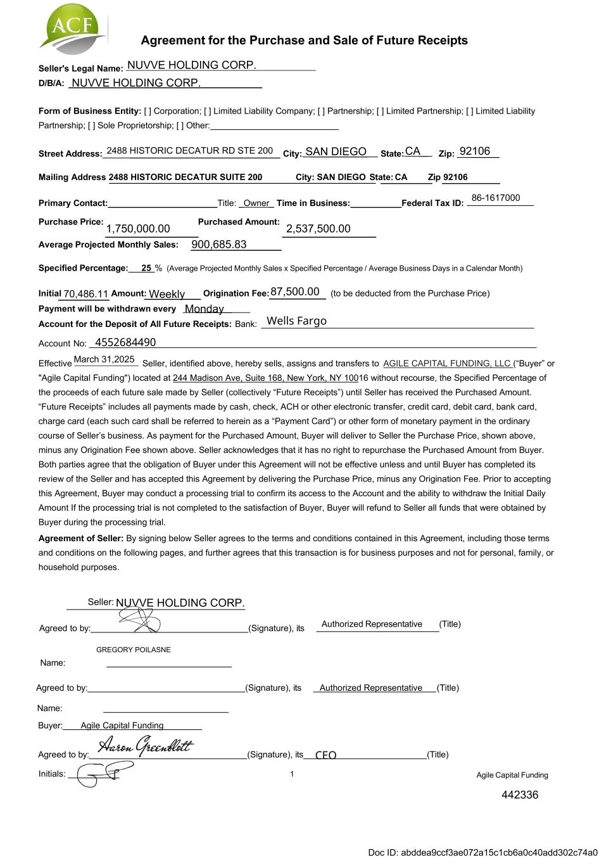

Agreement for the Purchase and Sale of Future Receipts Seller's Legal Name: D/B/A: Form of Business Entity: [ ] Corporation; [ ] Limited Liability Company; [ ] Partnership; [ ] Limited Partnership; [ ] Limited Liability Partnership; [ ] Sole Proprietorship; [ ] Other: Agreed to by: (Signature), its Authorized Representative (Title) Name: Agreed to by: Authorized Representative (Title)(Signature), its Name: Buyer: Agile Capital Funding Agreed to by: (Signature), its (Title) Initials: 1 Agile Capital Funding Primary Contact: Title: _Owner_ Time in Business: Federal Tax ID: Purchase Price: Purchased Amount: Average Projected Monthly Sales: NUVVE HOLDING CORP. NUVVE HOLDING CORP. 86-1617000 1,750,000.00 2,537,500.00 900,685.83 442336 70,486.11 Weekly 87,500.00 Monday March 31,2025 NUVVE HOLDING CORP. 2488 HISTORIC DECATUR RD STE 200 SAN DIEGO CA 92106 GREGORY POILASNE Specified Percentage: 25 % (Average Projected Monthly Sales x Specified Percentage / Average Business Days in a Calendar Month) Initial Amount: Origination Fee: (to be deducted from the Purchase Price) Payment will be withdrawn every __ _ _ ___ _______ Account for the Deposit of All Future Receipts: Bank: Account No: Effective Seller, identified above, hereby sells, assigns and transfers to AGILE CAPITAL FUNDING, LLC (“Buyer” or "Agile Capital Funding") located at 244 Madison Ave, Suite 168, New York, NY 10016 without recourse, the Specified Percentage of the proceeds of each future sale made by Seller (collectively “Future Receipts”) until Seller has received the Purchased Amount. “Future Receipts” includes all payments made by cash, check, ACH or other electronic transfer, credit card, debit card, bank card, charge card (each such card shall be referred to herein as a “Payment Card”) or other form of monetary payment in the ordinary course of Seller’s business. As payment for the Purchased Amount, Buyer will deliver to Seller the Purchase Price, shown above, minus any Origination Fee shown above. Seller acknowledges that it has no right to repurchase the Purchased Amount from Buyer. Both parties agree that the obligation of Buyer under this Agreement will not be effective unless and until Buyer has completed its review of the Seller and has accepted this Agreement by delivering the Purchase Price, minus any Origination Fee. Prior to accepting this Agreement, Buyer may conduct a processing trial to confirm its access to the Account and the ability to withdraw the Initial Daily Amount If the processing trial is not completed to the satisfaction of Buyer, Buyer will refund to Seller all funds that were obtained by Buyer during the processing trial. Agreement of Seller: By signing below Seller agrees to the terms and conditions contained in this Agreement, including those terms and conditions on the following pages, and further agrees that this transaction is for business purposes and not for personal, family, or household purposes. Seller: Street Address: _ ____ _ _ __ _ _ __ _ _ _____ ___ _ __ _ _ ___ City: ____ _____ ___ State: __ Zip: _ _ ____ Mailing Address 2488 HISTORIC DECATUR SUITE 200 : City: SAN DIEGO State: CA Zip 92106 CEO Wells Fargo 4552684490 Doc ID: abddea9ccf3ae072a15c1cb6a0c40add302c74a0

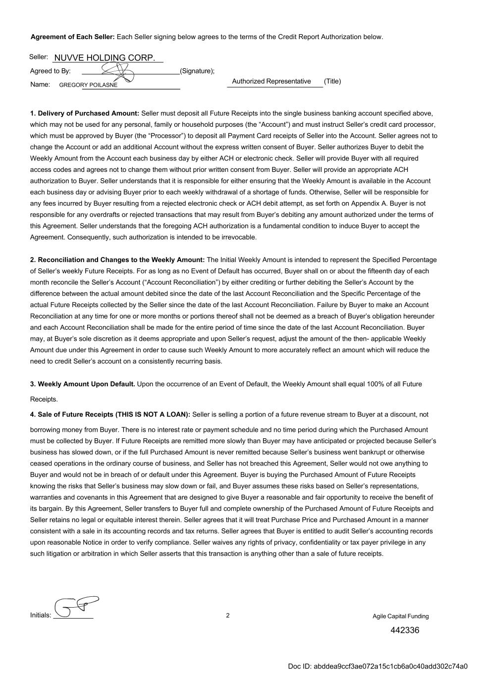
Initials: 2 Agreement of Each Seller: Each Seller signing below agrees to the terms of the Credit Report Authorization below. Agreed to By: (Signature); Name: Authorized Representative (Title) 1. Delivery of Purchased Amount: Seller must deposit all Future Receipts into the single business banking account specified above, which may not be used for any personal, family or household purposes (the “Account”) and must instruct Seller’s credit card processor, which must be approved by Buyer (the “Processor”) to deposit all Payment Card receipts of Seller into the Account. Seller agrees not to change the Account or add an additional Account without the express written consent of Buyer. Seller authorizes Buyer to debit the Weekly Amount from the Account each business day by either ACH or electronic check. Seller will provide Buyer with all required access codes and agrees not to change them without prior written consent from Buyer. Seller will provide an appropriate ACH authorization to Buyer. Seller understands that it is responsible for either ensuring that the Weekly Amount is available in the Account each business day or advising Buyer prior to each weekly withdrawal of a shortage of funds. Otherwise, Seller will be responsible for any fees incurred by Buyer resulting from a rejected electronic check or ACH debit attempt, as set forth on Appendix A. Buyer is not responsible for any overdrafts or rejected transactions that may result from Buyer’s debiting any amount authorized under the terms of this Agreement. Seller understands that the foregoing ACH authorization is a fundamental condition to induce Buyer to accept the Agreement. Consequently, such authorization is intended to be irrevocable. 2. Reconciliation and Changes to the Weekly Amount: The Initial Weekly Amount is intended to represent the Specified Percentage of Seller’s weekly Future Receipts. For as long as no Event of Default has occurred, Buyer shall on or about the fifteenth day of each month reconcile the Seller’s Account (“Account Reconciliation”) by either crediting or further debiting the Seller’s Account by the difference between the actual amount debited since the date of the last Account Reconciliation and the Specific Percentage of the actual Future Receipts collected by the Seller since the date of the last Account Reconciliation. Failure by Buyer to make an Account Reconciliation at any time for one or more months or portions thereof shall not be deemed as a breach of Buyer’s obligation hereunder and each Account Reconciliation shall be made for the entire period of time since the date of the last Account Reconciliation. Buyer may, at Buyer’s sole discretion as it deems appropriate and upon Seller’s request, adjust the amount of the then- applicable Weekly Amount due under this Agreement in order to cause such Weekly Amount to more accurately reflect an amount which will reduce the need to credit Seller’s account on a consistently recurring basis. 3. Weekly Amount Upon Default. Upon the occurrence of an Event of Default, the Weekly Amount shall equal 100% of all Future Receipts. 4. Sale of Future Receipts (THIS IS NOT A LOAN): Seller is selling a portion of a future revenue stream to Buyer at a discount, not borrowing money from Buyer. There is no interest rate or payment schedule and no time period during which the Purchased Amount must be collected by Buyer. If Future Receipts are remitted more slowly than Buyer may have anticipated or projected because Seller’s business has slowed down, or if the full Purchased Amount is never remitted because Seller’s business went bankrupt or otherwise ceased operations in the ordinary course of business, and Seller has not breached this Agreement, Seller would not owe anything to Buyer and would not be in breach of or default under this Agreement. Buyer is buying the Purchased Amount of Future Receipts knowing the risks that Seller’s business may slow down or fail, and Buyer assumes these risks based on Seller’s representations, warranties and covenants in this Agreement that are designed to give Buyer a reasonable and fair opportunity to receive the benefit of its bargain. By this Agreement, Seller transfers to Buyer full and complete ownership of the Purchased Amount of Future Receipts and Seller retains no legal or equitable interest therein. Seller agrees that it will treat Purchase Price and Purchased Amount in a manner consistent with a sale in its accounting records and tax returns. Seller agrees that Buyer is entitled to audit Seller’s accounting records upon reasonable Notice in order to verify compliance. Seller waives any rights of privacy, confidentiality or tax payer privilege in any such litigation or arbitration in which Seller asserts that this transaction is anything other than a sale of future receipts. Seller: Agile Capital Funding NUVVE HOLDING CORP. 442336 GREGORY POILASNE Doc ID: abddea9ccf3ae072a15c1cb6a0c40add302c74a0

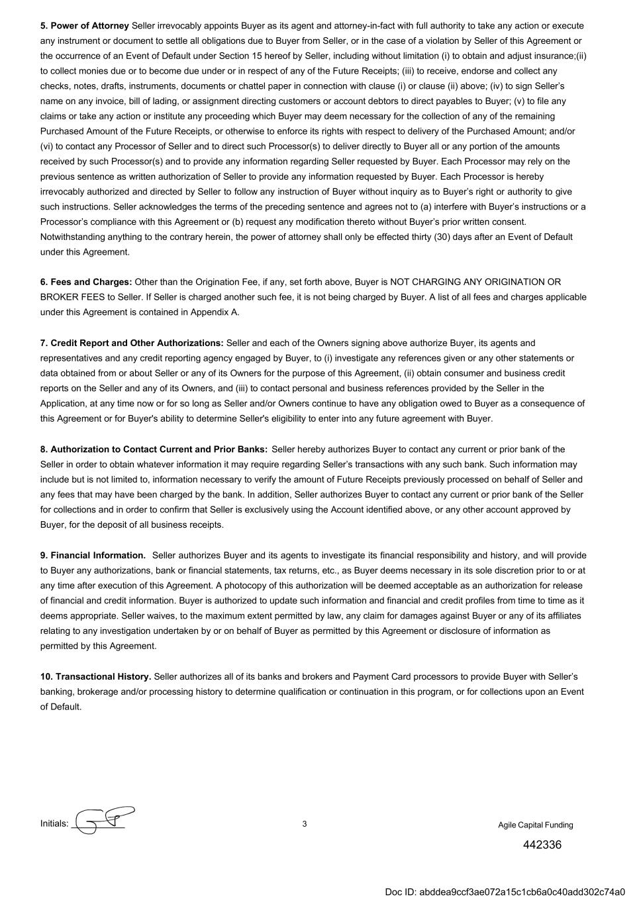
Initials: 3 5. Power of Attorney Seller irrevocably appoints Buyer as its agent and attorney-in-fact with full authority to take any action or execute any instrument or document to settle all obligations due to Buyer from Seller, or in the case of a violation by Seller of this Agreement or the occurrence of an Event of Default under Section 15 hereof by Seller, including without limitation (i) to obtain and adjust insurance;(ii) to collect monies due or to become due under or in respect of any of the Future Receipts; (iii) to receive, endorse and collect any checks, notes, drafts, instruments, documents or chattel paper in connection with clause (i) or clause (ii) above; (iv) to sign Seller’s name on any invoice, bill of lading, or assignment directing customers or account debtors to direct payables to Buyer; (v) to file any claims or take any action or institute any proceeding which Buyer may deem necessary for the collection of any of the remaining Purchased Amount of the Future Receipts, or otherwise to enforce its rights with respect to delivery of the Purchased Amount; and/or (vi) to contact any Processor of Seller and to direct such Processor(s) to deliver directly to Buyer all or any portion of the amounts received by such Processor(s) and to provide any information regarding Seller requested by Buyer. Each Processor may rely on the previous sentence as written authorization of Seller to provide any information requested by Buyer. Each Processor is hereby irrevocably authorized and directed by Seller to follow any instruction of Buyer without inquiry as to Buyer’s right or authority to give such instructions. Seller acknowledges the terms of the preceding sentence and agrees not to (a) interfere with Buyer’s instructions or a Processor’s compliance with this Agreement or (b) request any modification thereto without Buyer’s prior written consent. Notwithstanding anything to the contrary herein, the power of attorney shall only be effected thirty (30) days after an Event of Default under this Agreement. 6. Fees and Charges: Other than the Origination Fee, if any, set forth above, Buyer is NOT CHARGING ANY ORIGINATION OR BROKER FEES to Seller. If Seller is charged another such fee, it is not being charged by Buyer. A list of all fees and charges applicable under this Agreement is contained in Appendix A. 7. Credit Report and Other Authorizations: Seller and each of the Owners signing above authorize Buyer, its agents and representatives and any credit reporting agency engaged by Buyer, to (i) investigate any references given or any other statements or data obtained from or about Seller or any of its Owners for the purpose of this Agreement, (ii) obtain consumer and business credit reports on the Seller and any of its Owners, and (iii) to contact personal and business references provided by the Seller in the Application, at any time now or for so long as Seller and/or Owners continue to have any obligation owed to Buyer as a consequence of this Agreement or for Buyer's ability to determine Seller's eligibility to enter into any future agreement with Buyer. 8. Authorization to Contact Current and Prior Banks: Seller hereby authorizes Buyer to contact any current or prior bank of the Seller in order to obtain whatever information it may require regarding Seller’s transactions with any such bank. Such information may include but is not limited to, information necessary to verify the amount of Future Receipts previously processed on behalf of Seller and any fees that may have been charged by the bank. In addition, Seller authorizes Buyer to contact any current or prior bank of the Seller for collections and in order to confirm that Seller is exclusively using the Account identified above, or any other account approved by Buyer, for the deposit of all business receipts. 9. Financial Information. Seller authorizes Buyer and its agents to investigate its financial responsibility and history, and will provide to Buyer any authorizations, bank or financial statements, tax returns, etc., as Buyer deems necessary in its sole discretion prior to or at any time after execution of this Agreement. A photocopy of this authorization will be deemed acceptable as an authorization for release of financial and credit information. Buyer is authorized to update such information and financial and credit profiles from time to time as it deems appropriate. Seller waives, to the maximum extent permitted by law, any claim for damages against Buyer or any of its affiliates relating to any investigation undertaken by or on behalf of Buyer as permitted by this Agreement or disclosure of information as permitted by this Agreement. 10. Transactional History. Seller authorizes all of its banks and brokers and Payment Card processors to provide Buyer with Seller’s banking, brokerage and/or processing history to determine qualification or continuation in this program, or for collections upon an Event of Default. Agile Capital Funding 442336 Doc ID: abddea9ccf3ae072a15c1cb6a0c40add302c74a0

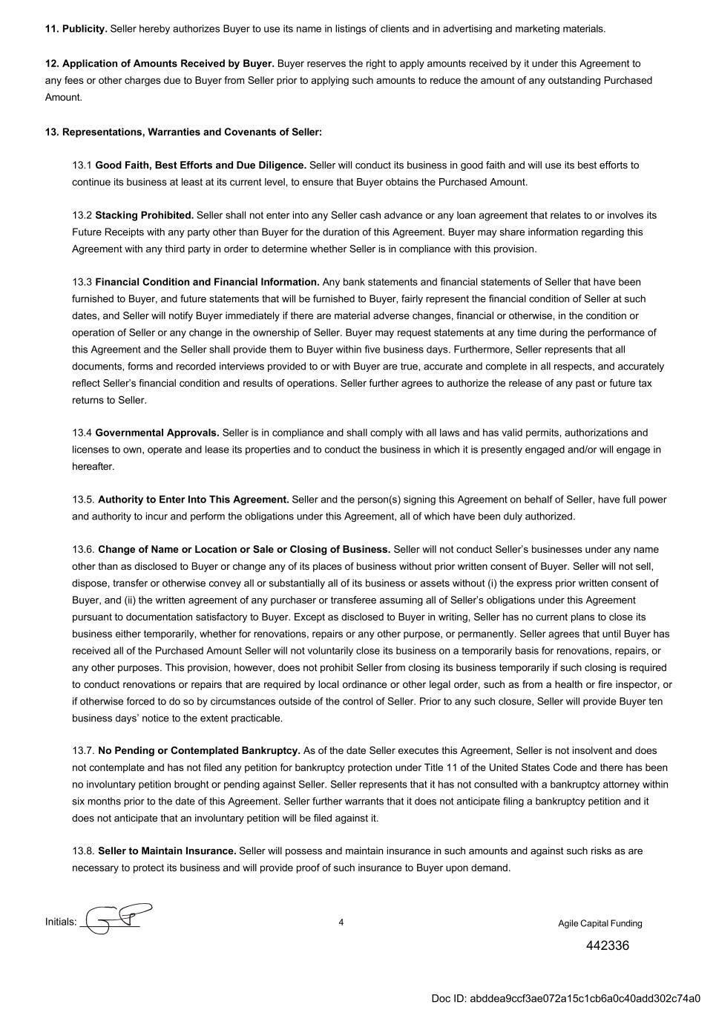
Initials: 4 11. Publicity. Seller hereby authorizes Buyer to use its name in listings of clients and in advertising and marketing materials. 12. Application of Amounts Received by Buyer. Buyer reserves the right to apply amounts received by it under this Agreement to any fees or other charges due to Buyer from Seller prior to applying such amounts to reduce the amount of any outstanding Purchased Amount. 13. Representations, Warranties and Covenants of Seller: 13.1 Good Faith, Best Efforts and Due Diligence. Seller will conduct its business in good faith and will use its best efforts to continue its business at least at its current level, to ensure that Buyer obtains the Purchased Amount. 13.2 Stacking Prohibited. Seller shall not enter into any Seller cash advance or any loan agreement that relates to or involves its Future Receipts with any party other than Buyer for the duration of this Agreement. Buyer may share information regarding this Agreement with any third party in order to determine whether Seller is in compliance with this provision. 13.3 Financial Condition and Financial Information. Any bank statements and financial statements of Seller that have been furnished to Buyer, and future statements that will be furnished to Buyer, fairly represent the financial condition of Seller at such dates, and Seller will notify Buyer immediately if there are material adverse changes, financial or otherwise, in the condition or operation of Seller or any change in the ownership of Seller. Buyer may request statements at any time during the performance of this Agreement and the Seller shall provide them to Buyer within five business days. Furthermore, Seller represents that all documents, forms and recorded interviews provided to or with Buyer are true, accurate and complete in all respects, and accurately reflect Seller’s financial condition and results of operations. Seller further agrees to authorize the release of any past or future tax returns to Seller. 13.4 Governmental Approvals. Seller is in compliance and shall comply with all laws and has valid permits, authorizations and licenses to own, operate and lease its properties and to conduct the business in which it is presently engaged and/or will engage in hereafter. 13.5. Authority to Enter Into This Agreement. Seller and the person(s) signing this Agreement on behalf of Seller, have full power and authority to incur and perform the obligations under this Agreement, all of which have been duly authorized. 13.6. Change of Name or Location or Sale or Closing of Business. Seller will not conduct Seller’s businesses under any name other than as disclosed to Buyer or change any of its places of business without prior written consent of Buyer. Seller will not sell, dispose, transfer or otherwise convey all or substantially all of its business or assets without (i) the express prior written consent of Buyer, and (ii) the written agreement of any purchaser or transferee assuming all of Seller’s obligations under this Agreement pursuant to documentation satisfactory to Buyer. Except as disclosed to Buyer in writing, Seller has no current plans to close its business either temporarily, whether for renovations, repairs or any other purpose, or permanently. Seller agrees that until Buyer has received all of the Purchased Amount Seller will not voluntarily close its business on a temporarily basis for renovations, repairs, or any other purposes. This provision, however, does not prohibit Seller from closing its business temporarily if such closing is required to conduct renovations or repairs that are required by local ordinance or other legal order, such as from a health or fire inspector, or if otherwise forced to do so by circumstances outside of the control of Seller. Prior to any such closure, Seller will provide Buyer ten business days’ notice to the extent practicable. 13.7. No Pending or Contemplated Bankruptcy. As of the date Seller executes this Agreement, Seller is not insolvent and does not contemplate and has not filed any petition for bankruptcy protection under Title 11 of the United States Code and there has been no involuntary petition brought or pending against Seller. Seller represents that it has not consulted with a bankruptcy attorney within six months prior to the date of this Agreement. Seller further warrants that it does not anticipate filing a bankruptcy petition and it does not anticipate that an involuntary petition will be filed against it. 13.8. Seller to Maintain Insurance. Seller will possess and maintain insurance in such amounts and against such risks as are necessary to protect its business and will provide proof of such insurance to Buyer upon demand. Agile Capital Funding 442336 Doc ID: abddea9ccf3ae072a15c1cb6a0c40add302c74a0

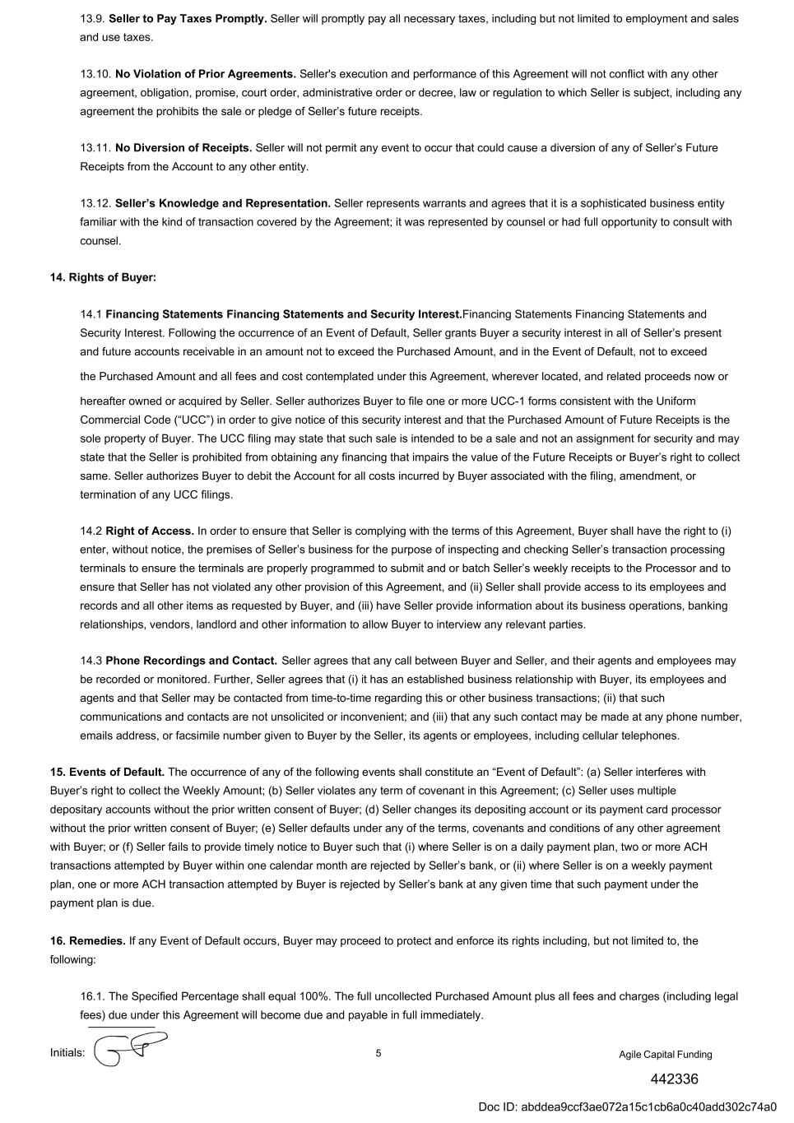
442336 13.9. Seller to Pay Taxes Promptly. Seller will promptly pay all necessary taxes, including but not limited to employment and sales and use taxes. 13.10. No Violation of Prior Agreements. Seller's execution and performance of this Agreement will not conflict with any other agreement, obligation, promise, court order, administrative order or decree, law or regulation to which Seller is subject, including any agreement the prohibits the sale or pledge of Seller’s future receipts. 13.11. No Diversion of Receipts. Seller will not permit any event to occur that could cause a diversion of any of Seller’s Future Receipts from the Account to any other entity. 13.12. Seller’s Knowledge and Representation. Seller represents warrants and agrees that it is a sophisticated business entity familiar with the kind of transaction covered by the Agreement; it was represented by counsel or had full opportunity to consult with counsel. 14. Rights of Buyer: 14.1 Financing Statements Financing Statements and Security Interest.Financing Statements Financing Statements and Security Interest. Following the occurrence of an Event of Default, Seller grants Buyer a security interest in all of Seller’s present and future accounts receivable in an amount not to exceed the Purchased Amount, and in the Event of Default, not to exceed the Purchased Amount and all fees and cost contemplated under this Agreement, wherever located, and related proceeds now or hereafter owned or acquired by Seller. Seller authorizes Buyer to file one or more UCC-1 forms consistent with the Uniform Commercial Code (“UCC”) in order to give notice of this security interest and that the Purchased Amount of Future Receipts is the sole property of Buyer. The UCC filing may state that such sale is intended to be a sale and not an assignment for security and may state that the Seller is prohibited from obtaining any financing that impairs the value of the Future Receipts or Buyer’s right to collect same. Seller authorizes Buyer to debit the Account for all costs incurred by Buyer associated with the filing, amendment, or termination of any UCC filings. 14.2 Right of Access. In order to ensure that Seller is complying with the terms of this Agreement, Buyer shall have the right to (i) enter, without notice, the premises of Seller’s business for the purpose of inspecting and checking Seller’s transaction processing terminals to ensure the terminals are properly programmed to submit and or batch Seller’s weekly receipts to the Processor and to ensure that Seller has not violated any other provision of this Agreement, and (ii) Seller shall provide access to its employees and records and all other items as requested by Buyer, and (iii) have Seller provide information about its business operations, banking relationships, vendors, landlord and other information to allow Buyer to interview any relevant parties. 14.3 Phone Recordings and Contact. Seller agrees that any call between Buyer and Seller, and their agents and employees may be recorded or monitored. Further, Seller agrees that (i) it has an established business relationship with Buyer, its employees and agents and that Seller may be contacted from time-to-time regarding this or other business transactions; (ii) that such communications and contacts are not unsolicited or inconvenient; and (iii) that any such contact may be made at any phone number, emails address, or facsimile number given to Buyer by the Seller, its agents or employees, including cellular telephones. 15. Events of Default. The occurrence of any of the following events shall constitute an “Event of Default”: (a) Seller interferes with Buyer’s right to collect the Weekly Amount; (b) Seller violates any term of covenant in this Agreement; (c) Seller uses multiple depositary accounts without the prior written consent of Buyer; (d) Seller changes its depositing account or its payment card processor without the prior written consent of Buyer; (e) Seller defaults under any of the terms, covenants and conditions of any other agreement with Buyer; or (f) Seller fails to provide timely notice to Buyer such that (i) where Seller is on a daily payment plan, two or more ACH transactions attempted by Buyer within one calendar month are rejected by Seller’s bank, or (ii) where Seller is on a weekly payment plan, one or more ACH transaction attempted by Buyer is rejected by Seller’s bank at any given time that such payment under the payment plan is due. 16. Remedies. If any Event of Default occurs, Buyer may proceed to protect and enforce its rights including, but not limited to, the following: 16.1. The Specified Percentage shall equal 100%. The full uncollected Purchased Amount plus all fees and charges (including legal fees) due under this Agreement will become due and payable in full immediately. Initials: 5 Agile Capital Funding Doc ID: abddea9ccf3ae072a15c1cb6a0c40add302c74a0

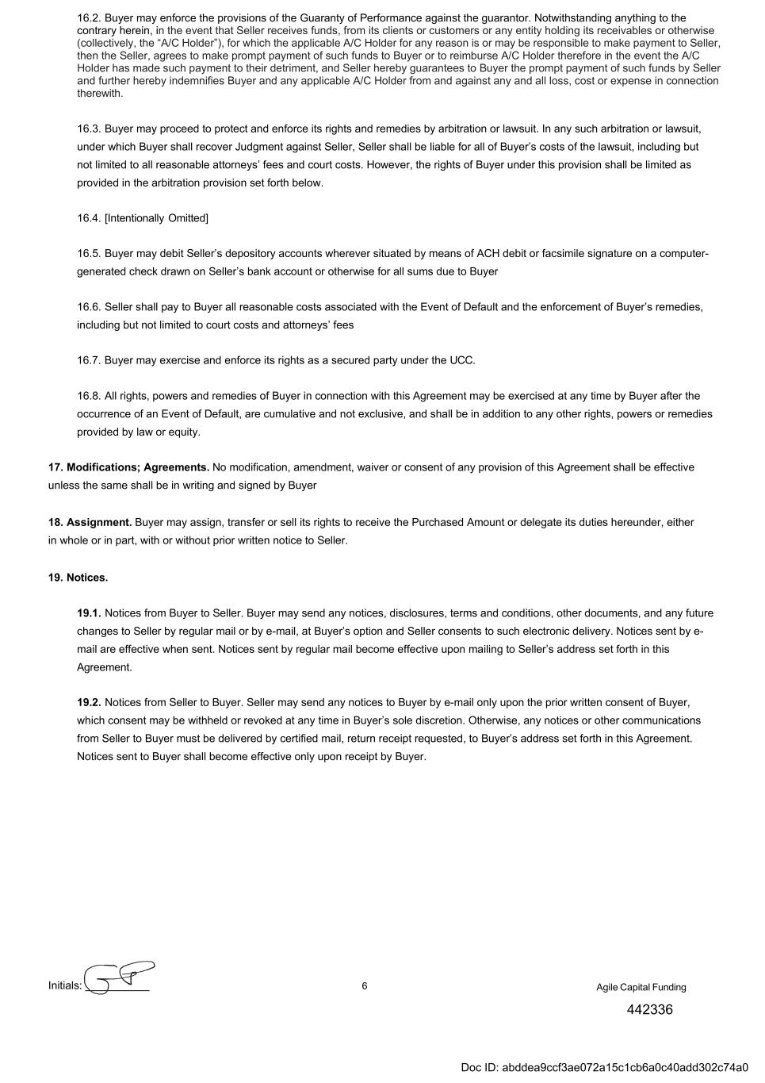
Initials: 6 16.2. Buyer may enforce the provisions of the Guaranty of Performance against the guarantor. Notwithstanding anything to the contrary herein, in the event that Seller receives funds, from its clients or customers or any entity holding its receivables or otherwise (collectively, the “A/C Holder”), for which the applicable A/C Holder for any reason is or may be responsible to make payment to Seller, then the Seller, agrees to make prompt payment of such funds to Buyer or to reimburse A/C Holder therefore in the event the A/C Holder has made such payment to their detriment, and Seller hereby guarantees to Buyer the prompt payment of such funds by Seller and further hereby indemnifies Buyer and any applicable A/C Holder from and against any and all loss, cost or expense in connection therewith. 16.3. Buyer may proceed to protect and enforce its rights and remedies by arbitration or lawsuit. In any such arbitration or lawsuit, under which Buyer shall recover Judgment against Seller, Seller shall be liable for all of Buyer’s costs of the lawsuit, including but not limited to all reasonable attorneys’ fees and court costs. However, the rights of Buyer under this provision shall be limited as provided in the arbitration provision set forth below. 16.4. [Intentionally Omitted] 16.5. Buyer may debit Seller’s depository accounts wherever situated by means of ACH debit or facsimile signature on a computer- generated check drawn on Seller’s bank account or otherwise for all sums due to Buyer 16.6. Seller shall pay to Buyer all reasonable costs associated with the Event of Default and the enforcement of Buyer’s remedies, including but not limited to court costs and attorneys’ fees 16.7. Buyer may exercise and enforce its rights as a secured party under the UCC. 16.8. All rights, powers and remedies of Buyer in connection with this Agreement may be exercised at any time by Buyer after the occurrence of an Event of Default, are cumulative and not exclusive, and shall be in addition to any other rights, powers or remedies provided by law or equity. 17. Modifications; Agreements. No modification, amendment, waiver or consent of any provision of this Agreement shall be effective unless the same shall be in writing and signed by Buyer 18. Assignment. Buyer may assign, transfer or sell its rights to receive the Purchased Amount or delegate its duties hereunder, either in whole or in part, with or without prior written notice to Seller. 19. Notices. 19.1. Notices from Buyer to Seller. Buyer may send any notices, disclosures, terms and conditions, other documents, and any future changes to Seller by regular mail or by e-mail, at Buyer’s option and Seller consents to such electronic delivery. Notices sent by e- mail are effective when sent. Notices sent by regular mail become effective upon mailing to Seller’s address set forth in this Agreement. 19.2. Notices from Seller to Buyer. Seller may send any notices to Buyer by e-mail only upon the prior written consent of Buyer, which consent may be withheld or revoked at any time in Buyer’s sole discretion. Otherwise, any notices or other communications from Seller to Buyer must be delivered by certified mail, return receipt requested, to Buyer’s address set forth in this Agreement. Notices sent to Buyer shall become effective only upon receipt by Buyer. Agile Capital Funding 442336 Doc ID: abddea9ccf3ae072a15c1cb6a0c40add302c74a0

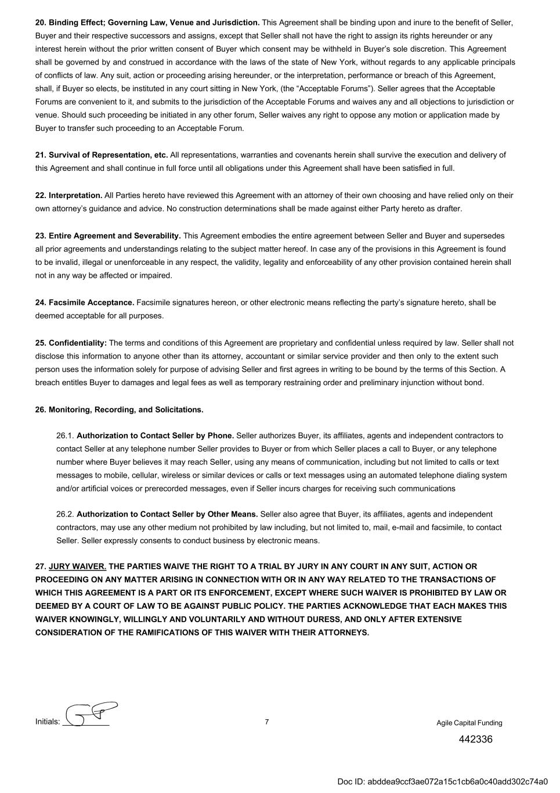
Initials: 7 20. Binding Effect; Governing Law, Venue and Jurisdiction. This Agreement shall be binding upon and inure to the benefit of Seller, Buyer and their respective successors and assigns, except that Seller shall not have the right to assign its rights hereunder or any interest herein without the prior written consent of Buyer which consent may be withheld in Buyer’s sole discretion. This Agreement shall be governed by and construed in accordance with the laws of the state of New York, without regards to any applicable principals of conflicts of law. Any suit, action or proceeding arising hereunder, or the interpretation, performance or breach of this Agreement, shall, if Buyer so elects, be instituted in any court sitting in New York, (the “Acceptable Forums”). Seller agrees that the Acceptable Forums are convenient to it, and submits to the jurisdiction of the Acceptable Forums and waives any and all objections to jurisdiction or venue. Should such proceeding be initiated in any other forum, Seller waives any right to oppose any motion or application made by Buyer to transfer such proceeding to an Acceptable Forum. 21. Survival of Representation, etc. All representations, warranties and covenants herein shall survive the execution and delivery of this Agreement and shall continue in full force until all obligations under this Agreement shall have been satisfied in full. 22. Interpretation. All Parties hereto have reviewed this Agreement with an attorney of their own choosing and have relied only on their own attorney’s guidance and advice. No construction determinations shall be made against either Party hereto as drafter. 23. Entire Agreement and Severability. This Agreement embodies the entire agreement between Seller and Buyer and supersedes all prior agreements and understandings relating to the subject matter hereof. In case any of the provisions in this Agreement is found to be invalid, illegal or unenforceable in any respect, the validity, legality and enforceability of any other provision contained herein shall not in any way be affected or impaired. 24. Facsimile Acceptance. Facsimile signatures hereon, or other electronic means reflecting the party’s signature hereto, shall be deemed acceptable for all purposes. 25. Confidentiality: The terms and conditions of this Agreement are proprietary and confidential unless required by law. Seller shall not disclose this information to anyone other than its attorney, accountant or similar service provider and then only to the extent such person uses the information solely for purpose of advising Seller and first agrees in writing to be bound by the terms of this Section. A breach entitles Buyer to damages and legal fees as well as temporary restraining order and preliminary injunction without bond. 26. Monitoring, Recording, and Solicitations. 26.1. Authorization to Contact Seller by Phone. Seller authorizes Buyer, its affiliates, agents and independent contractors to contact Seller at any telephone number Seller provides to Buyer or from which Seller places a call to Buyer, or any telephone number where Buyer believes it may reach Seller, using any means of communication, including but not limited to calls or text messages to mobile, cellular, wireless or similar devices or calls or text messages using an automated telephone dialing system and/or artificial voices or prerecorded messages, even if Seller incurs charges for receiving such communications 26.2. Authorization to Contact Seller by Other Means. Seller also agree that Buyer, its affiliates, agents and independent contractors, may use any other medium not prohibited by law including, but not limited to, mail, e-mail and facsimile, to contact Seller. Seller expressly consents to conduct business by electronic means. 27. JURY WAIVER. THE PARTIES WAIVE THE RIGHT TO A TRIAL BY JURY IN ANY COURT IN ANY SUIT, ACTION OR PROCEEDING ON ANY MATTER ARISING IN CONNECTION WITH OR IN ANY WAY RELATED TO THE TRANSACTIONS OF WHICH THIS AGREEMENT IS A PART OR ITS ENFORCEMENT, EXCEPT WHERE SUCH WAIVER IS PROHIBITED BY LAW OR DEEMED BY A COURT OF LAW TO BE AGAINST PUBLIC POLICY. THE PARTIES ACKNOWLEDGE THAT EACH MAKES THIS WAIVER KNOWINGLY, WILLINGLY AND VOLUNTARILY AND WITHOUT DURESS, AND ONLY AFTER EXTENSIVE CONSIDERATION OF THE RAMIFICATIONS OF THIS WAIVER WITH THEIR ATTORNEYS. Agile Capital Funding 442336 Doc ID: abddea9ccf3ae072a15c1cb6a0c40add302c74a0

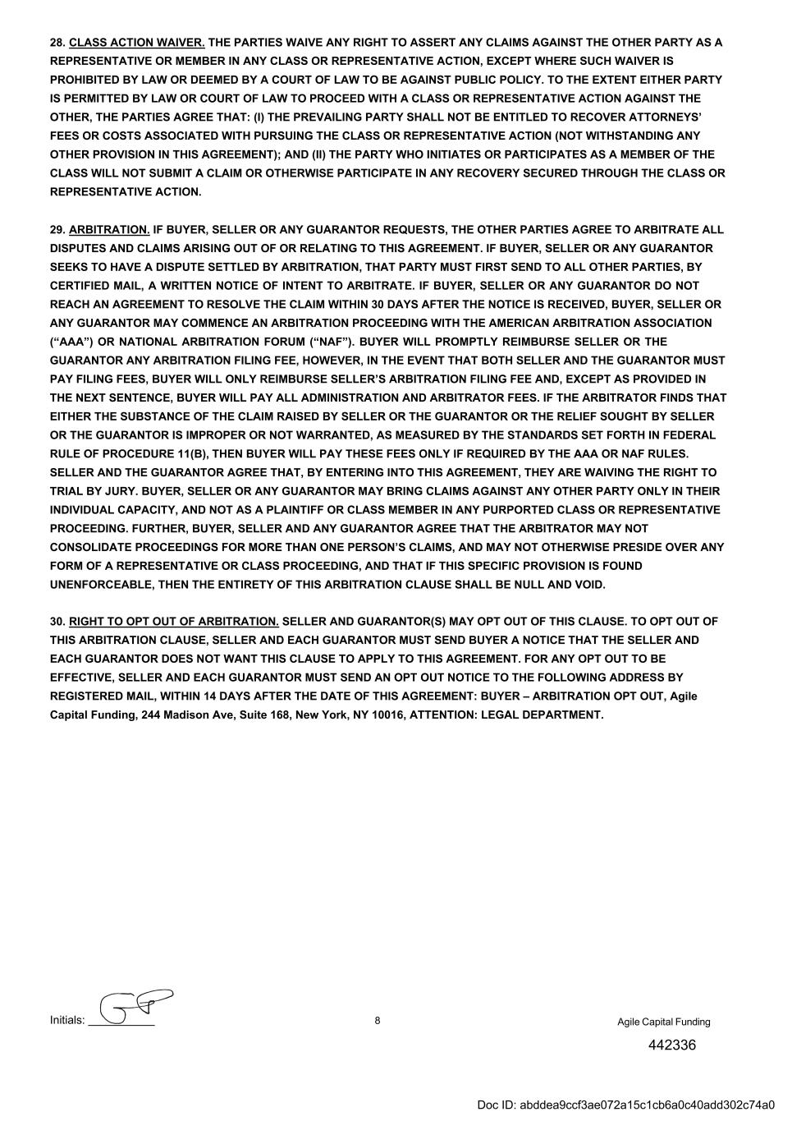
Initials: 8 Agile Capital Funding 442336 28. CLASS ACTION WAIVER. THE PARTIES WAIVE ANY RIGHT TO ASSERT ANY CLAIMS AGAINST THE OTHER PARTY AS A REPRESENTATIVE OR MEMBER IN ANY CLASS OR REPRESENTATIVE ACTION, EXCEPT WHERE SUCH WAIVER IS PROHIBITED BY LAW OR DEEMED BY A COURT OF LAW TO BE AGAINST PUBLIC POLICY. TO THE EXTENT EITHER PARTY IS PERMITTED BY LAW OR COURT OF LAW TO PROCEED WITH A CLASS OR REPRESENTATIVE ACTION AGAINST THE OTHER, THE PARTIES AGREE THAT: (I) THE PREVAILING PARTY SHALL NOT BE ENTITLED TO RECOVER ATTORNEYS’ FEES OR COSTS ASSOCIATED WITH PURSUING THE CLASS OR REPRESENTATIVE ACTION (NOT WITHSTANDING ANY OTHER PROVISION IN THIS AGREEMENT); AND (II) THE PARTY WHO INITIATES OR PARTICIPATES AS A MEMBER OF THE CLASS WILL NOT SUBMIT A CLAIM OR OTHERWISE PARTICIPATE IN ANY RECOVERY SECURED THROUGH THE CLASS OR REPRESENTATIVE ACTION. 29. ARBITRATION. IF BUYER, SELLER OR ANY GUARANTOR REQUESTS, THE OTHER PARTIES AGREE TO ARBITRATE ALL DISPUTES AND CLAIMS ARISING OUT OF OR RELATING TO THIS AGREEMENT. IF BUYER, SELLER OR ANY GUARANTOR SEEKS TO HAVE A DISPUTE SETTLED BY ARBITRATION, THAT PARTY MUST FIRST SEND TO ALL OTHER PARTIES, BY CERTIFIED MAIL, A WRITTEN NOTICE OF INTENT TO ARBITRATE. IF BUYER, SELLER OR ANY GUARANTOR DO NOT REACH AN AGREEMENT TO RESOLVE THE CLAIM WITHIN 30 DAYS AFTER THE NOTICE IS RECEIVED, BUYER, SELLER OR ANY GUARANTOR MAY COMMENCE AN ARBITRATION PROCEEDING WITH THE AMERICAN ARBITRATION ASSOCIATION (“AAA”) OR NATIONAL ARBITRATION FORUM (“NAF”). BUYER WILL PROMPTLY REIMBURSE SELLER OR THE GUARANTOR ANY ARBITRATION FILING FEE, HOWEVER, IN THE EVENT THAT BOTH SELLER AND THE GUARANTOR MUST PAY FILING FEES, BUYER WILL ONLY REIMBURSE SELLER’S ARBITRATION FILING FEE AND, EXCEPT AS PROVIDED IN THE NEXT SENTENCE, BUYER WILL PAY ALL ADMINISTRATION AND ARBITRATOR FEES. IF THE ARBITRATOR FINDS THAT EITHER THE SUBSTANCE OF THE CLAIM RAISED BY SELLER OR THE GUARANTOR OR THE RELIEF SOUGHT BY SELLER OR THE GUARANTOR IS IMPROPER OR NOT WARRANTED, AS MEASURED BY THE STANDARDS SET FORTH IN FEDERAL RULE OF PROCEDURE 11(B), THEN BUYER WILL PAY THESE FEES ONLY IF REQUIRED BY THE AAA OR NAF RULES. SELLER AND THE GUARANTOR AGREE THAT, BY ENTERING INTO THIS AGREEMENT, THEY ARE WAIVING THE RIGHT TO TRIAL BY JURY. BUYER, SELLER OR ANY GUARANTOR MAY BRING CLAIMS AGAINST ANY OTHER PARTY ONLY IN THEIR INDIVIDUAL CAPACITY, AND NOT AS A PLAINTIFF OR CLASS MEMBER IN ANY PURPORTED CLASS OR REPRESENTATIVE PROCEEDING. FURTHER, BUYER, SELLER AND ANY GUARANTOR AGREE THAT THE ARBITRATOR MAY NOT CONSOLIDATE PROCEEDINGS FOR MORE THAN ONE PERSON’S CLAIMS, AND MAY NOT OTHERWISE PRESIDE OVER ANY FORM OF A REPRESENTATIVE OR CLASS PROCEEDING, AND THAT IF THIS SPECIFIC PROVISION IS FOUND UNENFORCEABLE, THEN THE ENTIRETY OF THIS ARBITRATION CLAUSE SHALL BE NULL AND VOID. 30. RIGHT TO OPT OUT OF ARBITRATION. SELLER AND GUARANTOR(S) MAY OPT OUT OF THIS CLAUSE. TO OPT OUT OF THIS ARBITRATION CLAUSE, SELLER AND EACH GUARANTOR MUST SEND BUYER A NOTICE THAT THE SELLER AND EACH GUARANTOR DOES NOT WANT THIS CLAUSE TO APPLY TO THIS AGREEMENT. FOR ANY OPT OUT TO BE EFFECTIVE, SELLER AND EACH GUARANTOR MUST SEND AN OPT OUT NOTICE TO THE FOLLOWING ADDRESS BY REGISTERED MAIL, WITHIN 14 DAYS AFTER THE DATE OF THIS AGREEMENT: BUYER – ARBITRATION OPT OUT, Agile Capital Funding, 244 Madison Ave, Suite 168, New York, NY 10016, ATTENTION: LEGAL DEPARTMENT. Doc ID: abddea9ccf3ae072a15c1cb6a0c40add302c74a0

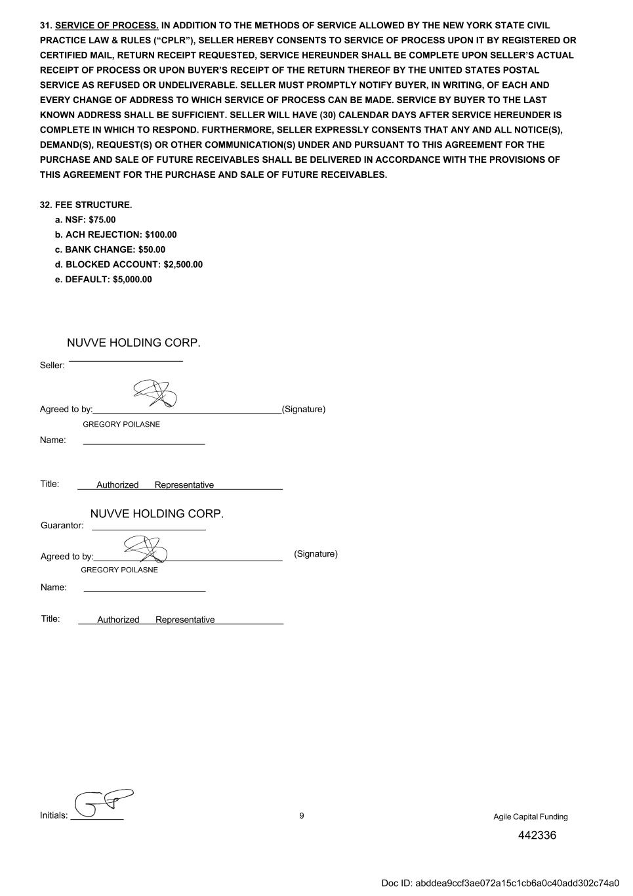
Initials: 9 31. SERVICE OF PROCESS. IN ADDITION TO THE METHODS OF SERVICE ALLOWED BY THE NEW YORK STATE CIVIL PRACTICE LAW & RULES (“CPLR”), SELLER HEREBY CONSENTS TO SERVICE OF PROCESS UPON IT BY REGISTERED OR CERTIFIED MAIL, RETURN RECEIPT REQUESTED, SERVICE HEREUNDER SHALL BE COMPLETE UPON SELLER’S ACTUAL RECEIPT OF PROCESS OR UPON BUYER’S RECEIPT OF THE RETURN THEREOF BY THE UNITED STATES POSTAL SERVICE AS REFUSED OR UNDELIVERABLE. SELLER MUST PROMPTLY NOTIFY BUYER, IN WRITING, OF EACH AND EVERY CHANGE OF ADDRESS TO WHICH SERVICE OF PROCESS CAN BE MADE. SERVICE BY BUYER TO THE LAST KNOWN ADDRESS SHALL BE SUFFICIENT. SELLER WILL HAVE (30) CALENDAR DAYS AFTER SERVICE HEREUNDER IS COMPLETE IN WHICH TO RESPOND. FURTHERMORE, SELLER EXPRESSLY CONSENTS THAT ANY AND ALL NOTICE(S), DEMAND(S), REQUEST(S) OR OTHER COMMUNICATION(S) UNDER AND PURSUANT TO THIS AGREEMENT FOR THE PURCHASE AND SALE OF FUTURE RECEIVABLES SHALL BE DELIVERED IN ACCORDANCE WITH THE PROVISIONS OF THIS AGREEMENT FOR THE PURCHASE AND SALE OF FUTURE RECEIVABLES. 32. FEE STRUCTURE. a. NSF: $75.00 b. ACH REJECTION: $100.00 c. BANK CHANGE: $50.00 d. BLOCKED ACCOUNT: $2,500.00 e. DEFAULT: $5,000.00 Seller: Name: Title: RepresentativeAuthorized Guarantor: (Signature) Name: Title: RepresentativeAuthorized Agile Capital Funding NUVVE HOLDING CORP. NUVVE HOLDING CORP. 442336 GREGORY POILASNE GREGORY POILASNE Agreed to by: (Signature) Agreed to by: Doc ID: abddea9ccf3ae072a15c1cb6a0c40add302c74a0

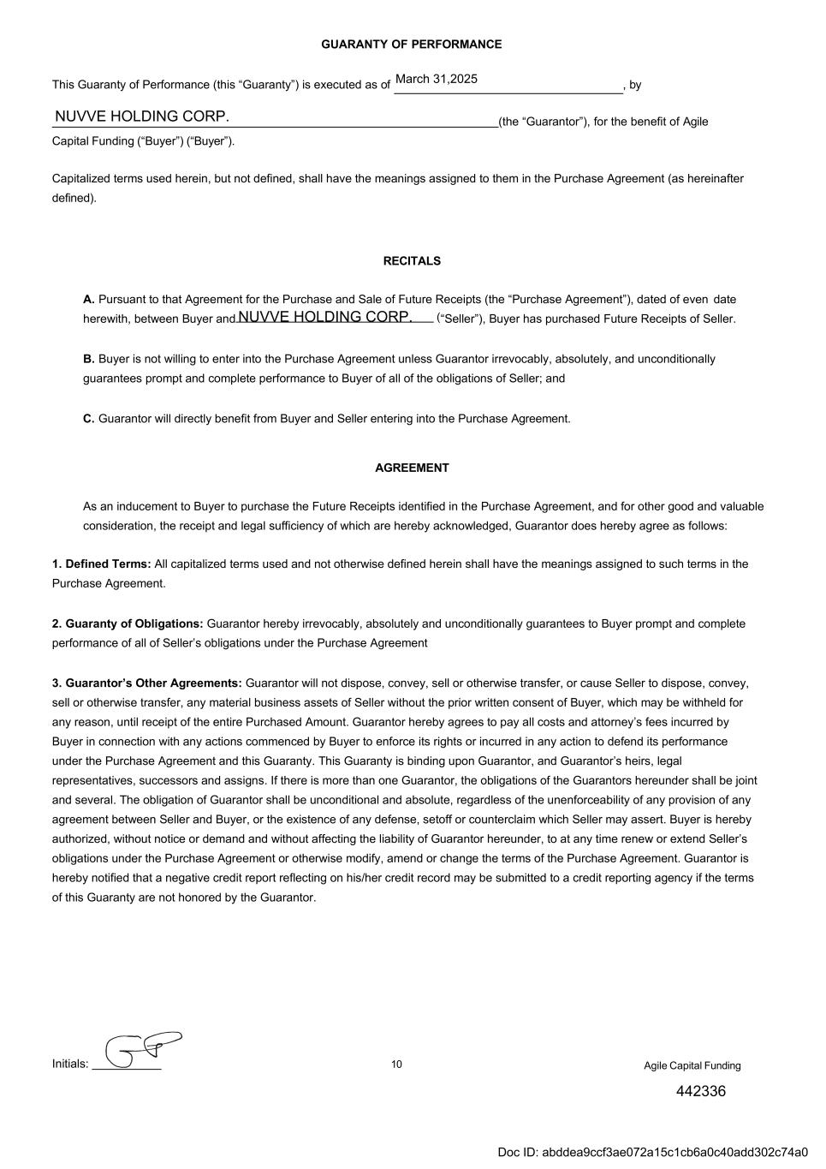
Initials: 10 Capital Funding (“Buyer”) (“Buyer”). (the “Guarantor”), for the benefit of Agile Capitalized terms used herein, but not defined, shall have the meanings assigned to them in the Purchase Agreement (as hereinafter defined). RECITALS A. Pursuant to that Agreement for the Purchase and Sale of Future Receipts (the “Purchase Agreement”), dated of even date herewith, between Buyer and (“Seller”), Buyer has purchased Future Receipts of Seller. B. Buyer is not willing to enter into the Purchase Agreement unless Guarantor irrevocably, absolutely, and unconditionally guarantees prompt and complete performance to Buyer of all of the obligations of Seller; and C. Guarantor will directly benefit from Buyer and Seller entering into the Purchase Agreement. AGREEMENT As an inducement to Buyer to purchase the Future Receipts identified in the Purchase Agreement, and for other good and valuable consideration, the receipt and legal sufficiency of which are hereby acknowledged, Guarantor does hereby agree as follows: 1. Defined Terms: All capitalized terms used and not otherwise defined herein shall have the meanings assigned to such terms in the Purchase Agreement. 2. Guaranty of Obligations: Guarantor hereby irrevocably, absolutely and unconditionally guarantees to Buyer prompt and complete performance of all of Seller’s obligations under the Purchase Agreement 3. Guarantor’s Other Agreements: Guarantor will not dispose, convey, sell or otherwise transfer, or cause Seller to dispose, convey, sell or otherwise transfer, any material business assets of Seller without the prior written consent of Buyer, which may be withheld for any reason, until receipt of the entire Purchased Amount. Guarantor hereby agrees to pay all costs and attorney’s fees incurred by Buyer in connection with any actions commenced by Buyer to enforce its rights or incurred in any action to defend its performance under the Purchase Agreement and this Guaranty. This Guaranty is binding upon Guarantor, and Guarantor’s heirs, legal representatives, successors and assigns. If there is more than one Guarantor, the obligations of the Guarantors hereunder shall be joint and several. The obligation of Guarantor shall be unconditional and absolute, regardless of the unenforceability of any provision of any agreement between Seller and Buyer, or the existence of any defense, setoff or counterclaim which Seller may assert. Buyer is hereby authorized, without notice or demand and without affecting the liability of Guarantor hereunder, to at any time renew or extend Seller’s obligations under the Purchase Agreement or otherwise modify, amend or change the terms of the Purchase Agreement. Guarantor is hereby notified that a negative credit report reflecting on his/her credit record may be submitted to a credit reporting agency if the terms of this Guaranty are not honored by the Guarantor. Agile Capital Funding NUVVE HOLDING CORP. NUVVE HOLDING CORP. 442336 March 31,2025 GUARANTY OF PERFORMANCE This Guaranty of Performance (this “Guaranty”) is executed as of , by Doc ID: abddea9ccf3ae072a15c1cb6a0c40add302c74a0

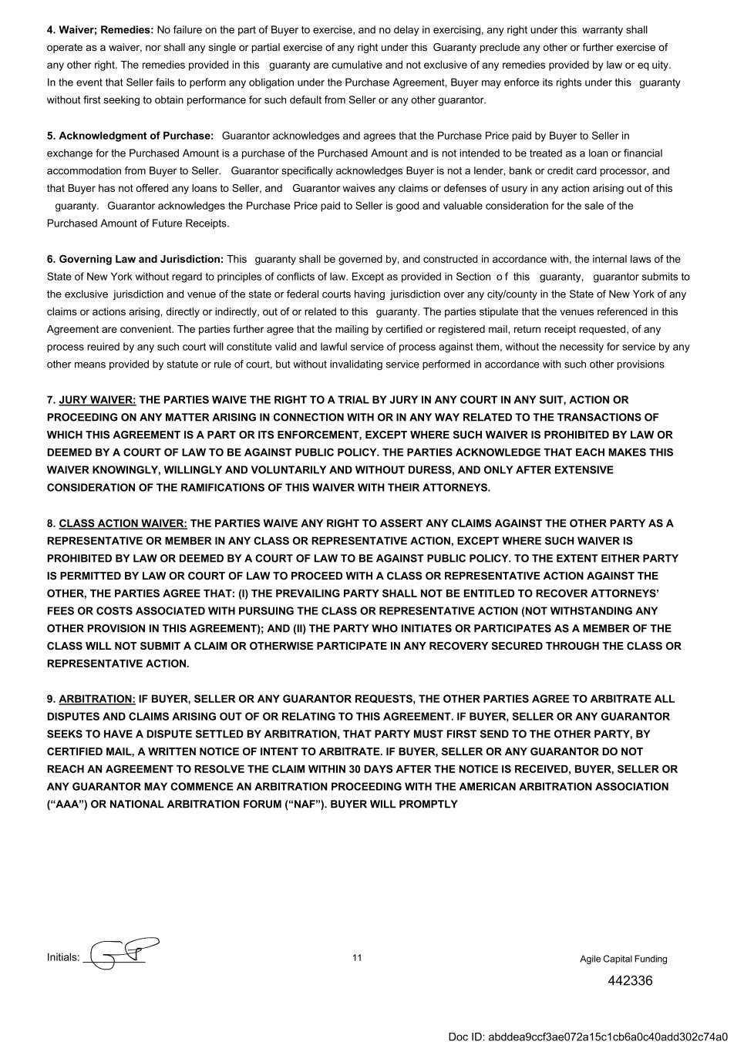
Initials: 11 4. Waiver; Remedies: No failure on the part of Buyer to exercise, and no delay in exercising, any right under this warranty shall operate as a waiver, nor shall any single or partial exercise of any right under this Guaranty preclude any other or further exercise of any other right. The remedies provided in this guaranty are cumulative and not exclusive of any remedies provided by law or eq uity. In the event that Seller fails to perform any obligation under the Purchase Agreement, Buyer may enforce its rights under this guaranty without first seeking to obtain performance for such default from Seller or any other guarantor. 5. Acknowledgment of Purchase: Guarantor acknowledges and agrees that the Purchase Price paid by Buyer to Seller in exchange for the Purchased Amount is a purchase of the Purchased Amount and is not intended to be treated as a loan or financial accommodation from Buyer to Seller. Guarantor specifically acknowledges Buyer is not a lender, bank or credit card processor, and that Buyer has not offered any loans to Seller, and Guarantor waives any claims or defenses of usury in any action arising out of this guaranty. Guarantor acknowledges the Purchase Price paid to Seller is good and valuable consideration for the sale of the Purchased Amount of Future Receipts. 6. Governing Law and Jurisdiction: This guaranty shall be governed by, and constructed in accordance with, the internal laws of the State of New York without regard to principles of conflicts of law. Except as provided in Section o f this guaranty, guarantor submits to the exclusive jurisdiction and venue of the state or federal courts having jurisdiction over any city/county in the State of New York of any claims or actions arising, directly or indirectly, out of or related to this guaranty. The parties stipulate that the venues referenced in this Agreement are convenient. The parties further agree that the mailing by certified or registered mail, return receipt requested, of any process reuired by any such court will constitute valid and lawful service of process against them, without the necessity for service by any other means provided by statute or rule of court, but without invalidating service performed in accordance with such other provisions 7. JURY WAIVER: THE PARTIES WAIVE THE RIGHT TO A TRIAL BY JURY IN ANY COURT IN ANY SUIT, ACTION OR PROCEEDING ON ANY MATTER ARISING IN CONNECTION WITH OR IN ANY WAY RELATED TO THE TRANSACTIONS OF WHICH THIS AGREEMENT IS A PART OR ITS ENFORCEMENT, EXCEPT WHERE SUCH WAIVER IS PROHIBITED BY LAW OR DEEMED BY A COURT OF LAW TO BE AGAINST PUBLIC POLICY. THE PARTIES ACKNOWLEDGE THAT EACH MAKES THIS WAIVER KNOWINGLY, WILLINGLY AND VOLUNTARILY AND WITHOUT DURESS, AND ONLY AFTER EXTENSIVE CONSIDERATION OF THE RAMIFICATIONS OF THIS WAIVER WITH THEIR ATTORNEYS. 8. CLASS ACTION WAIVER: THE PARTIES WAIVE ANY RIGHT TO ASSERT ANY CLAIMS AGAINST THE OTHER PARTY AS A REPRESENTATIVE OR MEMBER IN ANY CLASS OR REPRESENTATIVE ACTION, EXCEPT WHERE SUCH WAIVER IS PROHIBITED BY LAW OR DEEMED BY A COURT OF LAW TO BE AGAINST PUBLIC POLICY. TO THE EXTENT EITHER PARTY IS PERMITTED BY LAW OR COURT OF LAW TO PROCEED WITH A CLASS OR REPRESENTATIVE ACTION AGAINST THE OTHER, THE PARTIES AGREE THAT: (I) THE PREVAILING PARTY SHALL NOT BE ENTITLED TO RECOVER ATTORNEYS’ FEES OR COSTS ASSOCIATED WITH PURSUING THE CLASS OR REPRESENTATIVE ACTION (NOT WITHSTANDING ANY OTHER PROVISION IN THIS AGREEMENT); AND (II) THE PARTY WHO INITIATES OR PARTICIPATES AS A MEMBER OF THE CLASS WILL NOT SUBMIT A CLAIM OR OTHERWISE PARTICIPATE IN ANY RECOVERY SECURED THROUGH THE CLASS OR REPRESENTATIVE ACTION. 9. ARBITRATION: IF BUYER, SELLER OR ANY GUARANTOR REQUESTS, THE OTHER PARTIES AGREE TO ARBITRATE ALL DISPUTES AND CLAIMS ARISING OUT OF OR RELATING TO THIS AGREEMENT. IF BUYER, SELLER OR ANY GUARANTOR SEEKS TO HAVE A DISPUTE SETTLED BY ARBITRATION, THAT PARTY MUST FIRST SEND TO THE OTHER PARTY, BY CERTIFIED MAIL, A WRITTEN NOTICE OF INTENT TO ARBITRATE. IF BUYER, SELLER OR ANY GUARANTOR DO NOT REACH AN AGREEMENT TO RESOLVE THE CLAIM WITHIN 30 DAYS AFTER THE NOTICE IS RECEIVED, BUYER, SELLER OR ANY GUARANTOR MAY COMMENCE AN ARBITRATION PROCEEDING WITH THE AMERICAN ARBITRATION ASSOCIATION (“AAA”) OR NATIONAL ARBITRATION FORUM (“NAF”). BUYER WILL PROMPTLY Agile Capital Funding 442336 Doc ID: abddea9ccf3ae072a15c1cb6a0c40add302c74a0

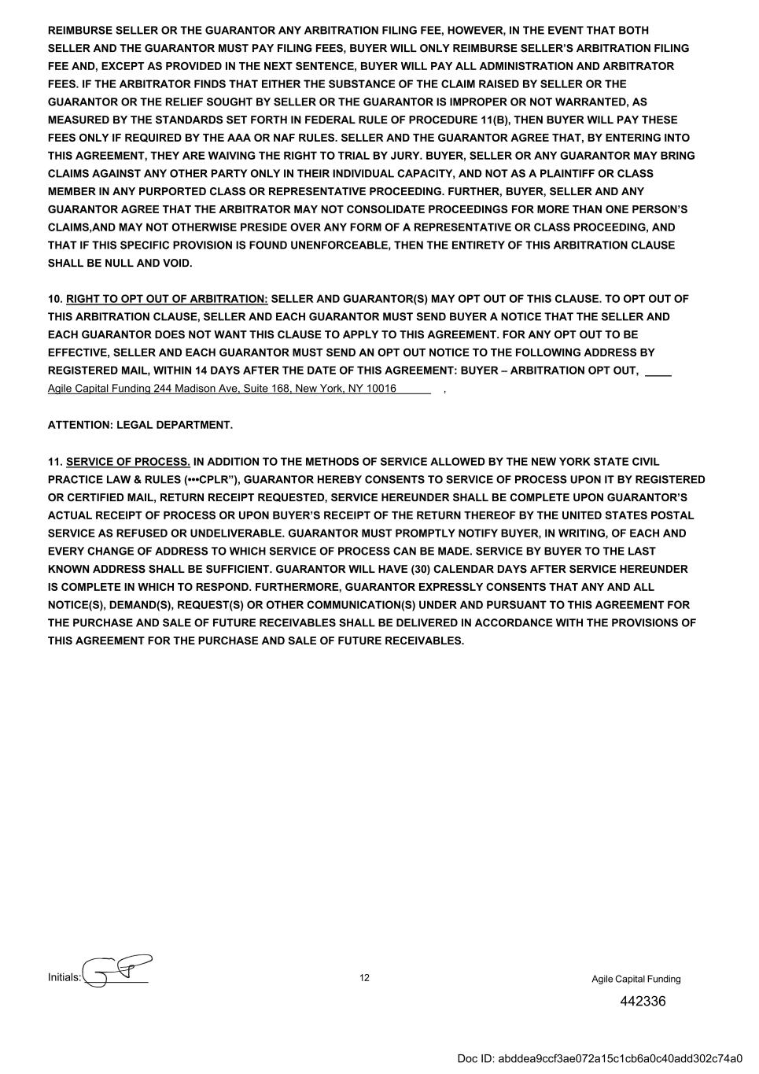
Initials: 12 Agile Capital Funding 442336 REIMBURSE SELLER OR THE GUARANTOR ANY ARBITRATION FILING FEE, HOWEVER, IN THE EVENT THAT BOTH SELLER AND THE GUARANTOR MUST PAY FILING FEES, BUYER WILL ONLY REIMBURSE SELLER’S ARBITRATION FILING FEE AND, EXCEPT AS PROVIDED IN THE NEXT SENTENCE, BUYER WILL PAY ALL ADMINISTRATION AND ARBITRATOR FEES. IF THE ARBITRATOR FINDS THAT EITHER THE SUBSTANCE OF THE CLAIM RAISED BY SELLER OR THE GUARANTOR OR THE RELIEF SOUGHT BY SELLER OR THE GUARANTOR IS IMPROPER OR NOT WARRANTED, AS MEASURED BY THE STANDARDS SET FORTH IN FEDERAL RULE OF PROCEDURE 11(B), THEN BUYER WILL PAY THESE FEES ONLY IF REQUIRED BY THE AAA OR NAF RULES. SELLER AND THE GUARANTOR AGREE THAT, BY ENTERING INTO THIS AGREEMENT, THEY ARE WAIVING THE RIGHT TO TRIAL BY JURY. BUYER, SELLER OR ANY GUARANTOR MAY BRING CLAIMS AGAINST ANY OTHER PARTY ONLY IN THEIR INDIVIDUAL CAPACITY, AND NOT AS A PLAINTIFF OR CLASS MEMBER IN ANY PURPORTED CLASS OR REPRESENTATIVE PROCEEDING. FURTHER, BUYER, SELLER AND ANY GUARANTOR AGREE THAT THE ARBITRATOR MAY NOT CONSOLIDATE PROCEEDINGS FOR MORE THAN ONE PERSON’S CLAIMS,AND MAY NOT OTHERWISE PRESIDE OVER ANY FORM OF A REPRESENTATIVE OR CLASS PROCEEDING, AND THAT IF THIS SPECIFIC PROVISION IS FOUND UNENFORCEABLE, THEN THE ENTIRETY OF THIS ARBITRATION CLAUSE SHALL BE NULL AND VOID. 10. RIGHT TO OPT OUT OF ARBITRATION: SELLER AND GUARANTOR(S) MAY OPT OUT OF THIS CLAUSE. TO OPT OUT OF THIS ARBITRATION CLAUSE, SELLER AND EACH GUARANTOR MUST SEND BUYER A NOTICE THAT THE SELLER AND EACH GUARANTOR DOES NOT WANT THIS CLAUSE TO APPLY TO THIS AGREEMENT. FOR ANY OPT OUT TO BE EFFECTIVE, SELLER AND EACH GUARANTOR MUST SEND AN OPT OUT NOTICE TO THE FOLLOWING ADDRESS BY REGISTERED MAIL, WITHIN 14 DAYS AFTER THE DATE OF THIS AGREEMENT: BUYER – ARBITRATION OPT OUT, Agile Capital Funding 244 Madison Ave, Suite 168, New York, NY 10016 , ATTENTION: LEGAL DEPARTMENT. 11. SERVICE OF PROCESS. IN ADDITION TO THE METHODS OF SERVICE ALLOWED BY THE NEW YORK STATE CIVIL PRACTICE LAW & RULES (•••CPLR”), GUARANTOR HEREBY CONSENTS TO SERVICE OF PROCESS UPON IT BY REGISTERED OR CERTIFIED MAIL, RETURN RECEIPT REQUESTED, SERVICE HEREUNDER SHALL BE COMPLETE UPON GUARANTOR’S ACTUAL RECEIPT OF PROCESS OR UPON BUYER’S RECEIPT OF THE RETURN THEREOF BY THE UNITED STATES POSTAL SERVICE AS REFUSED OR UNDELIVERABLE. GUARANTOR MUST PROMPTLY NOTIFY BUYER, IN WRITING, OF EACH AND EVERY CHANGE OF ADDRESS TO WHICH SERVICE OF PROCESS CAN BE MADE. SERVICE BY BUYER TO THE LAST KNOWN ADDRESS SHALL BE SUFFICIENT. GUARANTOR WILL HAVE (30) CALENDAR DAYS AFTER SERVICE HEREUNDER IS COMPLETE IN WHICH TO RESPOND. FURTHERMORE, GUARANTOR EXPRESSLY CONSENTS THAT ANY AND ALL NOTICE(S), DEMAND(S), REQUEST(S) OR OTHER COMMUNICATION(S) UNDER AND PURSUANT TO THIS AGREEMENT FOR THE PURCHASE AND SALE OF FUTURE RECEIVABLES SHALL BE DELIVERED IN ACCORDANCE WITH THE PROVISIONS OF THIS AGREEMENT FOR THE PURCHASE AND SALE OF FUTURE RECEIVABLES. Doc ID: abddea9ccf3ae072a15c1cb6a0c40add302c74a0

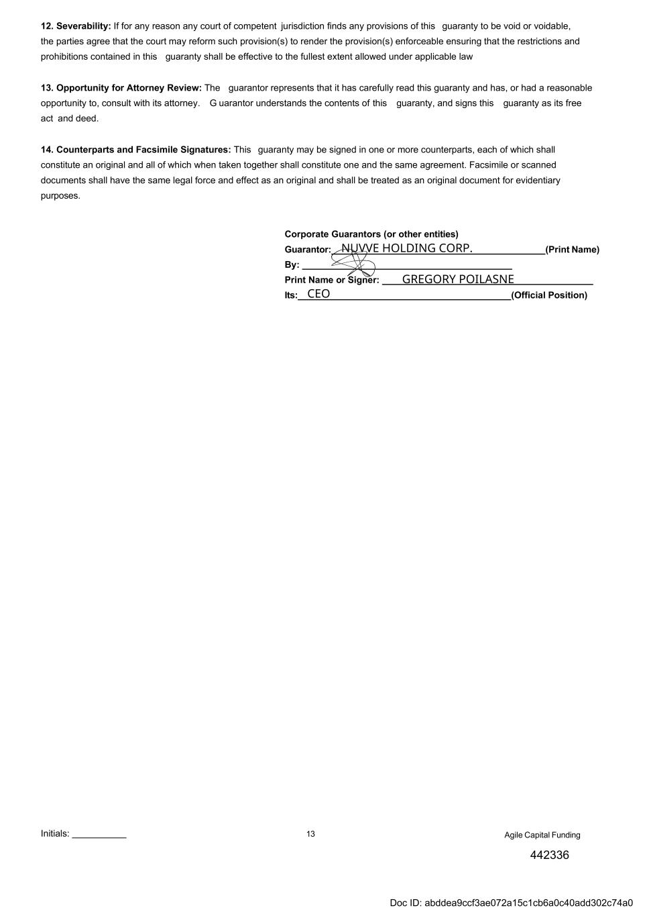
Initials: 13 12. Severability: If for any reason any court of competent jurisdiction finds any provisions of this guaranty to be void or voidable, the parties agree that the court may reform such provision(s) to render the provision(s) enforceable ensuring that the restrictions and prohibitions contained in this guaranty shall be effective to the fullest extent allowed under applicable law 13. Opportunity for Attorney Review: The guarantor represents that it has carefully read this guaranty and has, or had a reasonable opportunity to, consult with its attorney. G uarantor understands the contents of this guaranty, and signs this guaranty as its free act and deed. 14. Counterparts and Facsimile Signatures: This guaranty may be signed in one or more counterparts, each of which shall constitute an original and all of which when taken together shall constitute one and the same agreement. Facsimile or scanned documents shall have the same legal force and effect as an original and shall be treated as an original document for evidentiary purposes. Corporate Guarantors (or other entities) Guarantor: (Print Name) By: Print Name or Signer: Its: (Official Position) Agile Capital Funding 442336 NUVVE HOLDING CORP. GREGORY POILASNE CEO Doc ID: abddea9ccf3ae072a15c1cb6a0c40add302c74a0

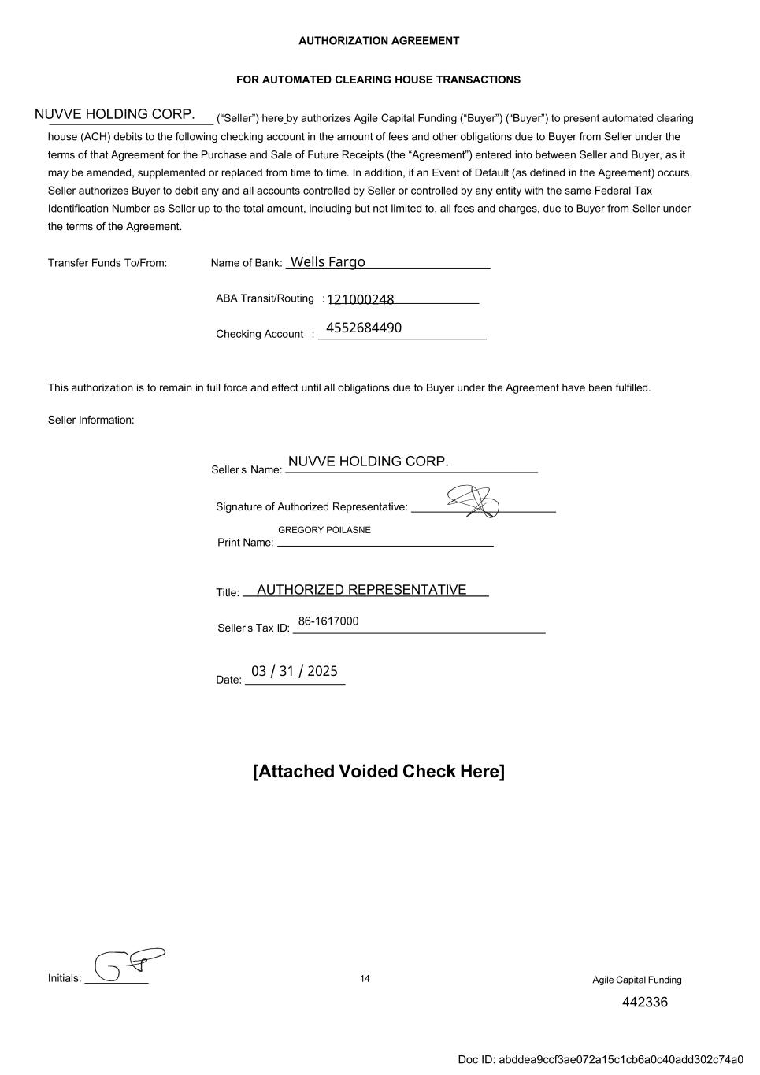
Initials: 14 AUTHORIZATION AGREEMENT FOR AUTOMATED CLEARING HOUSE TRANSACTIONS ________________________ (“Seller”) here by authorizes Agile Capital Funding (“Buyer”) (“Buyer”) to present automated clearing house (ACH) debits to the following checking account in the amount of fees and other obligations due to Buyer from Seller under the terms of that Agreement for the Purchase and Sale of Future Receipts (the “Agreement”) entered into between Seller and Buyer, as it may be amended, supplemented or replaced from time to time. In addition, if an Event of Default (as defined in the Agreement) occurs, Seller authorizes Buyer to debit any and all accounts controlled by Seller or controlled by any entity with the same Federal Tax Identification Number as Seller up to the total amount, including but not limited to, all fees and charges, due to Buyer from Seller under the terms of the Agreement. Transfer Funds To/From: Name of Bank: ABA Transit/Routing : Checking Account : This authorization is to remain in full force and effect until all obligations due to Buyer under the Agreement have been fulfilled. Seller Information: Seller s Name: Date: [Attached Voided Check Here] Agile Capital Funding NUVVE HOLDING CORP. NUVVE HOLDING CORP. 442336 GREGORY POILASNE 86-1617000 Signature of Authorized Representative: Print Name: Title: AUTHORIZED REPRESENTATIVE Seller s Tax ID: Wells Fargo 121000248 4552684490 03 / 31 / 2025 Doc ID: abddea9ccf3ae072a15c1cb6a0c40add302c74a0


Initials: 15 Dear Seller, Please fill out the form below with the access information for your bank account, please write legibly and indicate lower/upper case sensitivity. Legal Name/DBA: Bank portal Website: Username: Password: Security Question/Answer 1: Security Question/Answer 2: Security Question/Answer :3 Security Question/Answer 4: Security Question/Answer 5: Security Question/Answer :6 Any other information necessary to access your account: Agile Capital Funding 442336 Doc ID: abddea9ccf3ae072a15c1cb6a0c40add302c74a0

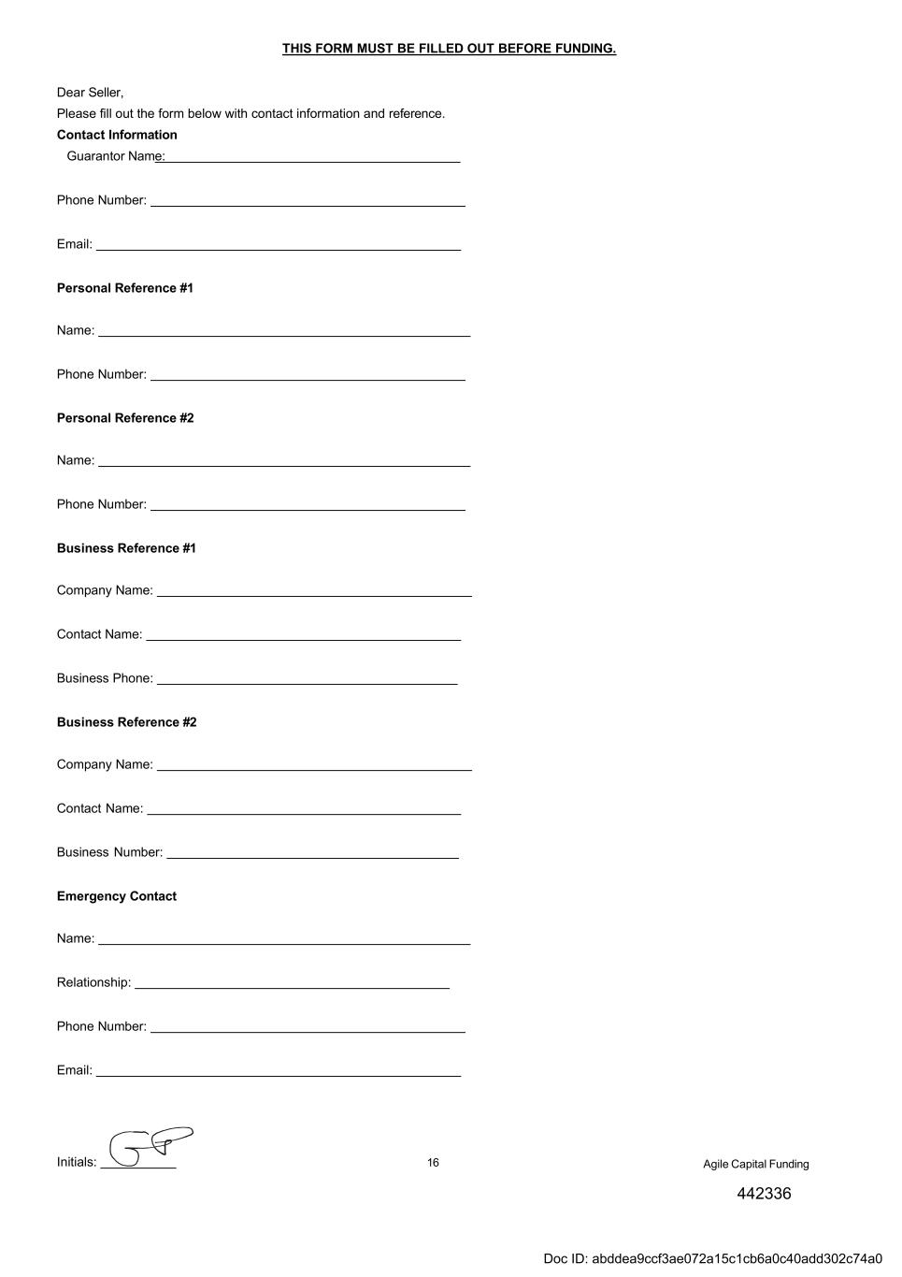
Initials: 16 THIS FORM MUST BE FILLED OUT BEFORE FUNDING. Dear Seller, Please fill out the form below with contact information and reference. Contact Information Guarantor Name: Phone Number: Email: Personal Reference #1 Name: Phone Number: Personal Reference #2 Name: Phone Number: Business Reference #1 Company Name: Contact Name: Business Phone: Business Reference #2 Company Name: Contact Name: Business Number: Emergency Contact Name: Relationship: Phone Number: Email: Agile Capital Funding 442336 Doc ID: abddea9ccf3ae072a15c1cb6a0c40add302c74a0

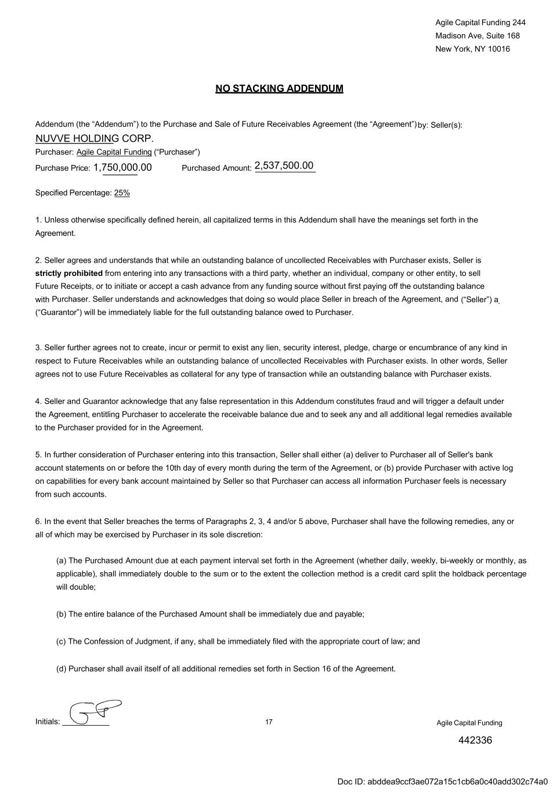
Initials: 17 Purchased Amount: Addendum (the “Addendum”) to the Purchase and Sale of Future Receivables Agreement (the “Agreement”) by: Seller(s): _______________ Purchaser: Agile Capital Funding (“Purchaser”) 1. Unless otherwise specifically defined herein, all capitalized terms in this Addendum shall have the meanings set forth in the Agreement. 2. Seller agrees and understands that while an outstanding balance of uncollected Receivables with Purchaser exists, Seller is strictly prohibited from entering into any transactions with a third party, whether an individual, company or other entity, to sell Future Receipts, or to initiate or accept a cash advance from any funding source without first paying off the outstanding balance with Purchaser. Seller understands and acknowledges that doing so would place Seller in breach of the Agreement, and (“Seller”) a (“Guarantor”) will be immediately liable for the full outstanding balance owed to Purchaser. 3. Seller further agrees not to create, incur or permit to exist any lien, security interest, pledge, charge or encumbrance of any kind in respect to Future Receivables while an outstanding balance of uncollected Receivables with Purchaser exists. In other words, Seller agrees not to use Future Receivables as collateral for any type of transaction while an outstanding balance with Purchaser exists. 4. Seller and Guarantor acknowledge that any false representation in this Addendum constitutes fraud and will trigger a default under the Agreement, entitling Purchaser to accelerate the receivable balance due and to seek any and all additional legal remedies available to the Purchaser provided for in the Agreement. 5. In further consideration of Purchaser entering into this transaction, Seller shall either (a) deliver to Purchaser all of Seller's bank account statements on or before the 10th day of every month during the term of the Agreement, or (b) provide Purchaser with active log on capabilities for every bank account maintained by Seller so that Purchaser can access all information Purchaser feels is necessary from such accounts. 6. In the event that Seller breaches the terms of Paragraphs 2, 3, 4 and/or 5 above, Purchaser shall have the following remedies, any or all of which may be exercised by Purchaser in its sole discretion: (a) The Purchased Amount due at each payment interval set forth in the Agreement (whether daily, weekly, bi-weekly or monthly, as applicable), shall immediately double to the sum or to the extent the collection method is a credit card split the holdback percentage will double; (b) The entire balance of the Purchased Amount shall be immediately due and payable; (c) The Confession of Judgment, if any, shall be immediately filed with the appropriate court of law; and (d) Purchaser shall avail itself of all additional remedies set forth in Section 16 of the Agreement. Agile Capital Funding NUVVE HOLDING CORP. 2,537,500.00 442336 1,750,000.00 Agile Capital Funding 244 Madison Ave, Suite 168 New York, NY 10016 NO STACKING ADDENDUM Purchase Price: _ _ _ ___ Specified Percentage: 25% Doc ID: abddea9ccf3ae072a15c1cb6a0c40add302c74a0

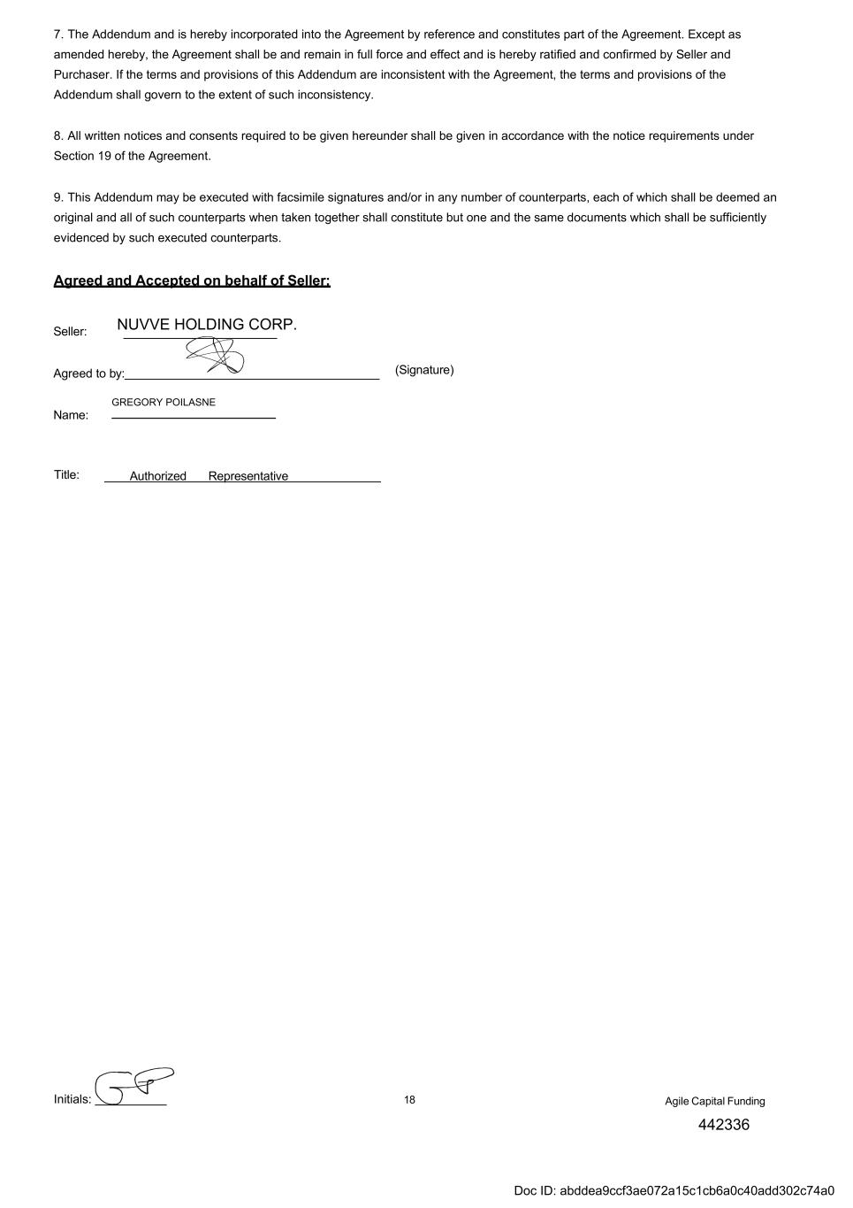
Initials: 18 7. The Addendum and is hereby incorporated into the Agreement by reference and constitutes part of the Agreement. Except as amended hereby, the Agreement shall be and remain in full force and effect and is hereby ratified and confirmed by Seller and Purchaser. If the terms and provisions of this Addendum are inconsistent with the Agreement, the terms and provisions of the Addendum shall govern to the extent of such inconsistency. 8. All written notices and consents required to be given hereunder shall be given in accordance with the notice requirements under Section 19 of the Agreement. 9. This Addendum may be executed with facsimile signatures and/or in any number of counterparts, each of which shall be deemed an original and all of such counterparts when taken together shall constitute but one and the same documents which shall be sufficiently evidenced by such executed counterparts. Agreed and Accepted on behalf of Seller: Seller: Agreed to by: (Signature) Title: RepresentativeAuthorized Agile Capital Funding NUVVE HOLDING CORP. 442336 GREGORY POILASNE Name: Doc ID: abddea9ccf3ae072a15c1cb6a0c40add302c74a0

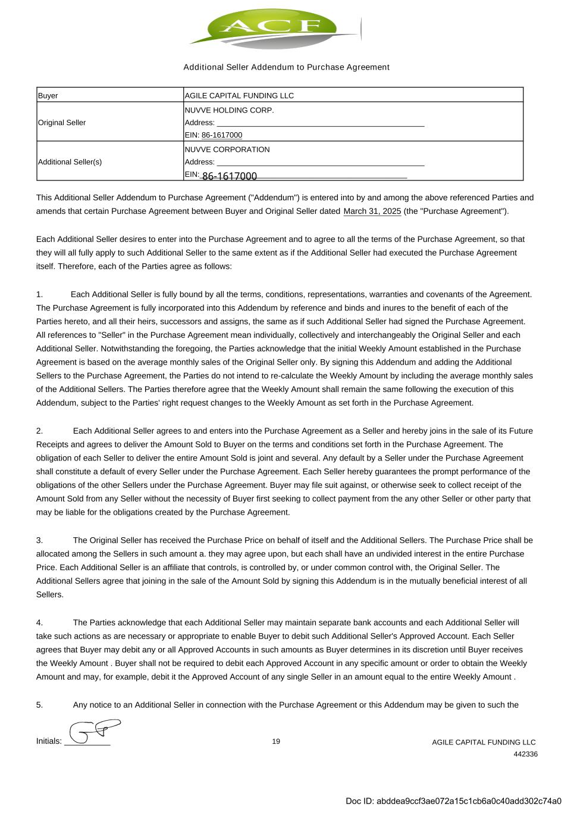
Additional Seller Addendum to Purchase Agreement Buyer AGILE CAPITAL FUNDING LLC Original Seller NUVVE HOLDING CORP. Address: _________________________________________________ EIN: 86-1617000 Additional Seller(s) NUVVE CORPORATION Address: _________________________________________________ EIN:_________________________________________________ This Additional Seller Addendum to Purchase Agreement ("Addendum") is entered into by and among the above referenced Parties and amends that certain Purchase Agreement between Buyer and Original Seller dated March 31, 2025 (the "Purchase Agreement"). Each Additional Seller desires to enter into the Purchase Agreement and to agree to all the terms of the Purchase Agreement, so that they will all fully apply to such Additional Seller to the same extent as if the Additional Seller had executed the Purchase Agreement itself. Therefore, each of the Parties agree as follows: 1. Each Additional Seller is fully bound by all the terms, conditions, representations, warranties and covenants of the Agreement. The Purchase Agreement is fully incorporated into this Addendum by reference and binds and inures to the benefit of each of the Parties hereto, and all their heirs, successors and assigns, the same as if such Additional Seller had signed the Purchase Agreement. All references to "Seller" in the Purchase Agreement mean individually, collectively and interchangeably the Original Seller and each Additional Seller. Notwithstanding the foregoing, the Parties acknowledge that the initial Weekly Amount established in the Purchase Agreement is based on the average monthly sales of the Original Seller only. By signing this Addendum and adding the Additional Sellers to the Purchase Agreement, the Parties do not intend to re-calculate the Weekly Amount by including the average monthly sales of the Additional Sellers. The Parties therefore agree that the Weekly Amount shall remain the same following the execution of this Addendum, subject to the Parties' right request changes to the Weekly Amount as set forth in the Purchase Agreement. 2. Each Additional Seller agrees to and enters into the Purchase Agreement as a Seller and hereby joins in the sale of its Future Receipts and agrees to deliver the Amount Sold to Buyer on the terms and conditions set forth in the Purchase Agreement. The obligation of each Seller to deliver the entire Amount Sold is joint and several. Any default by a Seller under the Purchase Agreement shall constitute a default of every Seller under the Purchase Agreement. Each Seller hereby guarantees the prompt performance of the obligations of the other Sellers under the Purchase Agreement. Buyer may file suit against, or otherwise seek to collect receipt of the Amount Sold from any Seller without the necessity of Buyer first seeking to collect payment from the any other Seller or other party that may be liable for the obligations created by the Purchase Agreement. 3. The Original Seller has received the Purchase Price on behalf of itself and the Additional Sellers. The Purchase Price shall be allocated among the Sellers in such amount a. they may agree upon, but each shall have an undivided interest in the entire Purchase Price. Each Additional Seller is an affiliate that controls, is controlled by, or under common control with, the Original Seller. The Additional Sellers agree that joining in the sale of the Amount Sold by signing this Addendum is in the mutually beneficial interest of all Sellers. 4. The Parties acknowledge that each Additional Seller may maintain separate bank accounts and each Additional Seller will take such actions as are necessary or appropriate to enable Buyer to debit such Additional Seller's Approved Account. Each Seller agrees that Buyer may debit any or all Approved Accounts in such amounts as Buyer determines in its discretion until Buyer receives the Weekly Amount . Buyer shall not be required to debit each Approved Account in any specific amount or order to obtain the Weekly Amount and may, for example, debit it the Approved Account of any single Seller in an amount equal to the entire Weekly Amount . 5. Any notice to an Additional Seller in connection with the Purchase Agreement or this Addendum may be given to such the Initials: __________ 19 AGILE CAPITAL FUNDING LLC 442336 86-1617000 Doc ID: abddea9ccf3ae072a15c1cb6a0c40add302c74a0

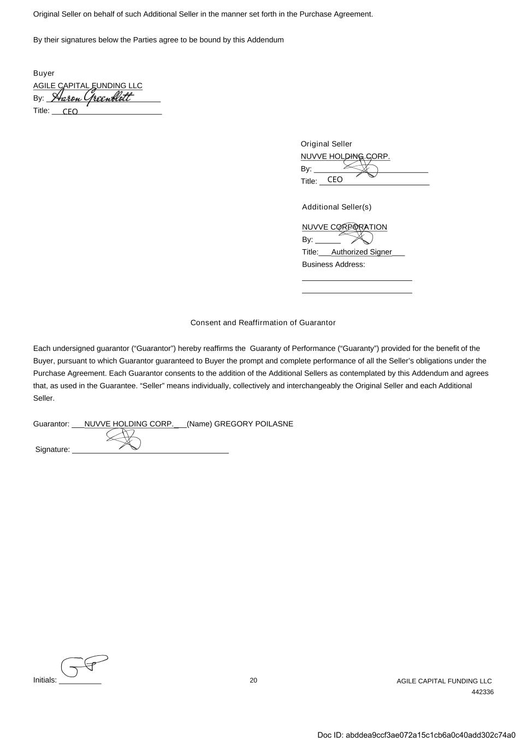
Initials: __________ 20 AGILE CAPITAL FUNDING LLC 442336 Original Seller on behalf of such Additional Seller in the manner set forth in the Purchase Agreement. By their signatures below the Parties agree to be bound by this Addendum Buyer AGILE CAPITAL FUNDING LLC By: ___________________________ Title: __________________________ Original Seller NUVVE HOLDING CORP. By: ___________________________ Title: __________________________ Additional Seller(s) NUVVE CORPORATION By: ______ Title:___Authorized Signer___ Business Address: __________________________ __________________________ Consent and Reaffirmation of Guarantor Each undersigned guarantor (“Guarantor”) hereby reaffirms the Guaranty of Performance (“Guaranty”) provided for the benefit of the Buyer, pursuant to which Guarantor guaranteed to Buyer the prompt and complete performance of all the Seller’s obligations under the Purchase Agreement. Each Guarantor consents to the addition of the Additional Sellers as contemplated by this Addendum and agrees that, as used in the Guarantee. “Seller” means individually, collectively and interchangeably the Original Seller and each Additional Seller. Guarantor: ___NUVVE HOLDING CORP.___(Name) GREGORY POILASNE Signature: _____________________________________ CEO CEO Doc ID: abddea9ccf3ae072a15c1cb6a0c40add302c74a0

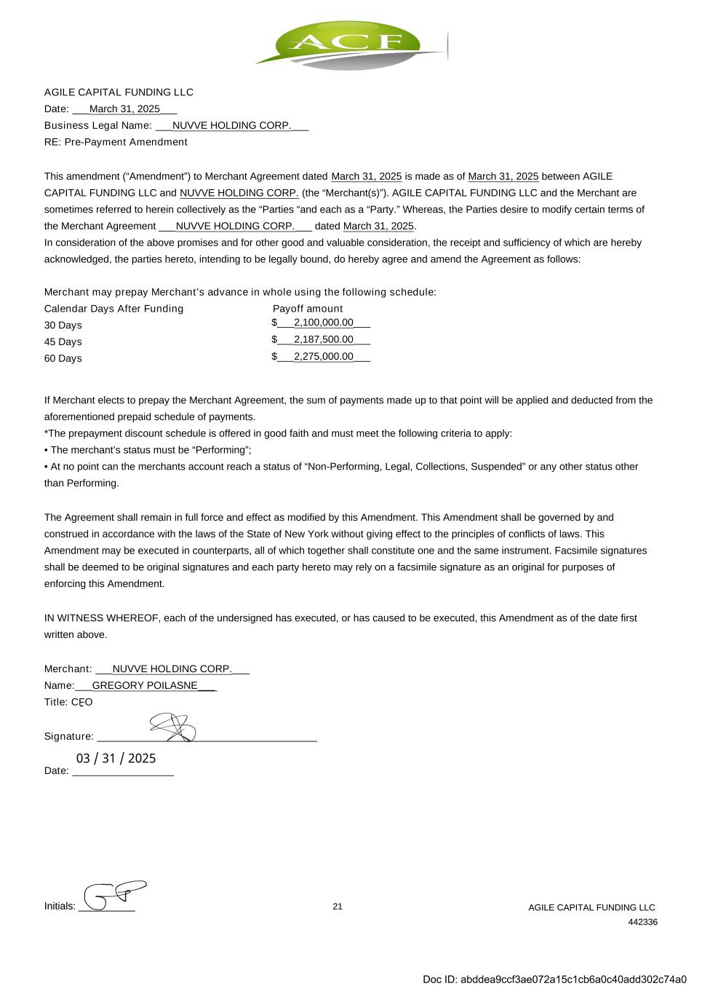
AGILE CAPITAL FUNDING LLC Date: ___March 31, 2025___ Business Legal Name: ___NUVVE HOLDING CORP.___ RE: Pre-Payment Amendment This amendment (“Amendment”) to Merchant Agreement dated March 31, 2025 is made as of March 31, 2025 between AGILE CAPITAL FUNDING LLC and NUVVE HOLDING CORP. (the “Merchant(s)”). AGILE CAPITAL FUNDING LLC and the Merchant are sometimes referred to herein collectively as the “Parties “and each as a “Party.” Whereas, the Parties desire to modify certain terms of the Merchant Agreement ___NUVVE HOLDING CORP.___ dated March 31, 2025. In consideration of the above promises and for other good and valuable consideration, the receipt and sufficiency of which are hereby acknowledged, the parties hereto, intending to be legally bound, do hereby agree and amend the Agreement as follows: Merchant may prepay Merchant’s advance in whole using the following schedule: Calendar Days After Funding Payoff amount 30 Days $___2,100,000.00___ Initials: __________ 21 AGILE CAPITAL FUNDING LLC 442336 45 Days $___2,187,500.00___ 60 Days $___2,275,000.00___ If Merchant elects to prepay the Merchant Agreement, the sum of payments made up to that point will be applied and deducted from the aforementioned prepaid schedule of payments. *The prepayment discount schedule is offered in good faith and must meet the following criteria to apply: • The merchant’s status must be “Performing”; • At no point can the merchants account reach a status of “Non-Performing, Legal, Collections, Suspended” or any other status other than Performing. The Agreement shall remain in full force and effect as modified by this Amendment. This Amendment shall be governed by and construed in accordance with the laws of the State of New York without giving effect to the principles of conflicts of laws. This Amendment may be executed in counterparts, all of which together shall constitute one and the same instrument. Facsimile signatures shall be deemed to be original signatures and each party hereto may rely on a facsimile signature as an original for purposes of enforcing this Amendment. IN WITNESS WHEREOF, each of the undersigned has executed, or has caused to be executed, this Amendment as of the date first written above. Merchant: ___NUVVE HOLDING CORP.___ Name:___GREGORY POILASNE___ Title: CFO Signature: _______________________________________ Date: __________________ - 03 / 31 / 2025 Doc ID: abddea9ccf3ae072a15c1cb6a0c40add302c74a0

THIS INSTRUMENT AND THE SECURITIES ISSUABLE UPON THE CONVERSION HEREOF HAVE NOT BEEN REGISTERED UNDER THE SECURITIES ACT OF 1933, AS AMENDED (THE "ACT"). THEY MAY NOT BE SOLD, OFFERED FOR SALE, PLEDGED, HYPOTHECATED OR OTHERWISE TRANSFERRED EXCEPT PURSUANT TO AN EFFECTIVE REGISTRATION STATEMENT UNDER THE ACT OR UPON RECEIPT BY THE COMPANY OF AN OPINION OF COUNSEL SATISFACTORY TO THE COMPANY THAT REGISTRATION IS NOT REQUIRED UNDER THE ACT.

FORM OF CONVERTIBLE PROMISSORY NOTE

No. CN-[NUMBER] |  |  | Date of Issuance
US$[PRINCIPAL AMOUNT] |  |  | 04/[ ]/2025

FOR VALUE RECEIVED, Fermata Energy II, LLC, a Delaware limited liability company (the "Company"), if the funding contingency described in Section 3 below is met and the Principal Amount hereunder is funded, hereby promises to pay to the order of [HOLDER NAME] (the "Holder"), the principal sum of US$[PRINCIPAL AMOUNT] (the "Principal Amount") including a 15% Original Issue Discount, together with interest thereon from the date of issuance of this convertible promissory note (this "Note"). Interest will accrue at a rate of 10% per annum. Unless earlier converted into Conversion Units (as defined below), the principal and accrued interest of this Note will be due and payable by the Company at any time on or after April 21, 2026 (the "Maturity Date") at the Company's election or upon demand by the holders (the "Requisite Noteholders") of a minimum 35% of the aggregate principal amount of the Series 1 Notes (as defined below).
This Note is one of a series (the "Series") of convertible promissory notes (collectively, the "Series 1 Notes") issued by the Company to investors with identical terms and on the same form as set forth herein (except that the holder, principal amount and date of issuance may differ in each Note). Capitalized terms not otherwise defined in this Note will have the meanings set forth in Section 5.1.
1.Payment. All payments will be made in lawful money of the United States of America at the principal office of the Company, or at such other place as the Holder may from time to time designate in writing to the Company. Payment will be credited first to accrued interest due and payable, with any remainder applied to principal. Prepayment of principal, together with accrued interest, may not be made without the written consent of the Holder, except in the event of a Corporate Transaction (as set forth in Section 5.3).
2.Security. This Note is a general unsecured obligation of the Company.
3.Funding Contingency. The Holder’s obligation to fund under this Note is contingent upon the successful consummation of that certain asset purchase transaction by and between Nuvve

Holding Corp., the Company and Fermata Energy LLC (the “Contingent Transaction”) no later than April 28, 2025 at 5:00 PM Pacific time (the “Outside Closing Date”). If the Contingent Transaction does not close by the Outside Closing Date or is otherwise terminated for any reason on or prior to the Outside Closing Date, the Holder’s obligations hereunder are terminated. The parties hereto specifically acknowledge and agree that the Holder’s funding obligations under this Note are strictly conditioned upon the successful completion of the Contingent Transaction on or before the Outside Closing Date, and the Holder shall have no obligation to fund hereunder unless such condition is satisfied. For the avoidance of doubt, in the event that this Note is not so funded, the Holder shall have no rights whatsoever pursuant to this Note.
4.Priority. This Note is senior in right of payment to all current debt of the Company for borrowed money.
5.Conversion. This Note will be convertible into Equity Securities pursuant to the terms in this Section 5.
5.1Definitions.
(a)"Units" means the Company's Class B Units, except as otherwise provided in Section 5.4 in the case of Shadow Preferred treatment upon maturity conversion.
(b)"Conversion Units" (for purposes of determining the type of Equity Securities issuable upon conversion of this Note) means:
(i)with respect to a conversion pursuant to Section 5.2, (A) of the Equity Securities issued in the Next Equity Financing or (B) at the Company's election (if applicable), shares of Shadow Preferred;
(ii)with respect to a conversion pursuant to Section 5.3, Units; and
(iii)with respect to a conversion pursuant to Section 5.4, Units.
(c)"Conversion Price" means (rounded to the nearest 1/100th of one cent):
(i)with respect to a conversion pursuant to Section 5.2, the lesser of: (A) the product of (x) 100% less the Discount and (y) the lowest per share purchase price of the Equity Securities issued in the Next Equity Financing; and (B) the quotient resulting from dividing (x) the Valuation Cap by (y) the Fully Diluted Capitalization immediately prior to the closing of the Next Equity Financing;
(ii)with respect to a conversion pursuant to Section 5.3, the quotient resulting from dividing (x) the Valuation Cap by (y) the Fully Diluted Capitalization immediately prior to the closing of the Corporate Transaction; and
(iii)with respect to a conversion pursuant to Section 5.4, the quotient resulting from dividing (x) the Valuation Cap by (y) the Fully Diluted Capitalization immediately prior to such conversion.
(d)"Corporate Transaction" means:
(i)The consolidation by the parent company (majority owner) of some or all of the convertible notes issued, the Series 1 Notes.
2

(ii)the closing of the sale, transfer or other disposition, in a single transaction or series of related transactions, of all or substantially all of the Company's assets or the exclusive license of all or substantially all of the Company’s material intellectual property;
(iii)the consummation of a merger or consolidation of the Company with or into another entity (except a merger or consolidation in which the holders of capital stock/units of the Company immediately prior to such merger or consolidation continue to hold a majority of the outstanding voting securities of the capital stock/units of the Company or the surviving or acquiring entity immediately following the consummation of such transaction); or
(iv)the closing of the transfer (whether by merger, consolidation or otherwise), in a single transaction or series of related transactions, to a "person" or "group" (within the meaning of Section 13(d) and Section 14(d) of the Exchange Act), of the Company's capital stock/units if, after such closing, such person or group would become the "beneficial owner" (as defined in Rule 13d-3 under the Exchange Act) of more than 50% of the outstanding voting securities of the Company (or the surviving or acquiring entity).
For the avoidance of doubt, a transaction will not constitute a "Corporate Transaction" if its sole purpose is to change the state of the Company's incorporation or to create a holding company that will be owned in substantially the same proportions by the persons who held the Company's securities immediately prior to such transaction. Notwithstanding the foregoing, the sale of Equity Securities in a bona fide financing transaction will not be deemed a "Corporate Transaction."
(e)"Discount" means 20%.
(f)"Equity Securities" means (i) Units; (ii) any securities conferring the right to purchase Units; or (iii) any securities directly or indirectly convertible into, or exchangeable for (with or without additional consideration) Units. Notwithstanding the foregoing, the following will not be considered "Equity Securities": (A) any security granted, issued or sold by the Company to any director, officer, employee, consultant or adviser of the Company for the primary purpose of soliciting or retaining their services; (B) any convertible promissory notes (including this Note) issued by the Company; and (C) any SAFEs that have been issued by the Company.
(g)"Exchange Act" means the Securities Exchange Act of 1934, as amended.
(h)"Fully Diluted Capitalization" means the number of issued and outstanding shares/units of the Company's capital stock or equity interests, assuming [(i)] the conversion or exercise of all of the Company's outstanding convertible or exercisable securities, including shares/units of convertible Preferred Units and all outstanding vested or unvested options or warrants to purchase the Company's capital stock[; and (ii) solely for purposes of Section 5.1(c)(i) and 5.1(c)(iii), the issuance of all shares/units of the Company's capital stock/units reserved and available for future issuance under any of the Company's existing equity incentive plans [or any equity incentive plan created or expanded in connection with the Next Equity Financing]]. Notwithstanding the foregoing, "Fully Diluted Capitalization" excludes: (A) any convertible promissory notes (including this Note) issued by the Company; (B) any
3

SAFEs issued by the Company; and (C) any Equity Securities that are issuable upon conversion of any outstanding convertible promissory notes or SAFEs.
(i)"Next Equity Financing" means the next sale (or series of related sales) by the Company of its Equity Securities following the date of issuance of this Note, in one or more offerings relying on Section 4(a)(2) of the Securities Act or Regulation D thereunder for exemption from the registration requirements of Section 5 of the Securities Act, with the principal purpose of raising capital and from which the Company receives aggregate gross proceeds of not less than US$3,500,000 (excluding, for the avoidance of doubt, the aggregate principal amount of the Series 1 Notes).
(j)"Preferred Units" means all series of the Company's preferred units, whether now existing or hereafter created.
(k)"SAFE" means any simple agreement for future equity (or other similar agreement) that is issued by the Company for bona fide financing purposes and that may convert into the Company's capital stock/units in accordance with its terms.
(l)"Securities Act" means the Securities Act of 1933, as amended.
(m)"Shadow Preferred" means a series of Preferred Units with substantially the same rights, preferences and privileges as the series of Preferred Units issued in the Next Equity Financing, except that the per share liquidation preference of the Shadow Preferred will equal the Conversion Price calculated pursuant to Section 5.1(c)(i), with corresponding adjustments to any price-based antidilution and/or dividend rights provisions.
(n)"Valuation Cap" means US$20,000,000.

5.2Next Equity Financing Conversion. The principal balance and unpaid accrued interest on this Note will automatically convert into Conversion Units upon the closing of the Next Equity Financing. The number of Conversion Units the Company issues upon such conversion will equal the quotient (rounded down to the nearest whole share) obtained by dividing (x) the outstanding principal balance and unpaid accrued interest under this Note on a date that is no more than five (5) days prior to the closing of the Next Equity Financing/the date of conversion by (y) the applicable Conversion Price. At least five (5) days prior to the closing of the Next Equity Financing, the Company will notify the Holder in writing of the terms of the Equity Securities that are expected to be issued in such financing. The issuance of Conversion Units pursuant to the conversion of this Note will be on, and subject to, the same terms and conditions applicable to the Equity Securities issued in the Next Equity Financing.
5.3Corporate Transaction Conversion. In the event of a Corporate Transaction prior to the conversion of this Note pursuant to Section 5.2 or Section 5.4 or the repayment of this Note, at the closing of such Corporate Transaction, the Holder may elect that either: (a) the Company will pay the Holder an amount equal to the sum of (x) all accrued and unpaid interest due on this Note and (y) 2 times the outstanding principal balance of this Note; or (b) this Note will convert into that number of Conversion Units equal to the quotient (rounded down to the nearest whole share) obtained by dividing (x) the outstanding principal
4

balance and unpaid accrued interest of this Note on a date that is no more than five (5) days prior to the closing of such Corporate Transaction/the date of conversion by (y) the applicable Conversion Price.
5.4The Company shall provide the Holder with written notice of any proposed Corporate Transaction at least five (5) business days prior to the closing thereof, including a summary of the material terms and expected treatment of Noteholders. The Holder shall have until the closing of such Corporate Transaction, or such later date as reasonably agreed by the Company and the Requisite Noteholders, to make the election set forth in this Section 5.3.
5.5Maturity Conversion. At any time on or after the Maturity Date, at the election of the Holder/the Requisite Noteholders, this Note will convert into that number of Conversion Units equal to the quotient (rounded down to the nearest whole share) obtained by dividing (x) the outstanding principal balance and unpaid accrued interest of this Note on the date of such conversion by (y) the applicable Conversion Price.
5.6Mechanics of Conversion.
(a)Financing Agreements. The Holder acknowledges that the conversion of this Note into Conversion Units pursuant to Section 5.2 may require the Holder's execution of certain agreements relating to the purchase and sale of the Conversion Units, as well as registration rights, rights of first refusal and co-sale, rights of first offer and voting rights, if any, relating to such securities (collectively, the "Financing Agreements"). The Holder agrees to execute all of the Financing Agreements in connection with a Next Equity Financing.
(b)Certificates. As promptly as practicable after the conversion of this Note and the issuance of the Conversion Units, the Company (at its expense) will issue and deliver a certificate or certificates evidencing the Conversion Units (if certificated) to the Holder, or if the Conversion Units are not certificated, will deliver a true and correct copy of the Company's share register reflecting the Conversion Units held by the Holder. The Company will not be required to issue or deliver the Conversion Units until the Holder has surrendered this Note to the Company (or provided an instrument of cancellation or affidavit of loss). The conversion of this Note pursuant to Section 5.2 and Section 5.3 may be made contingent upon the closing of the Next Equity Financing and Corporate Transaction, respectively.
5.7Timely Conversion or Repayment at Maturity. If the Holder or the Requisite Noteholders elect to convert this Note upon or after the Maturity Date pursuant to Section 5.4, or elect repayment instead, the Company shall complete such conversion or repayment within ten (10) business days of such election. Failure to do so shall constitute an Event of Default (as defined in Section 8.20), and beginning on the eleventh (11th) business day, all unpaid principal and accrued interest shall accrue additional interest at the lesser of (i) eighteen percent (18%) per annum or (ii) the maximum rate permitted by applicable law, until such conversion or repayment is completed.
6.Representations and Warranties of the Company. In connection with the transactions contemplated by this Note, the Company hereby represents and warrants to the Holder as follows:
5

6.1Due Organization; Qualification and Good Standing. The Company is a corporation duly organized, validly existing and in good standing under the laws of the State of Delaware and has all requisite corporate power and authority to carry on its business as now conducted. The Company is duly qualified to transact business and is in good standing in each jurisdiction in which the failure to so qualify or to be in good standing would have a material adverse effect on the Company.
6.2Authorization and Enforceability. Except for the authorization and issuance of the Conversion Units, all corporate action has been taken on the part of the Company and its officers, directors and equityholders necessary for the authorization, execution and delivery of this Note. Except as may be limited by applicable bankruptcy, insolvency, reorganization or similar laws relating to or affecting the enforcement of creditors' rights, the Company has taken all corporate action required to make all of the obligations of the Company reflected in the provisions of this Note valid and enforceable in accordance with its terms.
7.Representations and Warranties of the Holder. In connection with the transactions contemplated by this Note, the Holder hereby represents and warrants to the Company as follows:
7.1Authorization. The Holder has full power and authority (and, if an individual, the capacity) to enter into this Note and to perform all obligations required to be performed by it hereunder. This Note, when executed and delivered by the Holder, will constitute the Holder's valid and legally binding obligation, enforceable in accordance with its terms, except (a) as limited by applicable bankruptcy, insolvency, reorganization, moratorium, fraudulent conveyance and any other laws of general application affecting enforcement of creditors' rights generally, and (b) as limited by laws relating to the availability of specific performance, injunctive relief or other equitable remedies.
7.2Purchase Entirely for Own Account. The Holder acknowledges that this Note is made with the Holder in reliance upon the Holder's representation to the Company, which the Holder hereby confirms by executing this Note, that this Note, the Conversion Units, and any Units issuable upon conversion of the Conversion Units (collectively, the "Securities") will be acquired for investment for the Holder's own account, not as a nominee or agent (unless otherwise specified on the Holder's signature page hereto), and not with a view to the resale or distribution of any part thereof, and that the Holder has no present intention of selling, granting any participation in, or otherwise distributing the same. By executing this Note, the Holder further represents that the Holder does not have any contract, undertaking, agreement or arrangement with any person to sell, transfer or grant participations to such person or to any third person, with respect to the Securities. If other than an individual, the Holder also represents it has not been organized solely for the purpose of acquiring the Securities.
7.3Disclosure of Information; Non-Reliance. The Holder acknowledges that it has received all the information it considers necessary or appropriate to enable it to make an informed decision concerning an investment in the Securities. The Holder further represents that it has had an opportunity to ask questions and receive answers from the Company regarding the terms and conditions of the offering of the Securities. The Holder confirms that the Company has not given any guarantee or representation as to the potential success, return, effect or benefit (either legal, regulatory, tax, financial, accounting or otherwise) of an investment in the Securities. In deciding to purchase the Securities, the Holder is not relying on the advice or recommendations of the Company and has made its own independent decision that the investment in the Securities is suitable and appropriate for the Holder. The Holder understands that no federal or state agency has passed upon the merits or
6

risks of an investment in the Securities or made any finding or determination concerning the fairness or advisability of this investment.
7.4Investment Experience. The Holder is an investor in securities of companies in the development stage and acknowledges that it is able to fend for itself, can bear the economic risk of its investment and has such knowledge and experience in financial or business matters that it is capable of evaluating the merits and risks of the investment in the Securities.
7.5Accredited Investor. The Holder is an "accredited investor" within the meaning of Rule 501 of Regulation D promulgated under the Securities Act. The Holder agrees to furnish any additional information requested by the Company or any of its affiliates to assure compliance with applicable U.S. federal and state securities laws in connection with the purchase and sale of the Securities.
7.6Restricted Securities. The Holder understands that the Securities have not been, and will not be, registered under the Securities Act or state securities laws, by reason of specific exemptions from the registration provisions thereof which depend upon, among other things, the bona fide nature of the investment intent and the accuracy of the Holder's representations as expressed herein. The Holder understands that the Securities are "restricted securities" under U.S. federal and applicable state securities laws and that, pursuant to these laws, the Holder must hold the Securities indefinitely unless they are registered with the Securities and Exchange Commission ("SEC") and registered or qualified by state authorities, or an exemption from such registration and qualification requirements is available. The Holder acknowledges that the Company has no obligation to register or qualify the Securities for resale and further acknowledges that, if an exemption from registration or qualification is available, it may be conditioned on various requirements including, but not limited to, the time and manner of sale, the holding period for the Securities, and on requirements relating to the Company which are outside of the Holder's control, and which the Company is under no obligation, and may not be able, to satisfy.
7.7No Public Market. The Holder understands that no public market now exists for the Securities and that the Company has made no assurances that a public market will ever exist for the Securities.
7.8No General Solicitation. The Holder, and its officers, directors, employees, agents, equityholders or partners have not either directly or indirectly, including through a broker or finder, solicited offers for or offered or sold the Securities by means of any form of general solicitation or general advertising within the meaning of Rule 502 of Regulation D under the Securities Act or in any manner involving a public offering within the meaning of Section 4(a)(2) of the Securities Act. The Holder acknowledges that neither the Company nor any other person offered to sell the Securities to it by means of any form of general solicitation or advertising within the meaning of Rule 502 of Regulation D under the Securities Act or in any manner involving a public offering within the meaning of Section 4(a)(2) of the Securities Act.
7.9Residence. If the Holder is an individual, then the Holder resides in the state or province identified in the address shown on the Holder's signature page hereto. If the Holder is a partnership, corporation, limited liability company or other entity, then the Holder's principal place of business is located in the state or province identified in the address shown on the Holder's signature page hereto.
7.10Foreign Investors. If the Holder is not a United States person (as defined by Section 7701(a)(30) of the Internal Revenue Code of 1986, as amended), the Holder hereby
7

represents that it has satisfied itself as to the full observance of the laws of its jurisdiction in connection with any invitation to subscribe for the Securities, including (a) the legal requirements within its jurisdiction for the purchase of the Securities; (b) any foreign exchange restrictions applicable to such purchase; (c) any governmental or other consents that may need to be obtained; and (d) the income tax and other tax consequences, if any, that may be relevant to the purchase, holding, conversion, redemption, sale, or transfer of the Securities. The Holder's subscription and payment for and continued beneficial ownership of the Securities will not violate any applicable securities or other laws of the Holder's jurisdiction. The Holder acknowledges that the Company has taken no action in foreign jurisdictions with respect to the Securities.
7.11No "Bad Actor" Disqualification. The Holder represents and warrants that neither (A) the Holder nor (B) any entity that controls the Holder or is under the control of, or under common control with, the Holder, is subject to any of the “bad actor” disqualifications described in Rule 506(d)(1)(i) through (viii), as modified by Rules 506(d)(2) and (d)(3), under the Securities Act (“Disqualification Events”), except for Disqualification Events covered by Rule 506(d)(2)(ii) or (iii) or (d)(3) under the Securities Act and disclosed in writing in reasonable detail to the Company. The Holder represents that the Holder has exercised reasonable care to determine the accuracy of the representation made by the Holder in this paragraph and agrees to notify the Company if the Holder becomes aware of any fact that makes the representation given by the Holder hereunder inaccurate.
8.Miscellaneous.
8.1Successors and Assigns. Except as otherwise provided herein, the terms and conditions of this Note will inure to the benefit of, and be binding upon, the respective successors and assigns of the parties; provided, however, that the Company may not assign its obligations under this Note without the written consent of the Holder. This Note is for the sole benefit of the parties hereto and their respective successors and permitted assigns, and nothing herein, express or implied, is intended to or will confer upon any other person or entity any legal or equitable right, benefit or remedy of any nature whatsoever under or by reason of this Note, except as expressly provided in this Note.
8.2Choice of Law. This Note, and all matters arising out of or relating to this Note, whether sounding in contract, tort, or statute will be governed by and construed in accordance with the internal laws of the State of Delaware, without giving effect to the conflict of laws provisions thereof to the extent such principles or rules would require or permit the application of the laws of any jurisdiction other than those of the State of Delaware.
8.3Counterparts. This Note may be executed in counterparts, each of which will be deemed an original, but all of which together will be deemed to be one and the same agreement. Counterparts may be delivered via facsimile, electronic mail (including PDF or any electronic signature complying with the U.S. federal ESIGN Act of 2000, e.g., www.docusign.com) or other transmission method, and any counterpart so delivered will be deemed to have been duly and validly delivered and be valid and effective for all purposes.
8.4Titles and Subtitles. The titles and subtitles used in this Note are included for convenience only and are not to be considered in construing or interpreting this Note.
8.5Notices. All notices and other communications given or made pursuant hereto will be in writing and will be deemed effectively given: (a) upon personal delivery to the party to be notified; (b) when sent by email or confirmed facsimile; (c) five (5) days after having been sent by registered or certified mail, return receipt requested, postage prepaid; or (d) one
8

(1) day after deposit with a nationally recognized overnight courier, specifying next day delivery, with written verification of receipt. All communications will be sent to the respective parties at the addresses shown on the signature pages hereto (or to such email address, facsimile number or other address as subsequently modified by written notice given in accordance with this Section 7.5).
8.6No Finder's Fee. Each party represents that it neither is nor will be obligated to pay any finder's fee, broker's fee or commission in connection (directly or indirectly) with the transactions contemplated by this Note. The Holder agrees to indemnify and to hold the Company harmless from any liability for any commission or compensation in the nature of a finder's or broker's fee arising out of the transactions contemplated by this Note (and the costs and expenses of defending against such liability or asserted liability) for which the Holder or any of its officers, employees or representatives is responsible. The Company agrees to indemnify and hold the Holder harmless from any liability for any commission or compensation in the nature of a finder's or broker's fee arising out of the transactions contemplated by this Note (and the costs and expenses of defending against such liability or asserted liability) for which the Company or any of its officers, employees or representatives is responsible.
8.7Expenses. Each party will pay all costs and expenses that it incurs with respect to the negotiation, execution, delivery and performance of this Note.
8.8Attorneys' Fees. If any action at law or in equity is necessary to enforce or interpret the terms of this Note, the prevailing party will be entitled to reasonable attorneys' fees, costs and necessary disbursements in addition to any other relief to which such party may be entitled.
8.9Entire Agreement; Amendments and Waivers. This Note constitutes the full and entire understanding and agreement between the parties with regard to the subject hereof. The terms of this Note may not be amended or waived without the prior written consent of the Company and the Requisite Noteholders; provided, however that if any such amendments or waivers would adversely affect any Holder of a Series I Note in a manner that differs from that of the Requisite Noteholders, consent of such adversely affected Holder is required.
8.10Severability. If one or more provisions of this Note are held to be unenforceable under applicable law, such provisions will be excluded from this Note and the balance of the Note will be interpreted as if such provisions were so excluded and this Note will be enforceable in accordance with its terms.
8.11Transfer Restrictions.
(a)"Market Stand-Off" Agreement. The Holder hereby agrees that it will not, without the prior written consent of the managing underwriter, during the period commencing on the date of the final prospectus relating to the Company's first underwritten public offering (the "IPO") of its Units under the Securities Act, and ending on the date specified by the Company and the managing underwriter(s) (such period not to exceed one hundred eighty (180) days, or such other period as may be requested by the Company or an underwriter to accommodate regulatory restrictions on (i) the publication or other distribution of research reports, and (ii) analyst recommendations and opinions): (A) lend; offer; pledge; sell; contract to sell; sell any option or contract to purchase; purchase any option or contract to sell; grant any option, right, or warrant to purchase; or otherwise transfer or dispose of, directly or indirectly, any Units or any securities convertible into or exercisable or exchangeable
9

(directly or indirectly) for Units (whether such shares, units or any such securities are then owned by the Holder or are thereafter acquired); or (B) enter into any swap or other arrangement that transfers to another, in whole or in part, any of the economic consequences of ownership of such securities; whether any such transaction described in clause (A) or (B) above is to be settled by delivery of Units or other securities, in cash, or otherwise. The foregoing provisions of this Section 8.11(a) will: (x) apply only to the IPO and will not apply to the sale of any shares/units to an underwriter pursuant to an underwriting agreement; (y) not apply to the transfer of any shares/units to any trust for the direct or indirect benefit of the Holder or the immediate family of the Holder, provided that the trustee of the trust agrees to be bound in writing by the restrictions set forth herein, and provided further that any such transfer will not involve a disposition for value; and (z) be applicable to the Holder only if all officers and directors of the Company are subject to the same restrictions and the Company uses commercially reasonable efforts to obtain a similar agreement from all equityholders individually owning more than 5% of the outstanding Units. Notwithstanding anything herein to the contrary (including, for the avoidance of doubt, Section 8.1), the underwriters in connection with the IPO are intended third-party beneficiaries of this Section 8.11(a) and will have the right, power and authority to enforce the provisions hereof as though they were a party hereto. The Holder further agrees to execute such agreements as may be reasonably requested by the underwriters in connection with the IPO that are consistent with this Section 8.11(a) or that are necessary to give further effect thereto.
In order to enforce the foregoing covenant, the Company may impose stop transfer instructions with respect to the Holder's registrable securities of the Company (and the Company shares/units or securities of every other person subject to the foregoing restriction) until the end of such period. The Holder agrees that a legend reading substantially as follows will be placed on all certificates representing all of the Holder's registrable securities of the Company (and the Company shares/units or securities of every other person subject to the restriction contained in this Section 8.11a)):
THE SECURITIES REPRESENTED BY THIS CERTIFICATE ARE SUBJECT TO A LOCK-UP PERIOD BEGINNING ON THE EFFECTIVE DATE OF THE COMPANY'S REGISTRATION STATEMENT FILED UNDER THE SECURITIES ACT OF 1933, AS AMENDED, AS SET FORTH IN AN AGREEMENT BETWEEN THE COMPANY AND THE ORIGINAL HOLDER OF THESE SECURITIES, A COPY OF WHICH MAY BE OBTAINED AT THE COMPANY'S PRINCIPAL OFFICE. SUCH LOCK-UP PERIOD IS BINDING ON TRANSFEREES OF THESE SECURITIES.
(b)Further Limitations on Disposition. Without in any way limiting the representations and warranties set forth in this Note, the Holder further agrees not to make any disposition of all or any portion of the Securities unless and until the transferee has agreed in writing for the benefit of the Company to make the representations and warranties set out in Section 7 and the undertaking set out in Section 8.11(a) and:
10

(i)there is then in effect a registration statement under the Securities Act covering such proposed disposition, and such disposition is made in connection with such registration statement; or
(ii)the Holder has (A) notified the Company of the proposed disposition; (B) furnished the Company with a detailed statement of the circumstances surrounding the proposed disposition; and (C) if requested by the Company, furnished the Company with an opinion of counsel reasonably satisfactory to the Company that such disposition will not require registration under the Securities Act.
Notwithstanding the provisions of paragraphs (i) and (ii) above, no such registration statement or opinion of counsel shall be necessary for a transfer by the Holder to a partner (or retired partner) or member (or retired member) of the Holder in accordance with partnership or limited liability company interests, or transfers by gift, will or intestate succession to any spouse or lineal descendants or ancestors, if all transferees agree in writing to be subject to the terms hereof to the same extent as if they were the Holders hereunder. The Holder agrees not to make any disposition of any of the Securities to the Company's competitors, as determined in good faith by the Company.
(c)Legends. The Holder understands and acknowledges that the Securities may bear the following legend:
THIS INSTRUMENT AND THE SECURITIES ISSUABLE UPON THE CONVERSION HEREOF HAVE NOT BEEN REGISTERED UNDER THE SECURITIES ACT OF 1933, AS AMENDED (THE "ACT"). THEY MAY NOT BE SOLD, OFFERED FOR SALE, PLEDGED, HYPOTHECATED OR OTHERWISE TRANSFERRED EXCEPT PURSUANT TO AN EFFECTIVE REGISTRATION STATEMENT UNDER THE ACT OR UPON RECEIPT BY THE COMPANY OF AN OPINION OF COUNSEL SATISFACTORY TO THE COMPANY THAT REGISTRATION IS NOT REQUIRED UNDER THE ACT OR UNLESS SOLD PURSUANT TO RULE 144 UNDER THE ACT.
8.12Exculpation among Noteholders. The Holder acknowledges that it is not relying upon any person, firm, corporation or stockholder, other than the Company and its officers and directors in their capacities as such, in making its investment or decision to invest in the Company. The Holder agrees that no other holder of the Notes, nor the controlling persons, officers, directors, partners, agents, stockholders or employees of any other holder of the Notes, will be liable for any action heretofore or hereafter taken or not taken by any of them in connection with the purchase and sale of the Securities.
8.13Acknowledgment. For the avoidance of doubt, it is acknowledged that the Holder will be entitled to the benefit of all adjustments in the number of shares/units of the Company's capital stock/units as a result of any splits, recapitalizations, combinations or other similar transactions affecting the Company's capital stock/units underlying the Conversion Units that occur prior to the conversion of this Note.
8.14Further Assurances. From time to time, the parties will execute and deliver such additional documents and will provide such additional information as may reasonably be
11

required to carry out the full intent and purpose of this Note and any agreements executed in connection herewith, and to comply with state or federal securities laws or other regulatory approvals.
8.15Limitation on Interest. In no event will any interest charged, collected or reserved under this Note exceed the maximum rate then permitted by applicable law, and if any payment made by the Company under this Note exceeds such maximum rate, then such excess sum will be credited by the Holder as a payment of principal.
8.16Officers and Directors not Liable. In no event will any officer or director of the Company be liable for any amounts due and payable pursuant to this Note.
8.17Approval. The Company hereby represents that its board of directors, in the exercise of its fiduciary duty, has approved the Company's execution of this Note based upon a reasonable belief that the principal provided hereunder is appropriate for the Company after reasonable inquiry concerning the Company's financing objectives and financial situation. In addition, the Company hereby represents that it intends to use the principal of this Note primarily for the operations of its business, and not for any personal, family or household purpose.
8.18Waiver of Jury Trial. EACH PARTY HEREBY WAIVES ITS RIGHTS TO A JURY TRIAL OF ANY CLAIM OR CAUSE OF ACTION BASED UPON OR ARISING OUT OF THIS NOTE, THE SECURITIES OR THE SUBJECT MATTER HEREOF OR THEREOF. THE SCOPE OF THIS WAIVER IS INTENDED TO BE ALL-ENCOMPASSING OF ANY AND ALL DISPUTES THAT MAY BE FILED IN ANY COURT AND THAT RELATE TO THE SUBJECT MATTER OF THIS TRANSACTION, INCLUDING, WITHOUT LIMITATION, CONTRACT CLAIMS, TORT CLAIMS (INCLUDING NEGLIGENCE), BREACH OF DUTY CLAIMS, AND ALL OTHER COMMON LAW AND STATUTORY CLAIMS. THIS SECTION HAS BEEN FULLY DISCUSSED BY EACH OF THE PARTIES HERETO AND THESE PROVISIONS WILL NOT BE SUBJECT TO ANY EXCEPTIONS. EACH PARTY HERETO HEREBY FURTHER REPRESENTS AND WARRANTS THAT SUCH PARTY HAS REVIEWED THIS WAIVER WITH ITS LEGAL COUNSEL, AND THAT SUCH PARTY KNOWINGLY AND VOLUNTARILY WAIVES ITS JURY TRIAL RIGHTS FOLLOWING CONSULTATION WITH LEGAL COUNSEL.
8.19Transfer of Notes. This Note may be transferred only upon its surrender to the Company for registration of transfer, duly endorsed, or accompanied by a duly executed written instrument of transfer in form satisfactory to the Company. Thereupon, this Note shall be reissued to, and registered in the name of, the transferee, or a new Note for like principal amount and interest shall be issued to, and registered in the name of, the transferee. Interest and principal shall be paid solely to the registered holder of this Note. Such payment shall constitute full discharge of the Company’s obligation to pay such interest and principal.
8.20Events of Default. If there shall be any Event of Default (as defined below) hereunder, at the option and upon the declaration of the Requisite Noteholders and upon written notice to the Company (which election and notice shall not be required in the case of an Event of Default under subsection (b) or (c) below), this Note shall accelerate, and all principal and unpaid accrued interest shall become due and payable. The occurrence of any one or more of the following shall constitute an “Event of Default”:
(a)the Company fails to pay timely any of the principal amount due under this Note on the date the same becomes due and payable or any unpaid accrued
12

interest or other amounts due under this Note on the date the same becomes due and payable;
(b)the Company files any petition or action for relief under any bankruptcy, reorganization, insolvency or moratorium law or any other law for the relief of, or relating to, debtors, now or hereafter in effect, or makes any assignment for the benefit of creditors or takes any corporate action in furtherance of any of the foregoing; or
(c)an involuntary petition is filed against the Company (unless such petition is dismissed or discharged within 60 days under any bankruptcy statute now or hereafter in effect, or a custodian, receiver, trustee or assignee for the benefit of creditors (or other similar official) is appointed to take possession, custody or control of any property of the Company).
(d)In addition, upon the occurrence and during the continuation of any Event of Default, all outstanding amounts under this Note shall accrue additional interest at a rate per annum equal to the lesser of (i) eighteen percent (18%) or (ii) the maximum rate permitted by applicable law, until such amounts are paid or converted in full.
8.21Company Waiver; Delays and Omissions. The Company hereby waives demand, notice, presentment, protest and notice of dishonor. It is agreed that no delay or omission to exercise any right, power or remedy accruing to the Holder, upon any breach or default of the Company under this Note shall impair any such right, power or remedy, nor shall it be construed to be a waiver of any such breach or default, or any acquiescence therein, or of or in any similar breach or default thereafter occurring; nor shall any waiver of any single breach or default be deemed a waiver of any other breach or default theretofore or thereafter occurring.

8.22California Corporate Securities Law. THE SALE OF THE SECURITIES WHICH ARE THE SUBJECT OF THIS NOTE HAS NOT BEEN QUALIFIED WITH THE COMMISSIONER OF CORPORATIONS OF THE STATE OF CALIFORNIA AND THE ISSUANCE OF SUCH SECURITIES OR THE PAYMENT OR RECEIPT OF ANY PART OF THE CONSIDERATION THEREFOR PRIOR TO SUCH QUALIFICATION OR IN THE ABSENCE OF AN EXEMPTION FROM SUCH QUALIFICATION IS UNLAWFUL. PRIOR TO ACCEPTANCE OF SUCH CONSIDERATION BY THE COMPANY, THE RIGHTS OF ALL PARTIES TO THIS NOTE ARE EXPRESSLY CONDITIONED UPON SUCH QUALIFICATION BEING OBTAINED OR AN EXEMPTION FROM SUCH QUALIFICATION BEING AVAILABLE.
8.23Information Rights. Until the earlier of (i) the conversion or repayment of this Note in full or (ii) a Corporate Transaction, the Company shall furnish to the Holder:
(a)within forty-five (60) days after the end of each fiscal quarter (excluding the fourth quarter), an unaudited balance sheet and income statement for such quarter;
(b)within ninety (120) days after the end of each fiscal year, audited (if available) or unaudited financial statements of the Company; and
13

(c)reasonable access, upon request, to the Company’s then-current capitalization table, as well as prompt notice of any material events, litigation, or financing activity that may reasonably be expected to impact the Holder’s rights under this Note.
8.24Permitted Transfers of the Note. Notwithstanding anything to the contrary herein, the Holder may transfer this Note, in whole or in part, without the prior written consent of the Company, to any of the following (each, a “Permitted Transferee”): (a) any affiliate or subsidiary of the Holder; (b) any entity under common control with the Holder; (c) any investment fund or managed account that is managed or advised by the same investment manager as the Holder; (d) any limited partner, member, or shareholder of the Holder; (e) any trust, estate, or other entity for bona fide estate planning purposes of the Holder or its affiliates; or (f) any other person or entity approved by the Company in writing (such approval not to be unreasonably withheld, conditioned, or delayed). Any such Permitted Transferee shall agree to be bound by the terms of this Note as a condition to such transfer.
8.25 Most Favored Nation Provision. If the Company issues any promissory notes, convertible securities, or other debt or equity instruments (including any subsequent convertible notes or SAFEs) prior to the conversion or repayment of this Note, and such instruments are issued with terms more favorable to the investor than those set forth in this Note (including, without limitation, conversion discounts, valuation caps, interest rates, or rights upon a liquidity event), the Company shall promptly notify the Holder in writing of the terms of such new instruments. Upon receipt of such notice, the Holder shall have the right to elect to amend this Note to incorporate such more favorable terms, in whole or in part, by delivery of written notice to the Company.

[SIGNATURE PAGES FOLLOW]
14

FERMATA ENERGY II, LLC

By________________________
Name:
Title:

Address:

Email Address:
15

Agreed to and accepted:
If an individual:
___________________________
Name:

Address:
Email Address:
If an entity:
[PARTY NAME]

By_________________________
Name:
Title:

Address:

Email Address:

16

Exhibit 31.1
RULE 13A-14(D) CERTIFICATION
I, Gregory Poilasne, certify that:
1.I have reviewed this Quarterly Report on Form 10-Q for the quarter ended June 30, 2025 of Nuvve Holding Corp.;
2.Based on my knowledge, this report does not contain any untrue statement of a material fact or omit to state a material fact necessary to make the statements made, in light of the circumstances under which such statements were made, not misleading with respect to the period covered by this report;
3.Based on my knowledge, the financial statements, and other financial information included in this report, fairly present in all material respects the financial condition, results of operations and cash flows of the registrant as of, and for, the periods presented in this report;
4.The Registrant’s other certifying officer(s) and I are responsible for establishing and maintaining disclosure controls and procedures (as defined in Exchange Act Rules 13a-15(e) and 15d-15(e)) and internal control over financial reporting (as defined in Exchange Act Rules 13a-15(f) and 15d-15(f)) for the Registrant and have:
(a)Designed such disclosure controls and procedures, or caused such disclosure controls and procedures to be designed under our supervision, to ensure that material information relating to the registrant, including its consolidated subsidiaries, is made known to us by others within those entities, particularly during the period in which this report is being prepared;
(b)Designed such internal control over financial reporting, or caused such internal control over financial reporting to be designed under our supervision, to provide reasonable assurance regarding the reliability of financial reporting and the preparation of financial statements for external purposes in accordance with generally accepted accounting principles;
(c)Evaluated the effectiveness of the registrant’s disclosure controls and procedures and presented in this report our conclusions about the ineffectiveness of the disclosure controls and procedures, as of the end of the period covered by this report based on such evaluation; and
(d)Disclosed in this report any change in the registrant’s internal control over financial reporting that occurred during the registrant’s most recent fiscal quarter (the registrant’s fourth fiscal quarter in the case of an annual report) that has materially affected, or is reasonably likely to materially affect, the registrant’s internal control over financial reporting; and
5.The registrant’s other certifying officers and I have disclosed, based on our most recent evaluation of internal control over financial reporting, to the registrant’s auditors and the audit committee of the registrant’s board of directors (or persons performing the equivalent functions):
(a)All significant deficiencies and material weaknesses in the design or operation of internal control over financial reporting which are reasonably likely to adversely affect the registrant’s ability to record, process, summarize and report financial information; and
(b)Any fraud, whether or not material, that involves management or other employees who have a significant role in the registrant’s internal controls over financial reporting.
Date: August 14, 2025
 |  |  | By: |  |  | /s/ Gregory Poilasne
Gregory Poilasne
Chief Executive Officer
(Principal Executive Officer)

Exhibit 31.2
RULE 13A-14(D) CERTIFICATION
I, David Robson, certify that:
1.I have reviewed this Quarterly Report on Form 10-Q for the quarter ended June 30, 2025 of Nuvve Holding Corp.;
2.Based on my knowledge, this report does not contain any untrue statement of a material fact or omit to state a material fact necessary to make the statements made, in light of the circumstances under which such statements were made, not misleading with respect to the period covered by this report;
3.Based on my knowledge, the financial statements, and other financial information included in this report, fairly present in all material respects the financial condition, results of operations and cash flows of the registrant as of, and for, the periods presented in this report;
4.The Registrant’s other certifying officer(s) and I are responsible for establishing and maintaining disclosure controls and procedures (as defined in Exchange Act Rules 13a-15(e) and 15d-15(e)) and internal control over financial reporting (as defined in Exchange Act Rules 13a-15(f) and 15d-15(f)) for the Registrant and have:
(a)Designed such disclosure controls and procedures, or caused such disclosure controls and procedures to be designed under our supervision, to ensure that material information relating to the registrant, including its consolidated subsidiaries, is made known to us by others within those entities, particularly during the period in which this report is being prepared;
(b)Designed such internal control over financial reporting, or caused such internal control over financial reporting to be designed under our supervision, to provide reasonable assurance regarding the reliability of financial reporting and the preparation of financial statements for external purposes in accordance with generally accepted accounting principles;
(c)Evaluated the effectiveness of the registrant’s disclosure controls and procedures and presented in this report our conclusions about the ineffectiveness of the disclosure controls and procedures, as of the end of the period covered by this report based on such evaluation; and
(d)Disclosed in this report any change in the registrant’s internal control over financial reporting that occurred during the registrant’s most recent fiscal quarter (the registrant’s fourth fiscal quarter in the case of an annual report) that has materially affected, or is reasonably likely to materially affect, the registrant’s internal control over financial reporting; and
5.The registrant’s other certifying officers and I have disclosed, based on our most recent evaluation of internal control over financial reporting, to the registrant’s auditors and the audit committee of the registrant’s board of directors (or persons performing the equivalent functions):
(a)All significant deficiencies and material weaknesses in the design or operation of internal control over financial reporting which are reasonably likely to adversely affect the registrant’s ability to record, process, summarize and report financial information; and
(b)Any fraud, whether or not material, that involves management or other employees who have a significant role in the registrant’s internal controls over financial reporting.
Date: August 14, 2025
 |  |  | By: |  |  | /s/ David Robson
David Robson
Chief Financial Officer
(Principal Financial Officer and
Principal Accounting Officer)

Exhibit 32.1
CERTIFICATIONS OF CHIEF EXECUTIVE OFFICER
PURSUANT TO
18 U.S.C. SECTION 1350,
AS ADOPTED PURSUANT TO
SECTION 906 OF THE SARBANES-OXLEY ACT OF 2002
In connection with the Quarterly Report on Form 10-Q of Nuvve Holding Corp. (the “Company”) for the quarter ended June 30, 2025, as filed with the Securities and Exchange Commission on the date hereof (the “Report”), I, Gregory Poilasne, Chief Executive Officer of the Company, certify, pursuant to 18 U.S.C. Section 1350, as adopted pursuant to Section 906 of the Sarbanes-Oxley Act of 2002, that, to my knowledge:
1.The Report fully complies with the requirements of Section 13(a) or 15(d) of the Securities Exchange Act of 1934; and
2.the information contained in the Report fairly presents, in all material respects, the financial condition and results of operations of the Company.
Date: August 14, 2025
 |  |  | By: |  |  | /s/ Gregory Poilasne
Gregory Poilasne
Chief Executive Officer
(Principal Executive Officer)

Exhibit 32.2
CERTIFICATIONS OF CHIEF FINANCIAL OFFICER
PURSUANT TO
18 U.S.C. SECTION 1350,
AS ADOPTED PURSUANT TO
SECTION 906 OF THE SARBANES-OXLEY ACT OF 2002
In connection with the Quarterly Report on Form 10-Q of Nuvve Holding Corp. (the “Company”) for the quarter ended June 30, 2025, as filed with the Securities and Exchange Commission on the date hereof (the “Report”), I, David Robson, Chief Financial Officer of the Company, certify, pursuant to 18 U.S.C. Section 1350, as adopted pursuant to Section 906 of the Sarbanes-Oxley Act of 2002, that, to my knowledge:
1.The Report fully complies with the requirements of Section 13(a) or 15(d) of the Securities Exchange Act of 1934; and
2.the information contained in the Report fairly presents, in all material respects, the financial condition and results of operations of the Company.
Date: August 14, 2025
 |  |  | By: |  |  | /s/ David Robson
David Robson
Chief Financial Officer
(Principal Financial Officer and
Principal Accounting Officer)

